Common trends in fish recruitment in the Northeastern Atlantic in the XXIst century
Hilaire DROUINEAU^{1,✉}, Youen VERMARD², Henrique Cabral¹, Michaël GRAS⁴, Clara ULRICH⁵, and Olivier LE PAPE³
¹ INRAE, UR EABX, 50 avenue de Verdun, 33612 Cestas Cedex, France
² DECOD (Ecosystem Dynamics and Sustainability), L’Institut Agro, IFREMER, INRAE, Nantes, France
³ DECOD (Ecosystem Dynamics and Sustainability), Institut Agro, IFREMER, INRAE. 65 rue de Saint Brieuc, CS 84215, 35042 Rennes, France
⁴ European Commission, Joint Research Centre (JRC), Ispra, Italy
⁵ Ifremer, Nantes, France
✉ Correspondence: Hilaire DROUINEAU <hilaire.drouineau@inrae.fr>

Abstract
Recruitment variability is a central source of uncertainty in fisheries science, especially under climate change. Because many fish species exhibit high fecundity, they retain the potential to recover from low spawning stock biomass (SSB), promoting the resilience of populations. Linking recruitment with SSB and fishing pressure has been a challenge for decades. Growing evidence suggests that the environment is a key driver in recruitment, potentially leading to the synchronisation of stock dynamics. We investigated common recruitment trends among 65 ICES-assessed fish stocks in the Northeast Atlantic (2000–2024) and explored the contributions of various factors. Recruitment time series were analysed using a DFA to identify shared temporal patterns. Environmental covariates included large-scale oceanographic indices (Atlantic Meridional Overturning Circulation AMOC, North Atlantic Oscillation, East Atlantic pattern, Subpolar Gyre Index SPG), temperature, and chlorophyll concentration were considered in the analysis. Stocks were clustered according to DFA loadings, and associations with fishing mortality, SSB, spatial position, and life-history traits were examined. Three dominant common trends emerged: (1) a long-term decline stabilising after 2016; (2) a U-shaped pattern with a marked trough around 2012; and (3) a recent decline beginning around 2019. Trend 2 and 3 were significantly correlated with large-scale indices, particularly AMOC and SPG, consistent with environmentally driven synchrony (Moran effect). Six clusters were identified. Increasing recruitments were partly associated with stock recovery following reduced fishing pressure. In contrast, recent widespread declines, especially after 2019, were generally not explained by fishing mortality or SSB, suggesting stronger environmental drive. The 2012 trough was sharper in northwestern stocks and aligned with circulation indices. Life-history traits did not explain much of the variation, although populations far from species biogeographical limits remained less variable (species-range hypothesis). Faster-growing and shorter-lived species were more frequently associated to increasing trends, whereas slower-growing species tended to be linked to recent declines. Overall, recruitment dynamics in the Northeast Atlantic during the 21st century exhibits the combined influence of exploitation and large-scale oceanographic variability. The association with circulation indices highlights the potential for climate-driven changes in Atlantic dynamics to shape future recruitment and to hinder the resilience of a significant proportion of stocks.

keywords
recruitment; regime shifts; Moran effect; overexploitation; subpolar gyre

Introduction
Recruitment, i.e. the production of new individuals entering a population following reproduction, is a key biological process driving the renewal of marine fish populations. Understanding and predicting recruitment variability has long been a central concern in fishery sciences (Benezech et al. 2023; Hjort 1914; Ricker 1954; Silve et al. 2024). Considerable effort has been devoted to relating recruitment to spawning stock biomass or to environmental drivers (Cappelli et al. 2025; Cushing and Horwood 1994; Kell et al. 2016; Myers 1998; Myers and Barrowman 1996; Sellinger et al. 2024; Subbey et al. 2014; Szuwalski et al. 2015). Despite these efforts, recruitment remains largely unpredictable, owing to the weak explanatory power of stock-recruitment relationships in marine fish populations (Cury et al. 2014). Marine fishes typically exhibit high fecundity, producing large quantities of eggs and larvae whose subsequent survival is very low, highly variable, and critically dependent on environmental conditions (Juanes 2007; Le Pape and Bonhommeau 2015). Many marine fish species undergo extended larval drift from spawning to nursery ground; consequently, their recruitment success depends on effective transport by oceanic currents (Houde 2008). Environmental conditions and climate change alter oceanic currents, water temperature, and marine productivity (Bindoff et al. 2022; IPCC 2021; Ma et al. 2024; Mildenberger et al. 2025), with potentially severe consequences for larval survival. Furthermore, early life stages are particularly sensitive to habitat quality, including temperature and food availability Burrow et al. (2011) so that recruitment is strongly influenced by conditions in nursery grounds (Champagnat et al. 2024) and during the larval drift (Grandremy et al. 2026).
Climate change is one component of global change, i.e. the human-induced modification of ecosystems (Steffen et al. 2005), which also encompasses the overexploitation of natural resources, pollution, land/sea use change, and invasive species (IPBES 2019). Many marine fish species depend on coastal or estuarine nursery grounds (Seitz et al. 2014). These habitats are of major economic importance (A. k et al. 2023; Costanza et al. 1997), support a large fraction of the human population (Bianchi 2007; Harley et al. 2006), and are consequently among the ecosystems most severely impacted by global change (Brown et al. 2018; Cloern et al. 2016; Elliott and Hemingway 2002; Halpern et al. 2008). Given the sensitivity of fish early life stages to environmental conditions, these modifications to nursery grounds are expected to affect recruitment (Champagnat et al. 2024; Silve et al. 2024).
The impact of both environmental and anthropogenic pressures on recruitment is of particular concern, since unexpected trends , not necessarily explained by changes in fishing mortality or spawning stock biomass have widely reported (Vert-pre et al. 2013), including in recent years. For example, the recruitment of the Western Baltic Spring-Spawning (WBSS) herring (Clupea harengus) has declined since the early 2000s, likely due to unfavourable environmental conditions and habitat degradation (ICES 2024; Moyano et al. 2023). In the Bay of Biscay, declining recruitment has been observed for common sole despite moderate fishing mortality (Grandremy et al. 2026). Conversely, the biomass recoveryof red mullet (Mullus barbatus) in GSA 7 (Western Mediterranean Sea) appears to result from unexpectedly large increase in recruitment in recent years, possibly driven by an environmental regime shift (STECF 2024; Tserpes et al. 2019).
Because recruitment is influenced by large-scale oceanic drivers as well to other components of global change, temporal synchrony among stocks may be expected (Castillo-Jordán et al. 2016; Zimmermann et al. 2019). This is referred to as the Moran effect (Moran 1953): a situation in which the dynamics of distinct populations are synchronised by a shared set of environmental drivers (Hansen et al. 2020). Such environmentally driven synchrony in recruitment has been documented along the US north-eastern coast (Perretti et al. 2017), among predatory fish in the Baltic Sea (Ljunggren et al. 2010), and across the Pacific Ocean (Mueter et al. 2007). In this context, Zimmermann et al. (2019) explored trends in the productivity of a set of stocks, measured as the ratio of recruitment per unit of spawning stock biomass, and found correlations with several oceanic features. Given the increasing frequency of reported recruitment collapses, we extend this analysis by directly examining recruitment time series. Drawing on the large dataset of marine fish stocks for which ICES provides advice and estimates recruitment, our objectives were to: (i) identify stocks showing significant increases or decreases in recruitment, (ii) assess whether these trends can be attributed to the stock status (fishing mortality, spawning stock biomass), different environmental factors (Ma et al. 2024), or to ecological characteristics of the species that may influence recruitment dynamics (Chambers and Trippel 2012).

Material and methods

Datasets

Recruitment data
Recruitment estimates were extracted from ICES stock assessments using the icesSAG R package (Millar et al. 2024b). The analysis was restricted to stocks in ICES categories 1, 2 and 3 within FAO area 27 (Northeastern Atlantic) for which recruitment estimates were available from 2000 to 2024 (in case of missing data, stocks with less than 20 years of data were rejected from the analysis), using assessment carried out in 2024 or 2025. Because this analysis aimed to investigate the potential influence of environmental conditions on recruitment, and assuming that environmental factors primarily affect the earliest life stages, only stocks for which recruitment is estimated at age 0 or 1 were retained. For each stock, the final years of recruitment were discarded when they corresponded to model assumptions rather than estimates (e.g. geometric mean). This resulted in a dataset of 65 stocks. When available, spawning stock biomasses (SSB) estimates were also extracted.

Stock and species characteristics
For each stock, the icesSD package (Millar et al. 2024a) was used to retrieve additional information, including the species scientific name and their trophic, fisheries and size guilds. These guilds were aggregated to limit the number of categories (trophic: planktivore / piscivore / benthivore; size: small / medium / large; position: pelagic / benthic / demersal).
Fishing mortality and spawning stock biomass were also extracted from each stock assessment.
The spatial distribution of each stock was derived by drawing polygons from the ICES Stock Description Database. These polygons were intersected with species probability-of-presence estimates from AquaMaps (Kaschner et al. 2011) to derive the weighted centroid (latitude and longitude) of each stock, as well as the northern and southern boundaries of its distribution. The northern and southern boundaries of each species in the Northeastern Atlantic were also derived from AquaMaps.
Additional species-level information was retrieved from external databases. Life history traits (growth parameters: $L_{∞}$, $K$, $W_{∞}$; length and age at maturity $L_{m}$ and $t_{m}$; natural mortality $M$; maximum age $t_{max}$; steepness $h$) were extracted from the FishLife database (Thorson 2020; Thorson et al. 2017).
Several indicators of sensitivity to climate change were also compiled:
- a vulnerability index as estimated by Jones and Cheung (2018)
- experimental or imputed data on thermal tolerance (range, maximum and minimum temperatures) across different life stages (Dahlke et al. n.d.; Dahlke et al. 2020)
The dependence of each stock on coastal or estuarine nursery grounds was retrieved from Seitz et al. (2014).
An overview of the dataset is provided in supplementary material.

Environmental data

Oceanographic features
Four oceanographic indicators were retrieved:
- the yearly average North Atlantic Oscillation (NAO) index from NOAA, based on atmospheric pressure patterns associated with large-scale temperature and circulation anomalies
- the East Atlantic pattern (EA) index, similar to the NAO and correlated with surface temperatures in Europe, also retrieved from NOAA
- the Atlantic Meridional Overturning Circulation (AMOC) time series at 26°N from reanalysis, retrieved from the Copernicus Marine Service (https://doi.org/10.48670/moi-00232). The annual ensemble mean was computed for each year. This indicator is a major descriptor of large-scale Atlantic circulation.
- a proxy of the Subpolar Gyre (SPG) intensity, selected because of its well-documented influence on salinity and temperature across a large part of the North Atlantic (Fan et al. 2023) and its role as a key driver of ecosystem functioning, particularly in northern regions (Fluhr et al. 2017; Hátún et al. 2025, 2017a). Following Häkkinen and Rhines (2004), a gyre index was computed by applying an Empirical Orthogonal Function (EOF) to sea surface height anomalies over the box 0–80°W, 20–70°N; the first two EOF components (SPG1 and SPG2) were used as proxies of gyre intensity.

Water temperature: SST
Daily sea surface temperature (SST) data were retrieved from the Global Ocean ODYSSEA L4 product (https://doi.org/10.48670/mds-00345). For each stock and each year, SST was extracted over the spawning period (based on FishBase, at the seasonal scale) and within the stock distribution area (see “Stock and species characteristics”). Annual mean maps were computed, and yearly anomaly maps were derived as deviations from the overall annual mean. For each stock, annual anomalies were computed as the spatial average of these anomaly maps.

Food availability: CHL

Trend analysis
Chlorophyll concentration, as modelled by Mercator-Océan using the PISCES biogeochemical model (https://doi.org/10.48670/moi-00019), was used as a proxy of food availability. Annual anomalies per stock were computed following the same procedure as for SST.

DFA analysis
Dynamic Factor Analysis (DFA; Zuur et al. (2003)) is widely used to identify common trends within a set of time series. Here, DFA was applied to depict common trends in recruitment time series. DFA belongs to the state-space model family. It postulates that time series arise from a set of common latent trends, plus additional observation noise and, optionally, environmental covariates. Mathematically, the model is written as:
$$\begin{matrix}y_{i,t}=\sum_{n=1}^{N}{z_{i,n}}⋅α_{n,t}+\sum_{d=1}^{D}{v_{i,d}}⋅γ_{d,i,t}+ϵ_{i,t} \\ α_{n,t}=α_{n,t-1}+η_{n,t-1}\end{matrix}$$
with:
- $y_{i,t}$ is the value of time series $i$ at time $t$
- $α_{n,t}$ is the value of common trend $n$ (from 1 to $N$) at time $t$
- $z_{i,n}$ is the contribution of trend $n$ to time series $i$, referred to as the factor loading
- $v_{i,d}$ is the contribution of covariate $d$ (from 1 to $D$) to time series $i$, referred to as the covariate loading
- $γ_{d,i,t}$ is the value of covariate $d$ at time $t$ for time series $i$
- $ϵ_{i,t}$ and $η_{n,t}$ are Gaussian random errors: $ϵ_{i,t}∼N\left(0,σ_{i}\right)$ and $η_{n,t}∼N\left(0,ψ_{n}\right)$
DFA consists in estimating the factor and covariate loadings, which describe the relationship between the time series and the common trends or covariates, as well as the values of the common trends themselves. The modeller must specify the number of common trends $N$ and select the covariates to include, as well as the covariance structure of the random errors.
Prior to model fitting, recruitment time series were log-transformed (since recruitment is typically log-normally distributed) and z-scored following Zuur et al. (2003). Environmental covariates were also z-scored. Models were fitted using the MARSS R package (Holmes et al. 2012) with the TMB optimisation algorithm (Kristensen et al. 2016).

Comparison of models
Different DFA structures were tested and compared, varying the number of common trends $N$ (from 2 to 5), the set of environmental covariates (SST, SSB, AMOC, CHL, salinity, and NAO), and the error structure ($σ_{i}$ equal or unequal across time series). This resulted in a total of 1024 model structures (4 possible numbers of trends × 128 covariate combinations × 2 error structures). Models were compared using the corrected Akaike Information Criterion (AICc; Hurvich and Tsai (1989)).

DFA trends and loadings and covariates
The DFA common trends $α_{n,t}$ were extracted and their correlations with environmental drivers were tested. For each stock, the factor loadings $z_{i,n}$, which quantify the contribution of trend $n$ to the dynamics of stock $i$, were used to explore their association with stock characteristics.

Clustering of time series

Hierarchical clustering of DFA loadings
The DFA results were used to cluster time series displaying similar temporal patterns. Since the contribution of a trend to a time series depends on both the factor loading $z_{i,n}$ and the trend itself $α_{n,t}$, we computed for each trend and time series an indicator: Vi,n=sgnzi,n⋅t​αn,t⋅zi,n2
which can be interpreted as a proxy for the variance explained by trend $n$ in time series $i$ (the sign function $sgn$ takes value $-1$ if $z_{i,n}$ is negative and $+1$ otherwise, and is included to preserve information on the direction of the correlation). A hierarchical clustering (Ward’s method, Euclidean distance) was then applied to the vector $V_{i,n}$ of each time series. For each cluster, the average factor loadings were computed to derive a centroid time series. The predicted time series for these centroids were computed using the average factor loadings, with environmental covariates set to 0 (i.e. their mean value, since they had been z-scored). The distribution of stock characteristics (see “Stock and species characteristics”) across clusters was then compared to assess whether cluster membership was associated with specific species traits.
To identify potential breakpoints per cluster, a segmented regression was applied to all time series within each cluster. The number of breakpoints was selected using the BIC criterion.

Relating clusters and environmental covariates

Correlating recruitment trends and covariates
When including covariates in the DFA, the model includes the covariates for all stocks, leading to a rapid increase in model complexity. However, some covariates might affect some stocks while not others. Moreover, a DFA assumes a linear relationship between covariates and time-series, while non-linear relationships are frequent in ecology. That hinders the detection of covariates influence based on the AICc criterion. To explore further the possible contribution of covariates to the trends of stocks in each cluster, we computed for each stock Kendall correlation coefficients (Kendall 1975)) between z-scored recruitment and covariates. Kendall correlation is a non parametric test that aims at detecting monotonic association between two quantitative variables. Then, for each cluster, we computed the number of stock for which a significantly positive, significantly negative or no significant correlations were detected with each covariate.

Failed environment recruitment relationship
In the previous approaches (DFA with environmental covariates, correlation of DFA residuals with covariates), we assume a linear or monotonic relationships between recruitment and covariates. However, relationships might be more complex, for example in case of limiting factors when the effect of a covariate on recruitment is only visible when the covariate is below a given threshold. To explore the existence of such situations, we applied the method proposed by Gross and Hoenig (2025). For each stock and covariate, we split times series into “poor conditions” corresponding to years in which the co-variates is below its quantile 33% (“low values” - conversely above quantile 66% for “high” values). Then, we computed three indicators:
- whether the median of recruitment in poor conditions is below the median of recruitment in good conditions
- whether the standard deviation of recruitments in poor condition is below the standard deviation of recruitments in good conditions
- whether the frequency of years in poor conditions in which recruitment is below the median of recruitments in good condition is higher than 50%.
Those binary indicators were aggregated by covariates, high and low values and cluster of the DFA. Significance of the frequency of positive indicators were checked with a binomial test.

Results

DFA

Structure comparison and resulting trends
According to the AICc criterion, the best model includes 4 common trends but no covariates (Table 1. However, despite its bias correction compared to the traditional AIC, the AICc criterion is known to select overly complex model structure for state-space models such as DFA (Holmes et al. 2025). Since the model with 3 trends also show good performance, and since the trends in the 4 trends DFA were very correlated among each other, we decided to use the model with 3 trends.
Note that models with environmental covariates all had higher AICc and consequently were not considered in further analysis.
Table 1. AICc of the DFA for each model structure. Only the 10 best models are presented.
Trends | error structure | AIC | AICc
2 | diagonal and equal | 4,250.5 | 4,274.1
3 |  | 4,169.2 | 4,223.6
4 |  | 4,163.1 | 4,262.3
5 |  | 4,153.1 | 4,312.6
6 |  | 4,140.5 | 4,377.3
7 |  | 4,134.0 | 4,466.9
2 | diagonal and unequal | 4,184.4 | 4,239.3
3 |  | 4,065.8 | 4,166.6
4 |  | 3,989.1 | 4,151.8
5 |  | 3,947.0 | 4,189.4
Fig. 1 summarises the estimated trends $α_{i,n}$. Trend 1 corresponds to a broadly monotonic decreasing pattern with a stabilisation after 2016. Trend 2 represents a U-shaped pattern with a trough around 2013. Trend 3 shows a modest decreasing trajectory followed by a marked drop after 2019. Note that, depending on the sign of the factor loading, trends must be interpreted in the opposite direction (e.g. a time series with a negative loading for trend 2 would display a peak around 2012; a time series with a negative loading for trend 1 would exhibit a monotonic increase).
Fig. 1. Common trends for the best DFA model.
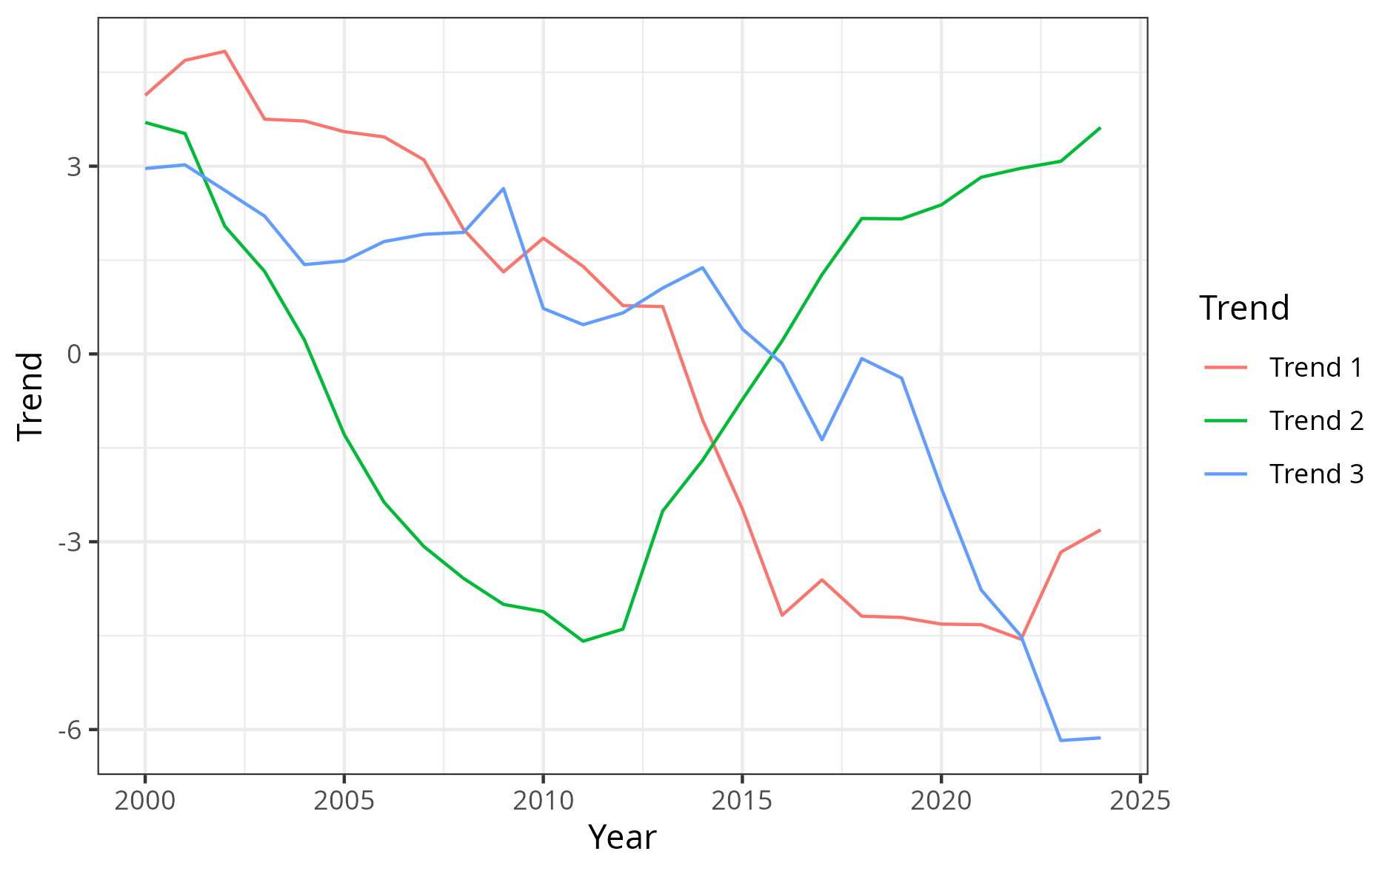

Correlation of trends with environmental covariates and association of loading and covariates
The DFA trends are correlated with environmental factors, particularly AMOC and the Subpolar Gyre index, suggesting that part of the common dynamics may result from large-scale environmental synchronisation (Fig. 2).
Fig. 2. Correlation between DFA main trends and oceanic factors. in each panel, “p” stands for the p-value of a Kendall correlation tests.
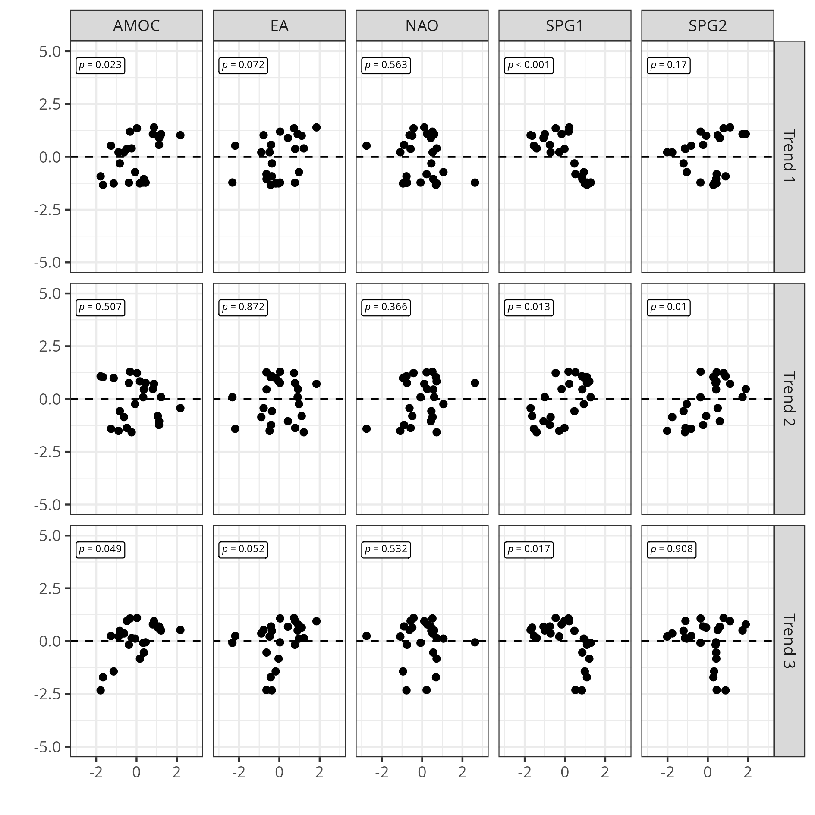
Spatially, stocks with strong positive factor loadings for trend 2 are predominantly located in north-western Europe, between the UK and Iceland (Fig. 3), suggesting that many stocks in this region experienced a recruitment trough around 2012. Conversely, stocks with strong positive factor loadings for trend 3 are mostly located in the North Sea, indicating that many stocks in this area may have experienced a recruitment decline after 2019. For trend 1, both positive and negative loadings are observed with no clear spatial pattern.
Fig. 3. Maps showing the spatial distribution of the factor loadings. Each point tends for the centroid of the stock and the color indicate the value of the factor loading for each trend (one panel per DFA trend).
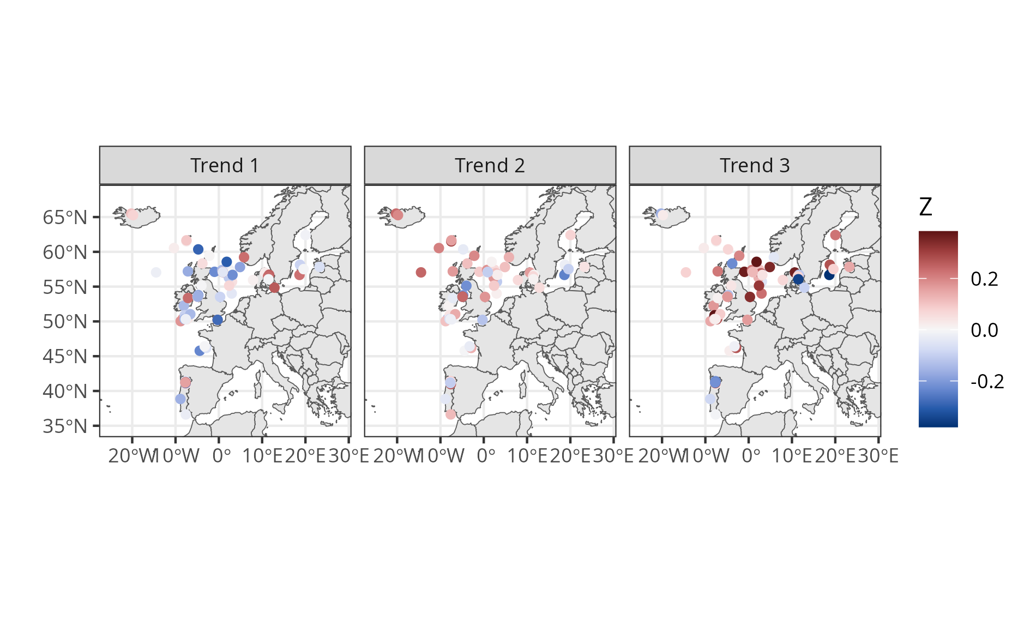

Correlation between factor loadings and covariates (this section could be removed and moved to supplementary material?)
Correlations between factor loadings for each trend and various species-level covariates were explored (Fig. 4). No significant correlations were found between factor loadings and trophic or size guilds, dependence on coastal/estuarine habitats, vulnerability indices or fishing pressure. However, significant associations were found between growth characteristics and trends 1 and 3. Species with faster growth (higher $K$) and smaller asymptotic size ( $L_{∞}$ , $L_{maturity}$, maximum age) tended to be more negatively associated with trend 1 and more positively associated with trend 3. This suggests that fast-growing species are more frequently associated with increasing recruitment (negative correlation with trend 1), while species showing a post-2019 recruitment decline (positive correlation with trend 3) tend to have slower life histories.
Fig. 4. Scatter plot of the factor loadings (y-axis) of the different stocks (point) and fish characteristics (x-axis, $L_{maturity}$ first row, $L_{∞}$ second row, maximum age third row and $K$ fourth row) for each trend (column). R stands for the Kendall correlation coefficient and the associated significance level (ns non significant, * 0.05, ** 0.1, *** 0.001)
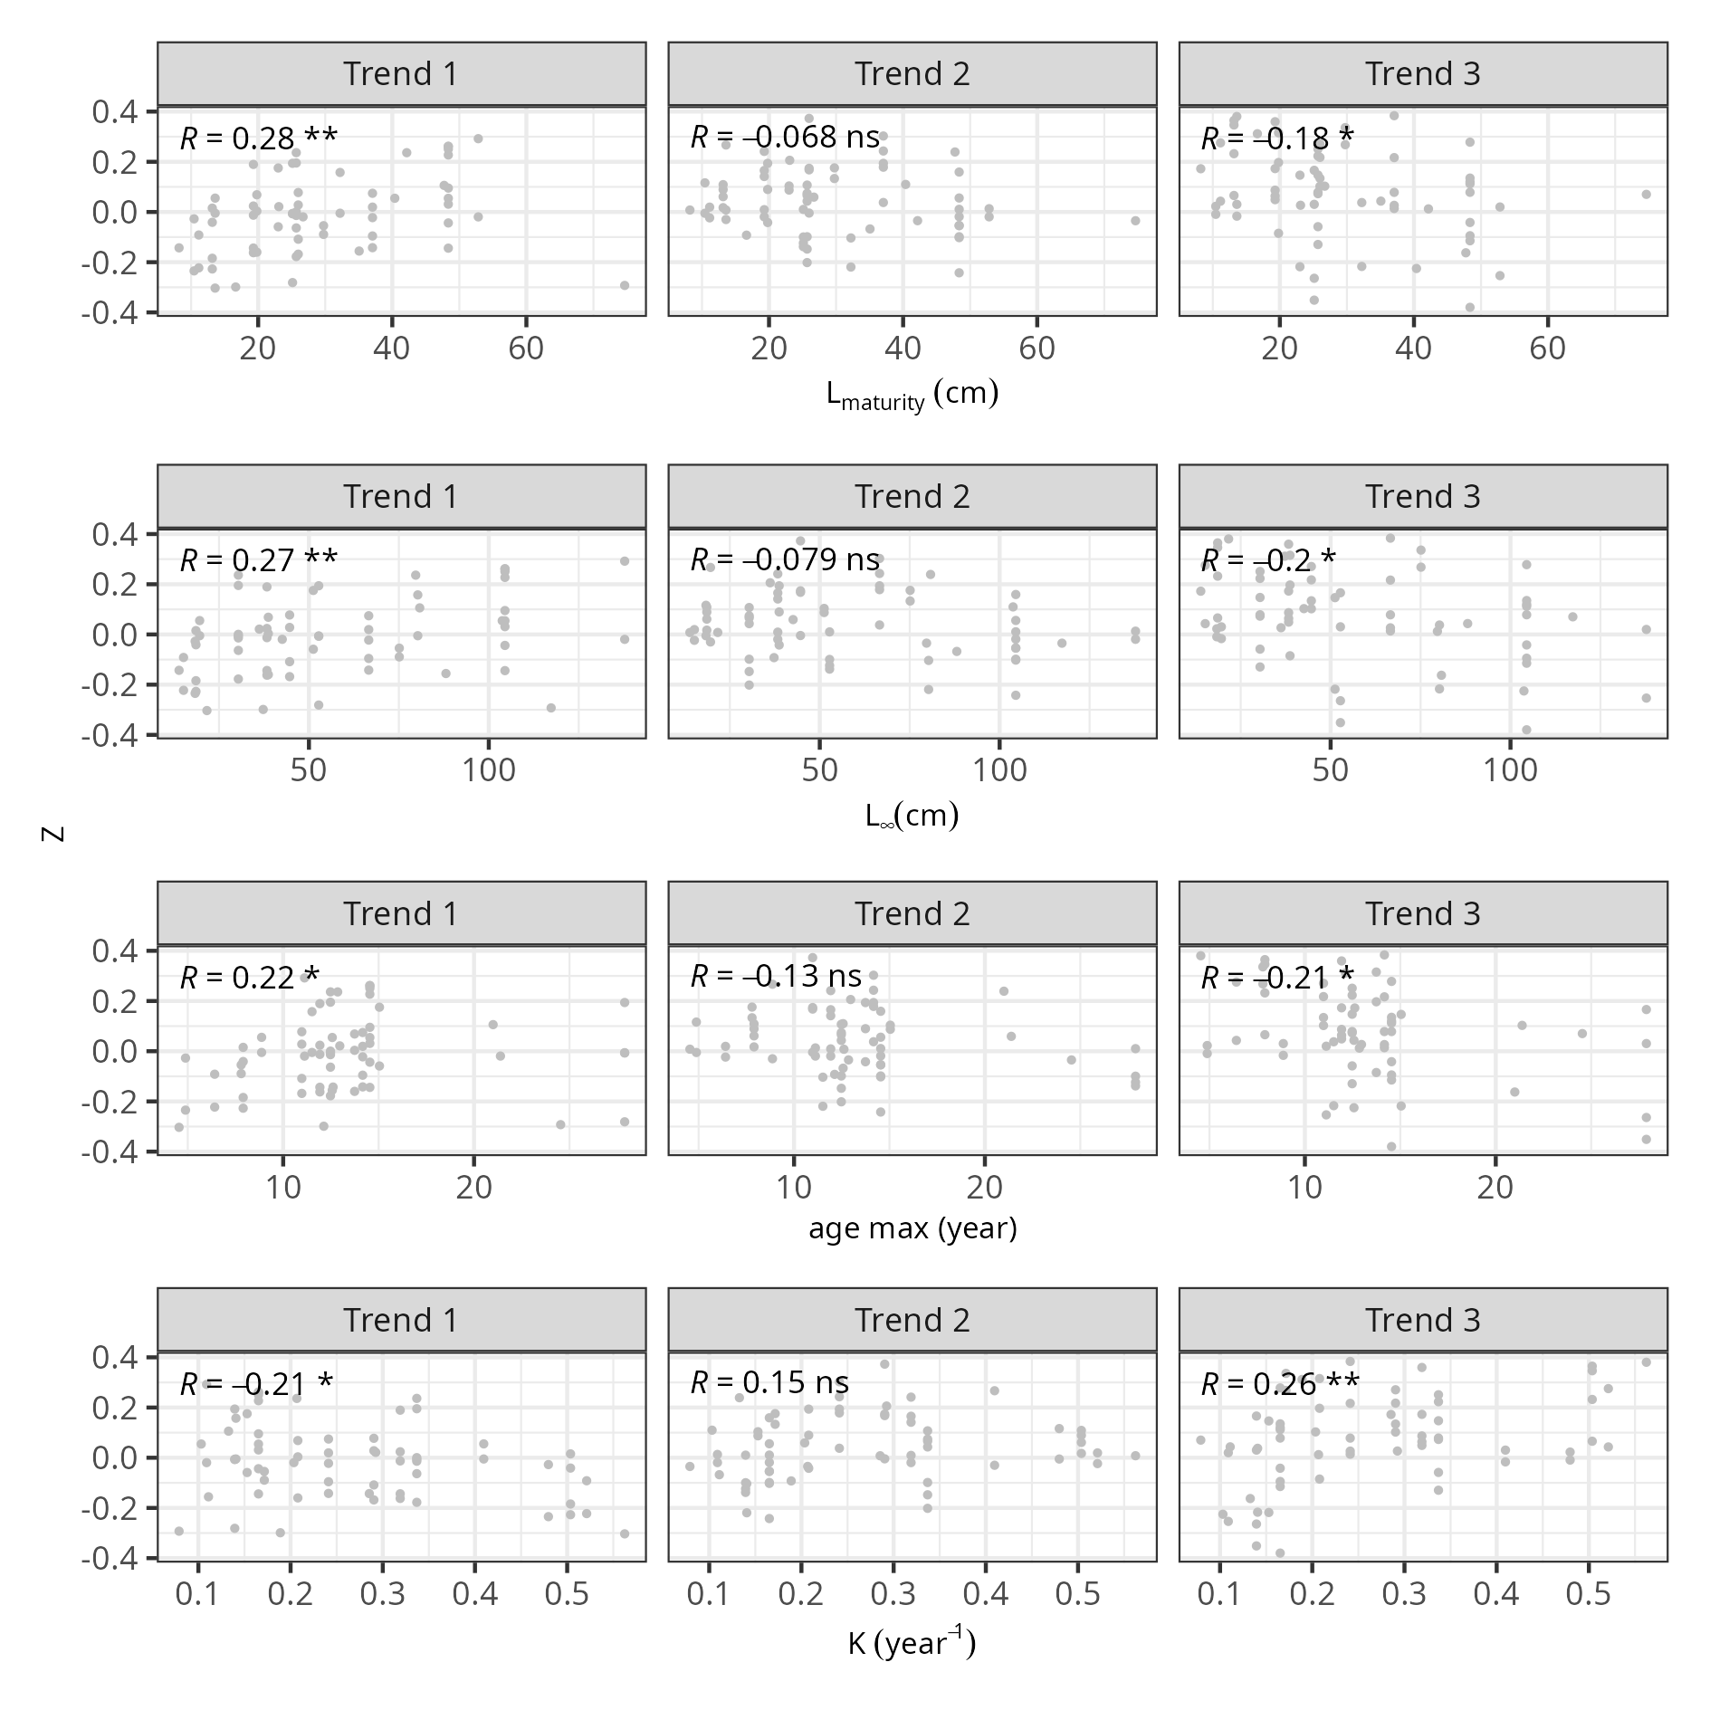
A significant correlation was also found between the position of a stock relative to its species’ northern distributional boundary and the factor loading for trend 2 (Fig. 5): stocks located closer to their northern boundary showed higher contributions from trend 2. This is consistent with the observation that stocks with high factor loadings for trend 2 are concentrated in the northernmost part of the study area (Fig. 3).
Fig. 5. Scatter plot of the factor loadings (y-axis) of the different stocks (point) and their distance to the species northern boundaries (x-axis) for each trend (column). Distance to the northern boundary is computed as the ratio of the difference between the lattitude of the species northern boundary and the lattitude the stock centroid over the difference of the lattitudes of the northern and southern boundaries of the species. R stands for the Kendall correlation coefficient and the associated significance level (ns non significant, * 0.05, ** 0.1, *** 0.001)
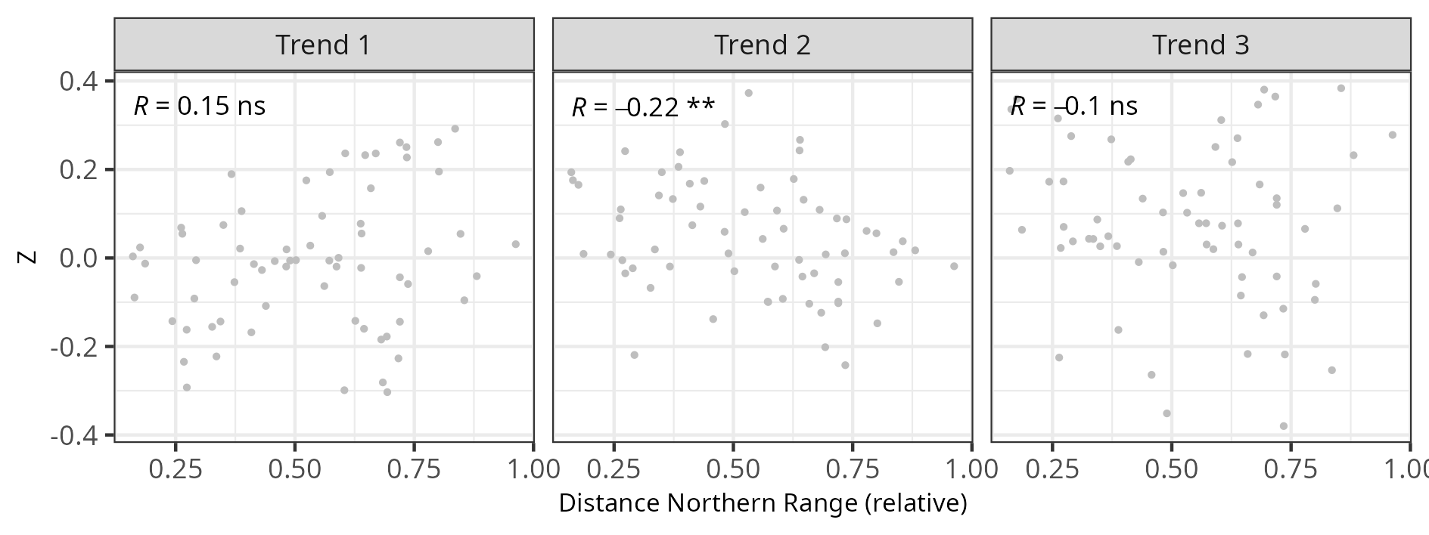

Clustering of stocks

Trends per cluster
The inertia profile of the hierarchical clustering supports a partition into 6 clusters (Fig. 6).
Fig. 6. Barplot of inertia gain (top panel) and dendogram of the hierarchical clustering. The red lines stand for a split in 4 clusters.
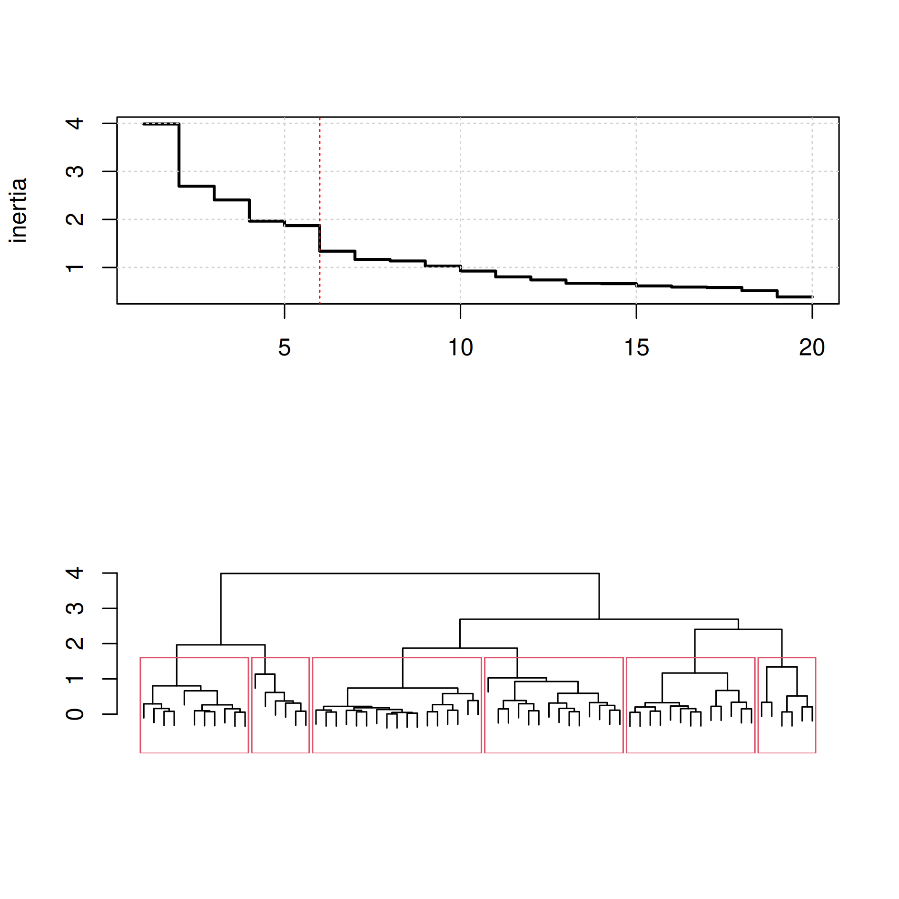
The centroid factor loadings for each cluster (Fig. 7) indicate the following patterns:
- Cluster 1 shows a negative loading for trend 1, yielding an overall increase over the period, but a negative loading for trend 3, suggesting a collapse after 2019.
- Cluster 2 displays a similar but attenuated pattern, with smaller factor loadings leading to a flatter temporal trajectory.
- Cluster 3 shows a negative loading for trend 3, corresponding to a rapid increase in recruitment in recent years.
- Cluster 4 shows a pattern broadly opposite to cluster 3, with a sharp decline in recruitment in recent years.
- Cluster 5 is positively associated with trend 1, corresponding to a continuous decline in recruitment over the full period. Most corresponding stocks are located in the North Sea, English Channel, and Celtic Sea (Fig. 9).
- Cluster 6 is strongly associated with trend 2, producing a U-shaped trajectory with a trough around 2012. Most of these stocks are located in the north-western extremity of the study area (Figure Fig. 9).
Segmented regressions identified a regime shift around 2020 in clusters 1, 3, 4, and 5 (Fig. 8). For cluster 6, a breakpoint was detected around 2012.
Fig. 7. Mean loadings per PCA trend of each cluster.
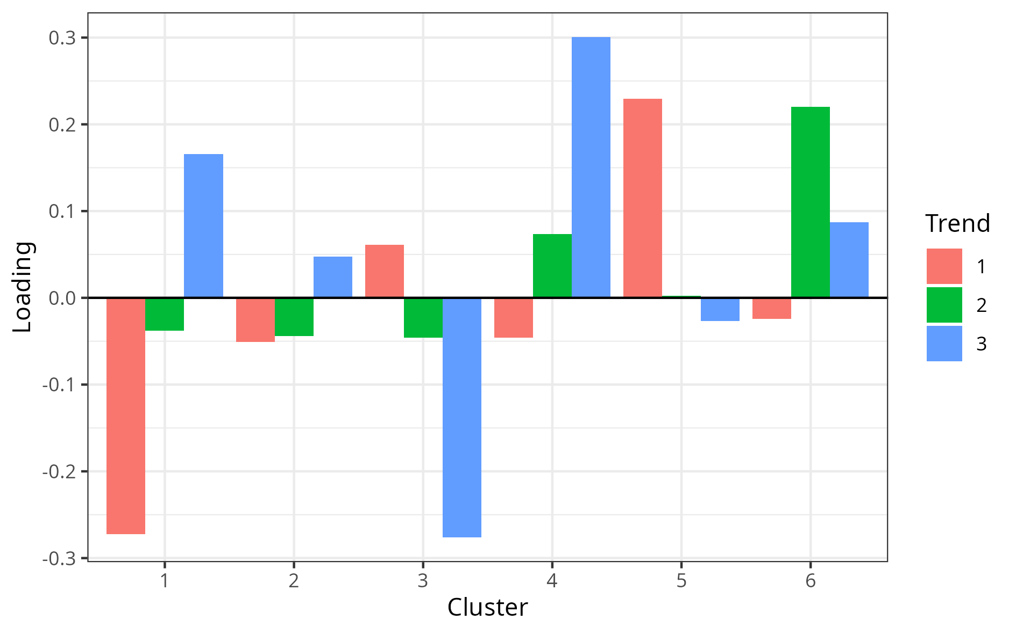
Fig. 8. Trends of the centroids (black solide line) as predicted by the DFA. Each line corresponds to a specific stock within the corresponding cluster. The dashed vertical lines indicate the breakpoints detected by the segmented regression over the stocks of the cluster.
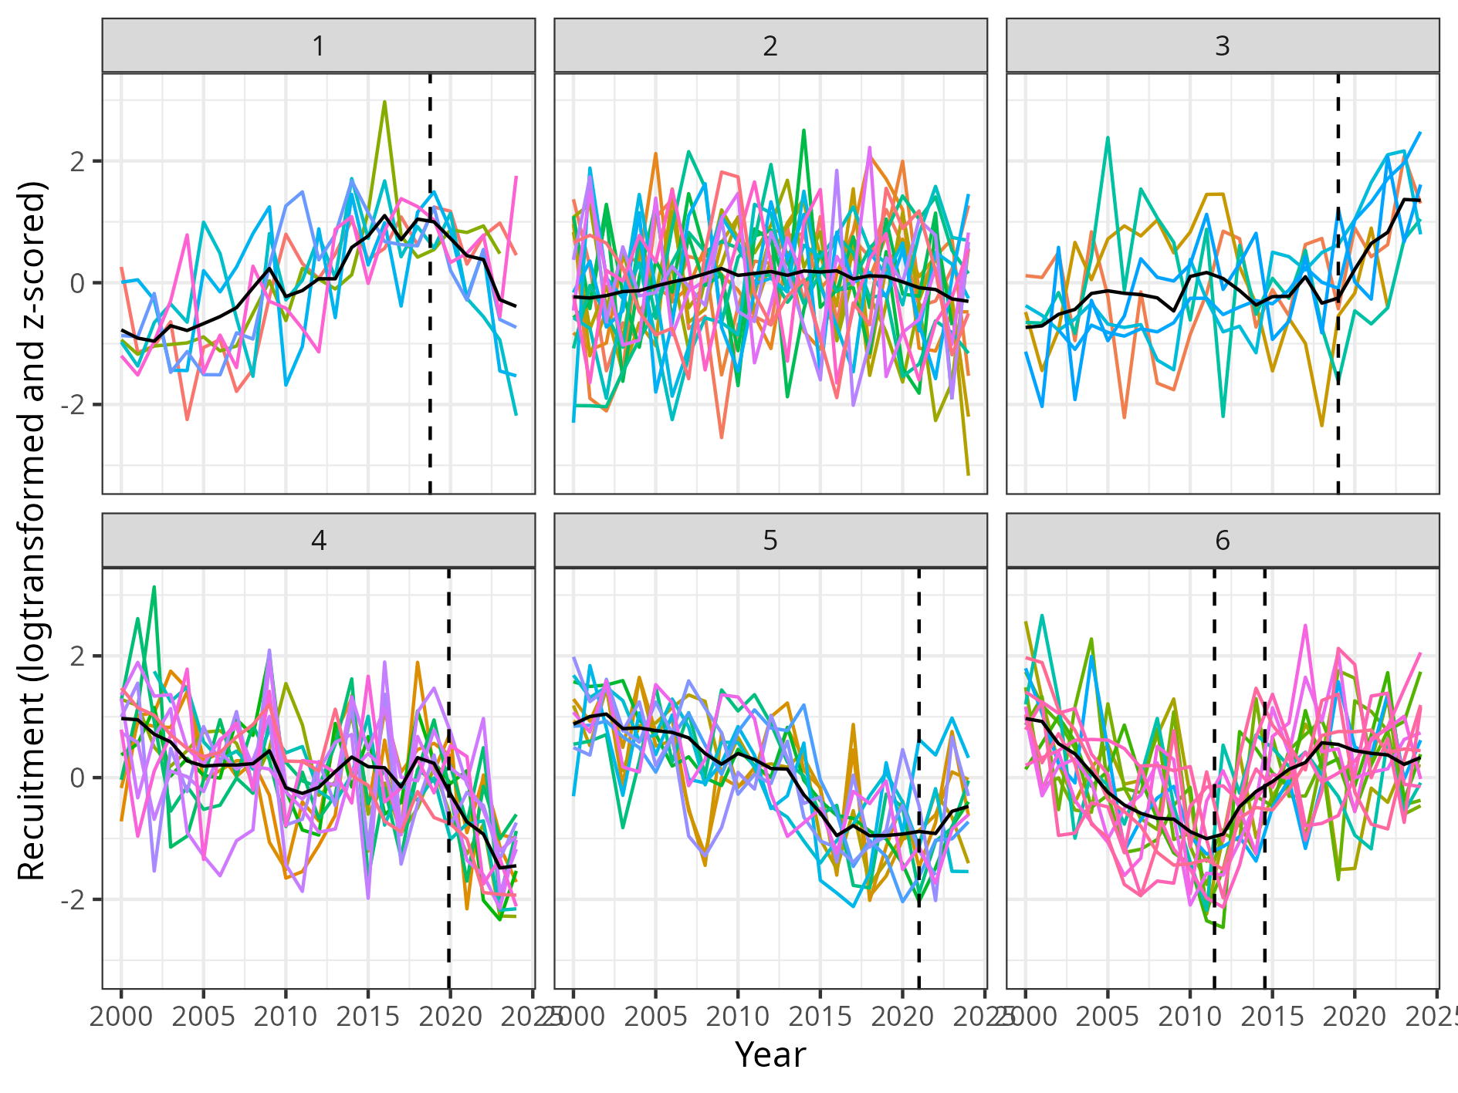
Fig. 9. Position of the stocks within each cluster. The points stands for the centroid of the stocks.
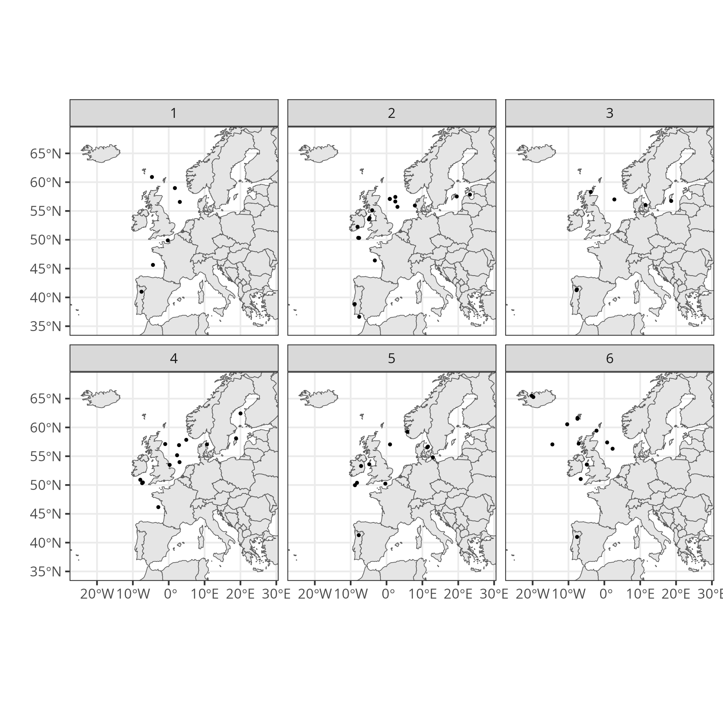

Species characteristics and clusters
The stock composition of each cluster is provided in supplementary material.
As for factor loadings, almost no significant associations were found between cluster belongings and species characteristics (Fisher exact test for qualitative variables, Kruskall Wallis tests for quantitative variable). The only exception is once again the growth parameters, with slower growth rate $K$ and older maximum age in cluster 3 (Fig. 10).
Fig. 10. Distribution of species life-history trait per cluster. The p-value of the Kruskall-Wallis test and associated significance level (***<0.001, **<0.01, *<0.05) are displayed on each panel.
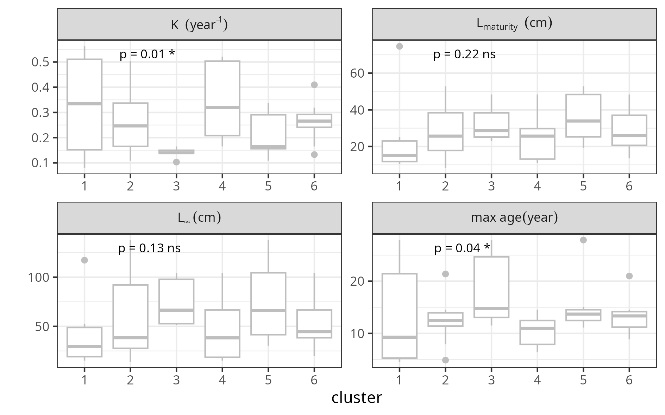

Clusters and covariates
Table 2 summarizes the result of the Kendall correlation tests between recruitment and Table 3 the results of the “failed environment recruitment relationships. A possible influence of environmental conditions is detected in many clusters, especially AMOC (cluster 1) and the SPG indices (clusters 1, 5 and 6).
Interestingly, results suggest a correlation with spawning stock biomass and fishing pressure for stocks in cluster 1, suggesting that the recruitment trends (almost monotoneous increase) might be the partly the result of the recovery of the stocks after a period of depletion and overexploitation. This is confirmed by the inspection of the stock assessment results which show that several of those stocks have displayed a period of low biomass, typicall below B_{LIM} or B_{PA}, and then recovered after a decrease of the fishing pressure (stocks ane.27.8, dgs.27.nea, nop.27.3a4, ldb.27.8c9a, ple.27.7d). The recruitment dynamics of spr.27.3a4 within this cluster do not seem to be related to changes in SSB and F.
Unsurprisingly, no effects of covariates were detected for stocks within cluster 2, this cluster not exhibiting a clear temporal pattern.
As cluster 1, cluster 3 displays an increase in recruitment, however, in cluster 3 this increase is especially fast in recent years. Here, few correlations were found with covariates. For some stocks of the cluster and similarly to cluster 1, the recovery of the stocks after a period of depletion due to overexploitation might partly explain the pattern (hke.27.8c9a, anf.27.3a46, ple.27.21-32, ple.27.420). Among those, the rapid increase of recruitment of ple.27.21-32 does not seem to result from further decrease in F. For meg.27.8c9a, the recruitment is concomitant to a fast increase of SSB in recent years, but which does not seem to result from a decrease of F. Finally, while F of cod.7.24-32 has decreased over the period, SSB remain at a low level and the seemingly increase in recruitment in recent years seem mostly to be due to a dip in 2018.
Cluster 4 displays an opposite trend to cluster 3: a decrease in recruitment, especially fast in recent years. Correlations analysis (Table 2) and failed recruitment ( Table 3) both suggest some links with environmental conditions (AMOC, SPG and potentially EA) but none with the status of the stocks. For bss.27.4bc7ad-h, the decrease in recent years occurs while SSB is increasing and F is below F_{MSY}. The same stands for bss.27.8ab though the recent seemingly decrease is partly perceived because of a peak of recruitment in 2018. For many stocks of the cluster (cod.27.7e-k, had.27.7b-k, her.27.3a47d,her.27.30.31, hom.27.4bc7d, sol.27.20-24, san.sa.3r), the recent lower recruitments might result from a decrease of SSB, but this decrease does not seem to be caused by an increase of F which appears to be stable (or even decreasing for sol.27.20-24). The ICES advice noted the issue of low recruitment in recent years for had.27.7b-k and do not suggest any drivers (ICES 2025a), that the the “recruitment has continuously declined over decades” and that factors other than fishing pressure have likely contributed to the decline in sol.27.20-24 productivity (ICES 2025b). For spr.27.22-32, the drop in recruitment seem to mostly corresponds to three years of poor recruitment in 2022-2024, which do not seem to be caused by a drop of SSB nor an increase of F. For whg.27.7b-ce-k, the decrease of recruitment seems to have occurred before the drop in SSB and the increase of F, suggesting that other factors might have played a role. Moreover, the SSB has continued to drop despite a slight decrease of F. The sandeel stock san.sa.1r is classified in this cluster but does not seem to display lower recruitment in recent years.
For cluster 5, some stocks display a correlation between recruitment of SSB (Table 2) and recruitment failure might also be associated to specific environmental conditions (SPG, SST). This is the only stock for which a reduction of the median of the recruitment is specifically associated to higher SST (Table 3). Many stocks of the cluster are collapsing despite no clear increase in F (cod.27.21, cod.27.22-24, her.27.20-24, her.27.irls, ple.27.7a, pol.27.67, sol.27.7d). ICES notes that the dynamics of her.27.20-24 is affected by non-fishing impacts (ICES 2025c), and that part of the dynamics of cod.27.22-24 is due to additional natural mortality by seal, cormorants, heat stress and hypoxia (ICES 2025d). For meg.27.7b-k8abd, the recruitments are decreasing while SSB is above MSY B_{trigger} , slightly increasing in recent years, and F is stable or decreasing. On the other hand, pra.27.3a4a lower recruitments can be associated to lower SSB below B_{LIM} which seem to result from an increase of F since the early 2000s. The stock mon.27.8c9a displays an increasing trend in recruitment since 2015, and seem to be missclassified by the hierarchical clustering.
Cluster 6 is characterised by a dip of recruitment around 2012 and both the correlation and recruitment failure analysis suggest a possible association with the gyre index (salinity). This possible environmental driver is also supported by the spatial grouping of those stocks (Fig. 9). For had.27.5a, had.27.5b, had.27.6b, had.27.46a20, hom.27.2a3a4a5b6a7a-cek8, pil.27.8c9a, sol.27.7a, whg.27.6a, whg.27.7a, whg.27.47d the good recruitments after 2013/2015 started while the biomasses were at their historical low. The same stands for whb.27.1-91214 though the dip in recruitment occured a bit earlier (2007-2009). For sol.27.7fg and usk.27.5a14 the period of low recruitments from 2005 to 2014 occured whild the SSB above B_{PA}. Finally, cod.27.5b1, the lower recruitment occurred during a period of lower SSB, while F was rather, might be due to the fishery?
Table 2. number of stocks within each cluster for which a significant monotonic positive (>0), negative (<0) or no significant (-) correlations were found for each covariate. Cells in grey indicates correlations that are does not make sense from an ecological point of view. To facilitate the reading, cells in bold correspond in situations for which the number of stocks in the cluster with significant correlations is higher than the number of stocks for which there is no significant correlation.
covariate | cluster 1 |  |  | cluster 2 |  |  | cluster 3 |  |  | cluster 4 |  |  | cluster 5 |  |  | cluster 6
 | - | ↘ | ↗ | - | ↘ | ↗ | - | ↘ | ↗ | - | ↘ | ↗ | - | ↘ | ↗ | - | ↘ | ↗
AMOC | 3 | 3 |  | 14 | 2 | 1 | 5 | 1 |  | 8 |  | 5 | 9 |  | 2 | 14
CHL | 4 |  | 2 | 15 | 1 | 1 | 5 |  | 1 | 10 | 3 |  | 8 | 3 |  | 14
EA | 6 |  |  | 15 | 1 | 1 | 6 |  |  | 10 |  | 3 | 9 |  | 2 | 14
F | 4 | 2 |  | 16 | 1 |  | 4 | 2 |  | 10 | 2 | 1 | 6 |  | 5 | 10 | 4
SPG1 | 1 |  | 5 | 15 | 1 | 1 | 3 | 1 | 2 | 9 | 3 | 1 | 1 | 10 |  | 8 |  | 6
SPG2 | 5 | 1 |  | 14 | 3 |  | 6 |  |  | 12 |  | 1 | 11 |  |  | 9 |  | 5
SSB | 3 |  | 3 | 15 |  | 2 | 4 |  | 2 | 8 | 1 | 4 | 3 | 2 | 6 | 12 |  | 2
SST | 5 |  | 1 | 16 | 1 |  | 4 |  | 2 | 10 | 3 |  | 7 | 4 |  | 13 | 1
Table 3. Results of the environment recruitment relationships from Gross and Hoenig (2025) per cluster of the DFA and covariate. High (conversely low) corresponds to the assumption that the covariate is a limiting factor at high (conversely low) values. “Reduction median” gives the proportions of stocks within the cluster for which the median in poor conditions is lower than in good conditions. “Std. deviation lower” indicates indicates the proportion of stock within the cluster for which the standard deviation of recruitment in poor conditions is lower than in good conditions. “Proportion of years with poor recruitment > 50%” gives the proportion of stocks per cluster for which the frequency of low recruitment is higher than 50% in poor conditions. A green backgound indicates that the value is significant (0.05 threshold) according to a binomial test.
 |  | Reduction median |  | Std. deviation lower |  | Proportion of years with poor recruitment > 50%
cluster | covariate | high | low | high | low | high | low
1 | AMOC | 1.00 | 0.17 | 1.00 | 0.17 | 1.00 | 0.33
 | CHL | 0.33 | 0.83 | 0.33 | 0.83 | 0.33 | 0.67
 | EA | 0.83 | 0.33 | 0.83 | 0.33 | 0.83 | 0.17
 | F | 1.00 | 0.33 | 1.00 | 0.33 | 1.00 | 0.17
 | NAO | 0.17 | 0.33 | 0.17 | 0.33 | 0.17 | 0.33
 | SPG1 | 0.00 | 1.00 | 0.00 | 1.00 | 0.00 | 0.83
 | SPG2 | 1.00 | 0.17 | 1.00 | 0.17 | 1.00 | 0.17
 | SSB | 0.00 | 1.00 | 0.00 | 1.00 | 0.00 | 1.00
 | SST | 0.33 | 0.67 | 0.33 | 0.67 | 0.33 | 0.67
2 | AMOC | 0.53 | 0.41 | 0.53 | 0.41 | 0.53 | 0.35
 | CHL | 0.53 | 0.59 | 0.53 | 0.59 | 0.53 | 0.53
 | EA | 0.53 | 0.24 | 0.53 | 0.24 | 0.53 | 0.18
 | F | 0.53 | 0.47 | 0.53 | 0.47 | 0.53 | 0.35
 | NAO | 0.53 | 0.47 | 0.53 | 0.47 | 0.53 | 0.35
 | SPG1 | 0.53 | 0.35 | 0.53 | 0.35 | 0.53 | 0.29
 | SPG2 | 0.65 | 0.47 | 0.65 | 0.47 | 0.59 | 0.35
 | SSB | 0.41 | 0.59 | 0.41 | 0.59 | 0.41 | 0.41
 | SST | 0.47 | 0.59 | 0.47 | 0.59 | 0.47 | 0.53
3 | AMOC | 0.67 | 0.17 | 0.67 | 0.17 | 0.67 | 0.17
 | CHL | 0.33 | 0.67 | 0.33 | 0.67 | 0.33 | 0.50
 | EA | 0.67 | 0.00 | 0.67 | 0.00 | 0.67 | 0.00
 | F | 0.67 | 0.17 | 0.67 | 0.17 | 0.67 | 0.17
 | NAO | 0.33 | 0.17 | 0.33 | 0.17 | 0.33 | 0.17
 | SPG1 | 0.33 | 0.67 | 0.33 | 0.67 | 0.33 | 0.67
 | SPG2 | 0.67 | 0.17 | 0.67 | 0.17 | 0.67 | 0.17
 | SSB | 0.00 | 0.83 | 0.00 | 0.83 | 0.00 | 0.83
 | SST | 0.33 | 0.33 | 0.33 | 0.33 | 0.33 | 0.33
4 | AMOC | 0.23 | 0.92 | 0.23 | 0.92 | 0.23 | 0.92
 | CHL | 0.62 | 0.54 | 0.62 | 0.54 | 0.62 | 0.31
 | EA | 0.08 | 0.92 | 0.08 | 0.92 | 0.08 | 0.85
 | F | 0.62 | 0.69 | 0.62 | 0.69 | 0.62 | 0.69
 | NAO | 0.69 | 0.62 | 0.69 | 0.62 | 0.69 | 0.46
 | SPG1 | 0.92 | 0.23 | 0.92 | 0.23 | 0.92 | 0.08
 | SPG2 | 0.46 | 0.69 | 0.46 | 0.69 | 0.46 | 0.54
 | SSB | 0.46 | 0.62 | 0.46 | 0.62 | 0.46 | 0.54
 | SST | 0.54 | 0.31 | 0.54 | 0.31 | 0.54 | 0.23
5 | AMOC | 0.18 | 0.73 | 0.18 | 0.73 | 0.00 | 0.82
 | CHL | 0.82 | 0.45 | 0.82 | 0.45 | 0.73 | 0.36
 | EA | 0.18 | 0.73 | 0.18 | 0.73 | 0.09 | 0.36
 | F | 0.36 | 0.73 | 0.36 | 0.73 | 0.27 | 0.73
 | NAO | 0.82 | 0.36 | 0.82 | 0.36 | 0.82 | 0.09
 | SPG1 | 1.00 | 0.00 | 1.00 | 0.00 | 0.91 | 0.00
 | SPG2 | 0.00 | 0.64 | 0.00 | 0.64 | 0.00 | 0.45
 | SSB | 0.18 | 0.73 | 0.18 | 0.73 | 0.18 | 0.55
 | SST | 0.91 | 0.27 | 0.91 | 0.27 | 0.82 | 0.27
6 | AMOC | 0.71 | 0.79 | 0.71 | 0.79 | 0.64 | 0.71
 | CHL | 0.29 | 0.64 | 0.29 | 0.64 | 0.29 | 0.50
 | EA | 0.64 | 0.64 | 0.64 | 0.64 | 0.64 | 0.43
 | F | 0.71 | 0.36 | 0.71 | 0.36 | 0.71 | 0.36
 | NAO | 0.50 | 0.79 | 0.50 | 0.79 | 0.50 | 0.71
 | SPG1 | 0.14 | 1.00 | 0.14 | 1.00 | 0.14 | 1.00
 | SPG2 | 0.36 | 0.93 | 0.36 | 0.93 | 0.36 | 0.71
 | SSB | 0.21 | 0.64 | 0.21 | 0.64 | 0.21 | 0.64
 | SST | 0.57 | 0.50 | 0.57 | 0.50 | 0.57 | 0.43

Discussion

Meta-analysis approach
Recruitment is a key process of fish population dynamics that have received much attention but still remain poorly understood and hardly predictable because of its large stochasticity (Cury et al. 2014; Myers 1998; Myers and Barrowman 1996; Szuwalski et al. 2015). This question is even more of interest given the concern of potential detrimental effects of global change, and especially climate change (Mildenberger et al. 2025; Zimmermann et al. 2019), and the recent occurrence of alarming trends in recruitment (Grandremy et al. 2026; Livdāne et al. 2025; Moyano et al. 2023; Wright et al. 2024){>> add fishing opportunity paper; add last cfp monitoring report <<}. Meta-analysis have proved to be a relevant approach to detect general rules and common features that could not be detected otherwise (Arnqvist and Wooster 1995; Fagard et al. 1996; Stewart 2009). Here, we suspected that combining a large dataset of stock assessment could allow to identify relationships that could not be detected at the stock level given the noise of the process. Such approach have already been applied by other authors to study the productivity of fish stocks in general (Ma et al. 2024), and even specially recruitment trends (Perretti et al. 2017; Zimmermann et al. 2019). Our analysis is very similar to the analysis made by Zimmermann et al. (2019), i.e. an analysis of temporal trends of recruitment time series across the Northeast Atlantic using, among others, a dynamic factor analysis to detect common trends and explore the influence of covariates. However, our update allow to cover recent years (Zimmermann et al. (2019) dataset ended in 2015) and as such to provide new insights on recent trends. Moreover, while Zimmermann et al. (2019) analysed trends in the ratio R/SSB, we directly analysed the recruitment time series for three main reasons. First, we wanted to avoid that the detecting trends are more influenced by trends in SSB than by R (especially since R is very stochastic and noisy, impairing the ability to detect temporal signals. Second, by dividing R/SSB, Zimmermann et al. (2019) was more focusing on the the productivity of stocks rather than on the trends in recruitment themselves. Finally, because we wanted to explore whether SSB could be a driver of recruitment trends.

Exploitation of stocks explain part of the dynamics
Historically, much work on the stock-recruitment relationship have focuses on the effect of the stock size on recruitment (Myers and Barrowman 1996; Szuwalski et al. 2015). Indeed, a large part the management of fisheries under the precautionary approach and related reference points, aimed to ensure that stocks remain above levels of biomass that prevent recruitment collapses (Silvar-Viladomiu et al. 2022). However, detecting the effect of the stock status on the level of recruitment is often impaired by the large influence of environmental drivers (Myers and Barrowman 1996). In general, the relationship is apparent only once stocks are depleted and the spawning stock biomass becomes a limiting factor. This is a significant explanation for the dynamics of many stocks in cluster 1 for which a correlation with the fishing mortality and the spawning stock biomass was observed. Indeed, the decrease of the fishing mortality in European waters have promoted the increase of biomass for many stocks (Gras et al. 2025; Winker et al. in press). In cluster 1, many stocks were outside safe biological limits, i.e. at levels at which recruitment was or could be impaired. The reduction of F have contributed to a recovery of the SSB which in turn, might have contributed to an increase in recruitment. The recovery of historically depleted stocks of main large benthivorous target species might also explain the increase of recruitment for some stocks of cluster 3. This confirms that commercial exploitation could drive synchrony in fish populations (Frank et al. 2016).
The effects was less obvious in other clusters and do not appear to explain the recruitment trends on their own. In clusters 4 and clusters 5, they are some signs of a detrimental impact of reduced SSB on recruitment. However, in many cases, it was not clear whether the detected correlations between SSB and R was due to depleted stocks levels affecting recruitment, or the other way around: because good recruitments due to other factors promoted an increase of biomass in following years. Anyway, for most of these stocks, the link with fishing mortality was not obvious, suggesting that the recruitment trends could not be explained by the fishery on its own.

The Moran effect of additional factors
The DFA allows to detect common trends in the set of recruitments (Fig. 1) . The regimes identified significant synchronous shifts among clusters stocks (Fig. 8). While SSB, and particularly F, appear to play a limited role, broader large-scale environmental drivers seem to dominate the dynamics and induce a Moran effect across stocks. In the study area, spatial synchrony driven by large-scale processes has been previously suggested for Atlantic salmon populations (Olmos et al. 2020, 2019), as well as for plankton communities (Bode 2024; Sheppard et al. 2019). The spatial distribution of factor loadings (Fig. 3) indicates stronger synchrony at shorter distances. Although synchrony arising from a Moran effect can extend across broad spatial scales when environmental drivers exhibit long-range correlations (Koenig 2002), a decline in synchrony with increasing distance is frequently observed (Walter et al. 2017). This may reflect spatial heterogeneity in environmental forcing across ecoregions, as well as differences in species composition among regions, possibly resulting from climatic forcing.
In this study, the subpolar gyre index appears to be one of the main environmental drivers, correlated to DFA trends (Fig. 1) and with the recruitment of many stocks (Table 2). The subpolar gyre has a large effect on abiotic conditions in the whole North Atlantic, modifying the salinity and the temperature on a wide spatial range (Fan et al. 2023). The influence on the gyre on seabirds (Descamps et al. 2013; Fluhr et al. 2017; Hátún et al. 2025, 2017b) and fish poulations is well known (Hátún et al. 2025; Koul et al. 2021; Post et al. 2021), and in general to the whole ecosystem from plankton to marine mammals across a very large part of the North Atlantic (Hátún et al. 2009). An other circulation driver, namely the AMOC, appears to have a significant influence on the trends of recruitment, especially for stocks in cluster 1. The AMOC is directly related to the subpolary gyre (Jackson et al. 2022). It transports warm water towads the Northen Atlantic (Boers 2021) and, as the gyre, have documented impacts on fish populations (Alheit et al. 2014; Drinkwater and Kristiansen 2018). Both the AMOC and the subpolar gyre are threaten by the climate change (Boers 2021; Ghosh et al. 2023; Madan et al. 2024), and this could have detrimental effects on the recruitments of a wide number of species.

Synchrony of regime shifts
The synchrony is among other visible through the existence of regime shifts detected at the multispecific scale within clusters (Figure Fig. 8). A first regime shift appears was detected around 2012 and is visible both in the trend 1 (onset of the decrease) and 2 (dip of the trend) (Fig. 1), and was detected for species in cluster 6, i.e. a cluster of species mostly located in the Nortwestern part of the study area (Fig. 9). Reviewing the existing literature on the plankton populations in the North Atlantic, Bode (2024) showed that many analysis reveal the existence of possible regime shift in the late 2000s early 2010s, possibly resulting from climatic drivers. This suggests a bottom-up control of the shift, with environmental drivers affecting the recruitment. This shift is also concomitant with a dip in the subpolar gyre intensity (Hátún et al. 2025), consistently with the detection of the shift mostly for stocks in the northwestern part of the study area.
The second period of shifts occur in the second half of the 2010s and is visible in all 3 trends of the DFA (Fig. 1), especially in trends 1 and 3 which are both correlated to the AMOC and SPG (Figure Fig. 2). The shifts are especially visible for stocks in cluster 1, 3 and 4 (a shift is also visible for stocks in cluster 5 but with a few year delay - Fig. 8). For cluster 3, the shift is followed by a rapid increase of the recruitment, while for the two others, the shift is followed by a rapid decrease of the recruitment. This shift appears to be especially important in the North and Celtic Seas, with most stocks of cluster 4 (the most abundant with 13 stocks, 6 for cluster 1, 6 for cluster 3) in the area (Figure Fig. 9). As mentioned earlier, this recent shift might be a first signal of the impacts of the modifications of the AMOC and of the gyre due to climate change. Cluster 4 includes many of the most important species for the fishery in the Celtic Sea
$$@hernvann2020$$
, including sea-bass, cod, haddock, whiting. In the North Sea, cluster 4 includes three stocks of sandeels, sea bass (shared with Celtic Sea), herring, horse mackerel, sole from Skagerrak and Kattegat.

The characteristics of species as limited effects
Different tests were carried out were made to explore whether trends in recruitment could be associated with some specific characteristics of the species (life history traits, use of estuarine nursery grounds, thermal tolerance). Few significant correlations were detected, except a correlation with species growth rate. Short-lived species with fast growth are generally more sensitive to environmental drivers, and this might explain why synchrony resulting from Moran effect could be more easily detected for such species. Arevalo et al. (2026) and Menu et al. (2023) have for example shown the evolution of different life history traits of small pelagic species as a response to bottom-up processes.
Interestingly, while cluster 5 displays a decreasing recruitment trend and poor recruitments in this cluster could be associated with higher temperatures (Table 3), few correlations were found between recruitment trends and species characteristics associated with the thermal tolerance. No correlations were found with the species thermal tolerance, with the Jones and Cheung (2018) vulnerability index nor with the position of the stock with respect to the species distribution range, as could have been expected as a result of climate change (Leggett and Frank 1997). The absence of apparent relationship with species range may also be due to the confusion with the geographic structuring of observed patterns among stocks. At this broad scale, northern stocks—being closer to the pole—are inherently nearer to their northern limit and farther from their southern limit.
These unexpectedly limited effects of life history traits (Champagnat et al. 2024) may also be related to the legacy of historical exploitation. The most vulnerable species, those with long lifespans and large body sizes, have often been targeted by fisheries and have suffered overexploitation. As such, they may have disproportionately benefited from the reductions in fishing mortality observed in European waters (Gras et al. 2025; Winker et al. in press), which may have promoted recruitment increases despite worsening environmental conditions. Still, species with slower life histories tend to be preferentially correlated to trend 3, i.e. displaying a drop in recruitment in recent years. The effect of management could also explain the absence of a relationship between recruitment trends and dependence on coastal or estuarine habitats, which are heavily impacted by global change (Brown et al. 2018; Cloern et al. 2016; Elliott and Hemingway 2002; Halpern et al. 2008). Recently, Grandremy et al. (2026) showed that, despite the critical dependence of common sole on estuarine and coastal nursery grounds in the Bay of Biscay, the recruitment decline may be more attributable to adverse environmental conditions during the larval drift at sea than to conditions in the nursery grounds. Conversely, Champagnat et al. (2021) demonstrated how habitat degradation in the same species in the Eastern English Channel may adversely affect recruitment. The relationship between habitat degradation and fish stock abundance is increasingly documented across species {>>some ref here?<<}.

References
A. k P., M M., Rajamanickam S., Sivarethinamohan S., Gaddam M.K.R., Velusamy P., R G., Ravindiran G., Gurugubelli T.R., Muniasamy S.K., 2023, Impact of climate change and anthropogenic activities on aquatic ecosystem a review. Environmental Research 238, 117233.
Alheit J., Licandro P., Coombs S., Garcia A., Giráldez A., Santamaría M.T.G., Slotte A., Tsikliras A.C., 2014, Atlantic multidecadal oscillation (AMO) modulates dynamics of small pelagic fishes and ecosystem regime shifts in the eastern north and central atlantic. Journal of Marine Systems 131, 21–35.
Arevalo E., Ibaibarriaga L., Aldanondo N., Mocoroa M.S., Taboada F.G., Cotano U., Alvarez P., Bachiller E., Zarauz L., Korta M., Villarino E., Chust G., 2026, Are Biological Responses Consistent With Ocean Warming Across Levels of Organisation in the Bay of Biscay? Fish and Fisheries 27, 313–341.
Arnqvist G., Wooster D., 1995, Meta-analysis: Synthesizing research findings in ecology and evolution. Trends in Ecology & Evolution 10, 236240.
Benezech M., Acou A., Bardonnet A., Boulenger C., Briand C., Diaz E., Lambert P., Mateo M., Beaulaton L., 2023, ICES ASC 2023.
Bianchi T.S., 2007, Biogeochemistry of Estuaries. Oxford University Press, USA.
Bindoff N.L., Cheung W.W.L., Kairo J.G., Arístegui J., Guinder V.A., Hallberg R., Hilmi N., Jiao N., Karim M. saiful, Levin L., O’Donoghue S., Purca S.R., Rinkevich B., Suga T., Tagliabue A., Williamson P., 2022, Changing Ocean, Marine Ecosystems, and Dependent Communities. In: Pörtner H.-O., Roberts D.C., Masson-Delmotte V., Zhai P., Tignor M., Poloczanska E., Mintenbeck K., Alegría A., Nicolai M., Okem A., Petzold J., Rama B., Weyer N.M. (Eds.),. United Kingdom, Cambridge University Press, pp. 447–587.
Bode A., 2024, Synchronized multidecadal trends and regime shifts in north atlantic plankton populations. ICES Journal of Marine Science 81, 575–586.
Boers N., 2021, Observation-based early-warning signals for a collapse of the Atlantic Meridional Overturning Circulation. Nature Climate Change 11, 680–688.
Brown E.J., Vasconcelos R.P., Wennhage H., Bergström U., Støttrup J.G., Wolfshaar K. van de, Millisenda G., Colloca F., Le Pape O., 2018, Conflicts in the coastal zone: Human impacts on commercially important fish species utilizing coastal habitat. ICES Journal of Marine Science 75, 1203–1213.
Burrow J.F., Horwood J.W., Pitchford J.W., 2011, The importance of variable timing and abundance of prey for fish larval recruitment. Journal of Plankton Research 33, 1153–1162.
Cappelli C., Hátún H., Jacobsen J.A., Visser A.W., Nielsen A., Berg C.W., Ferreira A.S.A., MacKenzie B.R., 2025, Ocean-climate conditions one year prior to spawning drive recruitment success of blue whiting. ICES Journal of Marine Science 82, fsaf102.
Castillo-Jordán C., Klaer N.L., Tuck G.N., Frusher S.D., Cubillos L.A., Tracey S.R., Salinger M.J., 2016, Coincident recruitment patterns of southern hemisphere fishes. Canadian Journal of Fisheries and Aquatic Sciences 73, 270–278.
Chambers R.C., Trippel E.A., 2012, Early Life History and Recruitment in Fish Populations. Springer Science & Business Media.
Champagnat J., Lecomte J.B., Rivot E., Douchet L., Martin N., Grasso F., Mounier F., Labadie P., Loizeau V., Bacq N., Pape O.L., 2021, Multidisciplinary assessment of nearshore nursery habitat restoration for an exploited population of marine fish. Marine Ecology Progress Series 680, 97–109.
Champagnat J., Rivot E., Le Pape O., 2024, The response of marine fish population productivity to juvenile habitat modifications depends upon life histories. Fish and Fisheries 25, 508–522.
Cloern J.E., Abreu P.C., Carstensen J., Chauvaud L., Elmgren R., Grall J., Greening H., Johansson J.O.R., Kahru M., Sherwood E.T., Xu J., Yin K., 2016, Human activities and climate variability drive fast-paced change across the world’s estuarinecoastal ecosystems. Global Change Biology 22, 513–529.
Costanza R., D’Arge R., De Groot R., Farber S., Grasso M., Hannon B., Limburg K., Naeem S., O’Neill R., Paruelo J., Raskin R., Sutton P., Van Den Belt M., 1997, The value of the world’s ecosystem services and natural capital. Nature 387, 253–260.
Cury P.M., Fromentin J.-M., Figuet S., Bonhommeau S., 2014, Resolving hjort’s dilemma: How is recruitment related to spawning stock biomass in marine fish? Oceanography 27, 42–47.
Cushing D.H., Horwood J.W., 1994, The growth and death of fish larvae. Journal of Plankton Research 16, 291–300.
Dahlke F.T., Wohlrab S., Butzin M., Pörtner H.-O., 2020, Thermal bottlenecks in the life cycle define climate vulnerability of fish. Science 369, 65–70.
Dahlke F., Wohlrab S., Butzin M., Pörtner H.-O., n.d., Experimental data compilation, thermal tolerance and thermal responsiveness of fish species and life stages.
Descamps S., Strøm H., Steen H., 2013, Decline of an arctic top predator: Synchrony in colony size fluctuations, risk of extinction and the subpolar gyre. Oecologia 173, 1271–1282.
Drinkwater K.F., Kristiansen T., 2018, A synthesis of the ecosystem responses to the late 20th century cold period in the northern north atlantic. ICES Journal of Marine Science 75, 2325–2341.
Elliott M., Hemingway K., 2002, Fishes in estuaries. Blackwell Science, London.
Fagard R.H., Staessen J.A., Thijs L., 1996, Advantages and disadvantages of the meta-analysis approach. Journal of Hypertension 14, S9.
Fan H., Borchert L.F., Brune S., Koul V., Baehr J., 2023, North Atlantic subpolar gyre provides downstream ocean predictability. npj Climate and Atmospheric Science 6, 145.
Fluhr J., Strøm H., Pradel R., Duriez O., Beaugrand G., Descamps S., 2017, Weakening of the subpolar gyre as a key driver of North Atlantic seabird demography: a case study with Brünnich’s guillemots in Svalbard. Marine Ecology Progress Series 563, 1–11.
Frank K.T., Petrie B., Leggett W.C., Boyce D.G., 2016, Large scale, synchronous variability of marine fish populations driven by commercial exploitation. Proceedings of the National Academy of Sciences of the United States of America 113, 8248–8253.
Ghosh R., Putrasahan D., Manzini E., Lohmann K., Keil P., Hand R., Bader J., Matei D., Jungclaus J.H., 2023, Two Distinct Phases of North Atlantic Eastern Subpolar Gyre and Warming Hole Evolution under Global Warming. Journal of Climate 36, 1881–1894.
Grandremy N., Lecomte J.-B., Le Pape O., 2026, Identifying the critical life stage of a recruitment-driven decline in an exploited marine fish stock: The bay of biscay common sole. Progress in Oceanography 244, 103724.
Gras M., Vasilakopoulos P., Pierucci A., Kupschus S., Mantopoulou Palouka D., Winker H., Konrad C., 2025, Monitoring the performance of the common fisheries policy. Luxembourg.
Gross J.M., Hoenig J.M., 2025, Resurrecting failed environment-recruitment relationships: Revisiting cod recruitment in light of the poor-recruitment paradigm. Reviews in Fish Biology and Fisheries 35, 317–343.
Häkkinen S., Rhines P.B., 2004, Decline of subpolar North Atlantic circulation during the 1990s. Science 304, 555–559.
Halpern B.S., Walbridge S., Selkoe K.A., Kappel C.V., Micheli F., D’Agrosa C., Bruno J.F., Casey K.S., Ebert C., Fox H.E., Fujita R., Heinemann D., Lenihan H.S., Madin E.M.P., Perry M.T., Selig E.R., Spalding M., Steneck R., Watson R., 2008, A global map of human impact on marine ecosystems. Science 319, 948–952.
Hansen B.B., Grøtan V., Herfindal I., Lee A.M., 2020, The Moran effect revisited: spatial population synchrony under global warming. Ecography 43, 1591–1602.
Harley C.D.G., Randall Hughes A., Hultgren K.M., Miner B.G., Sorte C.J.B., Thornber C.S., Rodriguez L.F., Tomanek L., Williams S.L., 2006, The impacts of climate change in coastal marine systems. Ecology Letters 9, 228–241.
Hátún H., Danielsen J., Olsen B., Jacobsen S., Vang H.B.M., Kristiansen I., Larsen K.M.H., Gaard E., Salter I., Steingrund P., Mork K.A., 2025, Unifying local and large-scale drivers of the faroe shelf ecosystem. Frontiers in Marine Science 12.
Hátún H., Olsen B., Pacariz S., 2017a, The dynamics of the north atlantic subpolar gyre introduces predictability to the breeding success of kittiwakes. Frontiers in Marine Science 4.
Hátún H., Olsen B., Pacariz S., 2017b, The Dynamics of the North Atlantic Subpolar Gyre Introduces Predictability to the Breeding Success of Kittiwakes. Frontiers in Marine Science 4.
Hátún H., Payne M.R., Beaugrand G., Reid P.C., Sandø A.B., Drange H., Hansen B., Jacobsen J.A., Bloch D., 2009, Large bio-geographical shifts in the north-eastern Atlantic Ocean: From the subpolar gyre, via plankton, to blue whiting and pilot whales. Progress in Oceanography 80, 149–162.
Hjort J., 1914, Fluctuations in the great fisheries of northern europe viewed in the light of biological research. Rapp. P.-V. Réun. Cons. Int. Explor. Mer. 20, 1228.
Holmes E.E., Scheuerell M.D., Ward E.J., 2025, Analysis of multivariate time-series using the MARSS package. Version 3.11.10.
Holmes E.E., Ward E.J., Wills K., 2012, MARSS: Multivariate autoregressive state-space models for analyzing time-series data. R journal 4.
Houde E.D., 1989, Comparative growth, mortality, and energetics of marine fish larvae: Temperature and implied latitudinal effects. Fishery Bulletin 87, 471495.
Houde E.D., 2008, Emerging from hjort’s shadow 41.
Hurvich C.M., Tsai C.-L., 1989, Regression and time series model selection in small samples. Biometrika 76, 297307.
ICES, 2024, Herring (Clupea harengus) in subdivisions 2024, spring spawners (Skagerrak, Kattegat, and western Baltic).
ICES, 2025d, Cod (Gadus Morhua) in subdivisions 22-24, western Baltic stock (western Baltic Sea) (report). ICES Advice: Recurrent Advice.
ICES, 2025c, Herring (Clupea Harengus) in subdivisions 20–24, spring spawners (Skagerrak, Kattegat, and western Baltic) (report). ICES Advice: Recurrent Advice.
ICES, 2025b, Sole (Solea Solea) in subdivisions 20-24 (Skagerrak and Kattegat, western Baltic Sea) (report). ICES Advice: Recurrent Advice.
ICES, 2025a, Haddock (Melanogrammus aeglefinus) in Divisions 7.b-k (southern Celtic Seas and English Channel).
IPBES, 2019, Global assessment report on biodiversity and ecosystem services of the intergovernmental science-policy platform on biodiversity and ecosystem services. Bonn, Germany.
IPCC, 2021, Climate change 2021: The physical science basis. Geneva, Switzerland, IPCC.
Jackson L.C., Biastoch A., Buckley M.W., Desbruyères D.G., Frajka-Williams E., Moat B., Robson J., 2022, The evolution of the north atlantic meridional overturning circulation since 1980. Nature Reviews Earth & Environment 3, 241254.
Jones M.C., Cheung W.W.L., 2018, Using fuzzy logic to determine the vulnerability of marine species to climate change. Global Change Biology 24, e719–e731.
Juanes F., 2007, Role of habitat in mediating mortality during the post-settlement transition phase of temperate marine fishes. Journal of Fish Biology 70, 661–677.
Kaschner K., Ready J.S., Agbayani E., Kesner-Reyes K., Rius-Barile J., Eastwood P.D., South A.B., Kullander S.O., Rees T., Watson R., Pauly D., Froese R., 2011, Using ’Aquamaps’ for representing species distribution in Regional Seas. In: Christensen V., Lai S., Palomares M.L.D., Zeller D., Pauly D. (Eds.),. Vancouver, BD, Canady, Fisheries Centre, University of British Columbia, pp. 17–21.
Kell L.T., Nash R.D.M., Dickey-Collas M., Mosqueira I., Szuwalski C., 2016, Is spawning stock biomass a robust proxy for reproductive potential? Fish and Fisheries 17, 596–616.
Kendall M.G., 1975, Rank correlation methods. 2nd impression. Charles Griffin and Company Ltd. London and High Wycombe.
Koenig W.D., 2002, Global patterns of environmental synchrony and the Moran effect. Ecography 25, 283–288.
Koul V., Sguotti C., Årthun M., Brune S., Düsterhus A., Bogstad B., Ottersen G., Baehr J., Schrum C., 2021, Skilful prediction of cod stocks in the North and Barents Sea a decade in advance. Communications Earth & Environment 2, 140.
Kristensen K., Nielsen A., Berg C.W., Skaug H., Bell B.M., 2016, TMB: Automatic Differentiation and Laplace Approximation. Journal of Statistical Software 70, 1–21.
Le Pape O., Bonhommeau S., 2015, The food limitation hypothesis for juvenile marine fish. Fish and Fisheries 16, 373–398.
Leggett W.C., Frank K.T., 1997, A comparative analysis of recruitment variability in north atlantic flatfishes testing the species range hypothesis. Journal of Sea Research, Proceedings of the third international symposium on flatfish ecology, part i 37, 281–299.
Livdāne L., Winkler G., Otto S., Kotterba P., Finke A., Moll D., Fischbach V., Zimmermann C., Polte P., 2025, Herring (Clupea harengus) recruitment failure in the western baltic sea as a consequence of a drastic zooplankton decline. Marine Ecology Progress Series 764, 75–89.
Ljunggren L., Sandström A., Bergström U., Mattila J., Lappalainen A., Johansson G., Sundblad G., Casini M., Kaljuste O., Eriksson B.K., 2010, Recruitment failure of coastal predatory fish in the baltic sea coincident with an offshore ecosystem regime shift. ICES Journal of Marine Science 67, 1587–1595.
Ma S., Huse G., Ono K., Nash R.D.M., Vølstad J.H., Kjesbu O.S., 2024, Northeast Atlantic fish stock productivity hindcasts and forecasts from a Bayesian framework reveal pronounced climate-induced dynamics. Fish and Fisheries 25, 686–710.
Madan G., Gjermundsen A., Iversen S.C., LaCasce J.H., 2024, The weakening AMOC under extreme climate change. Climate Dynamics 62, 1291–1309.
Menu C., Pecquerie L., Bacher C., Doray M., Hattab T., Kooij J. van der, Huret M., 2023, Testing the bottom-up hypothesis for the decline in size of anchovy and sardine across european waters through a bioenergetic modeling approach. Progress in Oceanography 210, 102943.
Mildenberger T.K., Berg C.W., Kempf A., Rindorf A., MacCall A.D., Taylor M.H., 2025, Estimating Time-Varying Productivity and Reference Points: A Case of North Sea Demersal Fish Stocks. Fish and Fisheries 26, 745–771.
Millar C., Large S., Magnusson A., 2024a, icesSD: Stock database web services.
Millar C., Large S., Magnusson A., Pinto C., Petre L.A., 2024b, icesSAG: Stock assessment graphs database web services.
Moran P.A.P., 1953, The statistical analysis of the canadian lynx cycle: II. Synchronization and meteorology. Australian Journal of Zoology 1, 291–298.
Moyano M., Illing B., Akimova A., Alter K., Bartolino V., Börner G., Clemmesen C., Finke A., Gröhsler T., Kotterba P., Livdane L., Mittermayer F., Moll D., Nordheim L. von, Peck M.A., Schaber M., Polte P., 2023, Caught in the middle: bottom-up and top-down processes impacting recruitment in a small pelagic fish. Reviews in Fish Biology and Fisheries 33, 55–84.
Mueter F.J., Boldt J.L., Megrey B.A., Peterman R.M., 2007, Recruitment and survival of northeast pacific ocean fish stocks: Temporal trends, covariation, and regime shifts. Canadian Journal of Fisheries and Aquatic Sciences 64, 911–927.
Myers R.A., 1998, When do environmentrecruitment correlations work? Reviews in Fish Biology and Fisheries 8, 285–305.
Myers R.A., Barrowman N.J., 1996, Is fish recruitment related to spawner abundance? Fishery Bulletin 94, 707724.
Olmos M., Massiot-Granier F., Prévost E., Chaput G., Bradbury I.R., Nevoux M., Rivot E., 2019, Evidence for spatial coherence in time trends of marine life history traits of Atlantic salmon in the North Atlantic. Fish and Fisheries 20, 322–342.
Olmos M., Payne M.R., Nevoux M., Prévost E., Chaput G., Pontavice H.D., Guitton J., Sheehan T., Mills K., Rivot E., 2020, Spatial synchrony in the response of a long range migratory species (Salmo salar) to climate change in the North Atlantic Ocean. Global Change Biology 26, 1319–1337.
Perretti C.T., Fogarty M.J., Friedland K.D., Hare J.A., Lucey S.M., McBride R.S., Miller T.J., Morse R.E., OBrien L., Pereira J.J., Smith L.A., Wuenschel M.J., 2017, Regime shifts in fish recruitment on the Northeast US Continental Shelf. Marine Ecology Progress Series 574, 1–11.
Post S., Werner K.M., Núñez-Riboni I., Chafik L., Hátún H., Jansen T., 2021, Subpolar gyre and temperature drive boreal fish abundance in Greenland waters. Fish and Fisheries 22, 161–174.
Ricker W.E., 1954, Stock and recruitment. Journal of the Fisheries Research Board of Canada 11, 559–623.
Seitz R.D., Wennhage H., Bergström U., Lipcius R.N., Ysebaert T., 2014, Ecological value of coastal habitats for commercially and ecologically important species. ICES Journal of Marine Science 71, 648–665.
Sellinger E.L., Szuwalski C., Punt A.E., 2024, The robustness of our assumptions about recruitment: A re-examination of marine recruitment dynamics with additional data and novel methods. Fisheries Research 269, 106862.
Sheppard L.W., Defriez E.J., Reid P.C., Reuman D.C., 2019, Synchrony is more than its top-down and climatic parts: interacting Moran effects on phytoplankton in British seas. PLOS Computational Biology 15, e1006744.
Silvar-Viladomiu P., Batts L., Minto C., Miller D., Lordan C., 2022, An empirical review of ICES reference points. ICES Journal of Marine Science 79, 2563–2578.
Silve V., Cabral H., Huret M., Drouineau H., 2024, Will most suitable spawning grounds for coastal fishes be impacted by climate change? A larval drift modelling approach. Estuarine, Coastal and Shelf Science 297, 108584.
STECF, 2024, Scientific, technical and economic committee for fisheries - stock assessments in the western mediterranean sea (STECF-24-10).
Steffen W., Sanderson A., Tyson P.D., Jäger J., Matson P.A., Moore III B., Oldfield F., Richardson K., Schellnhuber H.J., Turner II B.L., Wasson R.J., 2005, Global Change and the Earth System, Global Change The IGBP Series. Berlin/Heidelberg, Springer-Verlag.
Stewart G., 2009, Meta-analysis in applied ecology. Biology Letters 6, 78–81.
Subbey S., Devine J.A., Schaarschmidt U., Nash R.D.M., 2014, Modelling and forecasting stockrecruitment: current and future perspectives. ICES Journal of Marine Science 71, 2307–2322.
Szuwalski C.S., Vert-Pre K.A., Punt A.E., Branch T.A., Hilborn R., 2015, Examining common assumptions about recruitment: a meta-analysis of recruitment dynamics for worldwide marine fisheries. Fish and Fisheries 16, 633–648.
Thorson J.T., 2020, Predicting recruitment density dependence and intrinsic growth rate for all fishes worldwide using a data-integrated life-history model. Fish and Fisheries 21, 237–251.
Thorson J.T., Munch S.B., Cope J.M., Gao J., 2017, Predicting life history parameters for all fishes worldwide. Ecological Applications 27, 2262–2276.
Tserpes G., Massutí E., Fiorentino F., Facchini M.T., Viva C., Jadaud A., Joksimovic A., Pesci P., Piccinetti C., Sion L., Thasitis I., Vrgoc N., 2019, Distribution and spatio-temporal biomass trends of red mullets across the Mediterranean. Scientia Marina 83, 43–55.
Vert-pre K.A., Amoroso R.O., Jensen O.P., Hilborn R., 2013, Frequency and intensity of productivity regime shifts in marine fish stocks. Proceedings of the National Academy of Sciences 110, 1779–1784.
Walter J.A., Sheppard L.W., Anderson T.L., Kastens J.H., Bjørnstad O.N., Liebhold A.M., Reuman D.C., 2017, The geography of spatial synchrony. Ecology Letters 20, 801–814.
Winker H., Cardinale M., Sharma R., Kell L.T., Mosqueira I., Griffiths C., in press, Assessing the Progress of Stock Rebuilding in the Northeast Atlantic Against Levels That Can Produce Maximum Sustainable Yield. Fish and Fisheries.
Wright P.J., Dobby H., Fox C., 2024, Northwest european shelf cod stocks; north sea, west of scotland, irish sea and celtic sea. CRC Press.
Zimmermann F., Claireaux M., Enberg K., 2019, Common trends in recruitment dynamics of north-east Atlantic fish stocks and their links to environment, ecology and management. Fish and Fisheries 20, 518–536.
Zuur A.F., Tuck I.D., Bailey N., 2003, Dynamic factor analysis to estimate common trends in fisheries time series. Canadian Journal of Fisheries and Aquatic Sciences 60, 542–552.

Supplementary material: List of stocks in the dataset

Overview of the dataset and of cluster composition. Nursery dependence to estuarine or coastal habitats is based on the classification of Seitz et al. (2014). Risk and vulnerability were retrieved from Jones and Cheung (2018). Thermal tolerance correspond to the dataset built by Dahlke et al. (2020) and Dahlke et al. (n.d.). Life-history traits (Linf, K, steepness, age max, Lmaturity) were retrieved from Thorson et al. (2017) and Thorson (2020). Other data come from icesSD (Millar et al. 2024a).
cluster | Stock | Scientific  Name | Trophic  guild | Size  Guild | Linf  (cm) | K  (/year) | Steepness | Risk | Lmaturity  (cm) | Age  max | Vulnerability | Nursery  dependence | Distance  northern  range | Tolerance  range  embryo  (°C) | Tolerance  range  larvae  (°C) | First Year | Last Year
1 | ane.27.8 | Engraulis encrasicolus | planktivore | small | 18.36 | 0.48 | 0.59 | 61.0 | 10.44 | 4.88 | 15.0 | 1 | 0.27 | 7.80 | 21.91 | 2000 | 2024
 | dgs.27.nea | Squalus acanthias | piscivore | large | 117.33 | 0.08 | 0.27 | 74.0 | 74.66 | 24.54 | 61.0 | 0 | 0.27 |  |  | 2000 | 2023
 | ldb.27.8c9a | Lepidorhombus boscii | piscivore | medium | 37.28 | 0.19 | 0.73 | 50.0 | 16.64 | 12.13 | 30.0 | 0 | 0.60 |  |  | 2000 | 2024
 | nop.27.3a4 | Trisopterus esmarkii | planktivore | medium | 21.64 | 0.56 | 0.62 | 50.0 | 13.58 | 4.54 | 36.0 | 0 | 0.69 |  |  | 2000 | 2024
 | ple.27.7d | Pleuronectes platessa | benthivore | large | 52.72 | 0.14 | 0.67 | 56.0 | 25.12 | 27.89 | 44.0 | 1 | 0.68 | 8.87 | 18.62 | 2000 | 2024
 | spr.27.3a4 | Sprattus sprattus | planktivore | small | 15.14 | 0.52 | 0.66 | 57.0 | 11.14 | 6.41 | 15.0 | 1 | 0.34 | 7.68 | 24.81 | 2000 | 2024
2 | ane.27.9aS | Engraulis encrasicolus | planktivore | small | 18.36 | 0.48 | 0.59 | 61.0 | 10.44 | 4.88 | 15.0 | 1 | 0.43 | 7.80 | 21.91 | 2000 | 2024
 | ank.27.78abd | Lophius budegassa | piscivore | large | 88.09 | 0.11 | 0.77 | 56.0 | 35.06 | 12.57 | 38.0 | 0 | 0.33 |  |  | 2000 | 2024
 | boc.27.6-8 | Capros aper | planktivore | small | 13.90 | 0.29 | 0.74 | 46.0 | 8.20 | 12.61 | 21.0 | 0 | 0.24 |  |  | 2000 | 2024
 | cod.27.46a7d20 | Gadus morhua | piscivore | medium | 104.49 | 0.17 | 0.65 | 53.0 | 48.36 | 14.54 | 38.0 | 1 | 0.72 | 5.79 | 12.90
 | cod.27.46a7d20 | Gadus morhua | piscivore | medium | 104.49 | 0.17 | 0.65 | 53.0 | 48.36 | 14.54 | 38.0 | 1 | 0.72 | 5.79 | 12.90
 | cod.27.7a | Gadus morhua | piscivore | large | 104.49 | 0.17 | 0.65 | 53.0 | 48.36 | 14.54 | 38.0 | 1 | 0.85 | 5.79 | 12.90 | 2000 | 2024
 | her.27.25-2932 | Clupea harengus | planktivore | medium | 30.37 | 0.34 | 0.48 | 53.0 | 25.68 | 12.48 | 28.0 | 1 | 0.57 | 7.25 | 28.00 | 2000 | 2023
 | her.27.28 | Clupea harengus | planktivore | medium | 30.37 | 0.34 | 0.48 | 53.0 | 25.68 | 12.48 | 28.0 | 1 | 0.56 | 7.25 | 28.00 | 2000 | 2023
 | her.27.nirs | Clupea harengus | planktivore | medium | 30.37 | 0.34 | 0.48 | 53.0 | 25.68 | 12.48 | 28.0 | 1 | 0.69 | 7.25 | 28.00 | 2000 | 2024
 | hke.27.3a46-8abd | Merluccius merluccius | piscivore | medium | 80.26 | 0.14 | 0.46 | 55.0 | 32.21 | 11.51 | 38.0 | 0 | 0.29 | 4.15 | 13.95 | 2000 | 2024
 | hom.27.9a | Trachurus trachurus | piscivore | small | 38.71 | 0.21 | 0.63 | 61.0 | 19.80 | 13.74 | 25.0 | 0 | 0.64 | 7.05 | 20.00 | 2000 | 2024
 | mon.27.78abd | Lophius piscatorius | piscivore | large | 137.77 | 0.11 | 0.76 | 57.0 | 52.83 | 11.12 | 45.0 | 0 | 0.59 |  |  | 2000 | 2024
 | pil.27.8abd | Sardina pilchardus | planktivore | small | 19.62 | 0.41 | 0.64 | 53.0 | 13.58 | 8.87 | 23.0 | 0 | 0.50 | 3.50 | 20.30 | 2000 | 2024
 | san.sa.2r | Ammodytes marinus | planktivore | small | 18.59 | 0.50 | 0.43 |  | 13.15 | 7.90 |  | 1 | 0.78 |  |  | 2000 | 2024
 | sol.27.4 | Solea solea | benthivore | medium | 38.33 | 0.32 | 0.50 | 58.0 | 19.29 | 11.92 | 42.0 | 1 | 0.19 | 10.00 | 23.10 | 2000 | 2024
 | tur.27.4 | Psetta maxima (historic name)  Scophthalmus maximus | piscivore | large |  |  |  | 64.0 |  |  | 61.0 |  |  |  |  | 2000 | 2024
 | wit.27.3a47d | Glyptocephalus cynoglossus | benthivore | medium | 42.58 | 0.20 | 0.52 | 53.0 | 26.69 | 21.38 | 42.0 | 0 | 0.48 | 5.60 | 15.93 | 2000 | 2024
3 | anf.27.3a46 | Lophius budegassa  Lophius piscatorius | piscivore | large | 103.73 | 0.10 | 0.77 | 56.5 | 40.38 | 12.57 | 41.5 | 0 | 0.26 |  |  | 2000 | 2024
 | cod.27.24-32 | Gadus morhua | piscivore | large | 104.49 | 0.17 | 0.65 | 53.0 | 48.36 | 14.54 | 38.0 | 1 | 0.73 | 5.79 | 12.90 | 2000 | 2022
 | hke.27.8c9a | Merluccius merluccius | piscivore | medium | 80.26 | 0.14 | 0.46 | 55.0 | 32.21 | 11.51 | 38.0 | 0 | 0.66 | 4.15 | 13.95 | 2000 | 2024
 | meg.27.8c9a | Lepidorhombus whiffiagonis | piscivore | medium | 51.22 | 0.15 | 0.72 | 50.0 | 22.99 | 15.04 | 28.0 | 0 | 0.74 |  |  | 2000 | 2024
 | ple.27.21-32 | Pleuronectes platessa | benthivore | large | 52.72 | 0.14 | 0.67 | 56.0 | 25.12 | 27.89 | 44.0 | 1 | 0.49 | 8.87 | 18.62 | 2002 | 2024
 | ple.27.420 | Pleuronectes platessa | benthivore | large | 52.72 | 0.14 | 0.67 | 56.0 | 25.12 | 27.89 | 44.0 | 1 | 0.46 | 8.87 | 18.62 | 2000 | 2024
4 | bss.27.4bc7ad-h | Dicentrarchus labrax | piscivore | large | 75.12 | 0.17 | 0.77 | 59.0 | 29.75 | 7.80 | 48.0 | 1 | 0.16 | 7.10 | 9.35 | 2000 | 2024
 | bss.27.8ab | Dicentrarchus labrax | piscivore | large | 75.12 | 0.17 | 0.77 | 59.0 | 29.75 | 7.80 | 48.0 | 1 | 0.37 | 7.10 | 9.35 | 2000 | 2024
 | cod.27.7e-k | Gadus morhua | piscivore | large | 104.49 | 0.17 | 0.65 | 53.0 | 48.36 | 14.54 | 38.0 | 1 | 0.96 | 5.79 | 12.90 | 2000 | 2024
 | had.27.7b-k | Melanogrammus aeglefinus | piscivore | large | 66.62 | 0.24 | 0.54 | 54.0 | 37.05 | 14.17 | 41.0 | 0 | 0.85 | 10.53 | 13.67 | 2000 | 2024
 | her.27.3031 | Clupea harengus | planktivore | medium | 30.37 | 0.34 | 0.48 | 53.0 | 25.68 | 12.48 | 28.0 | 1 | 0.41 | 7.25 | 28.00 | 2000 | 2024
 | her.27.3a47d | Clupea harengus | planktivore | medium | 30.37 | 0.34 | 0.48 | 53.0 | 25.68 | 12.48 | 28.0 | 1 | 0.59 | 7.25 | 28.00 | 2000 | 2024
 | hom.27.4bc7d | Trachurus trachurus | piscivore | small | 38.71 | 0.21 | 0.63 | 61.0 | 19.80 | 13.74 | 25.0 | 0 | 0.26 | 7.05 | 20.00 | 2002 | 2024
 | san.sa.1r | Ammodytes marinus | planktivore | small | 18.59 | 0.50 | 0.43 |  | 13.15 | 7.90 |  | 1 | 0.88 |  |  | 2000 | 2024
 | san.sa.3r | Ammodytes marinus | planktivore | small | 18.59 | 0.50 | 0.43 |  | 13.15 | 7.90 |  | 1 | 0.68 |  |  | 2000 | 2024
 | san.sa.4 | Ammodytes marinus | planktivore | small | 18.59 | 0.50 | 0.43 |  | 13.15 | 7.90 |  | 1 | 0.72 |  |  | 2000 | 2024
 | sol.27.20-24 | Solea solea | benthivore | medium | 38.33 | 0.32 | 0.50 | 58.0 | 19.29 | 11.92 | 42.0 | 1 | 0.18 | 10.00 | 23.10 | 2000 | 2024
 | spr.27.22-32 | Sprattus sprattus | planktivore | small | 15.14 | 0.52 | 0.66 | 57.0 | 11.14 | 6.41 | 15.0 | 1 | 0.29 | 7.68 | 24.81 | 2000 | 2024
 | whg.27.7b-ce-k | Merlangius merlangus | piscivore | large | 44.64 | 0.29 | 0.58 | 56.0 | 25.98 | 10.97 | 45.0 | 1 | 0.64 |  |  | 2000 | 2024
5 | cod.27.21 | Gadus morhua | piscivore | large | 104.49 | 0.17 | 0.65 | 53.0 | 48.36 | 14.54 | 38.0 | 1 | 0.73 | 5.79 | 12.90 | 2000 | 2024
 | cod.27.22-24 | Gadus morhua | piscivore | large | 104.49 | 0.17 | 0.65 | 53.0 | 48.36 | 14.54 | 38.0 | 1 | 0.80 | 5.79 | 12.90 | 2000 | 2024
 | cod.27.46a7d20 | Gadus morhua | piscivore | medium | 104.49 | 0.17 | 0.65 | 53.0 | 48.36 | 14.54 | 38.0 | 1 | 0.72 | 5.79 | 12.90
 | her.27.20-24 | Clupea harengus | planktivore | medium | 30.37 | 0.34 | 0.48 | 53.0 | 25.68 | 12.48 | 28.0 | 1 | 0.61 | 7.25 | 28.00 | 2000 | 2024
 | her.27.irls | Clupea harengus | planktivore | medium | 30.37 | 0.34 | 0.48 | 53.0 | 25.68 | 12.48 | 28.0 | 1 | 0.80 | 7.25 | 28.00 | 2000 | 2024
 | meg.27.7b-k8abd | Lepidorhombus whiffiagonis | piscivore | medium | 51.22 | 0.15 | 0.72 | 50.0 | 22.99 | 15.04 | 28.0 | 0 | 0.52 |  |  | 2000 | 2024
 | mon.27.8c9a | Lophius piscatorius | piscivore | large | 137.77 | 0.11 | 0.76 | 57.0 | 52.83 | 11.12 | 45.0 | 0 | 0.84 |  |  | 2000 | 2024
 | ple.27.7a | Pleuronectes platessa | benthivore | large | 52.72 | 0.14 | 0.67 | 56.0 | 25.12 | 27.89 | 44.0 | 1 | 0.57 | 8.87 | 18.62 | 2000 | 2024
 | pol.27.67 | Pollachius pollachius | piscivore | large | 79.68 | 0.21 | 0.64 | 79.0 | 42.16 | 12.85 | 83.0 |  | 0.67 |  |  | 2000 | 2022
 | pra.27.3a4a | Pandalus borealis | planktivore | small |  |  |  | 49.0 |  |  | 26.0 | 0 | 0.65 |  |  | 2000 | 2024
 | sol.27.7d | Solea solea | benthivore | medium | 38.33 | 0.32 | 0.50 | 58.0 | 19.29 | 11.92 | 42.0 | 1 | 0.37 | 10.00 | 23.10 | 2000 | 2024
6 | cod.27.5b1 | Gadus morhua | piscivore | large | 104.49 | 0.17 | 0.65 | 53.0 | 48.36 | 14.54 | 38.0 | 1 | 0.56 | 5.79 | 12.90 | 2000 | 2024
 | had.27.46a20 | Melanogrammus aeglefinus | piscivore | large | 66.62 | 0.24 | 0.54 | 54.0 | 37.05 | 14.17 | 41.0 | 0 | 0.63 | 10.53 | 13.67 | 2000 | 2024
 | had.27.5a | Melanogrammus aeglefinus | piscivore | large | 66.62 | 0.24 | 0.54 | 54.0 | 37.05 | 14.17 | 41.0 | 0 | 0.35 | 10.53 | 13.67 | 2000 | 2024
 | had.27.5b | Melanogrammus aeglefinus | piscivore | large | 66.62 | 0.24 | 0.54 | 54.0 | 37.05 | 14.17 | 41.0 | 0 | 0.48 | 10.53 | 13.67 | 2000 | 2024
 | had.27.6b | Melanogrammus aeglefinus | piscivore | large | 66.62 | 0.24 | 0.54 | 54.0 | 37.05 | 14.17 | 41.0 | 0 | 0.64 | 10.53 | 13.67 | 2000 | 2024
 | hom.27.2a3a4a5b6a7a-ce-k8 | Trachurus trachurus | piscivore | small | 38.71 | 0.21 | 0.63 | 61.0 | 19.80 | 13.74 | 25.0 | 0 | 0.16 | 7.05 | 20.00 | 2000 | 2024
 | pil.27.8c9a | Sardina pilchardus | planktivore | small | 19.62 | 0.41 | 0.64 | 53.0 | 13.58 | 8.87 | 23.0 | 0 | 0.64 | 3.50 | 20.30 | 2000 | 2024
 | sol.27.7a | Solea solea | benthivore | medium | 38.33 | 0.32 | 0.50 | 58.0 | 19.29 | 11.92 | 42.0 | 1 | 0.27 | 10.00 | 23.10 | 2000 | 2024
 | sol.27.7fg | Solea solea | benthivore | medium | 38.33 | 0.32 | 0.50 | 58.0 | 19.29 | 11.92 | 42.0 | 1 | 0.34 | 10.00 | 23.10 | 2000 | 2024
 | usk.27.5a14 | Brosme brosme | piscivore | large | 80.80 | 0.13 | 0.47 | 54.0 | 47.74 | 21.00 | 44.0 | 0 | 0.39 |  |  | 2000 | 2024
 | whb.27.1-91214 | Micromesistius poutassou | planktivore | medium | 36.21 | 0.29 | 0.46 | 45.0 | 23.08 | 12.96 | 20.0 | 0 | 0.38 | 2.00 | 13.08 | 2000 | 2024
 | whg.27.47d | Merlangius merlangus | piscivore | medium | 44.64 | 0.29 | 0.58 | 56.0 | 25.98 | 10.97 | 45.0 | 1 | 0.44 |  |  | 2000 | 2024
 | whg.27.6a | Merlangius merlangus | piscivore | large | 44.64 | 0.29 | 0.58 | 56.0 | 25.98 | 10.97 | 45.0 | 1 | 0.41 |  |  | 2000 | 2024
 | whg.27.7a | Merlangius merlangus | piscivore | large | 44.64 | 0.29 | 0.58 | 56.0 | 25.98 | 10.97 | 45.0 | 1 | 0.53 |  |  | 2000 | 2024

