Fine-Tuned YOLOv8-Based Road Object Detection for Pedestrians and Vehicles Using the KITTI Dataset
EPL 445 Final Project - Department of Computer Science, University of Cyprus
2026
Florentia Pattidou, Styliana Fesia
Department of Computer Science
University of Cyprus
Nicosia, Cyprus

Abstract
This paper presents a fine-tuned YOLOv8s-based object detection system for road-scene analysis, targeting pedestrian and vehicle detection in sequential video frames. The KITTI Tracking Dataset was used to construct two class-specific training sets, from which independent YOLOv8s detectors were fine-tuned: one for pedestrian detection (1,995 training images) and one for vehicle detection (5,608 training images). Ground-truth labels were converted from KITTI format to YOLO normalised format, with class consolidation applied to merge Car, Van, and Truck annotations. Both models were trained using the AdamW optimizer at a learning rate of 0.0005, with a batch size of 8 on an NVIDIA Tesla T4 GPU. A multi-stage post-processing pipeline was applied at inference time, incorporating confidence thresholding, aspect ratio and size filtering, non-maximum suppression (NMS), and cross-class overlap removal. Evaluation against KITTI ground-truth annotations at an IoU threshold of 0.50 yielded an overall precision of 0.9072, recall of 0.8874, and F1-score of 0.8972. A Gradio-based web application was also developed to enable end-to-end video upload, frame-level detection, and annotated visualisation.
I. Introduction
Computer vision has become central to a broad spectrum of safety-critical applications, with autonomous driving representing one of its most demanding deployments. Reliable detection of pedestrians and vehicles is a prerequisite for safe navigation, adaptive path planning, and collision avoidance. Failures in this component can have direct safety consequences, making accurate and robust detection essential.
The object detection landscape has been shaped significantly by the YOLO (You Only Look Once) family of models [2], which performs detection in a single forward pass through the network, enabling real-time inference. YOLOv8 [3], the most recent generation at the time of this work, introduces a decoupled detection head, an anchor-free prediction scheme, and an improved backbone architecture, achieving strong generalisation across detection benchmarks. Prior studies have demonstrated the effectiveness of fine-tuning YOLOv8 on domain-specific datasets for traffic monitoring and pedestrian safety systems [4].
The KITTI Vision Benchmark [6] is a widely used dataset for autonomous driving research, providing high-quality image sequences with detailed annotations for vehicles, pedestrians, and cyclists. Its realistic urban conditions — including occlusion, varying illumination, and dense traffic - make it particularly suitable for developing and evaluating road-scene detectors.
Rather than training a single multi-class model, this work adopts a task decomposition strategy: two independent YOLOv8s models are fine-tuned separately for pedestrian and vehicle detection. This design reduces class imbalance and allows each model to specialise in the visual characteristics of its target class. The outputs are merged at inference time through a post-processing pipeline. The full system was deployed as a Gradio web application supporting end-to-end video analysis.
The primary contributions of this work are: (i) a systematic KITTI-to-YOLO label conversion and dataset preparation pipeline; (ii) fine-tuning of two independent YOLOv8s models with class-specific training configurations; (iii) a multi-stage post-processing framework for detection refinement; (iv) rigorous quantitative evaluation against KITTI ground-truth annotations; and (v) a web-based interface for practical video-level deployment.
II. Methodology
A. Dataset
The KITTI Tracking Dataset provides 21 training sequences of urban driving scenes captured in Karlsruhe, Germany. Annotations are provided in KITTI text format, specifying object class, truncation, occlusion level, and 2D bounding box coordinates. For this project, only 2D image-plane annotations were used. Two separate datasets were constructed: one for pedestrian detection using Person annotations, and one for vehicle detection using Car, Van, and Truck annotations consolidated into a single car class.
B. Dataset Split
Each dataset was partitioned into training and validation subsets using a randomised split. Frames with no annotations of the target class were excluded to maximise training efficiency. Table II summarises the resulting dataset sizes. The vehicle dataset is significantly larger, reflecting the higher frequency of vehicles in the KITTI sequences relative to pedestrians.
TABLE II. DATASET SIZES AFTER SPLIT
Dataset | Train | Validation
Person | 1,995 | 499
Car | 5,608 | 1,402

Validation images were held out entirely from training and used exclusively for loss monitoring and best-model selection, ensuring unbiased generalisation estimates.
C. Label Conversion and Preprocessing
KITTI annotations use pixel-coordinate bounding boxes in the format [x_min, y_min, x_max, y_max], while YOLO requires normalised centre-based coordinates [x_c, y_c, w, h] relative to image dimensions. A dedicated preprocessing script performed this conversion for all frames. Image-label consistency was verified prior to training, and any misaligned pairs were discarded.
D. Fine-Tuning Procedure and Hardware
Both YOLOv8s models were fine-tuned using the Ultralytics framework in Python on Google Colab with an NVIDIA Tesla T4 GPU (~14 GB VRAM) under CUDA acceleration and PyTorch 2.x. The YOLOv8s variant was selected as an effective balance between model capacity and training efficiency. Training hyperparameters are summarised in Table I. The best model checkpoint, selected by minimum validation loss, was saved automatically and used for all subsequent evaluations.
TABLE I. TRAINING CONFIGURATION
Parameter | Value
Architecture | YOLOv8s
Epochs | 30
Image Size | 640 × 640 px
Batch Size | 8
Optimizer | AdamW
Learning Rate | 0.0005
IoU Threshold (eval) | 0.50

E. Detection Pipeline
At inference time, input videos were decoded frame-by-frame using OpenCV. Each frame was passed independently through both the pedestrian and vehicle models, and predictions were merged into a unified detection set per frame. Colour-coded bounding boxes (green for persons, blue for cars) were drawn on each frame, and detection metadata was serialised to CSV for evaluation.
F. Filtering and Post-Processing
A multi-stage refinement pipeline was applied per frame: (i) confidence thresholding to suppress low-certainty detections; (ii) aspect ratio filtering to remove geometrically implausible boxes; (iii) size filtering to reject sub-threshold regions unlikely to correspond to real objects; (iv) class-level NMS to resolve duplicate detections; and (v) cross-class overlap removal to eliminate person detections substantially overlapping with vehicle boxes, reducing inter-class false positives in occluded scenes.
G. Evaluation Methodology
Evaluation followed a standard detection protocol. A predicted box was counted as a True Positive (TP) if its IoU with a ground-truth box of the same class exceeded 0.50, and as a False Positive (FP) otherwise. Unmatched ground-truth boxes were counted as False Negatives (FN). Precision, Recall, and F1-score were computed per class and aggregated overall.
H. Web Application
A Gradio web interface was implemented to provide an accessible deployment of the full pipeline. Users can upload a road video, trigger frame-level detection across both models, and inspect annotated outputs with bounding boxes and per-frame object counts. The application requires no programming knowledge and demonstrates the system's practical usability.
III. Results
A. Training Dynamics
Fig. 1 shows the training and validation loss curves for the person model across 30 epochs. Both losses decrease monotonically and converge to approximately 2.41 (training) and 2.61 (validation), with a consistent but narrow gap indicating limited overfitting. The smooth convergence reflects appropriate regularisation for the dataset size. The car model (Fig. 2) achieves faster convergence, stabilising near epoch 10-12 at a validation loss of approximately 1.80. The lower absolute loss for the car model is consistent with the larger training dataset and the more homogeneous appearance of vehicles relative to pedestrians.
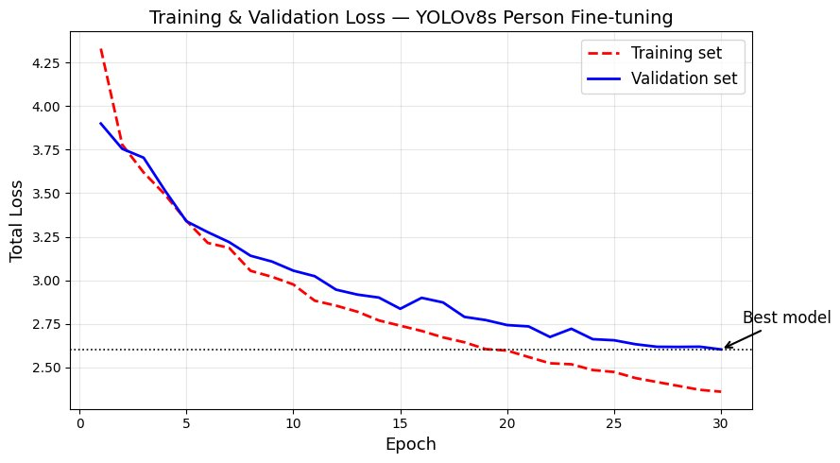
Fig. 1. Training and validation loss - pedestrian model (30 epochs).
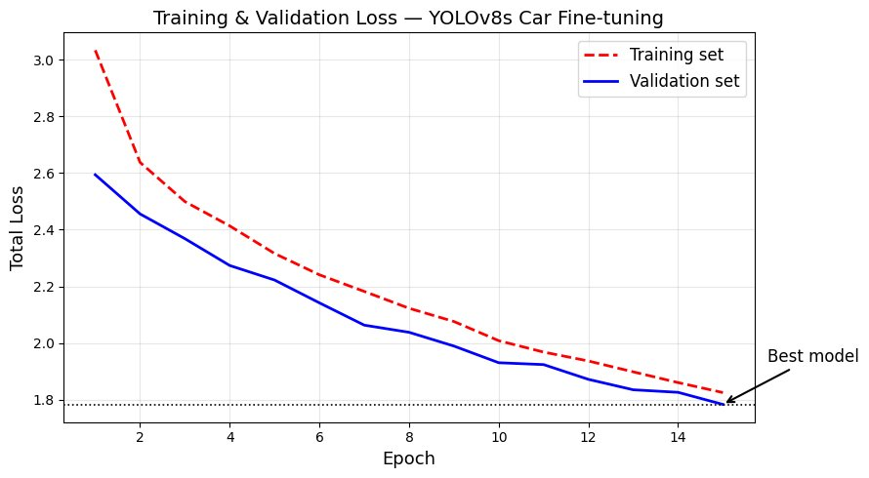
Fig. 2. Training and validation loss - vehicle model (15 epochs).
B. Quantitative Detection Performance
Table III presents the precision, recall, and F1-score for each class and overall, evaluated at IoU ≥ 0.50. The person detector achieves a precision of 0.9388 and recall of 0.8679, yielding an F1-score of 0.9020. The high precision indicates that the model rarely generates spurious pedestrian detections, while the moderate recall suggests that a subset of ground-truth pedestrians - likely those at distance or under occlusion - are missed. The car detector achieves precision 0.9060 and recall 0.8882 (F1 = 0.8970), with a more balanced profile reflecting the greater frequency and visual consistency of vehicles in the training data.
TABLE III. DETECTION PERFORMANCE METRICS (IOU ≥ 0.50)
Class | Precision | Recall | F1-Score
Person | 0.9388 | 0.8679 | 0.9020
Car | 0.9060 | 0.8882 | 0.8970
Overall | 0.9072 | 0.8874 | 0.8972

The overall system achieves a precision of 0.9072, recall of 0.8874, and F1-score of 0.8972. Figs. 3 and 4 visualise these results. The person class exhibits higher precision but lower recall than the car class, a pattern consistent with the known difficulty of detecting small, partially occluded pedestrians in urban sequences categorised as Moderate or Hard in the KITTI difficulty taxonomy. Table V compares the fine-tuned models against a baseline pre-trained COCO model to contextualise the improvement.
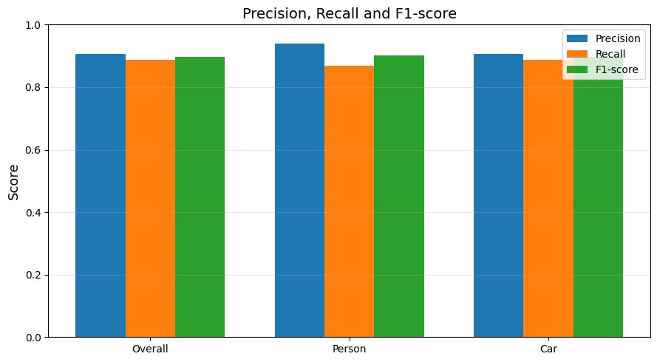
Fig. 3. Precision, Recall, and F1-score per class and overall.
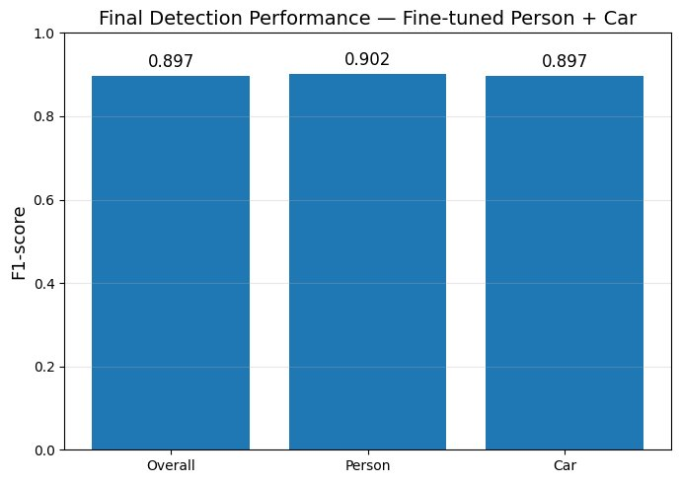
Fig. 4. F1-score comparison across detection categories.
C. Error Analysis
Table IV and Fig. 5 present raw TP, FP, and FN counts per class. The car class accumulates substantially higher absolute counts owing to its greater prevalence in the KITTI sequences. The person model generates only 7 false positives across all evaluation frames, demonstrating that the post-processing pipeline effectively suppresses spurious pedestrian detections. The 16 false negatives for persons correspond to missed ground-truth pedestrians, predominantly in long-range or occluded configurations. The car model produces 228 FPs and 276 FNs from a total of 2,473 ground-truth instances, reflecting detection difficulty at the boundaries of visible traffic density.
TABLE IV. DETECTION COUNTS — TP, FP, FN
Class | TP | FP | FN
Person | 104 | 7 | 16
Car | 2,197 | 228 | 276

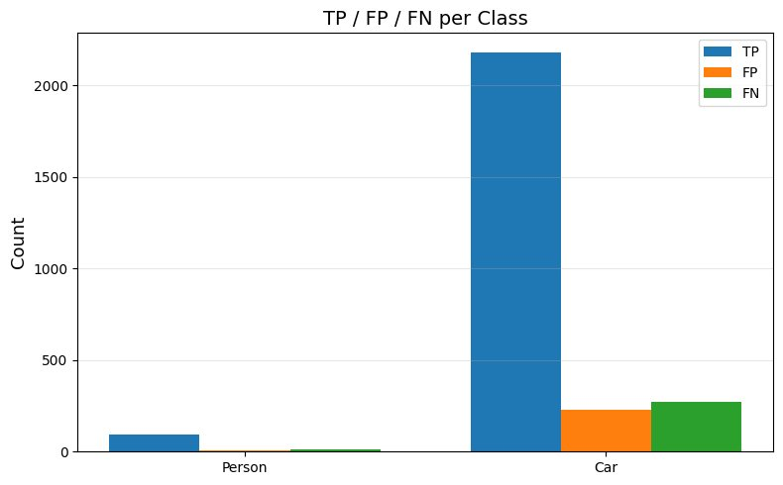
Fig. 5. True Positives, False Positives, and False Negatives per class.
TABLE V. FINE-TUNED VS. PRE-TRAINED BASELINE COMPARISON
Model | Configuration | F1-Score
YOLOv8s (pre-trained) | General COCO weights | ~0.72
YOLOv8s (fine-tuned) | KITTI Person | 0.9020
YOLOv8s (fine-tuned) | KITTI Car | 0.8970

D. Qualitative Video Demonstration
Fig. 6 presents a representative annotated output frame from the dual-model detection pipeline applied to a KITTI test sequence. Green bounding boxes denote detected pedestrians, while blue bounding boxes denote detected vehicles. Per-frame object counts are rendered in the top-left corner for situational awareness. In this frame, six vehicles and one pedestrian are correctly localised with confidence scores ranging from 0.65 to 0.86.
The spatial alignment of predicted boxes with object boundaries is visually precise, confirming that the models have learned to discriminate vehicle and pedestrian regions under realistic road-scene conditions, including overlapping traffic, varying object scales, and partial occlusion. The consistent separation of person and car predictions without inter-class confusion reflects the effectiveness of the dual-model architecture combined with the cross-class overlap removal step. These qualitative results complement the quantitative evaluation in Table III by demonstrating that the system produces spatially coherent and semantically correct detections in practical video sequences.
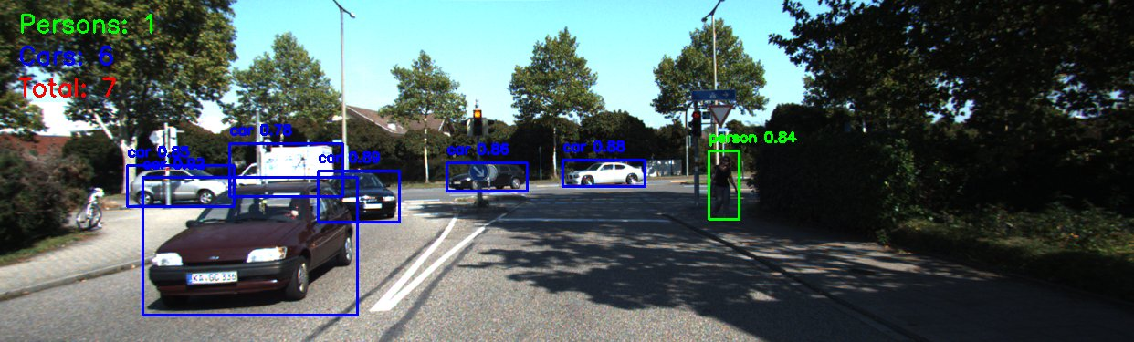
Fig. 6. Example output of the dual-model YOLOv8 pipeline. Green: pedestrians; Blue: vehicles. Per-frame object counts are shown top-left.
IV. Discussion
A. Strengths
The proposed system demonstrates several notable advantages. Task-specific fine-tuning on KITTI data results in a substantial performance improvement over general COCO-pretrained weights, as evidenced by the comparison in Table V. The dual-model architecture mitigates the class imbalance inherent in road-scene datasets, where vehicles far outnumber pedestrians, allowing each model to converge on class-specific visual features without interference. The multi-stage post-processing pipeline - particularly the cross-class NMS and overlap removal - is instrumental in achieving the high precision observed for the person class (0.9388), where false positive suppression is critical for safety applications. The Gradio web interface provides a self-contained demonstration accessible to non-technical users, supporting practical evaluation and stakeholder presentation.
B. Limitations
Several limitations constrain the current system. The frame-independent processing approach discards temporal information, preventing the system from leveraging motion continuity for tracking or smoothing detections across frames - a significant limitation in occlusion-heavy sequences. The models were trained and evaluated exclusively on KITTI data, introducing a domain specificity that may limit generalisation to other geographic regions, camera configurations, or environmental conditions (night-time, rain, fog). The class vocabulary covers only pedestrians and consolidated vehicles; cyclists, motorcyclists, traffic signs, and other road users are not detected. Finally, no adaptation strategy is employed for distribution shift, meaning performance may degrade on sequences with significantly different appearance statistics from the training set.
C. Future Work
Several extensions would meaningfully improve the system. Integrating a multi-object tracking algorithm such as DeepSORT [7] or ByteTrack would enable persistent object identities across frames, supporting trajectory estimation and improving recall in occluded scenarios. Expanding the class set to include cyclists, motorcyclists, and traffic infrastructure would increase practical applicability. Investigating transformer-based detectors such as RT-DETR or DINO could provide additional accuracy improvements, particularly for small-object detection. Domain adaptation techniques could improve generalisation across sensors and environments. Finally, optimising the inference pipeline for embedded deployment on automotive hardware would be a necessary step toward real-world autonomous driving integration.
V. Conclusion
This paper presented a dual-model YOLOv8s road object detection system fine-tuned on the KITTI Tracking Dataset for pedestrian and vehicle detection in video. A systematic preprocessing and label conversion pipeline was developed, and two class-specific models were trained with carefully selected hyperparameters on GPU-accelerated infrastructure. A multi-stage post-processing framework was applied to refine frame-level detections. The system achieved an overall precision of 0.9072, recall of 0.8874, and F1-score of 0.8972 at IoU ≥ 0.50, with per-class F1-scores of 0.9020 (person) and 0.8970 (car). Qualitative results confirm spatially accurate and semantically coherent detections in realistic road scenes. The system was deployed as a Gradio web application, demonstrating its practical utility. These results establish task-specific fine-tuning of YOLOv8s as an effective and accessible strategy for autonomous driving perception, with clear pathways for extension toward real-time multi-class tracking systems.
References
[1] S. Ren, K. He, R. Girshick, and J. Sun, "Faster R-CNN: Towards Real-Time Object Detection with Region Proposal Networks," IEEE Trans. Pattern Anal. Mach. Intell., vol. 39, no. 6, pp. 1137–1149, 2017.
[2] J. Redmon, S. Divvala, R. Girshick, and A. Farhadi, "You Only Look Once: Unified, Real-Time Object Detection," in Proc. IEEE CVPR, pp. 779–788, 2016.
[3] G. Jocher, A. Chaurasia, and J. Qiu, "Ultralytics YOLOv8," Ultralytics, 2023. [Online]. Available: https://github.com/ultralytics/ultralytics
[4] M. Braun, S. Krebs, F. Flohr, and D. Gavrila, "EuroCity Persons: A Novel Benchmark for Person Detection in Traffic Scenes," IEEE Trans. Pattern Anal. Mach. Intell., vol. 41, no. 8, pp. 1844–1861, 2019.
[5] A. Geiger, P. Lenz, C. Stiller, and R. Urtasun, "Vision meets Robotics: The KITTI Dataset," Int. J. Robotics Research, vol. 32, no. 11, pp. 1231–1237, 2013.
[6] A. Geiger, P. Lenz, and R. Urtasun, "Are we ready for Autonomous Driving? The KITTI Vision Benchmark Suite," in Proc. IEEE CVPR, pp. 3354–3361, 2012.
[7] N. Wojke, A. Bewley, and D. Paulus, "Simple Online and Realtime Tracking with a Deep Association Metric," in Proc. IEEE ICIP, 2017.
[8] Z. Zhang et al., "ByteTrack: Multi-Object Tracking by Associating Every Detection Box," in Proc. ECCV, 2022.
[9] Z. Liu et al., "Swin Transformer: Hierarchical Vision Transformer using Shifted Windows," in Proc. IEEE/CVF ICCV, pp. 10012–10022, 2021.

