1. Perform a postOrder, preOrder & inOrder traversal of the binary tree.
   1. postOrde: L K F E G M J I H D C B A
   2. preOrder: A B E K L F C G D H M I J
   3. inOrtder: K L E F B G C M H I J D A

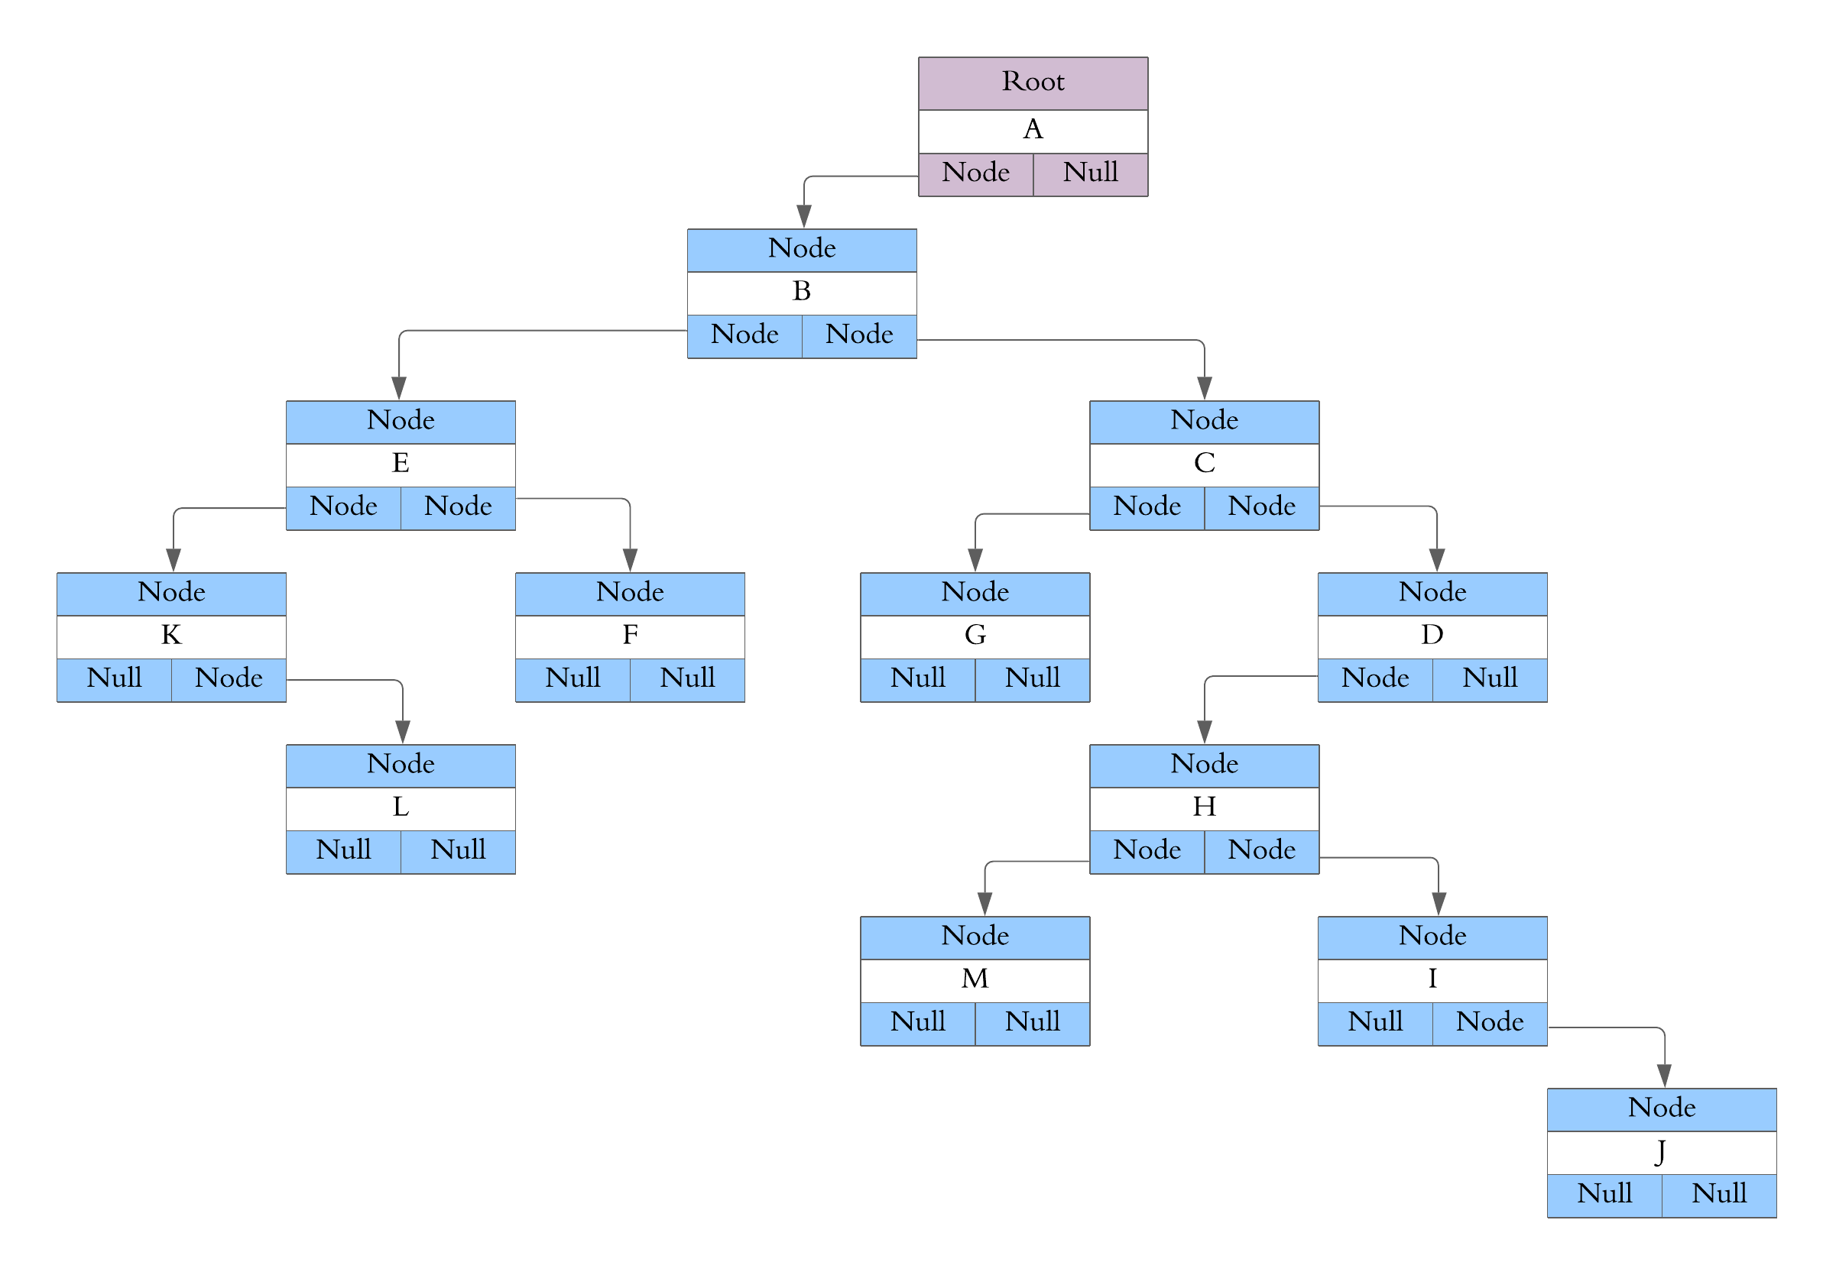

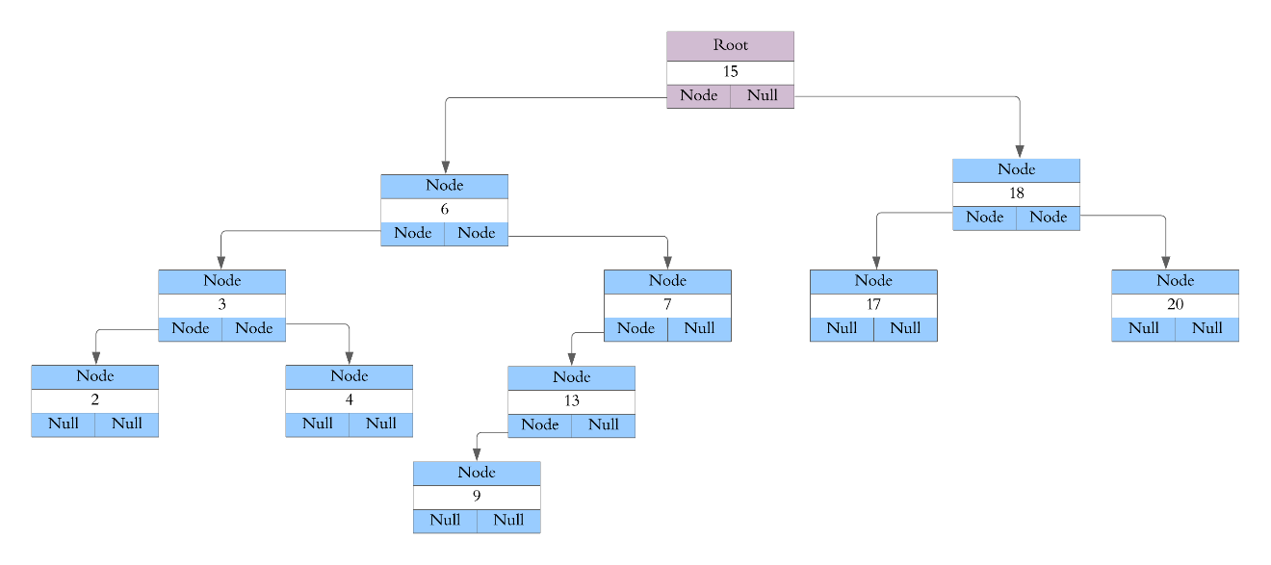

1. perform the following
   1. 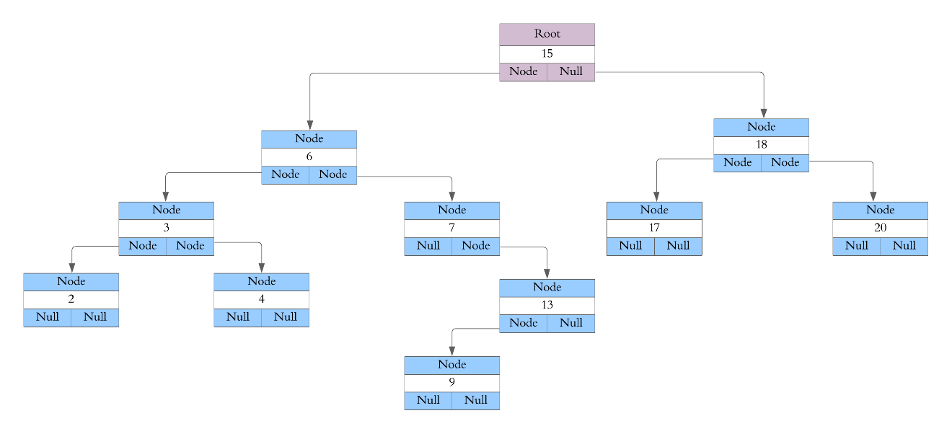Fix the tree above to ensure it is an actual Binary Search Tree and use this new tree to answers the questions below
   2. Perform a postorder, preorder & inorder traversal of the above binary search tree.
      1. postOrder: 2 4 3 9 13 7 6 17 20 18 15
      2. PreOrder: 15 6 3 2 4 7 13 9 18 17 20
      3. inOrder: 2 3 4 6 7 9 13 15 17 18 20
   3. 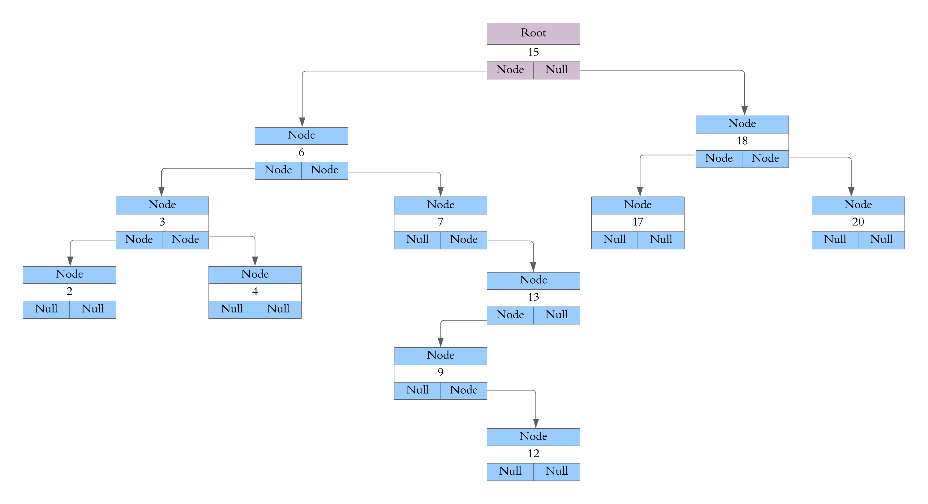Insert the value 12 into the above BST (please redraw the entire tree)
   4. 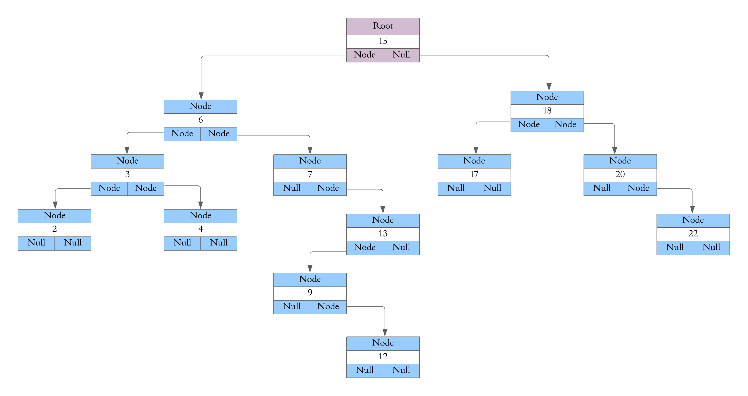Insert the value 22 into the above BST (please redraw the entire tree)
   5. Delete the value 6 from the above BST (please redraw the entire tree)Diagram

      Description automatically generated
   6. 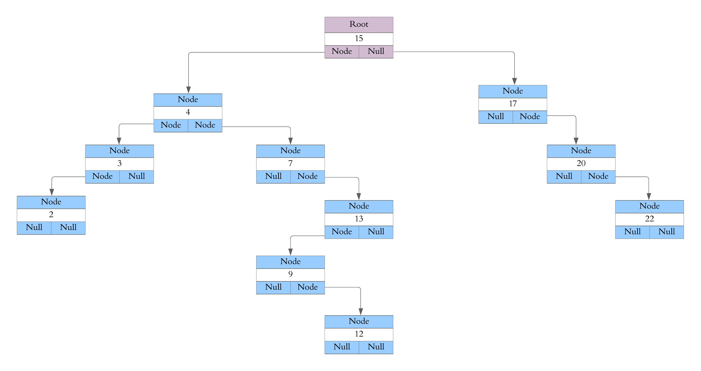Delete the value 18 from the above BST (please redraw the entire tree)
   7. 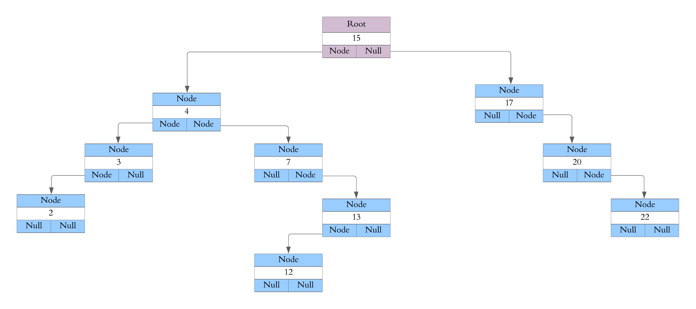Delete the value 9 from the above BST (please redraw the entire tree)
   8. 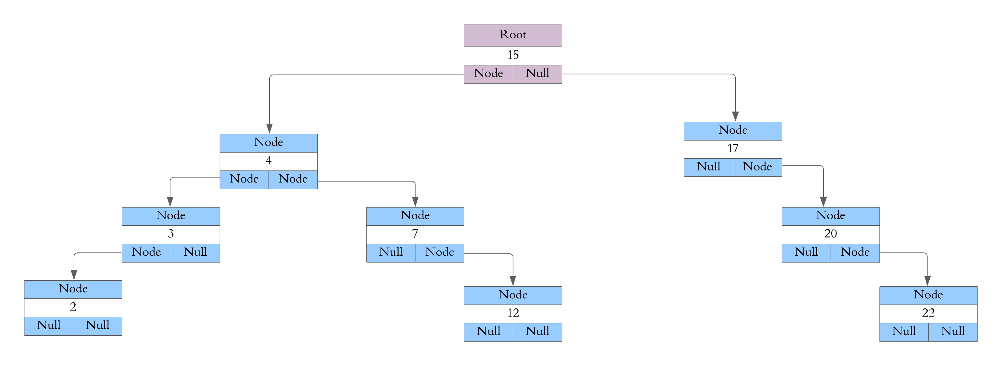Delete the value 13 from the above BST (please redraw the entire tree)
   9. What is the successor to value 15 in the above BST?
      1. 12 Node will be the successor
2. Draw the binary search tree that is created from inserting data in the following order. Start with the root node as 1 and then insert the values by asking the question “Is it greater or less than the current node?”.
   * 1. 1,12,9,18,17,19,4,5,3