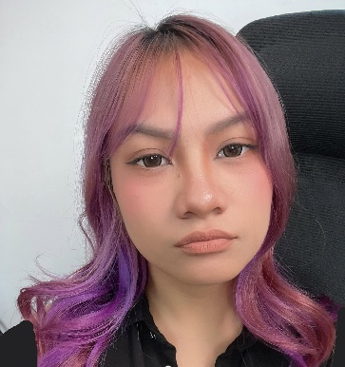
IVY DANIELLE CAYABYAB
79-1 12th 25th V.A.B, Pasay City
Mobile No.: 0945 340 7093
E-mail: ivydaniellecc@gmail.com
_____________________________________________________________________________________

EDUCATION

COLLEGE
University of Manila – Bachelor of Science in Computer

WORK EXPERIENCE

Name of Company: AMAZON
Position held: Customer Service
□ Job responsibility: Acting as a bridge between the customer and internal teams (like drivers or shipping partners) to ensure successful deliveries
Name of Company: ORRO HOME
Position held: Live Host
□ Job responsibility: Managing the live chat to resolve customer concerns immediately, ensuring a positive environment and high viewer retention.

Name of Company: MIFEI
Position held: Live Assistant
□ Job responsibility: Assisted live hosts during TikTok and Shopee livestream selling sessions and ensured smooth day-to-day operations

PERSONAL BACKGROUND

Date of Birth: January 20,2003
Civil Status: Single
Languages: English, Tagalog
Skills and Abilities: Communication Skills, Problem-Solving, Adaptability Time Management

REFERENCE

Name: Mary Jane Diaz
Position: Live Operator
Address: Robinsons Cyber Sigma
Phone Number: 0932 549 0406
Name: Precious Legaspi
Position: Live Assistant
Address: Robinsons Cyber Sigma
Phone Number: 0910 803 2117
Name: Jerome Fuertes
Position: Live Technician
Address: Robinsons Cyber Sigma
Phone Number: 0965 904 4434

