Master Agreement for Managed Services
Reference CG-2026-EN-014 — original counterpart executed in two copies
This master agreement sets out the general and particular conditions applicable to the managed services provided by the Provider to the Client, together with the service level commitments, the confidentiality obligations and the liability regime of the parties. It prevails over any prior document of equivalent scope.

Governance of the agreement rests on a quarterly steering committee and a monthly operational committee; these bodies review the indicators, arbitrate changes of scope and record their decisions in contradictory minutes. The parties agree that the quality of the relationship prevails over the mechanical application of penalties, which remain an instrument of last resort mobilised only in the event of persistent and duly characterised drift.
Governance of the agreement rests on a quarterly steering committee and a monthly operational committee; these bodies review the indicators, arbitrate changes of scope and record their decisions in contradictory minutes. The parties agree that the quality of the relationship prevails over the mechanical application of penalties, which remain an instrument of last resort mobilised only in the event of persistent and duly characterised drift.
Governance of the agreement rests on a quarterly steering committee and a monthly operational committee; these bodies review the indicators, arbitrate changes of scope and record their decisions in contradictory minutes. The parties agree that the quality of the relationship prevails over the mechanical application of penalties, which remain an instrument of last resort mobilised only in the event of persistent and duly characterised drift.

Article 1 — Purpose and scope
The purpose of this article is to specify the reciprocal rights and obligations of the parties; it shall be interpreted in the light of the preamble and the annexes, which form an indivisible whole and express the entirety of the agreement reached between the parties.
The parties acknowledge that performance of the services takes place within a relationship of good-faith cooperation, each undertaking to communicate in a timely manner any information likely to affect the proper delivery of the commitments entered into hereunder.

Article 2 — Definitions and interpretation
In the event of a material breach by either party of its essential obligations, not remedied within fifteen days following a formal notice that has remained without effect, the other party may terminate the agreement as of right, without prejudice to any damages.
The Provider shall deploy the human and technical resources required to deliver the services in accordance with industry standards, applicable regulations and the security requirements detailed in the technical annex, which forms an integral part of this agreement.

Article 3 — Obligations of the Provider
Upon expiry or termination of the agreement, the Provider shall ensure the reversibility of the data in an open and documented format, and shall provide reasonable assistance with the resumption of the services by the Client or any third party it may have designated.
The Client undertakes to provide, within reasonable time, all access rights, authorisations and documentary materials that are indispensable, it being understood that any delay attributable to the Client automatically suspends the corresponding deadlines binding the Provider.
- service availability measured on a monthly calendar basis
- the acknowledgement time for critical incidents
- the restoration time after a major interruption
- the frequency and format of steering committees
- the escalation procedure in case of persistent disagreement

Article 4 — Obligations of the Client
Neither party shall be held liable for a failure resulting from an event of force majeure within the meaning of applicable case law; the prevented party shall inform the other without delay and the affected obligations shall be suspended for the duration of the event.
Invoicing occurs monthly in arrears on the basis of the services actually rendered; any dispute regarding an invoice must be notified in writing within thirty days, failing which the invoice shall be deemed definitively accepted by the Client without further recourse.

Article 5 — Financial terms and invoicing
The purpose of this article is to specify the reciprocal rights and obligations of the parties; it shall be interpreted in the light of the preamble and the annexes, which form an indivisible whole and express the entirety of the agreement reached between the parties.
Service level commitments are measured on a monthly basis; where a breach is recorded, fixed penalties apply without prejudice to the Client's right to claim full compensation for the direct loss duly substantiated and demonstrably caused by the breach in question.

Article 6 — Service levels and penalties
In the event of a material breach by either party of its essential obligations, not remedied within fifteen days following a formal notice that has remained without effect, the other party may terminate the agreement as of right, without prejudice to any damages.
Each party retains ownership of the materials pre-existing the agreement; specific developments produced for the Client are assigned to it upon full payment of the corresponding price, subject to third-party components governed by their own licences.
- service availability measured on a monthly calendar basis
- the acknowledgement time for critical incidents
- the restoration time after a major interruption
- the frequency and format of steering committees
- the escalation procedure in case of persistent disagreement

Article 7 — Intellectual property
Upon expiry or termination of the agreement, the Provider shall ensure the reversibility of the data in an open and documented format, and shall provide reasonable assistance with the resumption of the services by the Client or any third party it may have designated.
The parties undertake to preserve the strict confidentiality of the information exchanged and to use it solely for the purpose of performing the agreement, this obligation surviving for three years after its termination for whatever cause.

Article 8 — Confidentiality and personal data
Neither party shall be held liable for a failure resulting from an event of force majeure within the meaning of applicable case law; the prevented party shall inform the other without delay and the affected obligations shall be suspended for the duration of the event.
The processing of personal data is carried out in compliance with the applicable regulation; the Provider acts as a processor and implements appropriate technical and organisational measures to guarantee a level of security suited to the risk presented by the processing.

Article 9 — Liability and insurance
The purpose of this article is to specify the reciprocal rights and obligations of the parties; it shall be interpreted in the light of the preamble and the annexes, which form an indivisible whole and express the entirety of the agreement reached between the parties.
The liability of each party is capped, per contract year, at the total amount excluding taxes actually paid over the preceding twelve months, save in cases of gross negligence, bodily injury or breach of the confidentiality obligation set out above.
- service availability measured on a monthly calendar basis
- the acknowledgement time for critical incidents
- the restoration time after a major interruption
- the frequency and format of steering committees
- the escalation procedure in case of persistent disagreement

Article 10 — Term, termination and reversibility
In the event of a material breach by either party of its essential obligations, not remedied within fifteen days following a formal notice that has remained without effect, the other party may terminate the agreement as of right, without prejudice to any damages.
The parties acknowledge that performance of the services takes place within a relationship of good-faith cooperation, each undertaking to communicate in a timely manner any information likely to affect the proper delivery of the commitments entered into hereunder.

Article 11 — Force majeure
Upon expiry or termination of the agreement, the Provider shall ensure the reversibility of the data in an open and documented format, and shall provide reasonable assistance with the resumption of the services by the Client or any third party it may have designated.
The Provider shall deploy the human and technical resources required to deliver the services in accordance with industry standards, applicable regulations and the security requirements detailed in the technical annex, which forms an integral part of this agreement.

Article 12 — Governing law and dispute resolution
Neither party shall be held liable for a failure resulting from an event of force majeure within the meaning of applicable case law; the prevented party shall inform the other without delay and the affected obligations shall be suspended for the duration of the event.
The Client undertakes to provide, within reasonable time, all access rights, authorisations and documentary materials that are indispensable, it being understood that any delay attributable to the Client automatically suspends the corresponding deadlines binding the Provider.
- service availability measured on a monthly calendar basis
- the acknowledgement time for critical incidents
- the restoration time after a major interruption
- the frequency and format of steering committees
- the escalation procedure in case of persistent disagreement

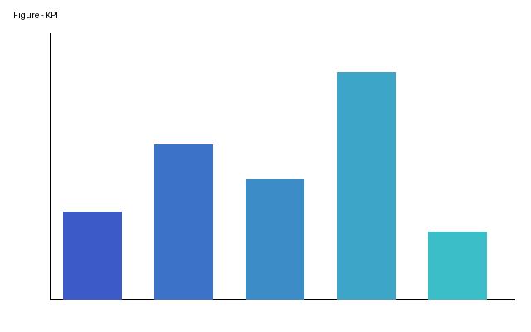
Figure 1. Table 1 — Service level commitments and associated penalties — figure
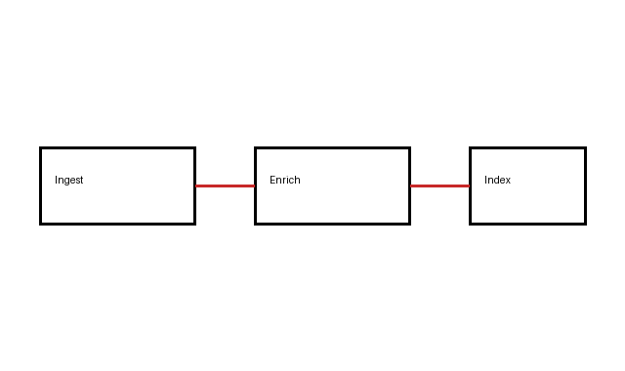
Figure 2. Purpose and scope

Figure 3. Definitions and interpretation

Table 1 — Service level commitments and associated penalties
Indicator | Target | Critical threshold | Penalty | Frequency
Availability | 99.9 % | 99.0 % | 5 % of fee | Monthly  Sous-poste Valeur  A 1  B 2
P1 acknowledgement | 15 min | 30 min | 2 % of fee | Per incident
P1 restoration | 4 h | 8 h | 5 % of fee | Per incident
Reporting | D+5 | D+10 | 1 % of fee | Monthly

Obligations of the Provider
- Amounts are stated exclusive of tax unless expressly indicated otherwise.
- Time periods are counted in business days according to the Provider's head-office calendar.
- No occasional tolerance shall constitute a waiver of the right to invoke a provision.
- service availability measured on a monthly calendar basis
- the acknowledgement time for critical incidents
- the restoration time after a major interruption
- the frequency and format of steering committees
- the escalation procedure in case of persistent disagreement

