Annual Activity and Digital Performance Report
Financial year 2026 — consolidated version for the management board
This report presents a consolidated analysis of the past year's activity, places the financial and operational results in perspective against the stated objectives, and sets out recommendations intended to inform the strategic trade-offs to come.

The market context remains favourable in the high-value-added segments, but competition is intensifying under the effect of specialised entrants and the gradual commoditisation of entry-level offerings. In this context, differentiation rests less on price than on perceived service quality, functional richness and the ability to support customers over time through a responsive support arrangement and a clear, well-documented service catalogue.
The market context remains favourable in the high-value-added segments, but competition is intensifying under the effect of specialised entrants and the gradual commoditisation of entry-level offerings. In this context, differentiation rests less on price than on perceived service quality, functional richness and the ability to support customers over time through a responsive support arrangement and a clear, well-documented service catalogue.
The market context remains favourable in the high-value-added segments, but competition is intensifying under the effect of specialised entrants and the gradual commoditisation of entry-level offerings. In this context, differentiation rests less on price than on perceived service quality, functional richness and the ability to support customers over time through a responsive support arrangement and a clear, well-documented service catalogue.

1. Executive summary
Over the year, the company confirmed a sustained growth trajectory despite an uncertain macroeconomic environment marked by volatile input costs and increased pressure on margins, which was partly absorbed by productivity gains across the main operating units.
Commercial momentum was particularly strong in the European markets, where the roll-out of a packaged offering accelerated the sales cycle and significantly improved the conversion rate of qualified prospects into recurring customers with multi-year commitments.

Market context and competitive environment
From a financial standpoint, gross margin grows in absolute value while the margin rate contracts slightly under the effect of a deliberately aggressive pricing policy on the acquisition segments deemed strategic for the conquest of additional market share.

2. Market context and competitive environment
Commercial momentum was particularly strong in the European markets, where the roll-out of a packaged offering accelerated the sales cycle and significantly improved the conversion rate of qualified prospects into recurring customers with multi-year commitments.
From a financial standpoint, gross margin grows in absolute value while the margin rate contracts slightly under the effect of a deliberately aggressive pricing policy on the acquisition segments deemed strategic for the conquest of additional market share.

Commercial performance by region
Digital transformation translated into the modernisation of the technical foundation, the rationalisation of the application portfolio and the industrialisation of the data processing chains, now governed by quality and freshness indicators measured continuously.

3. Commercial performance by region
From a financial standpoint, gross margin grows in absolute value while the margin rate contracts slightly under the effect of a deliberately aggressive pricing policy on the acquisition segments deemed strategic for the conquest of additional market share.
Digital transformation translated into the modernisation of the technical foundation, the rationalisation of the application portfolio and the industrialisation of the data processing chains, now governed by quality and freshness indicators measured continuously.

Detailed financial analysis
The operational risk map was updated; the main areas of exposure concern the dependence on a limited number of critical suppliers, cybersecurity and regulatory compliance, for which remediation plans have been initiated and are tracked at the operational committee.

4. Detailed financial analysis
Digital transformation translated into the modernisation of the technical foundation, the rationalisation of the application portfolio and the industrialisation of the data processing chains, now governed by quality and freshness indicators measured continuously.
The operational risk map was updated; the main areas of exposure concern the dependence on a limited number of critical suppliers, cybersecurity and regulatory compliance, for which remediation plans have been initiated and are tracked at the operational committee.

Digital transformation and information system
The organisation continued to build capability with a sustained training effort, a strengthening of cross-functional functions and particular attention paid to the retention of scarce profiles whose contribution is decisive for the success of the projects.

5. Digital transformation and information system
The operational risk map was updated; the main areas of exposure concern the dependence on a limited number of critical suppliers, cybersecurity and regulatory compliance, for which remediation plans have been initiated and are tracked at the operational committee.
The organisation continued to build capability with a sustained training effort, a strengthening of cross-functional functions and particular attention paid to the retention of scarce profiles whose contribution is decisive for the success of the projects.

Operational risk management
Environmental commitments are progressing in line with the roadmap; reducing the carbon footprint of operations and extending the service life of equipment are the two most structuring levers in the short and medium term for the group as a whole.

6. Operational risk management
The organisation continued to build capability with a sustained training effort, a strengthening of cross-functional functions and particular attention paid to the retention of scarce profiles whose contribution is decisive for the success of the projects.
Environmental commitments are progressing in line with the roadmap; reducing the carbon footprint of operations and extending the service life of equipment are the two most structuring levers in the short and medium term for the group as a whole.

Human resources and organisation
The outlook for the coming year rests on consolidating the positions acquired, the controlled launch of new offerings and reinforced execution discipline, a necessary condition for the gradual restoration of the margin rate to its target level.

7. Human resources and organisation
Environmental commitments are progressing in line with the roadmap; reducing the carbon footprint of operations and extending the service life of equipment are the two most structuring levers in the short and medium term for the group as a whole.
The outlook for the coming year rests on consolidating the positions acquired, the controlled launch of new offerings and reinforced execution discipline, a necessary condition for the gradual restoration of the margin rate to its target level.

Environmental and social commitments
Over the year, the company confirmed a sustained growth trajectory despite an uncertain macroeconomic environment marked by volatile input costs and increased pressure on margins, which was partly absorbed by productivity gains across the main operating units.

8. Environmental and social commitments
The outlook for the coming year rests on consolidating the positions acquired, the controlled launch of new offerings and reinforced execution discipline, a necessary condition for the gradual restoration of the margin rate to its target level.
Over the year, the company confirmed a sustained growth trajectory despite an uncertain macroeconomic environment marked by volatile input costs and increased pressure on margins, which was partly absorbed by productivity gains across the main operating units.

Outlook and action plan
Commercial momentum was particularly strong in the European markets, where the roll-out of a packaged offering accelerated the sales cycle and significantly improved the conversion rate of qualified prospects into recurring customers with multi-year commitments.

9. Outlook and action plan
Over the year, the company confirmed a sustained growth trajectory despite an uncertain macroeconomic environment marked by volatile input costs and increased pressure on margins, which was partly absorbed by productivity gains across the main operating units.
Commercial momentum was particularly strong in the European markets, where the roll-out of a packaged offering accelerated the sales cycle and significantly improved the conversion rate of qualified prospects into recurring customers with multi-year commitments.

Conclusion and recommendations
From a financial standpoint, gross margin grows in absolute value while the margin rate contracts slightly under the effect of a deliberately aggressive pricing policy on the acquisition segments deemed strategic for the conquest of additional market share.

10. Conclusion and recommendations
Commercial momentum was particularly strong in the European markets, where the roll-out of a packaged offering accelerated the sales cycle and significantly improved the conversion rate of qualified prospects into recurring customers with multi-year commitments.
From a financial standpoint, gross margin grows in absolute value while the margin rate contracts slightly under the effect of a deliberately aggressive pricing policy on the acquisition segments deemed strategic for the conquest of additional market share.

Executive summary
Digital transformation translated into the modernisation of the technical foundation, the rationalisation of the application portfolio and the industrialisation of the data processing chains, now governed by quality and freshness indicators measured continuously.

11. Executive summary
From a financial standpoint, gross margin grows in absolute value while the margin rate contracts slightly under the effect of a deliberately aggressive pricing policy on the acquisition segments deemed strategic for the conquest of additional market share.
Digital transformation translated into the modernisation of the technical foundation, the rationalisation of the application portfolio and the industrialisation of the data processing chains, now governed by quality and freshness indicators measured continuously.

Market context and competitive environment
The operational risk map was updated; the main areas of exposure concern the dependence on a limited number of critical suppliers, cybersecurity and regulatory compliance, for which remediation plans have been initiated and are tracked at the operational committee.

12. Market context and competitive environment
Digital transformation translated into the modernisation of the technical foundation, the rationalisation of the application portfolio and the industrialisation of the data processing chains, now governed by quality and freshness indicators measured continuously.
The operational risk map was updated; the main areas of exposure concern the dependence on a limited number of critical suppliers, cybersecurity and regulatory compliance, for which remediation plans have been initiated and are tracked at the operational committee.

Commercial performance by region
The organisation continued to build capability with a sustained training effort, a strengthening of cross-functional functions and particular attention paid to the retention of scarce profiles whose contribution is decisive for the success of the projects.

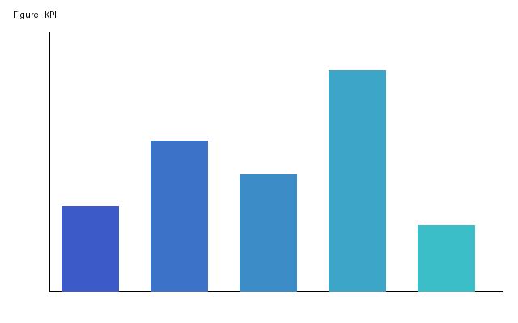
Figure 1. Table 1 — Key performance indicators by region (in thousands of euros) — figure
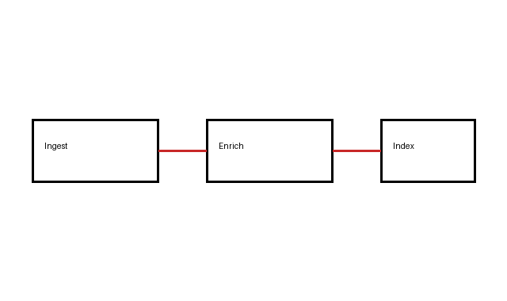
Figure 2. Executive summary

Figure 3. Market context and competitive environment

Table 1 — Key performance indicators by region (in thousands of euros)
Region | Revenue | Gross margin | Growth | Headcount
Europe | 12,480 | 4,742 | +12.4 % | 184  Sous-poste Valeur  A 1  B 2
Americas | 8,930 | 3,215 | +8.1 % | 97
Asia-Pacific | 5,210 | 1,980 | +15.7 % | 63
Rest of world | 2,140 | 742 | +4.3 % | 21

Commercial performance by region
- Amounts are expressed in thousands of euros and rounded to the nearest unit.
- Growth rates are calculated at constant scope and exchange rates.
- Headcount is expressed in full-time equivalents as at 31 December of the year.
- consolidate commercial positions in the core markets
- gradually restore the gross margin rate
- reduce dependence on critical suppliers
- accelerate the industrialisation of data processing
- strengthen the retention of scarce skills

