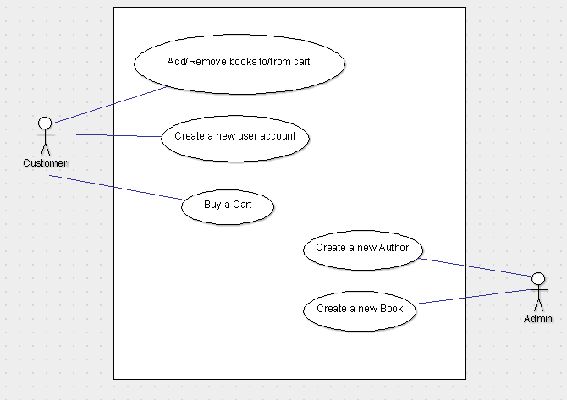

Add/Remove books from/to cart

* Login by choosing a User from the dropdown box and hit Login
* Add books by hitting the BUY
* Remove books by hitting the ShoppingCart button and pressing the “-“ button

Buy a Cart

* Login by choosing a User from the Dropdown box and hit Login
* Go hit the “ShoppingCart” button
* Press the “Buy Cart for x” button
* Check the order and press “OK”

Create a new user account

* Press the Sign Up Button
* Enter your Personal Information
* Hit “Create” Button

Create a new Book

* Press “Admin” Button
* Enter data for book
* Press “Create”

Create a new Author

* Press “Admin” Button
* Enter data for Author
* Press “Create”