DBSAI summary
Table of Contents
DBSAI summary 1
Index and Data Files 2
Memory Hierarchy 2
Performance Tricks 3
Improving I/O Performance 3
Clustering vs. De-clustering 3
RAID 3
MTTF: Mean-Time-To-Failure 4
Disk mirroring 4
Striping 4
Striping with parity 4
Parity Scheme 4
Disk Space Manager 4
Linked List of free blocks 5
free block Bitmap 5
Buffer Manager 5
Buffer Pool 5
BM interface 5
Strategic Questions 6
Buffer Allocation Policies 6
buffer Allocation policies 7
Typical Buffer Replacement Policies 7
Priority Hints 7
Prefetching 7
similar to OS 7
Files and Index Structures 8
Heap Files 8
Free Space Management 8

Index and Data Files

Memory Hierarchy
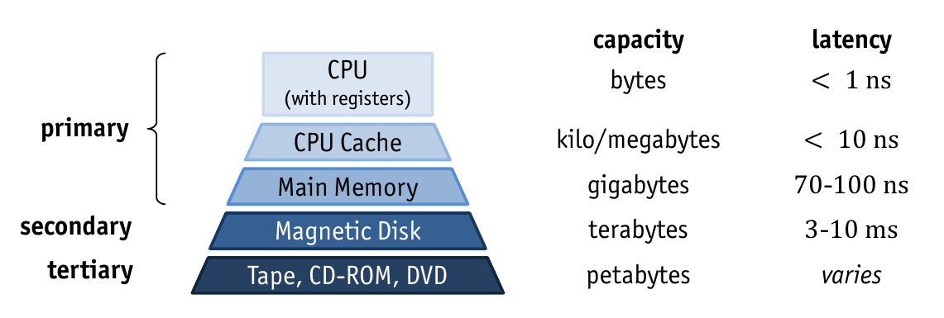
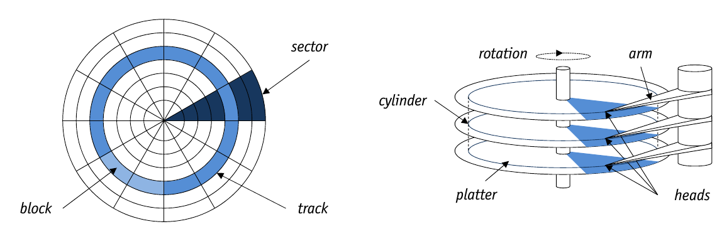
Data is read one block at a time

• Definition: access time is the sumt = t_{s} + t_{r} + t_{t}, where
– seek time (t_{s}): move head to track
– rotational delay (t_{r}): rotate disk to block
– transfer time (t_{t}): read/write

sequenctial Access is much faster than random access.
if we need at least 1.07%, reading entire file is faster than random access.

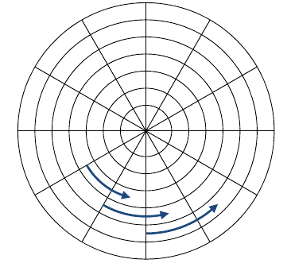
Performance Tricks
- Track skewing: sector 0 of each track is rotated.
- Request scheduling: on multiple requests, use shortest path between them
- zoning: outer tracks can be divided into more sectors

HDDs are usually the bottleneck.
Sequential vs. random access ratio gets worse over time.

Improving I/O Performance
- Reduce number of IO operations
  - DBMS buffer: cache data
  - physical database design: tables, indexes
- Reduce duration of IO operations
  - clustering: access neighboring disk blocks; bulk IO
  - de-clustering: different IO paths with parrallel access

Clustering vs. De-clustering
- Clustering
  - bulk IO: on top OR inside disk controller
  - pro: optimized seek time, minimized overhead, no add hardware needed
  - con: IO busy for long time
  - use cases: mid-sized data access (prefetching, sector buffering)
- De-clustering
  - advanced hardware or RAID
  - pro: parallel IO operations, min transfer time, multiplied bandwidth
  - con: seek time, increased rotational delay, blocked parallel transactions, additional hardware
  - use cases: large size data access

RAID
- Reliability
  - redundency
- performance
  - data striping
  - exploit parallel IO -> emulate single disk

MTTF: Mean-Time-To-Failure

Disk mirroring
Write to all disks, read from one disk
performance: parallel reads
reliabiliy: one disk can fail

Striping
File in Chunks to all disks.
Small chunks: high intra-access prallelism, many devices busy
large chunks: high inter-access parallelism, many IO operations in parallel
easy to fail

Striping with parity
Performance: high IO parallelism
reliability: disks may fail

Parity Scheme
Add bit-wise for check disk values

Disk Space Manager
- Lies between storage and dbms
- executes read/write and allocate/deallocate commands issued by dbms
- privides concept of pages
  - page is block in memory
  - page size = block size (on disk)
  - sequences of pages mapped as continguous sequences of blocks
  - unit of storage for all higher levels
- manages local mapping: page --> block --> position on disk, with pageID
- manages used and free blocks

Linked List of free blocks
- Pionter to first free block
- freed blocks appended to list
- next-pointer may be stored in blocks

free block Bitmap
- Reserve a block: bitwise representation of all pages
- toggle bits on (de-)allocation
Better for finding sequences of free pages

Buffer Manager
- Bring needed pages in memory
- overwrite pages that are not needed anymore
- BM mediates between external storage and main memory

Buffer Pool
Equivalent to main memory
empty frames(pages)
replacement policy decides on pages to evict

BM interface
- Pin(PageNo)
  - request page
  - load into memory, if not there
  - mark as clean
  - return frameNo
- Unpin(PageNo, dirty)
  - release page, make candidate for eviction
  - if modified, set dirty=true
Pages are written to disk when evicted: is faster, some pages are needed frequently

Strategic Questions
- Buffer Allocation Problem
  - how much buffer space for each active tx
    - static assignment
    - dynamic assignment
- Page Replacement Problem
- which page to replace when pool is full
  - decide without knowledge of future tx
  - presume knowledge of expected pattern

- Additional complexity for pages with different size
  - one buffer pool for all
  - pools for different sizes
- possible: set-oriented pin({p}) calls

Buffer Allocation Policies
Problem: part of pool for each tx? Or replacement strategy for space in pool?
- Local policies
  - buffer frames for specific tx without takint concurrent tx into account
  - needs mechanism for allocation of frames for shared pages
  - pro:
    - one tx can't hurt others
    - all tx equally treated
  - con:
    - possibly bad overall utilization of buffer space
    - some tx may have many old pages; internal page thrashing
- Global policies
  - consider reference patterns of all tx
  - problems:
    - all pages are references to newly loaded pages
    - almost all other pages are likely to be replaced
    - other tx need to load their pages again; external page thrashing

buffer Allocation policies
- Global: one buffer pool for all tx
- Local: use variour info (eg catalog, index, data, ...)
- Local: eacht tx gets certain fraction of buffer pool
  - static paritioning: assign budget once per tx
  - dynamic partitioning: adjust budget of tx according to past reference pattern or something else
- Or mixed policies

Typical Buffer Replacement Policies
- FIFO: First in First out
- LRU: least recentyly used
- LRU-k: evicts k latest
- MRU: most RU
- LFU: least frequently used
- LRD: least reference density
- CLOCK: second chance
- GCLOCK: generalized clock
- WS, HS: Working set, hot set
- RANDOM...

Priority Hints
On unpin: priority hints marc pages that may be needed again

Prefetching
- Prefetch lists: on-demand, asynchrounus read-ahead
  - for sequences
- heuristic(speculative) prefetching

similar to OS
But:
- dbms can predict access pattern
- concurrency control: write back order matters
- technical reasons may make OS unsuitable for database(file size,...)
virtual page fault of OS can interfere with dbms: DBMS buffer must be memory resident in OS

Files and Index Structures
How does DBMS use pages to store data?
Relational DBMS have tables of Rows and indexes
physically: Files of records
- File: one or more pages
- Page: one or more Records
- Record: one row

Heap Files
Most simple and most important
- unordered collection of records
- each record hast unique record identifier (rid)
- map<rid,record>

Free Space Management
- For openScan(), Heap file must keep track of all pages in file
- for insertRecord(), keep track of all pages that have free space in file
Two methods:
- (doubly) Linked List of Pages
- directory of pages

Linked List of Pages
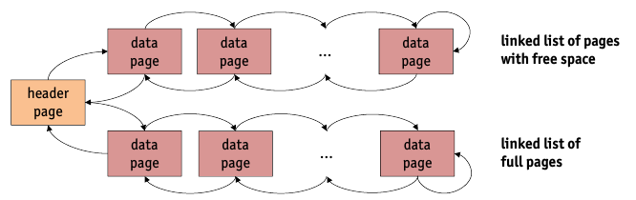

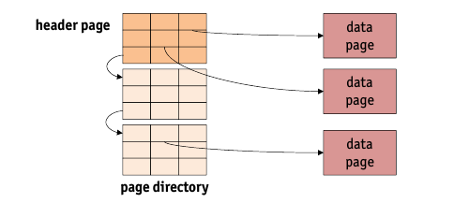
Directory of pages
Head page contains first page of a chain of directory pages

Free Space Management
Keeping exact values of free pages may be a bottleneck in multi-user systems.
Keep fuzzy information in directory.

Record Insertion Strategies
- Append Only
- Best Fit
- First Fit
- Next Fit

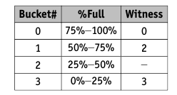
Free Space Witnesses
Classify pages into buckets with representive witness page

Linked List vs. Directory
Linked list
- pro
  - easy to implement
- con
  - most pages will end up in the list of pages with free space
  - might have to search many pages for place to fit large record
Directory
- pro
  - free space management more efficient
- con
  - memory overhead to host the page directory

Page Formats
To address pages: <pageNo p, slotNo r>

Fixed-Length Records
--> read slides! 01,88

Variable-Length Records
Fixed length variables stored befor variable length ones.
--> read slides! 01,92

Record Formats
Accessing fields in a Record.
On Create Table:
- DBMS computes field size info for the records of a file
- thin info is then recorded in the system catalog

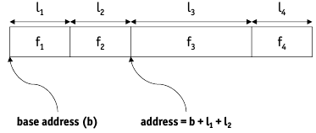
Fixed-Length Fields
Each field has fixed length.
Number of fields also fixed.
Fields are accessed via offset.

Variable-Length Fields
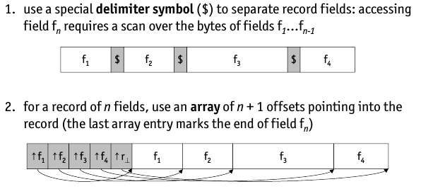

Delimiter vs. Array
Array usually superior
- array overhead translates to direct access to any field
- clean and compact way to deal with NULL-values.
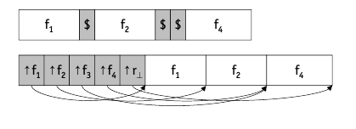

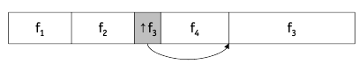
Combinations of delimiter and array is also possible: fixed length at beginning

Modifying Variable-Length Fields

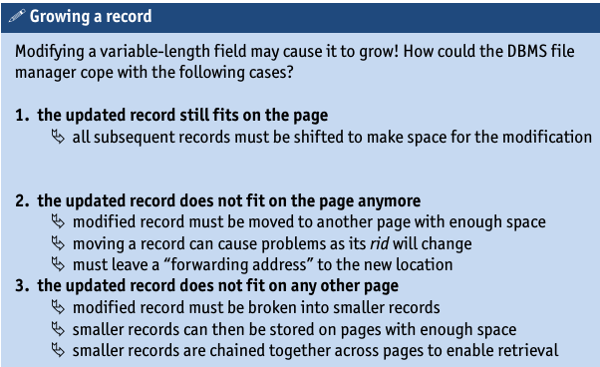
Addressing Schemes
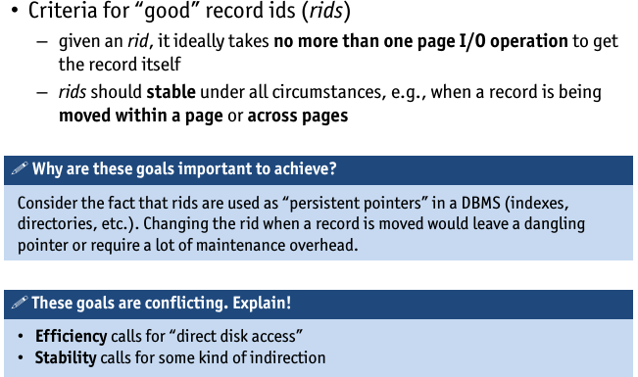

Direct Adressing
Relative Byte Address(RBA)
- disk file: persistent. Use byte-offset
  - +very efficient
  - -no stability
Page Pointers
- use disk page number
  - +very efficient to find page. Still efficient do find record
  - -stable w.r.t. to moving record within page. Still no stability for moving records acress pages

Indirect Addressing
Logical Sequence Numbers (LSN)
- assign logical numbers to records and transition table to map LSN to PP (or RBA)
  - +full stability
  - -addition IO operation to translation table (often in buffer)
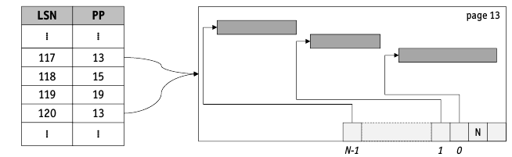
LSN with Probable Page Pointers (LSN/PPP)
- avoid extra IO by adding “probable” PP (PPP) to LSN, where PPP is PP at the time of insertion into database (if record is moved across pages, PPP is not updated)
  - +full stability w.r.t. all record relocations and PPP can save extra IO, if still correct
  - -two additional IO if PPP is no longer valid: need to read “old” page to notice that record has moved, then need to read translation table to lookup new page number

Tuple Identifier Addressing Scheme (TID)
Used by most DBMS!
<pageNo, slotNo>
stability by setting forewarding addresses: on second relocation, update. Don't build chains.
- +full stability w.r.t. all relocation of records, no extra IO due to indirection
- -only one additional page IO in case of forward pointer on original page
Heap Files only specifically support openScan().

Systematic File Organization
DBMS should habe data structure that is ordered and neighboring.
Three different file organizations
- randomly ordered records(heap file)
- sorted on one or more records
- hashed on one or more records
Comparison of file organizations
- simple cost model
- application of cost model to file operation
Introduction to index concept
- clustered vs. Unclustered indexes
- dense vs. Spare indexes

File Organizations
- Scan: read all recs
- search with equality test
- search with range selection
- insert
- delete

Simple Cost Model
Cost model is used to analyze execution time of given db operation
- block IO operations are major cost factor
- CPUtime for search , comparing selection...

To estimate execution time we use coarse cost model
- omit cost of n/w access
- not considre cache effects
- not consider burst IO
important for Query Optimization

Parameter | Description
b | number of pages in the file
r | number of records on a page
D | time to read/write a disk page
C | CPU time needed to process a record
 | (e.g., compare a field value)
H | CPU time take to apply a function to a record
 | (e.g., a comparison or hash function)

- Some typical values
  - D ≈ 15 ms
  - C ≈ H ≈ 0.1 μs

Cost of Scan
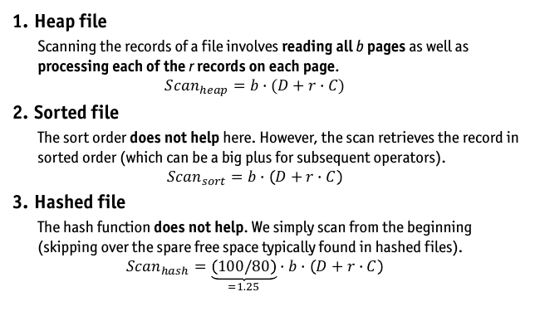
More Cost Evaluation in Slides!!!

Best File Organization
Different for each operation.
Can make huge difference

Indexes
An index is a guide for an attribute of the records.
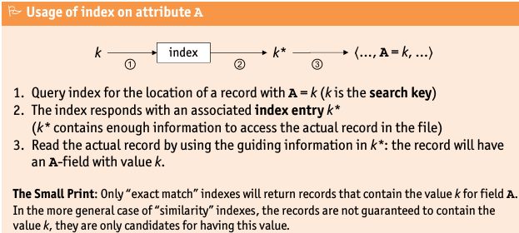
2-23

