Ben

* Presentation xp 3 phase
  + 1) association 1 scene; 1 object
  + 2) conditionning = association each obect with reward
  + 3) predict whether scenes rewarded
* Res = previous results have shown that scenes reactivated during presentation of objects in the conditioning phase
* BUT, news=
  + Half scene objects pairs have a preexisting semantic link
  + Check for reactivation during the 3rd decision phase
* Basic hypo
  + Find traces of Objects in Scenes
    - Zeithamova 2012 = MVPA classifier trained to recognise scenes/objects
      * Trained on localizer on mask around temporal Cx
    - Wimmer 2012 ≈ GLM to isolate bold activity predicted by type of previous stim – not really suited here because only one type
      * ((Reactivation of category-specific visual areas during the first half of the reward phase is related to subsequent decision bias. A GLM was estimated with separate regressors for S1 face, scene, and body part stimuli. Contrasts were constructed to estimate responses to specific S1 categories: [face - (scene + body)], [scene - (face + body)], [body - (face + scene)]. The resulting individual contrasts were masked to include only the top 1% of voxels for each contrast which also fell within a group mask (thresholded at P < 0.001, uncorrected) based on activation to category-specific stimuli in the Association phase.
      * GLM modeled the presentation of S2 circle stimuli (2 s duration) that were incidentally paired with the face, scene, and body part S1 stimuli in the Association phase. Contrasts were between S2 stimuli that differed only in their S1 associations. category-specific masks from the Association phase were applied to the resulting contrasts of the Reward phase GLM. Reward phase, beta values in voxels falling within the mask were averaged to produce one value per S2- associated category per subject))
      * Low and bias averagedd separately
* Parameters
  + Localizer = 4\*10 Objects and 4\*10 scenes
  + 16 Associations pairs repeated 6times
  + Reward repeated 6 times
  + Decision repeated 2 times
* Possible other analysis
  + Decoding would be projecting S2 activity on S1 decoding vector
  + RSA
    - More similarity S and O when linked in xp
    - More similarity S and O when semantically linked
    - Possibly assess change if we used same images for localizer??
  + Decoding of the specific associated O or S?
  + If we were to add incongruent condition
    - Eg some object are associated with a scene for reward, but semantically associated to other scene
      * Would it be possible to see which scene is reactivated?

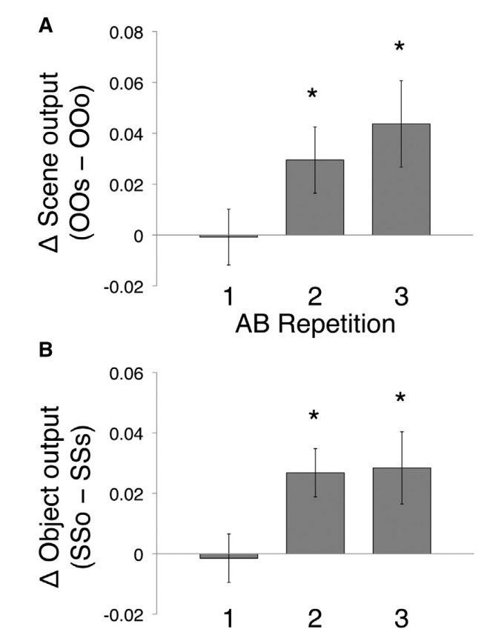

Possible other analysis