This experiment has several phases, with different rules

**In the first phase**, you will learn associations between pairs of images, one scene and one object

Example:

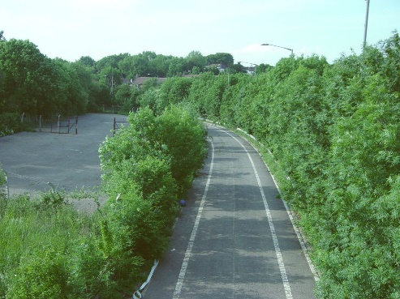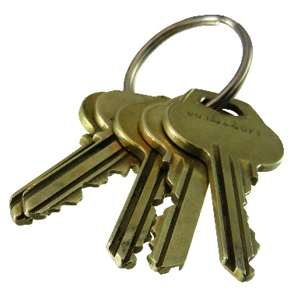

Your task is to press both left and right arrow when the two objects are different, but don’t press in trials when you have a pair of two objects or of two scenes

**In the second phase**, you will learn which objects are associated with a reward. You will be presented with a single image with a plus and a minus sign under it, followed by a reward (a coin) or not. The position of the plus and minus are random.

Example:

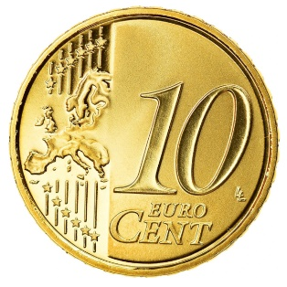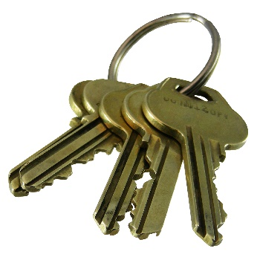



🡪 1S 🡪 **or**

+ -

Your task is to predict whether an object is rewarded or not. If you think the object is rewarded, i.e. if you think it will be followed by a coin, select the plus sign with the corresponding arrow. If you think it will not be rewarded, select the minus sign.

**Remark:** For the first trials, you cannot know, so you have to choose at random. But as the experiment goes on, you should learn which object is rewarded or not and choose intentionally.

**Remark:** The second part (coin or no coin) always appear, whether you were right or wrong. It doesn’t depend on your answer

**For the third phase,** you will be presented with a sequence of images, following each other

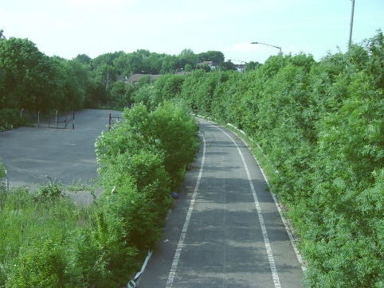Example

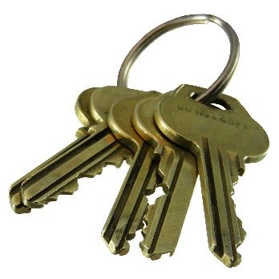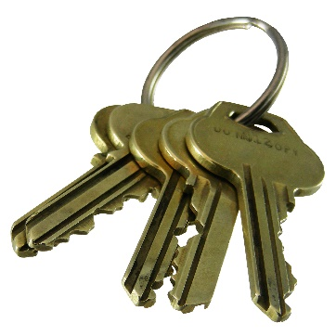

🡪1s 🡪 🡪1s 🡪

You need to press the left and right arrow at the same time, when you see twice the same image in a row.

**The fourth phase** is similar to the second one, **except** you don’t have any feedback. You will need to use your memory to answer.

Example:

🡪1s 🡪

+ -

Remark: Some of the associations are indirect, you will need to use your memory to answer. From the example before, if the key is rewarded, the road is rewarded too because it was associated with the key before.

**The fifth phase** is a memory test: if you recognize the pair, select +, if not, select -.