Thank you for participating in this study. This experiment consists of four task phases plus a few MRI scans with no task at the end.

First there will be a short practice session outside the scanner.

In the scanner, the tasks in each phase will be separated into sessions of approximately X-Y minutes. Within each phase, the scanner will stop briefly between the sessions and then start up again. We will not talk to you during these short stops.  
  
The four phases are separated by breaks in which the scanner will stop and you can rest before we continue with the next phase. In these breaks, we will be able to hear you and talk to you through the intercom. You will be able to rest for as long as you like during these breaks.   
  
We will tell you before each phase how long each session will last and how many sessions the phase will consist of.

It is important that you keep your head as still as possible during the whole scanning period, even in the breaks when the scanner is not running.

**Phase 1**

In each trial, you will be shown two pictures on the screen, one after the other. In most of the trials, one image will be a scene and the other one will be an object. Please try to **remember which images are paired**. One some trials, the same picture will be shown twice in a row. Please **press** **the left button** on the response pad when **an image is directly repeated.**A cross will be shown on the screen between the trials. Please fixate on it. The cross will not be shown between pairs of images that belong together, helping you perceive the association.

This is an example of a pair of images that you will be asked to learn:

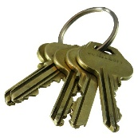 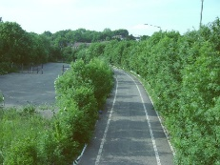

This is an example of a repetition when you should press the left button:

 

**Phase 2**

In this phase, your task is learning to predict which objects are associated with a reward. You will see a single image, followed by a reward (a coin) or not. **Please indicate for each picture whether you expect a reward trial (press the left button) or whether you expect a neutral trial (press the right button)**. In the beginning, you cannot know yet which objects are rewarded, but over time, you can use the feedback to learn the association between objects and reward.

If you correctly indicate that a rewarded object is rewarded, you will win X Cents.  
If you incorrectly indicate that a rewarded object is neutral, you will not receive anything.

For neutral trials, you will never receive anything and will always see a grey circle as feedback. However, if you incorrectly indicate too many times that a neutral object is rewarding, there will be a penalty of X % that will be deducted at the end of the experiment.

Please fixate on the cross on the screen between the trials.

This is an example of a rewarded trial with a correct button press and a win of X Cents:

 

This is an example of a rewarded object with an incorrect button press, i.e. no monetary gain:

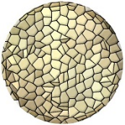 

This is an example of a neutral trial:



**Phase 3**

In this phase, you will see pictures of scenes and objects presented one by one. Unlike the previous phases, the images are presented in blocks of 13 pictures of the same type (13 scenes or 13 objects in a row). Please **press the left button when an image is repeated**. In this phase, images are **not** presented in pairs**.** Please fixate on the cross on the screen between the images.

This is an example of images in an object block:

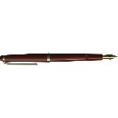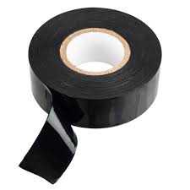

**Phase 4**

Your task in this phase is the same as in phase 2, **except** **you won’t receive any feedback**. You will therefore need to use your memory to indicate whether a trial will be **rewarded (left button) or neutral (right button)**. Even though there is no feedback, you will win X cents for each correct response in a reward trial (like in phase 2). Please fixate on the cross on the screen between trials.

