## Image processing basics

* X = left/right; y antero post; Z inferior superior
* Talairach; **MNI** space
* **Transformations** to align, different models with different number of parameters
  + Cost function to minimize (approx. distance between 2 images)
    - Interpolation when resampling to create a new transformed image
  + **Linear** transformations (3 params in 3D)
    - = translation, rotation, scaling, and shearing (diagonal)
    - Eg rigid body transformation = 6 param = translation + rotation
  + Piecewise linear = divide image and transform each division
  + **Nonlinear** = polynomial, po/bending
    - Discrete cosine transform (eg in SPM)
    - Spline Basis functions, close to Fourrier, global to local
  + **Cost function**
    - Least squares, good for within modality, needs scaling intensities
    - Normalized correlation = most accurate for motion correction
    - (Normalized)Mutual information, best for between modalities
    - Correlation ratio
  + **Optimization**
    - Computationnaly demanding, often use gradient descent
    - **Regularization** to prevent unreasonable warps (penalty on parameters)
    - **Multiscale optimization** align larger, then smaller, local finer transform
  + Reslicing and interpolation (eg when mvt correction, new voxel overlap 2 old)
    - Nearest neighbor => not used bc loss of resolution and weird behavior, works bad with optimization
    - (tri) linear => wighted average, fast, but very blury
    - Higher order interpolation
      * Sinc (sinx/x) => basically a filter, but need to linit it
        + Add a window hanning too, >rectangular
      * Basis functions
  + Filtering and Fourier

## Preproceyssing fmri

* **Quality control**
  + Scanner artifacts
    - Spikes (high intensity stripes happens discretely)
    - Ghosting (other brains seen in front and behind real ones bc of phase offset)
  + LOOK AT Time series
  + LOOK AT ICA, good for head motion
    - But need explicit criteria for rejection, eg alternation between slices, spiking pattern
* **Distortion correction** – especially at air tissue interfaces eg nose and ears
  + Can cause dropout, nota orbitofrontal cx
  + Amd geometric distortion => correct with use of field maps (detect misattribution of activity by imaging at 2 times points), but might be noisy and introduce artifacts
* Slice timing correction
  + Po to use interleaved imaging (1 3 5 2 4 6)
  + Reference slice, match other slices to itr
  + NOT nec though, espe for short TRs (<2s)
    - Use statistical models including temporal derivative
* Motion correction
  + Bulk motion = Artefact (flaming brain) when a voxel that previously contained ait now contains tissue
  + Spin history effects => movement affect protons spins => stripes if interleaved
    - Po correct w ICA
  + Stimulus correlated motion (eg speech, concentration), pb bc locked to task
    - But po correct bc delay bold
  + Motion correction (realignment)
    - Estimation, relative to a target slice, w a cost function…
    - Prospective motion correction: change gradient position online, but hard and complicated
    - Quality control = visualize time series
  + Interaction with susceptibility (OFC) and slice timing (apply AFTER motion correction)
  + Phylosiogical motion
    - Record heart and respiration and use as predictors, OR use ICA
* Spatial smoothing
  + Increase signal to noise ratio (SNR) if you look at larger scale
  + Reduce dropout
  + Help between subject ana, bc spatial normalization doesn’t solve all
  + BUT NOT FOR PATTERN CLASSIFICATION
  + Use convolution a 3D gaussian kernel
  + NO LARGER THAN ACTIVATION SIGNAL YOU WANT TO DETECT

## Spatial normalization

* **ATLAS BAS**ED **Talairach**, coordinate space relative to landmarks
  + Anterior and posterior commissures + midline sagittal plane + exterior boundaries of brain
  + (0,0,0) = intersection AC and midline
    - Axial plane = goes through AC and PC, orthogonal to midline sagittal
* **automated** mostly used nowadays => **MNI template**
* preprocessing
  + bias field correction
    - correct inhomogeneities (eg darker on sides) with high pass filter
    - use segmentation to equate intensity distribution across tissue types
  + brain extraction
    - use algo based on segmentation or on delimitation
  + tissue segmentation
    - pb bc some overlap in intensity, especially with inhomogeneities
      * and bc some voxel overlap several tissue types
    - eg **algo in SPM use unified segmentatio**n
      * combine BF correct, extraction, segmentation, automatic but atlas aided
  + processing streams
    - before or after preprocessing and stats?
    - to align with template, multistep, using anat and functional images
      * align coplanar images, align with high res images, then normalize with standard space
* normalization methods
  + atlas based
  + volume based
    - computational anatomy => use vector field transformation, nonlinear rather than linear transformation functions
    - (DARTEL in SPM)
  + surface based
    - more susceptible to topological defects
    - BUT very good registration of cortical areas, not compared with nonlinear tho
  + choice? → results more fione with non linear!
* quality control
  + less blury possible, only yhe outline of 1 brain
  + watch time serie movies
  + make sure axis match, possibly to re-orient manually for easier registration
  + if pb, check that previous steps done well
  + if special population, use MNI if comparison w normal pop, otherwise use specific template (if lesion, put a mask on the cost function of the area lesioned)

## Statistical modelling :single subject

search for voxel bold time series that matches the stimulus presentation => GLM

* create GLM predictor that best model BOLD
* modelling and accounting for BOLD noise and other src of var

**Bold**

* mix of blood flow, volume and oxygenation
* **features of the HRF**
  + **peak height**, 5% for senso, .5% for cog
  + **time to peak** = 4-6s after stim onset
  + **width** = start 1-2s after onset, complete baseline 12-20s after
  + initial dip (small drop at begining, barely visible often, IGNORE)
  + **post-stimulus undershoot** = small dip after resp
* high variation between subjects AND between areas of the brain
* **convolution**
  + linear time invariant properties
    - BOLD response = proportional with neural response
    - bc slower, 2 smallneural responses distant in time will be combined into one big weirdly shaped BOLD response
    - 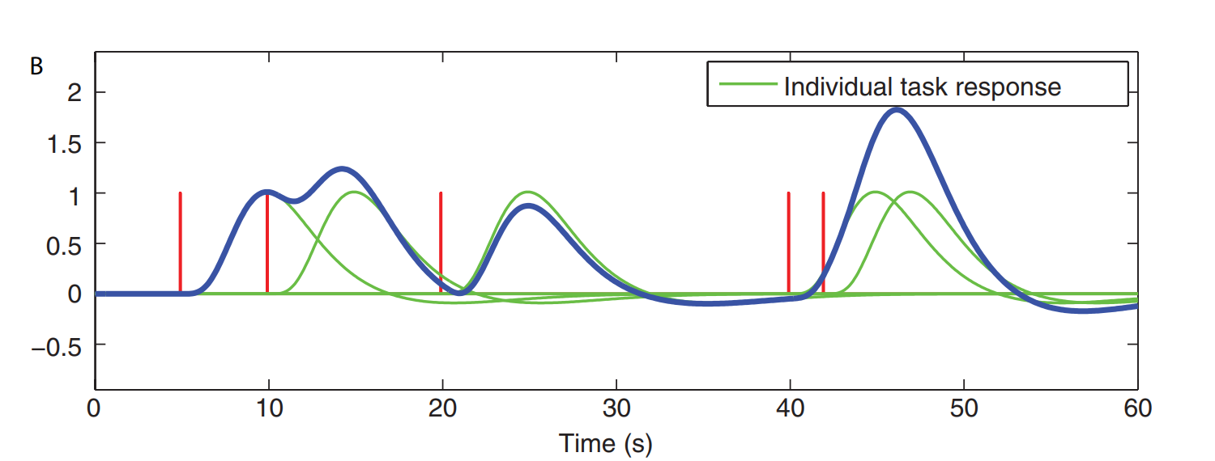
  + (actually a lot of nonlinearities (phasic response, logarithmic temporal response [eg 5ms stim response = ½ 2s stim], adaptation if less than 2 s apart…)
* **HRF (hemodynamic response function)**
  + average timelocked response to get shape?
  + best model = gamma function, especially **double-gamm**a function account for undershoot, but peak too early
    - =canonical HRF
  + BUT good to have flexibility, as the HRF change across brain/ppl
    - bias-variance trade-off
  + eg
    - linearly combining several basis funtions
    - modelling derivatives (allwing for temporal shifts)
    - usings different sets of function: fourier, sine/cosine, finite impulse response model (FIR)
  + derivative
    - taylor series expansion to capture delays, add regressor(s)
    - time and dispersion (width) derivatives available in SPM
  + FIR = most flexible
    - a regressor by timepoint of the response
      * less bias about output shape
      * BUT high variability bc lots of parameters xompared to data
        + also pb = colinearity
        + also pb = multi response => if between subject, need multivariate model
  + constrained basis set
    - middle range regarding bias and variance
    - 1) create plausible HRFs
    - 2) do PCA on them to get functions that describe those HRF
    - 3) allow different linear combinations of those fcts to match the data
* other consideration when modelling:
  + time resolution of the model
    - for better HRF
      * 1) upsample stimulus presentation times (a fraction of TR)
      * 2) convolve with HRF
      * 3) down sample to the TR resolution
    - better pck more sensitive to <TR stim timing
  + modelling parametric modulation
    - build parametric regressors from parametric stimuli
      * convolve HRF with stick function of parametric value
    - ALWAYS keep a non parametric regressor in addition
      * otherwise assuption that ALL response depends on stim params
  + modelling behavioral response time
    - might capture difference due to time
  + modelling motion parameters => capture noise due to mvt
    - include parameters used for head motion correction (= translation, rotation etc.)
    - =nuisance regressors
    - and their derivative
  + orthogonalisation
    - often some regressors = correlated
    - BC regressors ONLY CAPTURE UNIQUE VARIABILTY
      * so SHARED VARIABILITY =lost
    - but with orthogonalization, variability attribution = a bit random

The bold noise