Thank you for participating in this study. Here are the instructions. This experiment has several phases, with different rules

**Phase 1**

Try to **remember associations between pairs of** **images**, which scenes goes with which object.

At the same time, you also need is to **press** the left and/or right button when **one image is repeated**

Example:

1) PAIR

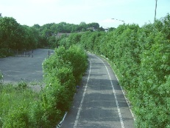 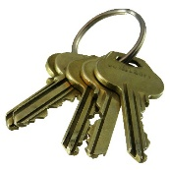

2) Symbol shown between trials:

3) PAIR

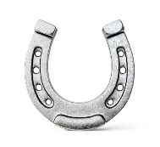 

**Phase 2: Predict the reward**

Learn to predict which objects are associated with a reward. You will be presented with a single image with a plus and a minus sign under it, followed by a reward (a coin) or not. The position of the plus and minus are random. Your task is to predict whether an object is rewarded or not. If you think the object is rewarded, i.e**. if you think it will be followed by a coin, select the plus sign** with the corresponding button. **If you think it will not be rewarded, select the minus sign.** You really win the money for correctly predicting a reward (1), and really have a penalty if you incorrectly predict no reward (4)

**Remark: For the first trials, you cannot know, so you have to choose at random**. But as the experiment goes on, you should learn which object is rewarded or not and choose intentionally.

**Examples**:

**1**

**2**

**3**

**4**

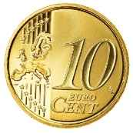 



**+ – + –**

 

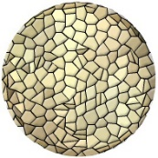

**+ – + –**





* **+ – +**





* **+ – +**

**PHASE 3:**

Same rule as phase 1: **press when you see twice the same image in row**. This time images are not presented by pairs and **you don’t have to remember.**

Example:

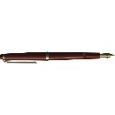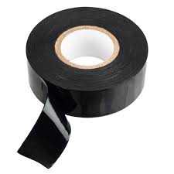



**PHASE 4:**

Same as Phase 2, **except** **you don’t have any feedback**. You will need to use your memory to answer. **You will get more instructions at this time.**

 



**+ – + –**