EXO 1
<!DOCTYPE html>
<html>

<head>
<meta charset='utf-8'>
<meta http-equiv='X-UA-Compatible' content='IE=edge'>
<title>Page Title</title>
<meta name='viewport' content='width=device-width, initial-scale=1'>
<link rel='stylesheet' type='text/css' media='screen' href='style.css'>
<script src='main.js'></script>
</head>

<body>
<div id="Bandeau">
<h1 class="Titre">Bandeau</h1>
</div>
<div class="Contenu">
<h1 class="Titre">Contenu</h1>
</div>
<div class="Footer">
<h1 class="Titre">Pied de page</h1>
</div>
</body>

</html>

html {
height: 100%;
}

body {
margin: 0;
padding: 0;
min-height: 100vh;
}

#Bandeau {
background-color: rgb(255, 20, 147);
width: 100%;
height: 10vh;
}

.Footer {
background-color: rgb(255, 165, 0);
width: 100%;
height: 10vh;
}

.Titre {
text-align: center;
margin: 0;
line-height: 10vh;
}

.Contenu {
background-color: rgb(128, 255, 0);
width: 100%;
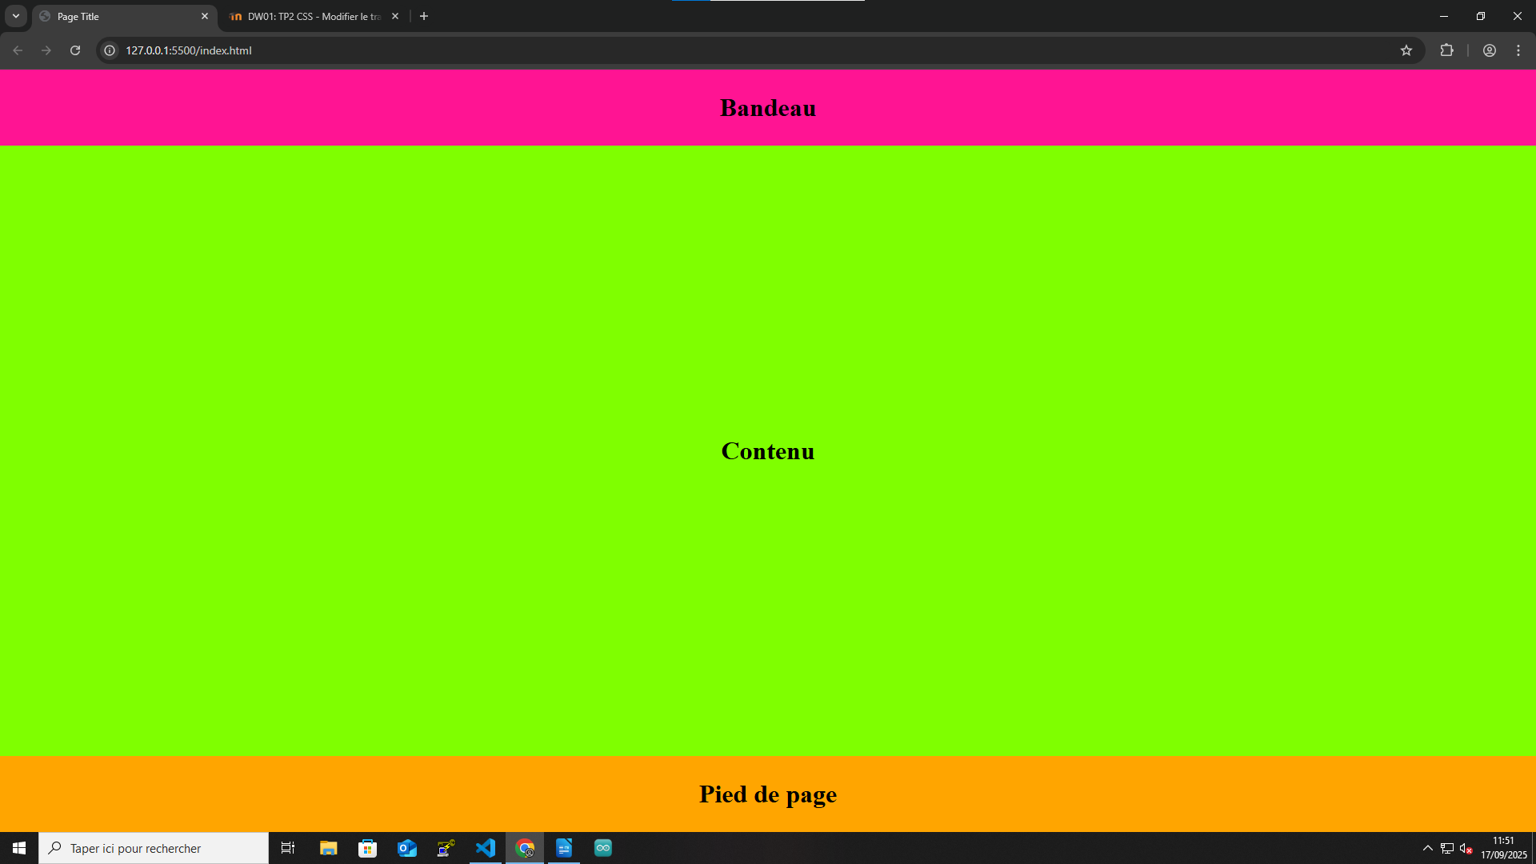
height: 80vh;
display: flex;
}

.Contenu .Titre {
flex-grow: 1;
display: flex;
justify-content: center;
align-items: center;
}

Exo2

<!DOCTYPE html>
<html>

<head>
<meta charset='utf-8'>
<meta http-equiv='X-UA-Compatible' content='IE=edge'>
<title>Page Title</title>
<meta name='viewport' content='width=device-width, initial-scale=1'>
<link rel='stylesheet' type='text/css' media='screen' href='style.css'>
<script src='main.js'></script>
</head>

<body>
<div id="Bandeau">
<h1 class="Titre">Bandeau</h1>
</div>
<div class="Contenu">
<div class="Menu">
<h1 class="Titre">Menu</h1>
</div>
<h1 class="Titre">Contenu</h1>
</div>
<div class="Footer">
<h1 class="Titre">Pied de page</h1>
</div>
</body>

</html>

html {
height: 100%;
}

body {
margin: 0;
padding: 0;
min-height: 100vh;
}

#Bandeau {
background-color: rgb(255, 20, 147);
width: 100%;
height: 10vh;
}
.Footer {
background-color: rgb(255, 165, 0);
width: 100%;
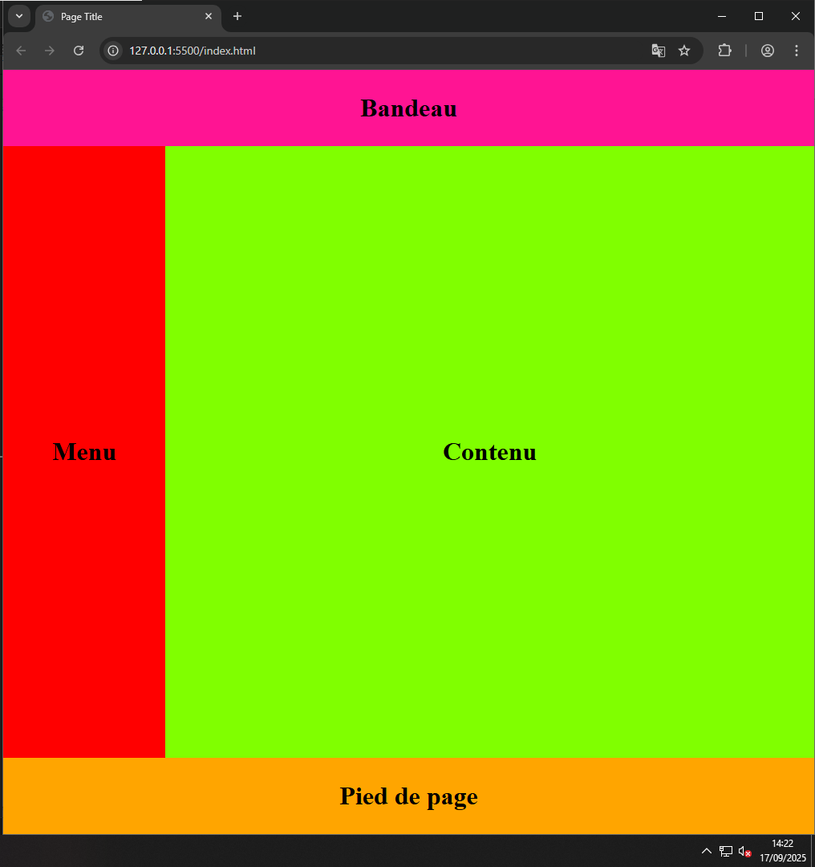
height: 10vh;
}

.Titre {
text-align: center;
margin: 0;
line-height: 10vh;
}

.Contenu {
background-color: rgb(128, 255, 0);
width: 100%;
height: 80vh;
display: flex;

}

.Menu {
background-color: rgb(255, 0, 0);
width: 20%;
display: flex;
justify-content: center;
align-items: center;
}

.Contenu .Titre {
flex-grow: 1;
display: flex;
justify-content: center;
align-items: center;
}
EXO3

<!DOCTYPE html>
<html>

<head>
<meta charset='utf-8'>
<meta http-equiv='X-UA-Compatible' content='IE=edge'>
<title>Page Title</title>
<meta name='viewport' content='width=device-width, initial-scale=1'>
<link rel='stylesheet' type='text/css' media='screen' href='style.css'>
<script src='main.js'></script>
</head>

<body>
<div id="Bandeau">
<h1 class="Titre">Bandeau</h1>
</div>
<div class="Contenu">
<div class="Menu">
<div class="SousMenu">
<h1 class="Titre">Menu haut</h1>
</div>
<div class="SousMenu2">
<h1 class="Titre">Menu Bas</h1>
</div>
</div>
<div class="CorpsContenu">
<a>Lorem ipsum dolor sit amet consectetur adipisicing elit. Ullam nobis dolorum fugit eius cumque alias numquam libero perspiciatis omnis, architecto nemo, quos nesciunt eaque repellendus laboriosam nulla voluptatum obcaecati. Aut sunt illo blanditiis inventore harum corrupti minus velit ad, obcaecati aliquam quidem aspernatur excepturi architecto. Sunt veniam illum optio minima expedita distinctio deleniti aperiam nihil hic deserunt doloribus dolorum, repudiandae dolor! Modi ab asperiores sit nam incidunt necessitatibus hic veniam, dolore dolorum eaque reprehenderit mollitia eius ut tempora, rem libero repudiandae dolorem ullam? Repellendus fugit nulla beatae quo praesentium in voluptatibus, eius omnis nihil incidunt voluptas tempora ad quae dicta temporibus blanditiis velit, perferendis architecto doloribus suscipit. Quaerat voluptas, praesentium corporis, velit expedita, ab repellendus cum est obcaecati sapiente et. Sed minus optio perspiciatis sequi at cumque! Autem minus nesciunt, enim, nulla, omnis sint asperiores praesentium necessitatibus quas consequuntur ullam provident voluptatibus quos! Eaque animi asperiores similique ipsam nesciunt id, vel, beatae molestias placeat expedita, quam velit molestiae voluptatibus ad nam soluta eveniet nobis illum officia. Quasi, nemo atque aliquid quas qui cupiditate numquam natus provident saepe voluptate quidem unde itaque fugit excepturi magni ratione aliquam sequi. Cumque excepturi dolores soluta dolorum. Rem excepturi magni dolores. At voluptatibus dolorum minus.</a>
<h1 class="Titre">Contenu</h1>
</div>
<div class="Block">
<h1 class="Titre">Block News</h1>
</div>

</div>
<div class="Footer">
<h1 class="Titre">Pied de page</h1>
</div>
</body>

</html>

html {
height: 100%;
}

body {
margin: 0;
padding: 0;
min-height: 100vh;
}

#Bandeau {
background-color: rgb(255, 20, 147);
width: 100%;
height: 10vh;
display: flex;
justify-content: center;
align-items: center;
}

.Footer {
background-color: rgb(255, 165, 0);
width: 100%;
height: 10vh;
display: flex;
justify-content: center;
align-items: center;
}

.Titre {
text-align: center;
margin: 0;
}

.Contenu {
background-color: rgb(128, 255, 0);
width: 100%;
height: 80vh;
display: flex;

}

.Menu {
display: flex;
flex-direction: column;
width: 20%;
flex-shrink: 0
}

.SousMenu {
background-color: rgb(255, 0, 0);
height: 40vh;
display: flex;
justify-content: center;
align-items: center;
flex-shrink: 0
}

.SousMenu2 {
background-color: rgb(17, 0, 255);
height: 40vh;
display: flex;
justify-content: center;
align-items: center;
flex-shrink: 0
}
a{
font-size: 30px;
}
.CorpsContenu {
background-color: rgb(128, 255, 0);
flex-grow: 1;
display: flex;
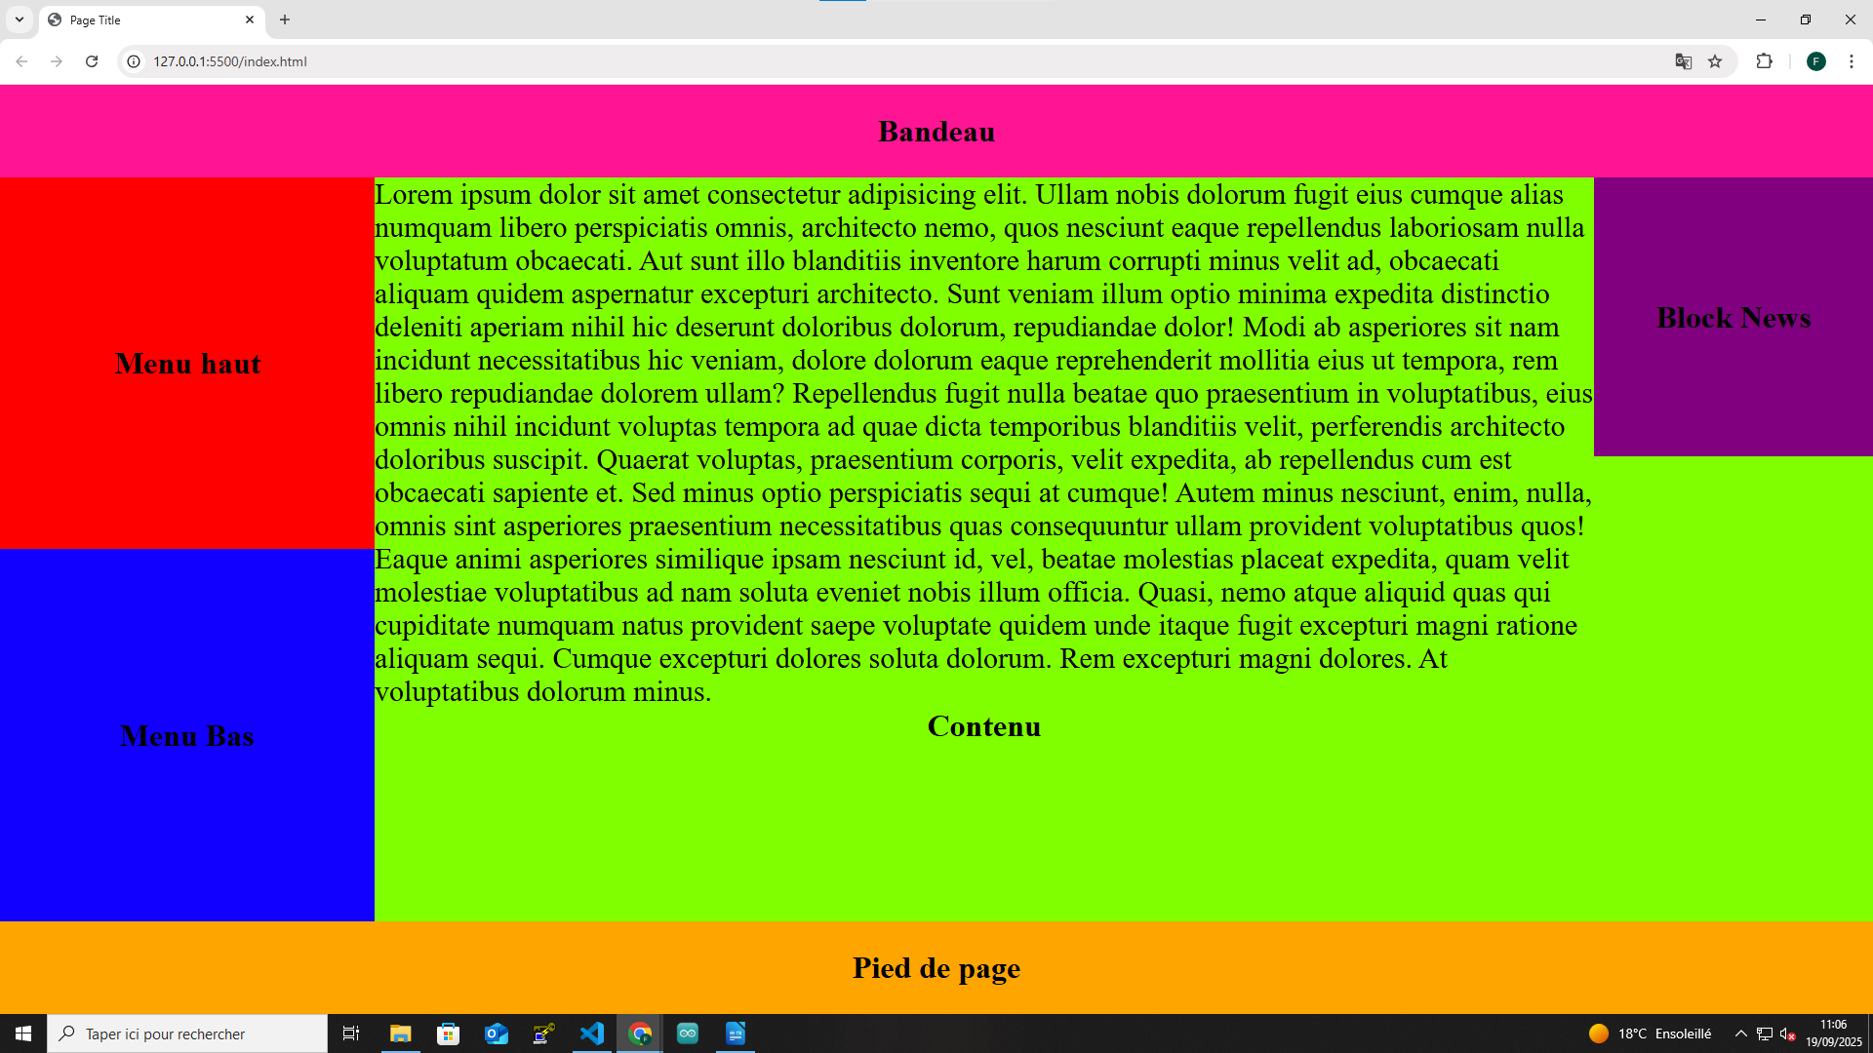
flex-direction: column;
}

.Block{
background-color: purple;
display: flex;
width: 30vh;
height: 30vh;
justify-content: center;
align-items: center;
flex-shrink: 0
}
Exo 4
<!DOCTYPE html>
<html>

<head>
<meta charset='utf-8'>
<meta http-equiv='X-UA-Compatible' content='IE=edge'>
<title>Page Title</title>
<meta name='viewport' content='width=device-width, initial-scale=1'>
<link rel='stylesheet' type='text/css' media='screen' href='style.css'>
<script src='main.js'></script>
</head>

<body>
<div id="Bandeau">
<h1 class="Titre">Bandeau</h1>
</div>
<div class="Contenu">
<div class="Menu">
<div class="SousMenu">
<h1 class="Titre">Menu haut</h1>
</div>
<div class="SousMenu2">
<h1 class="Titre">Menu Bas</h1>
</div>
</div>
<div class="CorpsContenu">
<a class="blue">Lorem ipsum dolor sit amet consectetur adipisicing elit. Ullam nobis dolorum fugit eius cumque alias numquam libero perspiciatis omnis, architecto nemo, quos nesciunt eaque repellendus laboriosam nulla voluptatum obcaecati. Aut sunt illo blanditiis inventore harum corrupti minus velit ad, obcaecati aliquam quidem aspernatur excepturi architecto. Sunt veniam illum optio minima expedita distinctio deleniti aperiam nihil hic deserunt doloribus dolorum, repudiandae dolor! Modi ab asperiores sit nam incidunt necessitatibus hic veniam, dolore dolorum eaque reprehenderit mollitia eius ut tempora, rem libero repudiandae dolorem ullam? Repellendus fugit nulla beatae quo praesentium in voluptatibus, eius omnis nihil incidunt voluptas tempora ad quae dicta temporibus blanditiis velit, perferendis architecto doloribus suscipit. Quaerat voluptas, praesentium corporis, velit expedita, ab repellendus cum est obcaecati sapiente et. Sed minus optio perspiciatis sequi at cumque! Autem minus nesciunt, enim, nulla, omnis sint asperiores praesentium necessitatibus quas consequuntur ullam provident voluptatibus quos! Eaque animi asperiores similique ipsam nesciunt id, vel, beatae molestias placeat expedita, quam velit molestiae voluptatibus ad nam soluta eveniet nobis illum officia. Quasi, nemo atque aliquid quas qui cupiditate numquam natus provident saepe voluptate quidem unde itaque fugit excepturi magni ratione aliquam sequi. Cumque excepturi dolores soluta dolorum. Rem excepturi magni dolores. At voluptatibus dolorum minus.</a>

<h1 class="Titre">Contenu</h1>
</div>
<div class="Block">
<h1 class="Titre">Block News</h1>
</div>

</div>
<div class="Footer">
<h1 class="Titre">Pied de page</h1>
</div>
</body>

</html>
html {
height: 100%;
}

body {
margin: 0;
padding: 0;
min-height: 100vh;
}

#Bandeau {
background-color: rgb(255, 20, 147);
width: 100%;
height: 10vh;
display: flex;
justify-content: center;
align-items: center;
}

.Footer {
background-color: rgb(255, 165, 0);
width: 100%;
height: 10vh;
display: flex;
justify-content: center;
align-items: center;
}

.Titre {
text-align: center;
margin: 0;
}

.Contenu {
background-color: rgb(128, 255, 0);
width: 100%;
height: 80vh;
display: flex;

}

.Menu {
display: flex;
flex-direction: column;
width: 20%;
flex-shrink: 0
}

.SousMenu {
background-color: rgb(255, 0, 0);
height: 40vh;
display: flex;
justify-content: center;
align-items: center;
flex-shrink: 0
}

.SousMenu2 {
background-color: rgb(17, 0, 255);
height: 40vh;
display: flex;
justify-content: center;
align-items: center;
flex-shrink: 0
}
.blue{
font-size: 20px;
color: blue;
}

.CorpsContenu {
background-color: rgb(128, 255, 0);
flex-grow: 1;
display: flex;

flex-direction: column;
}

.Block{
background-color: purple;
display: flex;
width: 30vh;
height: 30vh;
justify-content: center;
align-items: center;
flex-shrink: 0
}

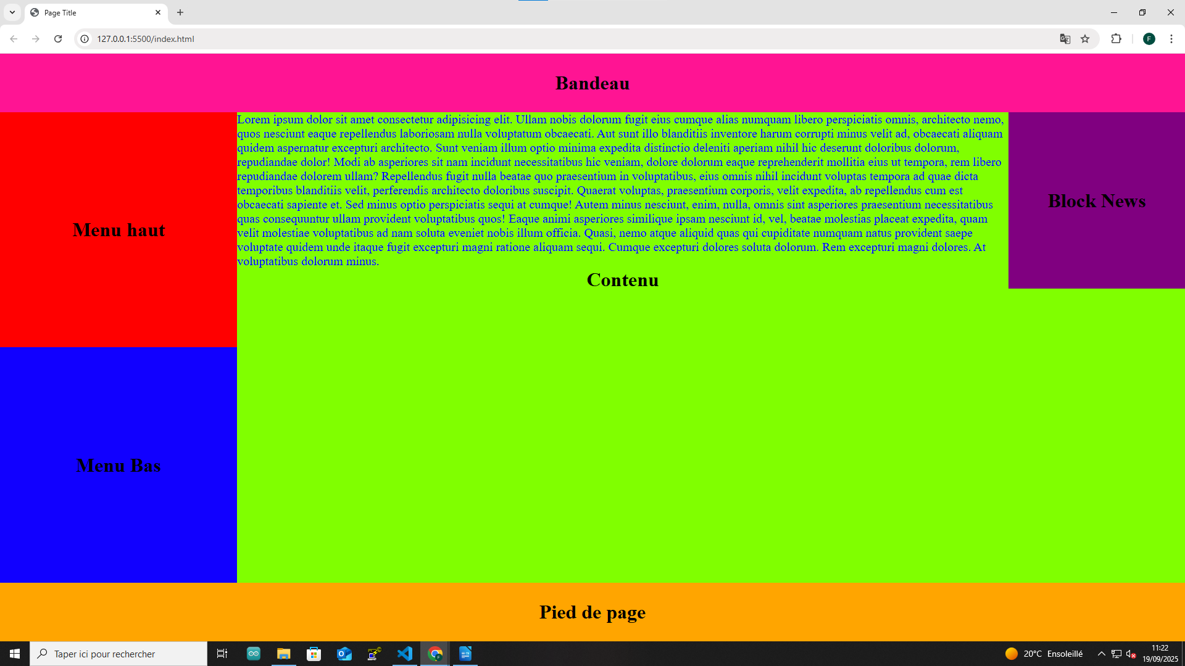

EXO 5

<!DOCTYPE html>
<html>

<head>
<meta charset='utf-8'>
<meta http-equiv='X-UA-Compatible' content='IE=edge'>
<title>Page Title</title>
<meta name='viewport' content='width=device-width, initial-scale=1'>
<link rel='stylesheet' type='text/css' media='screen' href='style.css'>
<script src='main.js'></script>
</head>

<body>
<div id="Bandeau">
<h1 class="Titre">Bandeau</h1>
</div>
<div class="Contenu">
<div class="Menu">
<div class="SousMenu">
<h1 class="Titre">Menu haut</h1>
</div>
<div class="SousMenu2">
<h1 class="Titre">Menu Bas</h1>
</div>
</div>
<div class="CorpsContenu">
<a class="blue">Lorem ipsum dolor sit amet consectetur adipisicing elit. Ullam nobis dolorum fugit eius
cumque alias numquam libero perspiciatis omnis, architecto nemo, quos nesciunt eaque repellendus
laboriosam nulla voluptatum obcaecati. Aut sunt illo blanditiis inventore harum corrupti minus velit ad,
obcaecati aliquam quidem aspernatur excepturi architecto. Sunt veniam illum optio minima expedita
distinctio deleniti aperiam nihil hic deserunt doloribus dolorum, repudiandae dolor! Modi ab asperiores
sit nam incidunt necessitatibus hic veniam, dolore dolorum eaque reprehenderit mollitia eius ut tempora,
rem libero repudiandae dolorem ullam? Repellendus fugit nulla beatae quo praesentium in voluptatibus,
eius omnis nihil incidunt voluptas tempora ad quae dicta temporibus blanditiis velit, perferendis
architecto doloribus suscipit. Quaerat voluptas, praesentium corporis, velit expedita, ab repellendus
cum est obcaecati sapiente et.</a><a class="red">optio perspiciatis sequi at cumque! Autem minus nesciunt, enim,
nulla, omnis sint asperiores praesentium necessitatibus quas consequuntur ullam provident voluptatibus
quos! Eaque animi asperiores similique ipsam nesciunt id, vel, beatae molestias placeat expedita, quam
velit molestiae voluptatibus ad nam soluta eveniet nobis illum officia. Quasi, nemo atque aliquid quas
qui cupiditate numquam natus provident saepe voluptate quidem unde itaque fugit excepturi magni ratione
aliquam sequi. Cumque excepturi dolores soluta dolorum. Rem excepturi magni dolores. At voluptatibus
dolorum minus.</a>

<h1 class="Titre">Contenu</h1>
</div>
<div class="Block">
<h1 class="Titre">Block News</h1>
</div>

</div>
<div class="Footer">
<h1 class="Titre">Pied de page</h1>
</div>
</body>

</html>

html {
height: 100%;
}

body {
margin: 0;
padding: 0;
min-height: 100vh;
}

#Bandeau {
background-color: rgb(255, 20, 147);
width: 100%;
height: 10vh;
display: flex;
justify-content: center;
align-items: center;
}

.Footer {
background-color: rgb(255, 165, 0);
width: 100%;
height: 10vh;
display: flex;
justify-content: center;
align-items: center;
}

.Titre {
text-align: center;
margin: 0;
}

.Contenu {
background-color: rgb(128, 255, 0);
width: 100%;
height: 80vh;
display: flex;

}

.Menu {
display: flex;
flex-direction: column;
width: 20%;
flex-shrink: 0
}

.SousMenu {
background-color: rgb(255, 0, 0);
height: 40vh;
display: flex;
justify-content: center;
align-items: center;
flex-shrink: 0
}

.SousMenu2 {
background-color: rgb(17, 0, 255);
height: 40vh;
display: flex;
justify-content: center;
align-items: center;
flex-shrink: 0
}
.blue{
font-size: 20px;
color: blue;
}

.red{
font-size: 30px;
color: red;
}
.CorpsContenu {
background-color: rgb(128, 255, 0);
flex-grow: 1;
display: flex;

flex-direction: column;
}

.Block{
background-color: purple;
display: flex;
width: 30vh;
height: 30vh;
justify-content: center;
align-items: center;
flex-shrink: 0
}

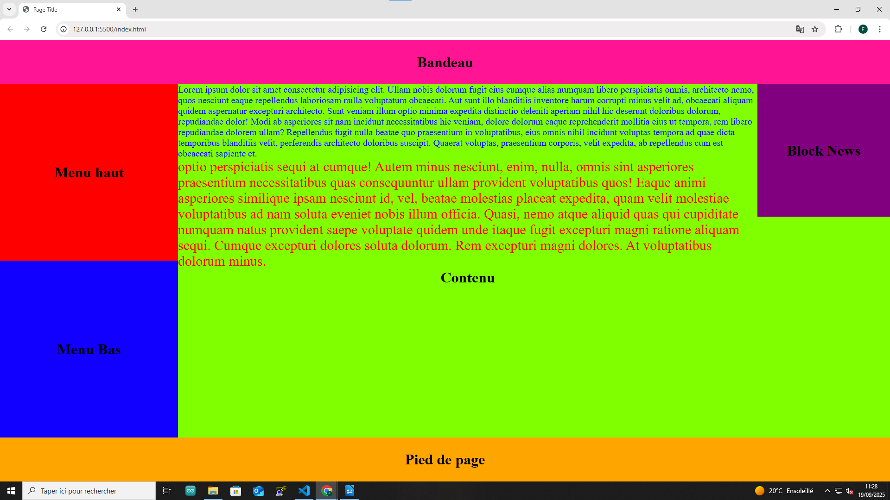

Exo6
<!DOCTYPE html>
<html>

<head>
<meta charset='utf-8'>
<meta http-equiv='X-UA-Compatible' content='IE=edge'>
<title>Page Title</title>
<meta name='viewport' content='width=device-width, initial-scale=1'>
<link rel='stylesheet' type='text/css' media='screen' href='style.css'>
<script src='main.js'></script>
</head>

<body>
<div id="Bandeau">
<h1 class="Titre">Bandeau</h1>
</div>
<div class="Contenu">
<div class="Menu">
<div class="SousMenu">
<h1 class="Titre">Menu haut</h1>
</div>
<div class="SousMenu2">
<h1 class="Titre">Menu Bas</h1>
</div>
</div>
<div class="CorpsContenu">
<table>
<tr>
<td class="green">Ceci est une phrase.</td>
<td class="green">Ceci est une autre phrase.</td>
</tr>
<tr>
<td class="green">Encore une phrase.</td>
<td class="green">Et une dernière.</td>
</tr>
</table>
<p class="red">Voici une phrase entre les tableaux.</p>
<table>
<tr>
<td class="blue">Ceci est une phrase du milieu.</td>
<td class="blue">Une autre phrase du milieu.</td>
</tr>
<tr>
<td class="blue">C'est la dernière phrase ici.</td>
<td class="blue">Une dernière phrase du milieu.</td>
</tr>
</table>
<p class="red">Une autre phrase entre les tableaux.</p>
<table>
<tr>
<td class="green">Ceci est la phrase finale.</td>
<td class="green">Une autre phrase.</td>
</tr>
<tr>
<td class="green">Une phrase de plus.</td>
<td class="green">Ceci est la toute dernière phrase.</td>
</tr>
</table>
<h1 class="Titre">Contenu</h1>
</div>
<div class="Block">
<h1 class="Titre">Block News</h1>
</div>

</div>
<div class="Footer">
<h1 class="Titre">Pied de page</h1>
</div>
</body>

</html>

html {
height: 100%;
}

body {
margin: 0;
padding: 0;
min-height: 100vh;
}

#Bandeau {
background-color: rgb(255, 20, 147);
width: 100%;
height: 10vh;
display: flex;
justify-content: center;
align-items: center;
}

.Footer {
background-color: rgb(255, 165, 0);
width: 100%;
height: 10vh;
display: flex;
justify-content: center;
align-items: center;
}

.Titre {
text-align: center;
margin: 0;
}

.Contenu {
background-color: rgb(128, 255, 0);
width: 100%;
height: 80vh;
display: flex;
}

.Menu {
display: flex;
flex-direction: column;
width: 20%;
flex-shrink: 0
}

.SousMenu {
background-color: rgb(255, 0, 0);
height: 40vh;
display: flex;
justify-content: center;
align-items: center;
flex-shrink: 0
}

.SousMenu2 {
background-color: rgb(17, 0, 255);
height: 40vh;
display: flex;
justify-content: center;
align-items: center;
flex-shrink: 0
}

.blue {
font-size: 20px;
color: blue;
}

.red {
font-size: 30px;
color: red;
}

.CorpsContenu {
background-color: rgb(128, 255, 0);
flex-grow: 1;
display: flex;
flex-direction: column;
}

.Block {
background-color: purple;
display: flex;
width: 30vh;
height: 30vh;
justify-content: center;
align-items: center;
flex-shrink: 0
}

.green {
font-size: 15px;
color: green;
}
