Track Design and Material Usage

This document consists of the current track design and possible materials which we will use to build a physical track.

Current track design
Right now we plan to build a replica of the AWS re:Invent 2018 track. This offers us the ability to test out models trained either locally or in the AWS cloud in a real environment.
Figure 1AWS DeepRacer reInvent 2018 track

As seen in the picture above it is a circular track used previously during an AWS event. Therefor it is proven to work well with the vehicle.

Size and Dimensions
Since we use an official track, scale and size are fix, although slight deviations are acceptable. To be more precise the colours can vary from the references, as it is difficult to obtain exactly this colour scheme.
The track dimensions are as follows:
26’ x 17’ or 7.93m x 5.18 m
The width of the road is 24’’ or 60.96 cm. The width should not fall below this threshold as it can impact the performance of the vehicle.

Material and Colour
To be able to move the track and – if necessary – replace parts of it, it will be constructed out of several smaller pieces. One recommended material was interlocking foam tiles. These offer a good surface for the vehicle and are lightweight while still holding together.
A drawback of these foam tiles is that they are not available in the exact colour which was used for the original track. The simpler option is to buy tiles in a similar colour, like the ones shown below, and just paint the black road. This is the fastest way but might lead to worse performance.

Foam tiles like the one shown here offer a comparably cheap way of laying out the track.
Properties:
Size: 90 x 90 x 1,2 cm
Price: 9,99 € per tile
Approximated total: 480 €

Amazon link:
https://www.amazon.de/Eyepower-Bodenschutz-Puzzlematte-Trainingsmatte-Schutzmatte/dp/B079S5N8PP/ref=sr_1_26?__mk_de_DE=%C3%85M%C3%85%C5%BD%C3%95%C3%91&dchild=1&keywords=Bodenschutzmatte+gr%C3%BCn&qid=1595335744&s=sports&sr=1-26
Although they do not match the colour, there would be no need to paint these except for the black road and the markings.

Alternatively, black foam tiles can be painted with the right colour and then used for the track. This would offer better performance and more accurate colours but requires more work.
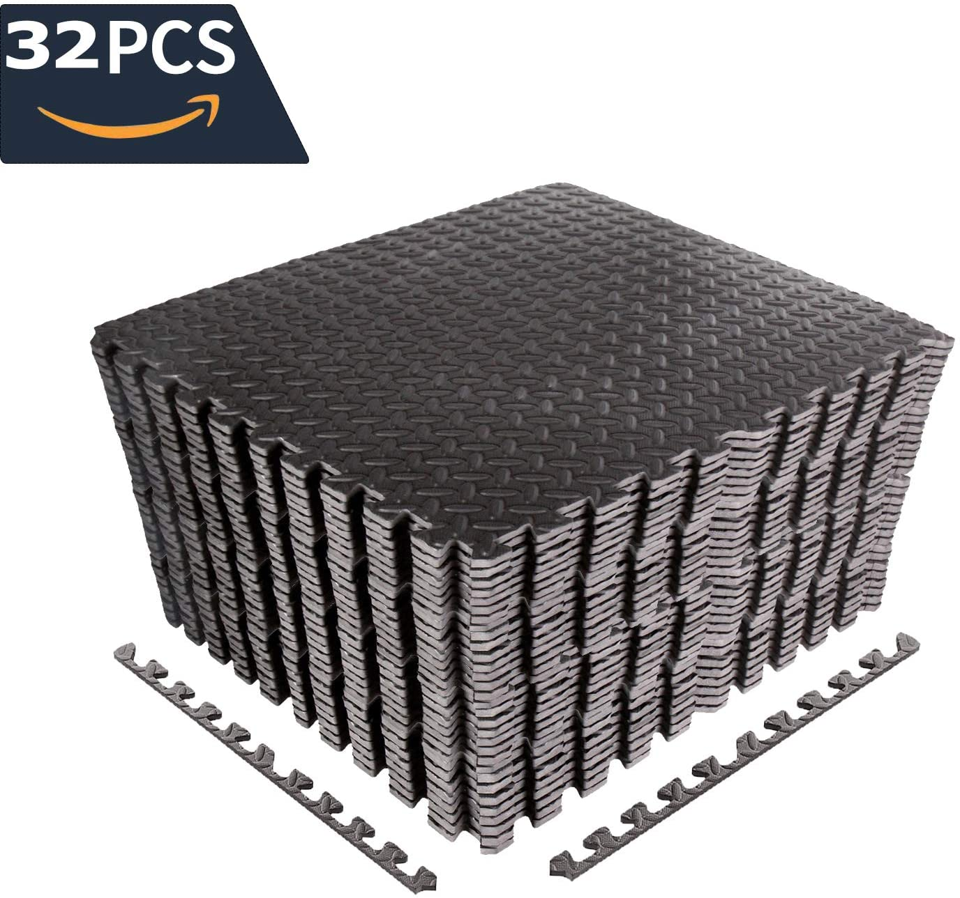
Properties:
Size: 60 x 60 x 1 cm
Price: 99,95 € per 32 set
Approximated total: 400 €
It should be considered that painting these can prove difficult, as we do not know how well the paint will stay on the foam and if we need to repaint them after some time.

Amazon link:
https://www.amazon.de/CCLIFE-Bodenschutzmatte-Schutzmatte-Unterlegmatten-Bodenmatte/dp/B07WFNRLD6/ref=pd_sbs_200_1/261-5377856-5394911?_encoding=UTF8&pd_rd_i=B07V7D91DV&pd_rd_r=8138d7b4-8a40-4044-9fae-f74dfed24656&pd_rd_w=V5fPI&pd_rd_wg=FhxL3&pf_rd_p=42bf0ad8-ce6f-4127-a2f0106727020a41&pf_rd_r=WG7BH86M1G7CFY2PWJHD&refRID=WG7BH86M1G7CFY2PWJHD&th=1
If we decide to use black foam, we need to buy appropriate paint. One option is to spray paint them with the right colour.
Amazon link:
https://www.amazon.de/TRISTARcolor-Autolack-Spraydose-Basislack-Spr%C3%BChdose/dp/B01F4GVZC6
If it turns out that this paint does not hold well, we might need to consult a painting company in order to get proper paint which will work on the foam. This will lead to a considerable increase on costs.

The lines and markings on the track will be done with duct tape, as it is easy to do and repair.

Track placement and storage
Last but not least we need to consider where to place the track and where to store it. If our measurements are correct, the track can fit on the ground in the robotics lab, between the tables and the “super computer”, although this needs to be confirmed. Apart from that storing these tiles should not be troublesome as they are lightweight, and the track can easily be taken apart.

Pricing
No matter what type of track we use, the total will come out at no less than 400 €, probably even more.

