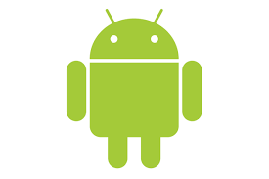

Android Project

Sebille Florian

Brocherieux Thibault

MemorAh

[https://github.com/FlorianSebille/jeuxDesPaires_M1Embarquee](https://github.com/FlorianSebille/jeuxDesPaires_M1Embarquees)

Summary

|  |  |
| --- | --- |
| Introduction | 2 |
| Specifications | 2 |
| Current state & evolutions | 6 |
| Conclusion | 7 |
| Annexes | 8 |

Introduction

This project is a part of embedded interface programming course. The objectives of this courses were to acquire fundamentals knowledge of Android development.

Our work group is composed of two students Sebille Florian and Thibault Brocherieux.

Our applications is based on a memory game. It requires observation, concentration and a good memory to win. Despite the fact that it is designed for two players whose play against each other, we decided to design it for a single player.

The object of the game is to collect all the matching pairs.

Specifications

* Our application will be composed of 4 main screens
  + Main menu : Inside this view, you will be able to access settings of the applications as well as the two main features of our games.
  + Level menu : This menu will give you access to a new screen, you will be able to choose between “worlds”, once you chose a specific world, you will be able to see current scoreboard for this world. At the bottom you will be able to choose the difficulty that you wish to play.
  + Collection menu: inside this screen you can access all the cards you’ve collected throughouts the game.
  + Game screen : you will be able to play on this screen.
* Our application will save many informations
  + five score by game
  + sound and music preferences
  + collection of cards
* Our application is targeting a wide audience
  + children
  + adult

Sketch

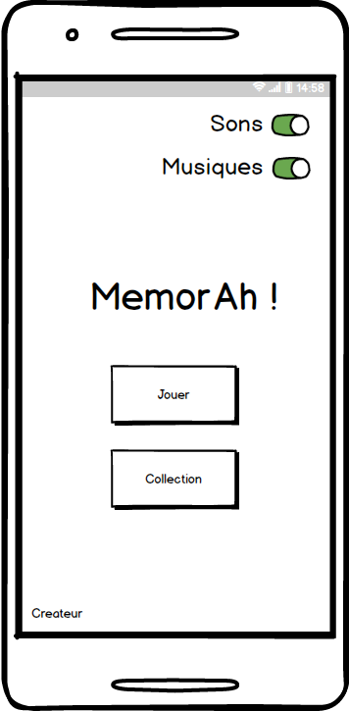

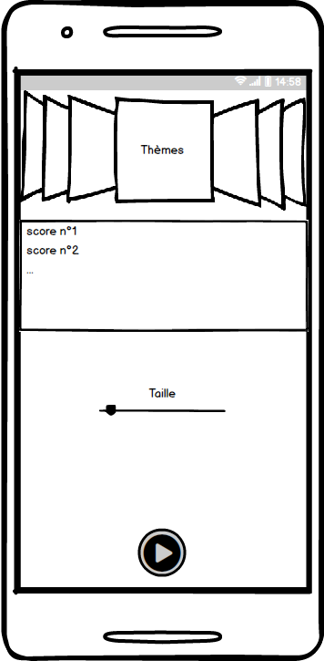

figure 1 : MenuActivity figure 2 : GameActivity

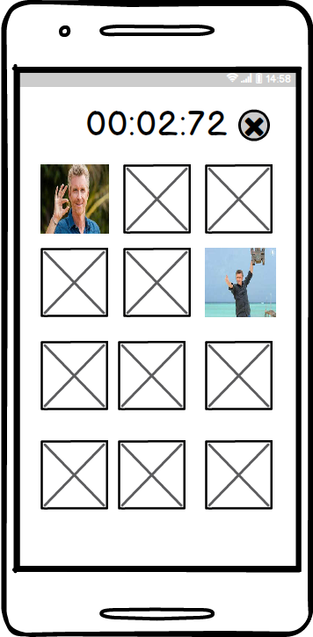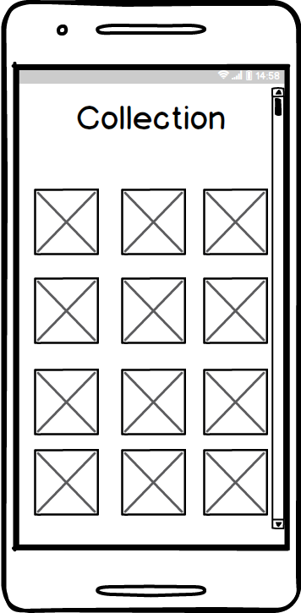

figure 3 : PlayActivity figure 4 : CollectionActivity

# Persona

|  |  |
| --- | --- |
|  | ***Identity***  **Name:** not important  **age:** 15 – 60  **Gender:** not important  **Job:** not important  **Informatic level:** low |
| ***Goals***  People who want to relax him, and pass a good time in a game | ***Characteristics***  People who are using smartphone, and downloading an app and playing memory game. |

# Users stories

* US 1: As a user, I want to enable/disable sound so that I won’t disturb anyone.
* US 2: As a user, I want to enable/disable music so that I won’t disturb anyone.
* US 3: As a user, I want to check my cards so that I can see which one I am missing.
* US 4: As a user, I want to choose level difficulty so that it will adjust to my abilities
* US 5: As a user, I want to check game time so that I can see my swiftness
* US 6: As a user, I want to check scoreboard so that I can compare my score to others/ my old scores.

# MVC architecture

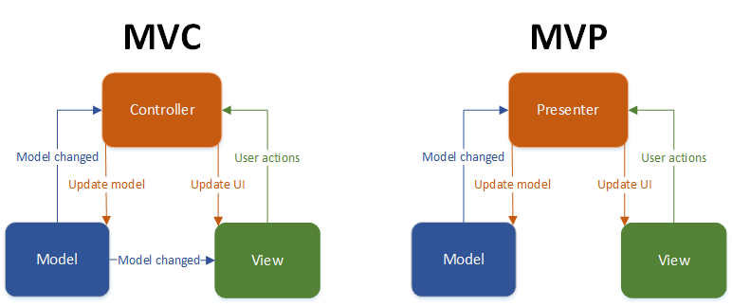

Model :

* Scores
* Cards
* Constants

View :

* 5 activity
  + MainActivity
  + MenuActivity
  + PlayActivity
  + GameActivity (Composed of fragment)
    - Level Fragment
    - Result Fragment
  + CollectionActivity

Controller:

* Adapters

Current state & evolution

We achieved all the user stories and specifications that were planned. We rightfully evaluated the time we had to achieve what we wanted. We would’ve liked to implement a bluetooth communication between two smartphone to exchange cards player collected.

In evolution, we could improve the idea of “world”, we would like to really differentiate world by using design or game mechanics. Also

Conclusion

The goal of this project was for us, to learn a new framework and architecture by making an android application while dealing with the creation of users interface.

We discovered the android studio IDE, android framework , make use of pre-existing android’s libraries

Florian Sebille:

As I never did android before, it was totally a new experience for me. I had to learn it from scratch, eventually I found it quite simple, you just have to take note of available libraries and functionalities. In fact you just have to put bricks of code together to bring up an application.

Thibault Brocherieux :

Developing this application was quite interesting even if we didn’t had much time to do it. I had already made Android application before but I learnt lots of new features / tricks for native Android. We used sound effect in our application as well as animation which I’ve never done before. I enjoyed doing it even if I would have liked to go further.

Annexes

