Compte-rendu TD2

Brocherieux Thibault  
Sebille Florian

GitHub: <https://github.com/FlorianSebille/jeuxDesPaires_M1Embarquees>

## Sketch

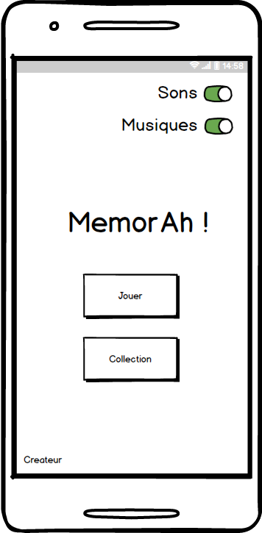

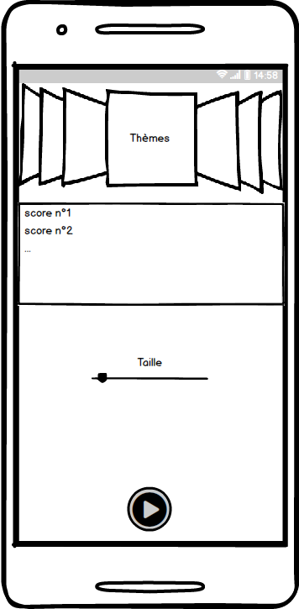

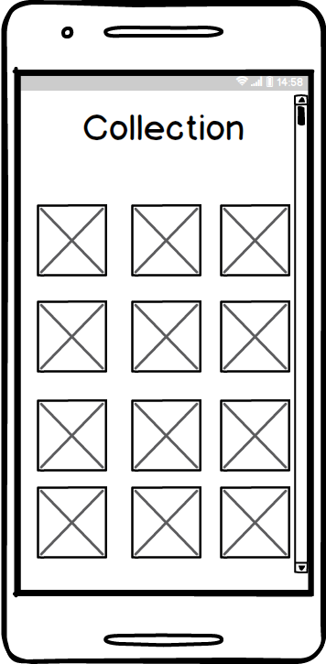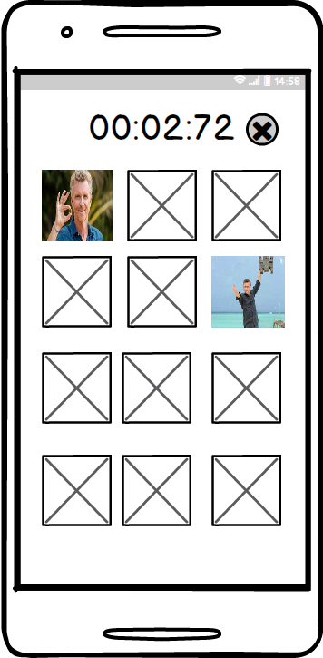

# Persona

|  |  |
| --- | --- |
|  | ***Identity***  **Name:** not important  **age:** 15 – 60  **Gender:** not important  **Job:** not important  **Informatic level:** low |
| ***Goals***  People who want to relax him, and pass a good time in a game | ***Characteristics***  People who are using smartphone, and downloading an app and playing memory game. |

# Users stories

* US 1: As a user, I want to enable/disable sound so that I won’t disturb anyone.
* US 2: As a user, I want to enable/disable music so that I won’t disturb anyone.
* US 3: As a user, I want to check my cards so that I can see which one I am missing.
* US 4: As a user, I want to choose level difficulty so that it will adjust to my abilities
* US 5: As a user, I want to check game time so that I can see my swiftness
* US 6: As a user, I want to check scoreboard so that I can compare my score to others/ my old scores.

# Model MVC

Modèle :

Score utilisateur.

Vue :

Layouts utilisés par Android

Contrôleur :

Toutes nos activitées et nos fragments.

(MainActivity, MenuActivity, PlayActivity, GameActivity)