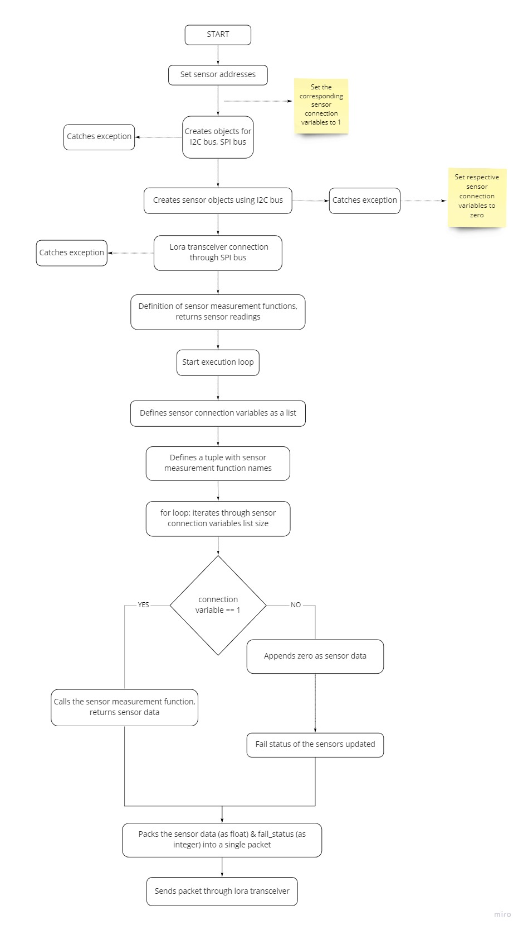

Not necessarily with the I²C Bus

Also catches exception, if sensor is disconnected. Connects Sensor back, i.e. updates Sensor status if reconnected