**Language**: CSS

**what is it about?** keywords & key information

**Focus**: Vocabulary & Translation

**expected outcome**: understand how to use this tool (check with the quiz)!

CSS is the language used to style a Web page.

What is CSS?

* CSS stands for Cascading Style Sheets
* CSS describes how HTML elements are to be displayed on screen, paper, or in other media
* CSS saves a lot of work. It can control the layout of multiple web pages all at once
* External stylesheets are stored in CSS files

CSS Demo - One HTML Page - Multiple Styles!

Here we will show one HTML page displayed with four different stylesheets. Click on the "Stylesheet 1", "Stylesheet 2", "Stylesheet 3", "Stylesheet 4" links below to see the different styles:

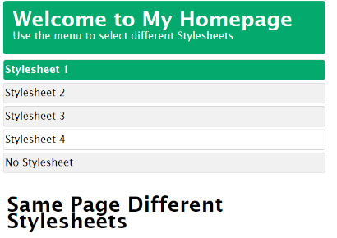 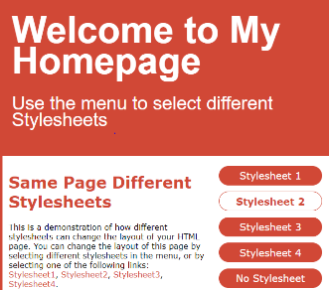 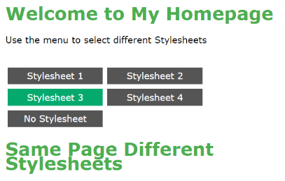

Why Use CSS?

CSS is used to define styles for your web pages, including the design, layout and variations in display for different devices and screen sizes.

CSS Solved a Big Problem

HTML was NEVER intended to contain tags for formatting a web page!

HTML was created to describe the content of a web page, like:

<h1>This is a heading</h1> <p>This is a paragraph.</p>

When tags like <font>, and color attributes were added to the HTML 3.2 specification, it started to be a nightmare for web developers. Development of large websites, where fonts and color information were added to every single page, became a long and expensive process.

To solve this problem, the World Wide Web Consortium (W3C) created CSS.

CSS removed the style formatting from the HTML page!

CSS Saves a Lot of Work!

The style definitions are normally saved in external .css files.

With an external stylesheet file, you can change the look of an entire website by changing just one file!

CSS Syntax

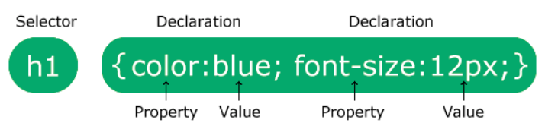

The selector points to the HTML element you want to style.

The declaration block contains one or more declarations separated by semicolons.

Each declaration includes a CSS property name and a value, separated by a colon.

Multiple CSS declarations are separated with semicolons, and declaration blocks are surrounded by curly braces.

p {  
   color: red;  
   text-align: center;  
}

**Example Explained**

* p is a selector in CSS (it points to the HTML element you want to style: <p>).
* color is a property, and red is the property value
* text-align is a property, and center is the property value

CSS Selectors

CSS selectors are used to "find" (or select) the HTML elements you want to style.

We can divide CSS selectors into five categories:

* Simple selectors (select elements based on name, id, class)
* [Combinator selectors](https://www.w3schools.com/css/css_combinators.asp) (select elements based on a specific relationship between them)
* [Pseudo-class selectors](https://www.w3schools.com/css/css_pseudo_classes.asp) (select elements based on a certain state)
* [Pseudo-elements selectors](https://www.w3schools.com/css/css_pseudo_elements.asp) (select and style a part of an element)
* [Attribute selectors](https://www.w3schools.com/css/css_attribute_selectors.asp) (select elements based on an attribute or attribute value)

**The element selector** selects HTML elements based on the element name.

**The id selector** uses the id attribute of an HTML element to select a specific element.

**The id of an element** is unique within a page, so the id selector is used to select one unique element!

To select an element with a specific id, write a hash (#) character, followed by the id of the element.

**The class selector** selects HTML elements with a specific class attribute.

To select elements with a specific class, write a period (.) character, followed by the class name.

HTML elements can also refer to more than one class.

**Note:** A class name cannot start with a number!

**The universal selector** (*) selects all HTML elements on the page.

**The grouping selector** selects all the HTML elements with the same style definitions.

It will be better to group the selectors, to minimize the code.

To group selectors, separate each selector with a comma.

How To Add CSS

When a browser reads a style sheet, it will format the HTML document according to the information in the style sheet.

Three Ways to Insert CSS

There are three ways of inserting a style sheet:

* External CSS
* Internal CSS
* Inline CSS

With **an external style sheet**, you can change the look of an entire website by changing just one file!

Each HTML page must include a reference to the external style sheet file inside the <link> element, inside the head section.

<!DOCTYPE html>  
<html>  
<head>  
<link rel="stylesheet" href="mystyle.css">  
</head>  
<body>  
  
<h1>This is a heading</h1>  
<p>This is a paragraph.</p>  
  
</body>  
</html>

**An external style sheet** can be written in any text editor, and must be saved with a .css extension.

The external .css file should not contain any HTML tags.

Here is how the "mystyle.css" file looks:

body {  
  background-color: lightblue;  
}  
  
h1 {  
  color: navy;  
  margin-left: 20px;  
}

**Note:** Do not add a space between the property value and the unit:  
Incorrect (space): margin-left: 20 px;  
Correct (nospace): margin-left: 20px;

**An internal style sheet** may be used if one single HTML page has a unique style.

The internal style is defined inside the <style> element, inside the head section.

**An inline style** may be used to apply a unique style for a single element.

To use inline styles, add the style attribute to the relevant element. The style attribute can contain any CSS property.

**Tip:** An inline style loses many of the advantages of a style sheet (by mixing content with presentation). Use this method sparingly.

Cascading Order

What style will be used when there is more than one style specified for an HTML element?

All the styles in a page will "cascade" into a new "virtual" style sheet by the following rules, where number one has the highest priority:

1. Inline style (inside an HTML element)
2. External and internal style sheets (in the head section)
3. Browser default

So, an inline style has the highest priority, and will override external and internal styles and browser defaults.

CSS Comments

CSS comments are not displayed in the browser, but they can help document your source code.

Comments are used to explain the code, and may help when you edit the source code at a later date.

Comments are ignored by browsers.

A CSS comment is placed inside the <style> element, and starts with /* and ends with */:

/* This is a single-line comment */  
p {  
  color: red;  
}

You can add comments wherever you want in the code. Comments can also span multiple lines.

HTML **Colors,** Color Names, Background Color, Text Color, Border Color

Colors are specified using predefined color names, or RGB, HEX, HSL, RGBA, HSLA values. In CSS, a color can be specified by using a predefined color name. You can set the background color, the color of a text or a border for HTML elements.

**CSS Backgrounds,** CSS background-color, Other Elements

The CSS background properties are used to add background effects for elements.

* background-color
* background-image
* background-repeat
* background-attachment
* background-position
* background (shorthand property)
* The background-color property specifies the background color of an element.
* You can set the background color for any HTML elements:

**CSS Borders**

The CSS border properties allow you to specify the style, width, and color of an element's border.

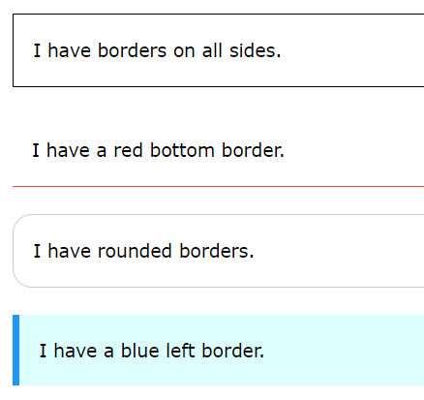

CSS Border Style

The border-style property specifies what kind of border to display.

The following values are allowed:

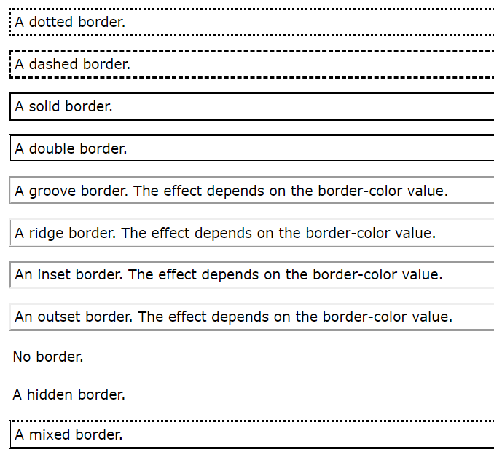

The border-style property can have from one to four values (for the top border, right border, bottom border, and the left border).

**Note:** None of the OTHER CSS border properties will have ANY effect unless the border-style property is set!

**CSS Border Width, Border Color**, Shorthand Property

The border-width property specifies the width of the four borders.

The width can be set as a specific size (in px, pt, cm, em, etc) or by using one of the three pre-defined values: thin, medium, or thick:

The border-color property is used to set the color of the four borders.

The color can be set by:

* name - specify a color name, like "red"
* HEX - specify a HEX value, like "#ff0000"
* RGB - specify a RGB value, like "rgb(255,0,0)"
* HSL - specify a HSL value, like "hsl(0, 100%, 50%)"
* transparent

**Note:** If border-color is not set, it inherits the color of the element.

There are many properties to consider when dealing with borders.

To shorten the code, it is also possible to specify all the individual border properties in one property.

The border property is a shorthand property for the following individual border properties:

* border-width
* border-style (required)
* border-color

CSS Icons

Icons can easily be added to your HTML page, by using an icon library.

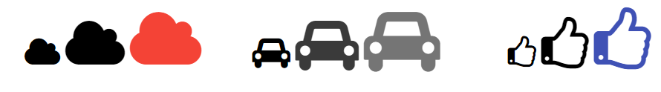

How To Add Icons

The simplest way to add an icon to your HTML page, is with an icon library, such as Font Awesome.

Add the name of the specified icon class to any inline HTML element (like <i> or <span>).

All the icons in the icon libraries below, are scalable vectors that can be customized with CSS (size, color, shadow, etc.)

Font Awesome Icons

To use the Font Awesome icons, go to [fontawesome.com](https://fontawesome.com/), sign in, and get a code to add in the <head> section of your HTML page:

<script src="https://kit.fontawesome.com/*yourcode*.js" crossorigin="anonymous"></script>

Read more about how to get started with Font Awesome in our [Font Awesome 5 tutorial](https://www.w3schools.com/icons/fontawesome5_intro.asp).

**Note:** No downloading or installation is required!

Bootstrap Icons

To use the Bootstrap glyphicons, add the following line inside the <head> section of your HTML page:

<link rel="stylesheet" href="https://maxcdn.bootstrapcdn.com/bootstrap/3.3.7/css/bootstrap.min.css">

**Note:** No downloading or installation is required!

Google Icons

To use the Google icons, add the following line inside the <head> section of your HTML page:

<link rel="stylesheet" href="https://fonts.googleapis.com/icon?family=Material+Icons">

**Note:** No downloading or installation is required!

CSS Links

Links can be styled with any CSS property (e.g. color, font-family, background, etc.).

In addition, links can be styled differently depending on what **state** they are in.

The four links states are:

* a:link - a normal, unvisited link
* a:visited - a link the user has visited
* a:hover - a link when the user mouses over it
* a:active - a link the moment it is clicked

When setting the style for several link states, there are some order rules:

* a:hover MUST come after a:link and a:visited
* a:active MUST come after a:hover

Text Decoration

The text-decoration property is mostly used to remove underlines from links.

CSS Lists

|  |  |
| --- | --- |
| **Unordered Lists**:   * Coffee * Tea * Coca Cola * Coffee * Tea * Coca Cola | **Ordered Lists**:   1. Coffee 2. Tea 3. Coca Cola 4. Coffee 5. Tea 6. Coca Cola |

HTML Lists and CSS List Properties

In HTML, there are two main types of lists:

* unordered lists (<ul>) - the list items are marked with bullets
* ordered lists (<ol>) - the list items are marked with numbers or letters

The CSS list properties allow you to:

* Set different list item markers for ordered lists
* Set different list item markers for unordered lists
* Set an image as the list item marker
* Add background colors to lists and list items

Different List Item Markers

The list-style-type property specifies the type of list item marker.

Remove Default Settings

The list-style-type:none property can also be used to remove the markers/bullets. Note that the list also has default margin and padding. To remove this, add margin:0 and padding:0 to <ul> or <ol>

CSS Tables

The look of an HTML table can be greatly improved with CSS.

To specify table borders in CSS, use the border property.

The example below specifies a solid border for <table>, <th>, and <td> elements:

|  |  |
| --- | --- |
| **Firstname** | **Lastname** |
| Peter | Griffin |
| Lois | Griffin |

Full-Width Table

The table above might seem small in some cases. If you need a table that should span the entire screen (full-width), add width: 100% to the <table> element:

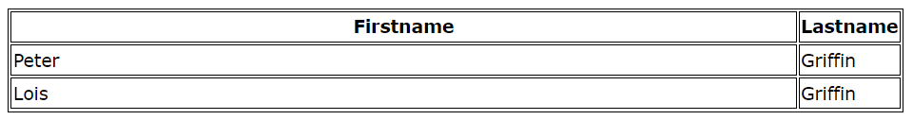

CSS Layout - The display Property

The display property is the most important CSS property for controlling layout.

The display property specifies if/how an element is displayed.

Every HTML element has a default display value depending on what type of element it is. The default display value for most elements is block or inline.

Override The Default Display Value

As mentioned, every element has a default display value. However, you can override this.

Changing an inline element to a block element, or vice versa, can be useful for making the page look a specific way, and still follow the web standards.

**Note:** Setting the display property of an element only changes **how the element is displayed**, NOT what kind of element it is. So, an inline element with display: block; is not allowed to have other block elements inside it.

Hide an Element - display:none or visibility:hidden?

Hiding an element can be done by setting the display property to none. The element will be hidden, and the page will be displayed as if the element is not there:

visibility:hidden; also hides an element.

However, the element will still take up the same space as before. The element will be hidden, but still affect the layout.

**Vocabulary search**

|  |  |  |  |
| --- | --- | --- | --- |
| **Nouns** |  | **Verbs** |  |
| Appareils | devices | Afficher | To display |
| L’apparence | The look | Ajouter | To add |
| Une bordure en pointillé | Dotter border | Améliorer | To improve |
| Un élément seul | A single element | Autoriser | To allow |
| L’élément concerné | The relevant element | Couvrir | To span |
| Un fichier | A file | Définir | To define |
|  |  | Se renseigner | To document |
| La mise en page | The layout | Economiser | To save |
| Un moyen | A way | Expliquer | To esplain |
| Les normes | The standards | Gérer / s’occuper de | To handle / to deal with |
| es règles | The rules | Modifier | To edit |
| Paramètres | settings | Passer outre / ignorer | To ignore |
| Un tiret | A dash / a hyphen | Personnaliser | To customize |
| Les valeurs par défaut du navigateur | Browser value | Réduire | reduce |
|  |  | Résoudre | To resolve |
|  |  | Requis | To required |
|  |  | Stocker | Store |
|  |  | Utiliser | To use |
|  |  | Télécharger | download |
|  |  |  |  |

|  |  |
| --- | --- |
| **Miscellaneous** |  |
| A l’intérieur de | Inside of |
| A moins que | Unless |
| Aucun | None |
| Cependant | However |
| ci-dessus | Above |
| ci-dessous | Below |
| Evolutif / extensible | Scalable |
| Par défaut | By default |
| Plusieurs | Several |
| Principal | Main |
| Selon | According to |
| Tel que | Such as |
| Utile | Useful |



Now this is your go! Test your knowledge with the quiz!