## How do you read?

1. **Date?**
2. **Time?**
3. **Exercises: write the numbers**Haut du formulaireBas du formulaire

|  |  |  |
| --- | --- | --- |
| 0 | 130,401 | one hundred and thirty thousand, four hundred and one |
| 1 | 504,215 | five hundred and four thousand, two hundred and fifteen |
| 2 | 865,376 | eight hundred and sixty-five thousand, three hundred and seventy-six |
| 3 | 600,100 | six hundred thousand, one hundred |
| 4 | 726,800 | seven hundred and twenty-six thousand, eight hundred |
| 5 | 220,007 | two hundred and twenty thousand and seven |
| 6 | 900,120 | nine hundred thousand, one hundred and twenty |
| 7 | 410,018 | four hundred and ten thousand and eighteen |
| 8 | 313,040 | three hundred and thirteen thousand and forty |
| 9 | 1,230,642 | one million, two hundred and thirty thousand, six hundred and forty-two |
| 10 | 22,345,930 | twenty-two million, three hundred and forty-five thousand, nine hundred and thirty |

1. **NOW, Your GO :**
2. **listen and write**
3. **https://agendaweb.org/exercises/vocabulary/numbers/numbers-big-write**

|  |  |
| --- | --- |
| 1 | 1,000 |
| 2 | 4,720 |
| 3 | 5,005 |
| 4 | 17,400 |
| 5 | 20,137 |
| 6 | 36,845 |
| 7 | 78,017 |
| 8 | 240,872 |
| 9 | 800,000 |
| 10 | 905,606 |
| 11 | 1,200,000 |
| 12 | 3,455,722 |

**NOW, Your GO :**

Complete the following table with the dates & times using the link: <https://www.youtube.com/watch?v=RPu-z7WBBBc>

|  |  |
| --- | --- |
| 1 |  |
| 2 |  |
| 3 |  |
| 4 |  |
| 5 |  |
| 6 |  |
| 7 |  |
| 8 |  |
| 9 |  |
| 10 |  |

|  |  |
| --- | --- |
| 1 | 2.30 pm Saturday 1st March 2001 |
| 2 | 12.15 pm Monday 31st October 1972 |
| 3 | Thursday 23rd April 1997 |
| 4 | Quarter past 3 in the afternoon |
| 5 | Sunday 13th June 2016 |
| 6 | January 1902 |
| 7 | Friday 25t November 2016 |
| 8 | 1.10 am Saturday 7th August 2009 |
| 9 | 7.30 pm Wednesday 21st May 2013 |
| 10 | 19.00 Saturday 2nd February 2011 |

Work with a mate & exchange INFORMATION!

Product Name: ____________________________________________

Brand name: ____________________________________________

Model number: ____________________________________________

Year of release: ____________________________________________

Processor model Number: ____________________________________________

Processor speed: ____________________________________________

Storage type: ____________________________________________

Total storage capacity: ____________________________________________

Total state drive capacity: ____________________________________________

System memory: ____________________________________________

System memory RAM expandable to: ____________________________________________

Graphics: NVIDIA Geforce ____________________________________________

Video memory: ____________________________________________

Operating system: ____________________________________________

Product Height: ____________________________________________

Product Width: ____________________________________________

Product Weight: ____________________________________________

Free Geek tech support available ____________________________________________

Free delivery and standard installation

Protect your computer with a 1-Year Accidental Geek Squad Protection of _____________, about ___________ / month

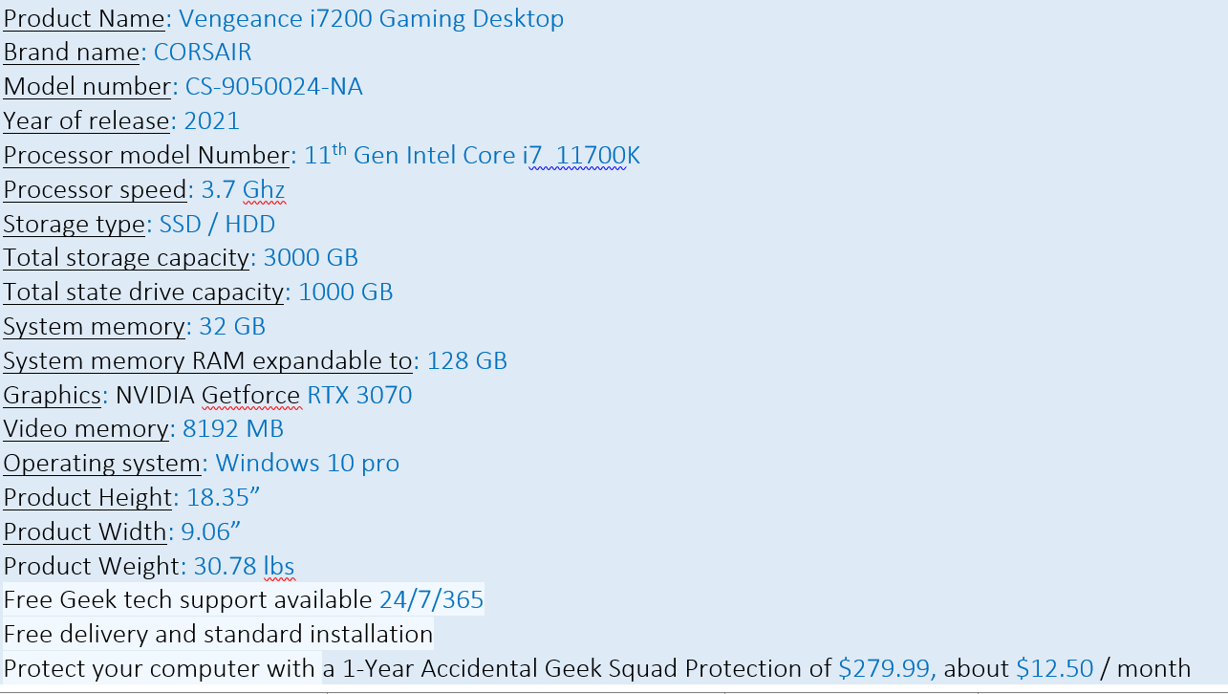

***Numbers Trivia (kahoot)***