Table des matières

1/ Install de jenkins 1

2/ Install de Gitlab 1

# Installation de jenkins

Accès à la documentation en ligne : https://www.jenkins.io/doc/book/installing/linux/

Après installation de la VM, l’installation de wget, suivi du process

sudo wget -O /etc/yum.repos.d/jenkins.repo \

https://pkg.jenkins.io/redhat-stable/jenkins.repo

sudo rpm --import https://pkg.jenkins.io/redhat-stable/jenkins.io.key

sudo yum upgrade

sudo yum install jenkins java-1.8.0-openjdk-devel

sudo systemctl daemon-reload

Le resultat

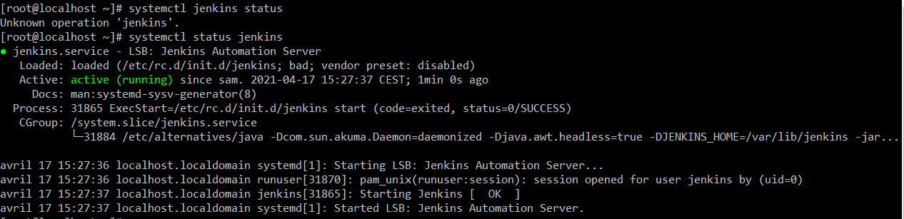

Puis ouvrir les port dans le firewall

YOURPORT=8080

PERM="--permanent"

SERV="$PERM --service=jenkins"

firewall-cmd $PERM --new-service=jenkins

firewall-cmd $SERV --set-short="Jenkins ports"

firewall-cmd $SERV --set-description="Jenkins port exceptions"

firewall-cmd $SERV --add-port=$YOURPORT/tcp

firewall-cmd $PERM --add-service=jenkins

firewall-cmd --zone=public --add-service=http --permanent

firewall-cmd --reload

# Deployement du serveur applicatif

# Install de Gitlab

## Installation des dépendances

sudo yum install curl policycoreutils-python openssh-server

sudo yum install postfix

sudo systemctl start postfixsudo

systemctl enable postfix

## Installation des dépendances

curl https://packages.gitlab.com/install/repositories/gitlab/gitlab-ce/script.rpm.sh | sudo bash

sudo yum install gitlab-ce

sudo firewall-cmd --permanent --zone=public --add-service=http

sudo firewall-cmd --permanent --zone=public --add-service=https

sudo firewall-cmd --reload

sudo vim /etc/gitlab/gitlab.rb

external_url 'https://gitlab.example.com'

letsencrypt['enable'] = true

letsencrypt['contact_emails'] = ['admin@example.com']

sudo gitlab-ctl reconfigure

<https://your_gitlab_domain_or_server_IP.com>

# Installation du registry

Git clone <https://github.com/SUSE/Portus.git>

Docker-compose up

http://<docker host>:3000