Geosciences/Apporto User Guide

Browser
In order to use Apporto, all you need is a browser and a reasonably fast internet connection.
Google Chrome is the recommended browser for Apporto. You may download the latest version of Chrome here: www.google.com/chrome

Internet Connection
A reliable internet connection is important for optimal performance in Apporto.
If you have a poor network connection, you may notice slowness or a lag in response and images may appear pixelated. If your network connection is interrupted you may even lose unsaved work.
The quality of your network connection has two parts: bandwidth and latency. Bandwidth is typically not an issue for Apporto. Latency is the more important factor. Latency of < 100 ms is ideal for good performance in Apporto.
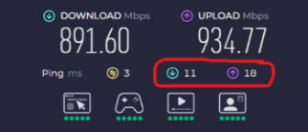
To test your bandwidth and latency, you may use www.speedtest.net. Latency upload and download numbers can be found in the circled area of the result as shown below.

Login to Apporto
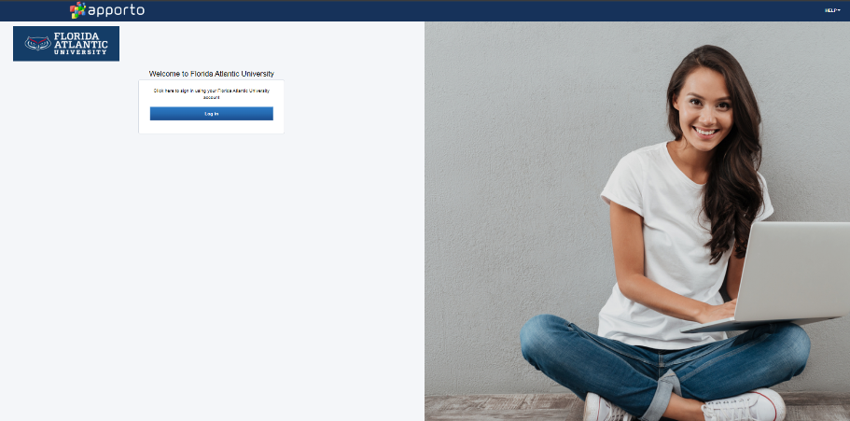
Logging in with Single Sign-on (SSO) is the most common way to login to Apporto. Using your preferred web browser, navigate to the web address https://fau.apporto.com

Click Log In to access your university Login page. Enter your Single Sign-On (SSO) username and password. Authenticate through DUO. The App Store displays.
Navigating the App Store

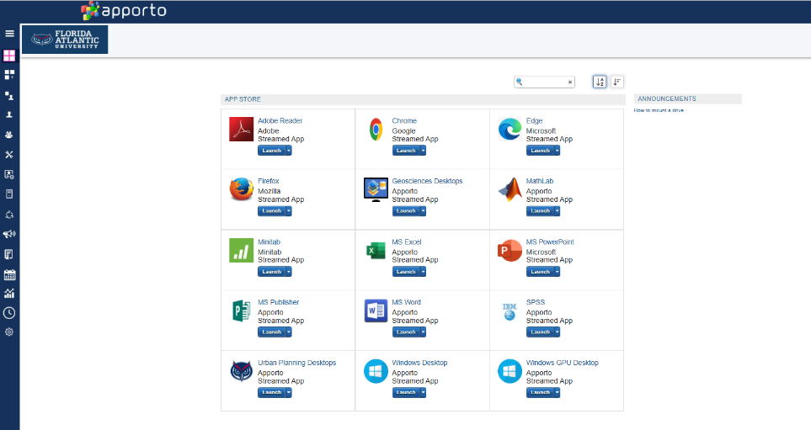
The App Store is where you can access all of the applications and desktops available to you via Apporto. For each application or desktop, you will see the name of the application and Launch button.

Select your App or Desktop
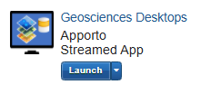
Locate the desired app or desktop and click Launch
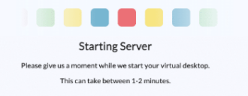
You will see a “Starting Server” message.
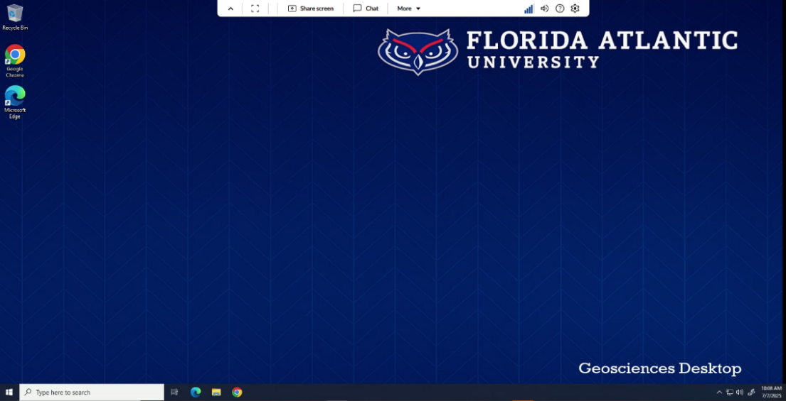
The selected app or desktop opens in a new browser tab.

Use Apps and Desktops
The Menu
Available menu options are displayed as icons (buttons) in the top menu bar. Hover your mouse over an icon to see tooltip text explaining what the menu option is.

Click the up arrow ^ to hide the menu bar. Click the down arrow to unhide the menu bar.
Change Display Mode
Click the  icon in the top menu bar to toggle the display to full-screen mode.
Press and hold the <Esc> key to return the display to normal mode. In full screen mode, the menu bar is hidden to maximize screen real estate. Click on the down arrow to access the menu.
Use Multiple Monitors
To use multiple monitors, click the More menu option and select Second Monitor 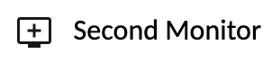 to open a second browser tab. Drag the tab to another monitor and resize as needed. The desktop view will span both tabs/monitors. Then, you can drag applications to either monitor. You may use up to three monitors.

Turn Sound On/Off
Click the Sound  button to turn sound on. Click again  to turn sound off. By default, sound is turned off.

Network Indicator
View the Network Indicator  to gauge the strength of your network connection. The number of bars depends on network latency (the amount of time in milliseconds for response from the server).
Settings
Click the Settings  menu to access screen scaling, resolution, , microphone and clipboard options. By default the Apporto cloud desktop will match the scale of your local device.
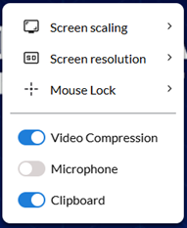

If you want desktop images and text to appear larger, you may increase the scale up to 50%. Increasing the scale may reduce system responsiveness though, since more data is transferred from the cloud to your browser.
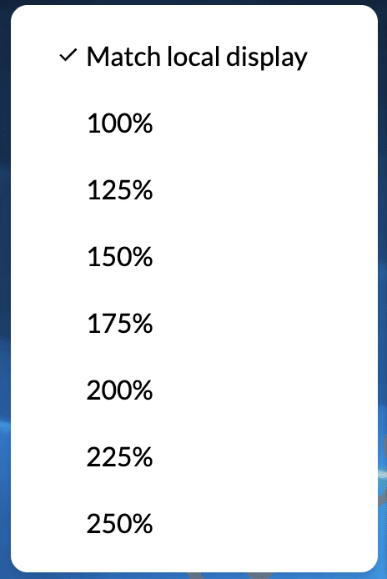

By default, the Apporto desktop displays at a high resolution for optimal image quality. The resolution is dynamically adjusted when you change your browser size (for example by toggling to full screen mode).

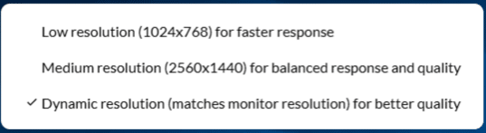

If you are using a high-resolution monitor that is impacting app performance, you may opt for the medium resolution. And if you have a poor network connection, you may want to use the low resolution (1024 x 768) setting. This option will ensure a faster system responsiveness, since less data is transferred from the cloud to your browser.

Enabling the microphone  (in your browser and device settings) enables you to use voice features in the Apporto desktop like making calls via Messenger.
Enabling the clipboard  in your browser settings enables you to copy and paste text and images to and from your local device to the Apporto cloud desktop.

Help
Click the Help  menu to access the Apporto User Guide, the Support Request form, and version information About Apporto.
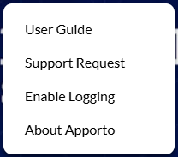

File Storage

In our remote learning environment (Apporto), students can store their work in several ways. While all options ultimately rely on centralized storage infrastructure, they behave differently in terms of performance, flexibility, and purpose. Below is a breakdown of the three main options, including when to use each one.

📁 Option A: User Profile (FSLogix)
Best for: Daily GIS use, personal settings, lightweight projects
How it works: When the student logs into a Geosciences desktop, a user profile is created mounted automatically.
✅ Advantages:
- Seamless access at login
- Consistent experience across sessions throughout the semester
- Integrated with ArcGIS and most other applications default save locations
❌ Disadvantages:
- Not suitable for large GIS datasets or spatial files
- Data is stored inside a container not easily restored if deleted or corrupted
- Can slow login times if profile grows too large
- Profiles may be reset, and data stored in them deleted, at any time during the semester.

🗂️ Option B: Mapped Network Drive
Best for: Large GIS files, course assignment submissions
How it works: Students access a shared folder on our server via a mapped network drive (e.g., G:\MyCourses and T:\TempWork).
✅ Advantages:
- Supports large datasets (e.g., rasters, shapefiles, geodatabases)
- Files are stored outside the profile, making them easier to manage and back up.
❌ Disadvantages:
- Students must remember to use it intentionally
- Data stored on mapped drives are deleted after 180 days.

☁️ Option C: Microsoft OneDrive (Cloud Storage)
Best for: Non-GIS academic work — Word, Excel, PowerPoint, PDFs, notes
How it works: Each student has access to their OneDrive account through FAU ‘s Microsoft 365 license).
✅ Advantages:
- Ideal for small to medium-sized academic files
- Cloud-based: accessible from anywhere, any device
- Integrated directly into Office apps for autosave and sharing
- Secure back up files saved in user profiles and/or mapped drives
❌ Disadvantages:
- Not suitable for large GIS datasets or spatial files

💡 Summary: When to Use Each

Task / File Type | Recommended Storage
ArcGIS, large raster or spatial data (to be submitted for grading by course instructor) | G:\MyCourses (mapped drive)
ArcGIS, large raster or spatial data (not submitted for grading by course instructor) | T:\TempWork (mapped drive)
Personal coursework files (small projects) | Documents, Desktop, Downloads, etc. (FSLogix User Profile)
Word, Excel, PowerPoint, PDFs | OneDrive
Backing up files across platforms | OneDrive

