Hummer movement controlled via NODE MCU WebServer

# 1.Introduction

"Hummer” is a multifunctional car based on the Arduino UNO , L298N motor and ESP8266 WiFi . Compared with the traditional car, this is also equipped with wireless control.

I used the Arduino uno r3 as the main control board, which has 14 digital input/output pins (6 of which can be used as PWM output), 6 analog inputs, and a 16 MHz ceramic resonator, 1 USB connection, 1 power socket, 1 ICSP head and 1 reset button. It contains everything that supports the microcontroller; You just need to connect it to a computer via a USB cable or start with an AC-DC adapter or battery.

# 2.State of the Art

Digilent design contest 2019 3-rd prize winners – Zybo Autonomous Car

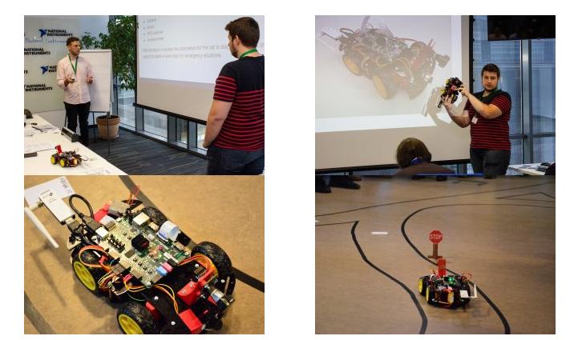

# 3.Design

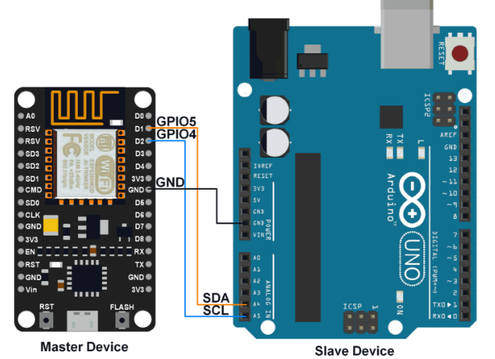

# 4.Implementation

# 5.Testing

# 6.Refferences

1.Keywish open source project

2.Digilent contest

3.circuits4you.com

4.forum.arduino.cc