Versions:

Date | Versiune | Autor | Comentarii

Analisys&Design for <Project_Name>

Continut:
- General Presentation

- Theoretical Fundamentals

- IT Technology (which will be implemented)

- Functionalities

- Actors and related access rights

- Use Case Diagrams

- System Architecture

- Design (UML Diagrams)

- Operation Mode (Operation Guide, including screen-shots)

- Portability

1. General Presentation

There are situations when the owner has a certain number of servers which are maintained by employees and he can not be always physically present to check their activities. A person who works in IT assistance might need remote control of the computers in which the troubleshooting is performed. Other situations can be colaboration, online meetings and conferencing between the employees within a company. In order to solve these problems this project aims to offer the possibility for the administrator to have full access to his remote servers. Therefore he gains full capability to supervise the activity of his employees and he can also take control when is needed. Whenever a technical issue arises, the maintenance of the servers is assured by the person in charge using RAT.
Outside of the industry this application can be also used for personal needs.

- Theoretical Fundamentals

-THREADS:
A multi-threaded program contains two or more parts that can run concurrently and each part can handle a different task at the same time making optimal use of the available resources specially when your computer has multiple CPUs.
By definition, multitasking is when multiple processes share common processing resources such as a CPU. Multi-threading enables you to write in a way where multiple activities can proceed concurrently in the same program.
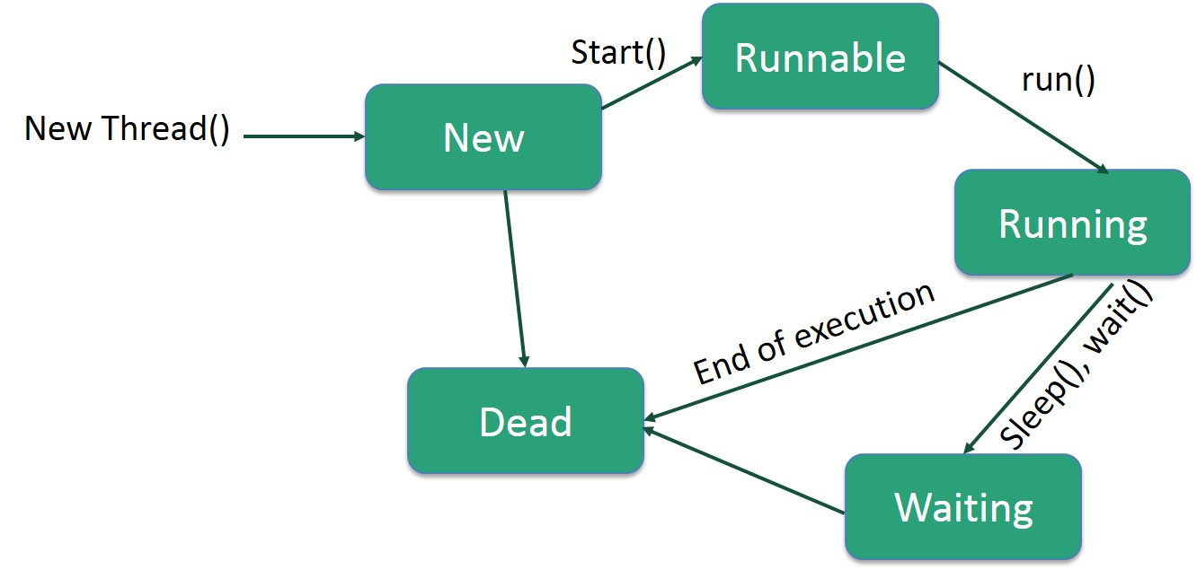
-SOCKETS :
A socket is one end-point of a two-way communication link between two programs running on the network. Socket classes are used to represent the connection between a client program and a server program. The java.net package provides two classes--Socket and ServerSocket--that implement the client side of the connection and the server side of the connection, respectively.
- Open a socket.
- Open an input stream and output stream to the socket.
- Read from and write to the stream according to the server's protocol.
- Close the streams.
- Close the socket.
Only step 3 differs from client to client, depending on the server. The other steps remain largely the same.
The java.net package provides support for the two common network protocols −
- TCP − TCP stands for Transmission Control Protocol, which allows for reliable communication between two applications. TCP is typically used over the Internet Protocol, which is referred to as TCP/IP.
- UDP − UDP stands for User Datagram Protocol, a connection-less protocol that allows for packets of data to be transmitted between applications.
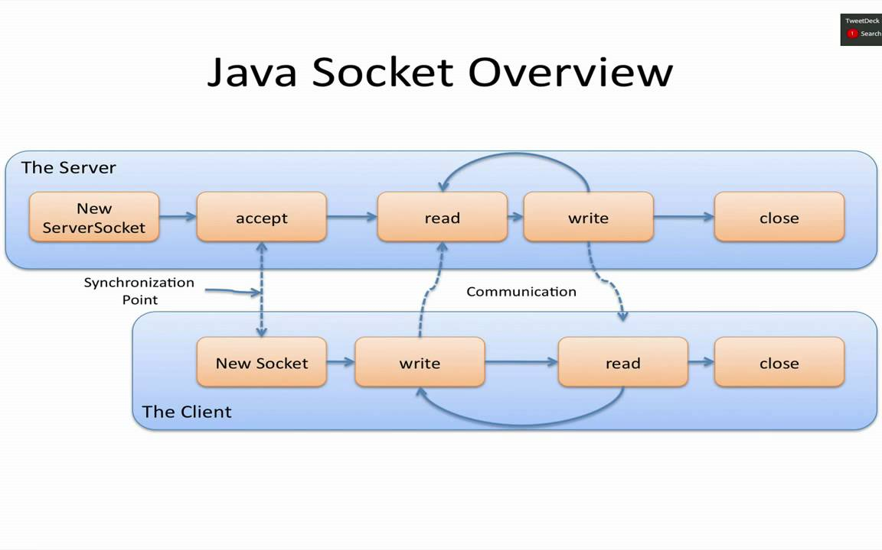
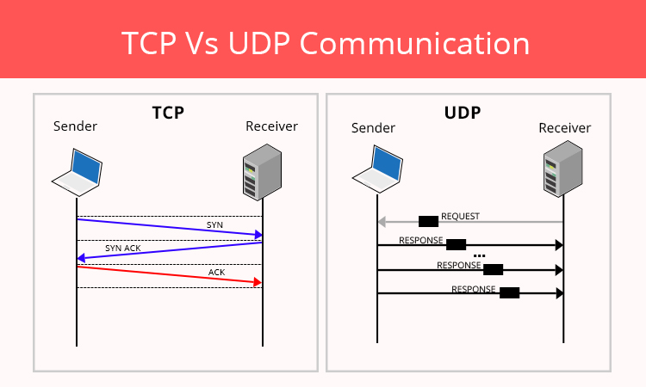
-CONCURRENT HASHMAP :
ConcurrentHashMap: It allows concurrent access to the map. Part of the map called Segment (internal data structure) is only getting locked while adding or updating the map. So ConcurrentHashMap allows concurrent threads to read the value without locking at all. This data structure was introduced to improve performance.
Concurrency-Level: Defines the number which is an estimated number of concurrently updating threads. The implementation performs internal sizing to try to accommodate this many threads.
Load-Factor: It's a threshold, used to control resizing.
Initial Capacity: The implementation performs internal sizing to accommodate these many elements.
A ConcurrentHashMap has internal final class called Segment so we can say that ConcurrentHashMap is internally divided in segments of size 32, so at max 32 threads can work at a time. It means each thread can work on a each segment during high concurrency and atmost 32 threads can operate at max which simply maintains 32 locks to guard each bucket of the ConcurrentHashMap.
-EXECUTORS :
The Concurrency API introduces the concept of an ExecutorService as a higher level replacement for working with threads directly. Executors are capable of running asynchronous tasks and typically manage a pool of threads, so we don't have to create new threads manually. All threads of the internal pool will be reused under the hood for revenant tasks, so we can run as many concurrent tasks as we want throughout the life-cycle of our application with a single executor service. The class Executors provides convenient factory methods for creating different kinds of executor services. In this sample we use an executor with a thread pool of size one. An ExecutorService provides two methods for that purpose: shutdown() waits for currently running tasks to finish while shutdownNow() interrupts all running tasks and shut the executor down immediately.
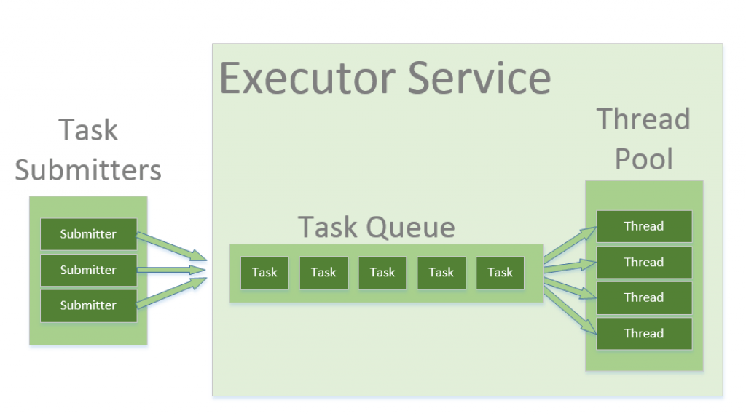

- IT Technology
-REMOTE ACCESS :
In computer networking, remote access technology allows a user to log in to a system as an authorized user without being physically present at its keyboard. Remote access is commonly used on corporate computer networks but can also be used on home networks.

Remote Desktop
The most sophisticated form of remote access enables users on one computer to see and interact with the actual desktop user interface of another computer. Setting up remote desktop support involves configuring software on both the host (the local computer controlling the connection) and client/target (the remote computer being accessed). When connected, this software opens a window on the host computer containing a view of the client's desktop.

Remote Access to Files

Basic remote network access allows files to be read from and written to the client computer, even without remote desktop capability in place, though most remote desktop programs support both. Virtual Private Network technology provides remote login and file access functionality across wide area networks.

A VPN requires client software be present on host systems and VPN server technology installed on the target computer. As an alternative to VPNs, client/server software based on the secure shell SSH protocol can be also be used for remote file access. SSH provides a command line interface to the target system.

File sharing within a home or other local area network is generally not considered to be a remote access environment even though it's still technically remotely accessing the other device.

Is Remote Desktop Safe?
Programs that can remotely connect to your computer are usually safe, but like all things, there are definitely methods to use them maliciously. Some misuses of remote desktop tools might be to steal your information, delete files from your computer, install other programs without your knowledge, etc.
-USER CONFIRMATION
Request the end user's stamp of approval before initiating a remote session, and require technicians to provide a reason for connecting to employees' computers.

- Functionalities
Supervising functionalities :
-recording the mouse events
-capturing keyboard
-visualising server’s screen
-using the camera
Control functionalities :
-access file system (create files, delete files, write files)
-send command via Command Prompt
-running code
-using applications

- Actors and related access rights
The actors are the client and the servers, the client having full access rights over the servers when the authentification succedes.

- Use Case Diagrams

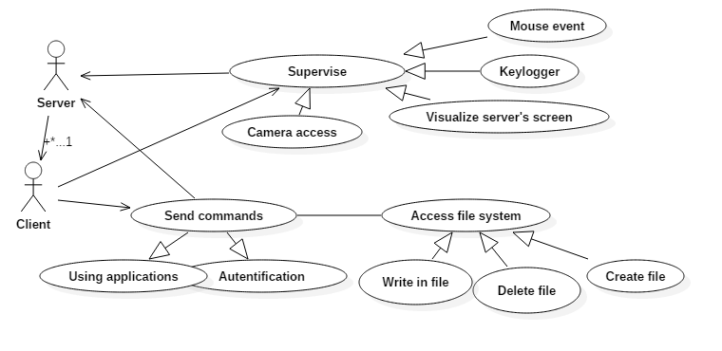

- General Architecture Diagram
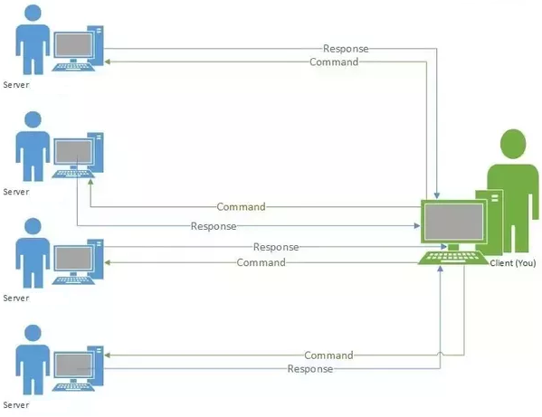

- Design (aprox 12 UML Diagrams!!!)
Flowchart diagram

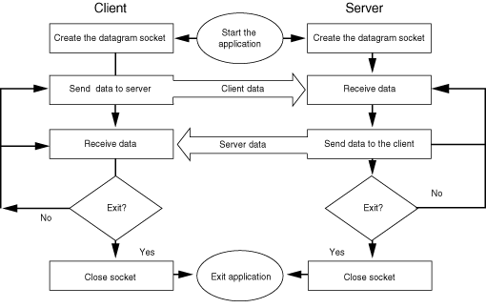

- Operation Mode (Interactivity presentation) + screen shots (UI design)

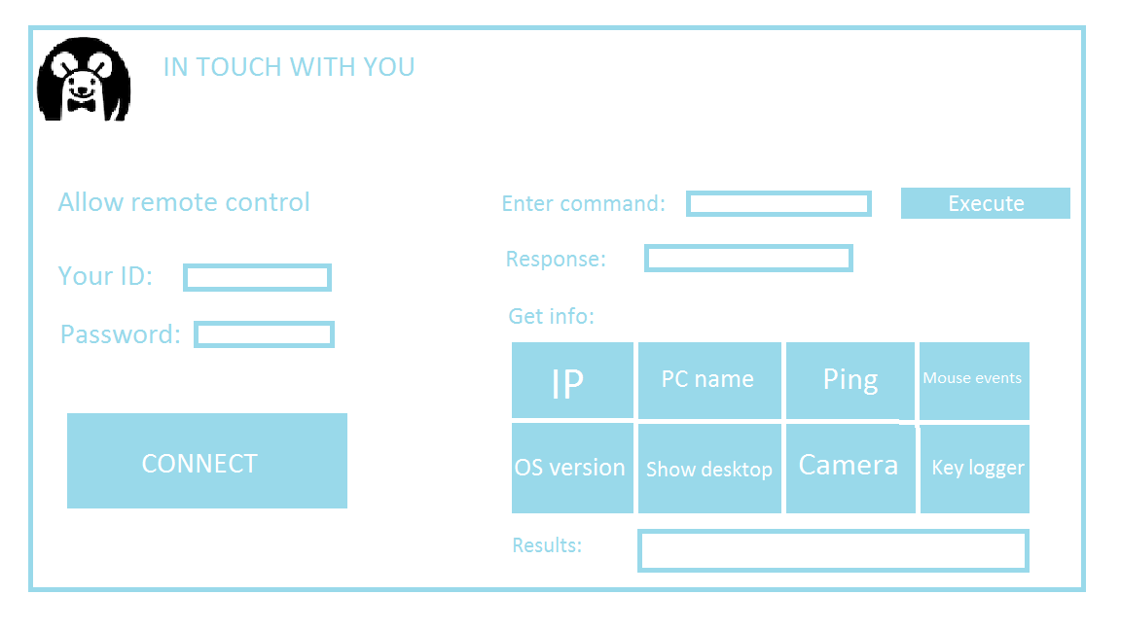
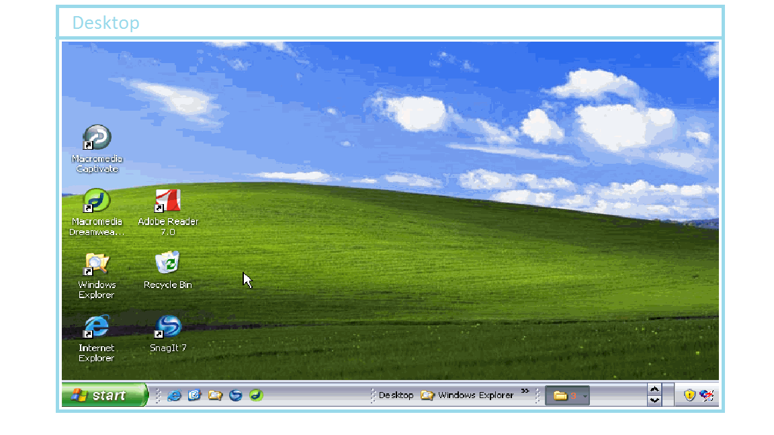

- Portability

The software is portable on all Windows machines as it was written in a portable programming language but, on the other hand is not portable on other operating systems such as Linux, Mac etc.

- Competing software

Team Viewer
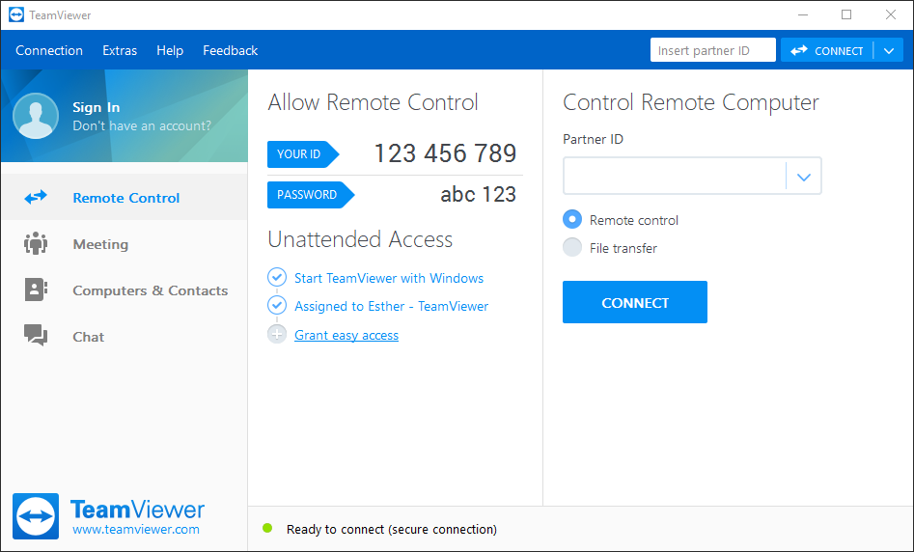

Team Viewer is a software that shares your system(laptop/Desktop) with other person in screen mirroring way.
So when you give your ID and Password of Team Viewer(TV), other person can access your machine, can see your display that you can see as well, when he moves the cursor(Mouse pointer), you can see your cursor moving on your display, he can do anything on your system and you can see that. When he transfer files, Team Viewer shows file transfer update as well, this is for safety purpose so anyone won't transfer/take virus or important information from your system.
The most important part is, as soon you close your TV, the connection get closed and other person won't be able to access your system until you start TV and give your password again. Note that the ID remains same always, but the password get changed every-time when you close a TV connection(Until you selected a static password, if so, you have chosen to keep the password same and so other person can log in back if you start your team viewer again.)

User manual

1.Firstly , in order to set a client in a remote systm firstly we need to create socket on a port and to find your local ip
IPv4 using : ipconfig on Win, isconfig on Ubuntu ,ip addr on Arch Linux : 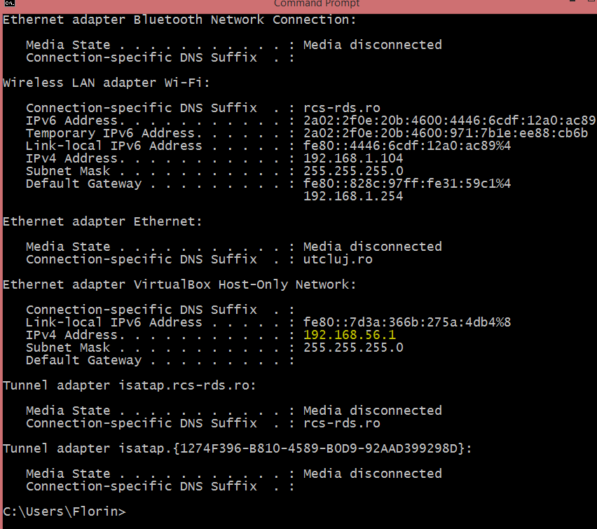

2.Open the application 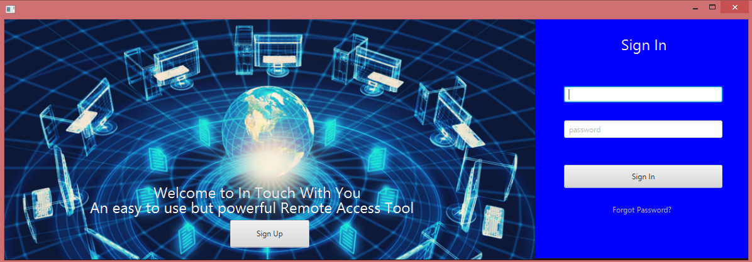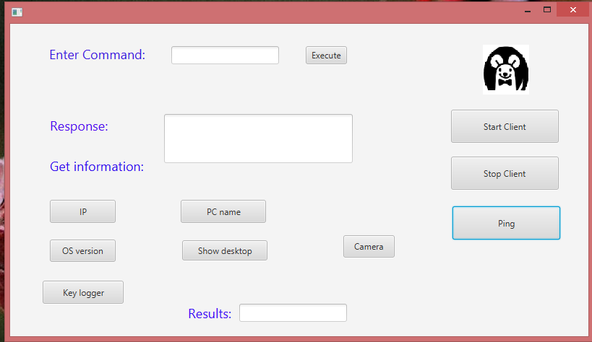

3.Compile a simple java test in which you will set a socket with the master’s system IP
And the desired :

Ex. private static final String IP = "192.168.56.1";
private static final int PORT = 3055;
Socket s = new Socket(IP,PORT);

