**How to Use this Template**

1. Create a new document, and copy and paste the text from this template into your new document [ Select All → Copy → Paste into new document ]
2. Name your document file: “**Capstone_Stage1**”

Replace the text in green

Description

Intended User

Features

User Interface Mocks

Screen 1

Screen 2

Screen 3

Screen 4

Screen 5

Key Considerations

How will your app handle data persistence?

Describe any corner cases in the UX.

Describe any libraries you’ll be using and share your reasoning for including them.

Describe how you will implement Google Play Services.

Next Steps: Required Tasks

Task 1: Project Setup

Task 2: Implement UI for Each Activity and Fragment

Task 3: FAB button actions

Task 4: Make widgets

# **GitHub Username**: FlorinBacu

# NewMovies

# Description

This is a app that show recent movie from moma.org

# Intended User

This is intented for showing latest movie for people

# Features

* Display articles
* Show details about article

# User Interface Mocks

## Screen 1

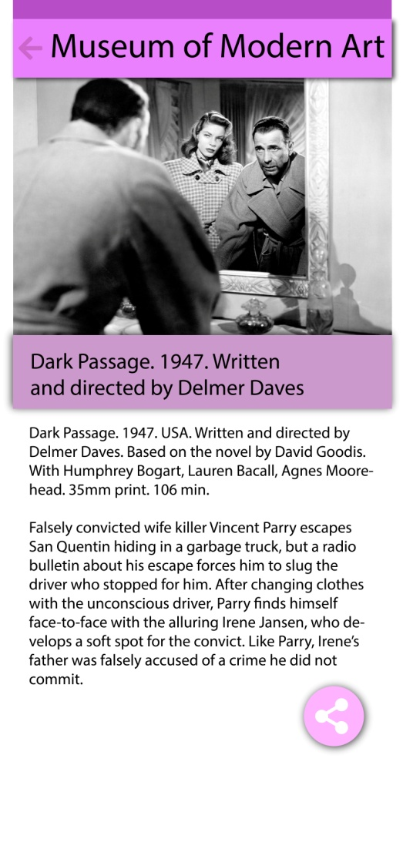

This is the detail on mobile app fab button is for sharing

## Screen 2

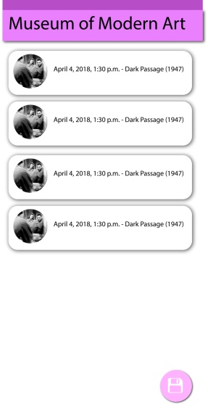

Fab button save list in database on mobile for offline loading

## Screen 3

## Table master.jpg

This is are master detail on tablet

## Screen 4

## main widget-01.jpg

This the widget for main activity

## Screen 5

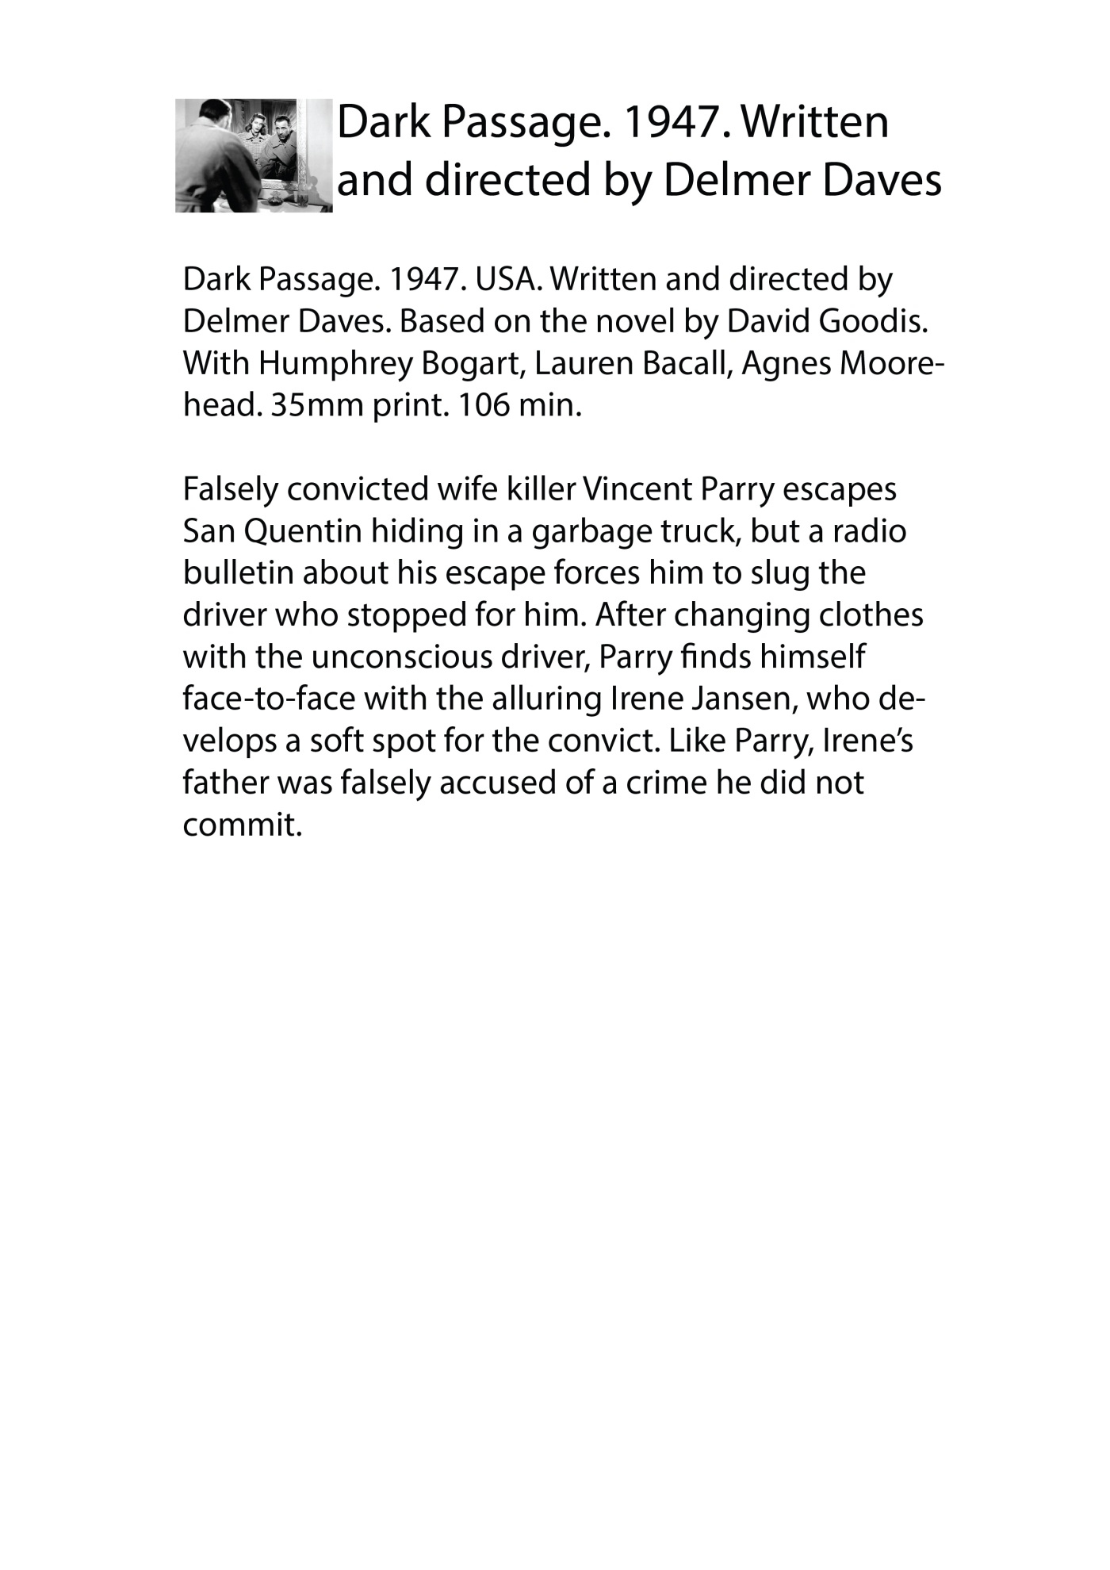

This is the widget for detail activity.

# Key Considerations

### How will your app handle data persistence?

A snapshot of data will be saved in database by using FAB button

The database is SQLite used by Content provider. From database the data will be loaded when the app is offline.Loader will be used for loading the data from web togheter with AsyncTask.

### Describe any edge or corner cases in the UX.

When we have problem with network we will display the toast message „No internet available” and if data are in database we load from there.

In case of offline if were no data in database we display the message „database is empty” else the message will be „data loaded from database”

### Describe any libraries you’ll be using and share your reasoning for including them.

Piccasso are used for simplifying loading images from internet

Butterkniff is used for avoid using findViewById method and write more closer the binding to natural language

Tinker is used for logging without using a static variable

### Describe how you will implement Google Play Services or other external services.

The xml feed is on link <https://www.moma.org/feeds/events_films_30_days.rss>

Using a XML parser

From google play services I used ads services to add ad in main activity.

The dependency that I will use for this is

**'com.google.android.gms:play-services-ads:12.0.1'**

Code for initializing ad is

MobileAds.*initialize*(**this**, **"ca-app-pub-3940256099942544~3347511713"**);  
**mAdView** = findViewById(R.id.***adView***);  
AdRequest adRequest = **new** AdRequest.Builder().build();  
**mAdView**.loadAd(adRequest);

On layout will be a element called

**com.google.android.gms.ads.AdView**

that have the id=”adView” for accessing it

Firebase are used for analitycs and send possible notification to users.

The dependency that I will use for this is

**'com.google.firebase:firebase-core:12.0.0'**

Together with file google-services.json and at the and of app gradle file I will put

apply **plugin**: **'com.google.gms.google-services'**

# Next Steps: Required Tasks

## Task 1: Project Setup

The project setup using a thread using async task loader to load data.

You may want to list the subtasks. For example:

* Configure libraries
* Load rss data via web

If it helps, imagine you are describing these tasks to a friend who wants to follow along and build this app with you.

## Task 2: Implement UI for Each Activity and Fragment

List the subtasks. For example:

* Build UI for MainActivity
* Build UI for Detail activity

## Task 3: FAB button actions

FAB Action on main activity have save button for saving data in database and other for sharing

## Task 4: Make widgets

In this app there are 2 widget one for the main activity and another for detail activity

* Make widget for main activity
* Make widget for detail activity

**Submission Instructions**

* After you’ve completed all the sections, download this document as a PDF [ File → Download as PDF ]
  + Make sure the PDF is named “**Capstone_Stage1.pdf**”
* Submit the PDF as a zip or in a GitHub project repo using the project submission portal

If using GitHub:

* Create a new GitHub repo for the capstone. Name it “**Capstone Project**”
* Add this document to your repo. Make sure it’s named “**Capstone_Stage1.pdf**”