Description and Comparison of the Three EMB Architectures
References:
[1] Peng, J.; Wu, T.; Chu, L.; Rong, J.; Yang, X.; Meng, Y. "Electro-Mechanical Brake System Architectural Design and Analysis Based on Functional Safety of Vehicles." Actuators 2024, 13, 346.
[2] Li, C.; Zhuo, G.; Tang, C.; Xiong, L.; Tian, W.; Qiao, L.; Cheng, Y.; Duan, Y. "A Review of Electro-Mechanical Brake (EMB) System: Structure, Control and Application." Sustainability 2023, 15, 4514.
[3] Ji, Q.; Zheng, L.; Bi, Y.; Pang, H. "Review of Brake-by-Wire Technology for Low-Speed and Autonomous Vehicles." World Electric Vehicle Journal 2024, 15, 581.
Why Redundancy Is Needed in EMB (Introductory Context)
Before describing the three architectures, it is useful to recall why the issue of redundancy is so crucial in Electro-Mechanical Brake (EMB) systems. Unlike Electro-Hydraulic Brake (EHB) systems—which retain a hydraulic circuit and can therefore stop the vehicle in certain cases even during a total electronic failure—EMB completely eliminates the hydraulic circuit: the brake pedal is no longer mechanically connected to the wheels in any way [2, 3]. As highlighted by Ji et al. (2024), "the greatest issue with EMBs is the lack of a fallback to a direct connection from the foot pedal to the wheel brake elements in case of a malfunction; therefore, necessary redundancy technology and reliable backup mechanisms are essential" [3]. It is precisely this lack of a mechanical fallback that explains why Peng et al. (2024) propose and evaluate three different control architectures, each featuring a distinct level of electronic redundancy to compensate for the absence of mechanical backup [1].
Description of the Three Architectures
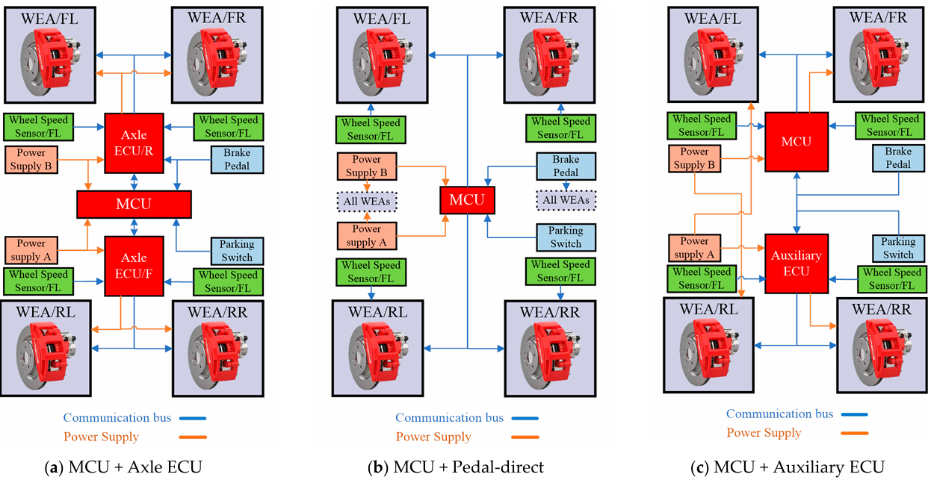
Architecture (c): MCU + Axle ECU
In this configuration, braking control is distributed across a combination of controllers: a central MCU (Main Control Unit) plus two dedicated axle electronic control units—one for the front axle (Axle ECU/F) and one for the rear axle (Axle ECU/R). Each Axle ECU is topologically positioned between the central MCU and the two Wheel-End Actuators (WEAs) of its respective axle; hence, it manages two wheels (either the front pair or the rear pair), rather than all four. Both the power supply and communication bus follow an "H"-circuit layout, described in the reference paper as a same-side redundancy design: simpler to implement, but more vulnerable if an entire vehicle side loses its circuit [1]. This architecture exhibits the highest level of control redundancy among the three, but also carries the highest cost due to the greater number of components [1].
Architecture (a): MCU + Pedal-Direct
This represents the simplest and most cost-effective configuration. There is no intermediate ECU tier: a single MCU receives the brake pedal signal and communicates directly with all four WEAs via a shared communication bus. The power supply is arranged in a full redundancy layout (two independent power sources covering the entire system), while the communication bus adopts an "X"-circuit layout, which according to the reference study coordinates braking force distribution more effectively than an "H" circuit, albeit at the expense of more complex wiring [1]. The study explicitly points out that this architecture "provides poor residual capability after the MCU failure while reducing cost" [1]: if the single MCU fails, there is no backup controller for the system to rely on.
Architecture (b): MCU + Auxiliary ECU
This architecture stands as an intermediate compromise between the other two. The primary MCU is supplemented by a single Auxiliary ECU for backup—unlike architecture (a), this auxiliary controller is not dedicated to a specific axle, but instead supports the overall system. The power supply follows an "X"-circuit layout (as in architecture b), while the communication bus follows an "H"-circuit layout (as in architecture a). Consequently, this design inherits the higher resilience of the "X" circuit for power delivery, but retains the same-side vulnerability of the "H" circuit for data communications [1]. The reference study characterizes this approach as a pragmatic compromise: "balancing controller redundancy with cost efficiency" [1].
General Structural Differences of the EMB System (Review Context)
Regardless of the specific control topology, all three architectures share the underlying EMB system building blocks detailed by both Peng et al. and Li et al.: sensors (pedal stroke/force, wheel speed, clamping force, motor speed, motor current), MCU/ECUs for calculating target braking torque, WEAs (Wheel-End Actuators, each integrating an ACU, servo motor, reduction drive, motion-conversion mechanism, and caliper), power supplies, and communication buses (CAN, LIN, FlexRay) [1, 2]. What varies across the three architectures is not the physical nature of these core elements, but how the controllers interconnecting them are structured and partitioned—the exact focus of the comparative table below.
Comparative Summary of the Three Architectures
Feature | (a) MCU + Axle ECU | (b) MCU + Pedal-direct | (c) MCU + Auxiliary ECU
Primary Controller | Central MCU | Single MCU | Primary MCU
Additional Controllers | 2 Axle ECUs (one per axle: Front and Rear) | None | 1 Auxiliary ECU (system-wide, not axle-specific)
Pedal-to-WEA Connection | Indirect, routed through MCU and Axle ECUs | Direct, handled exclusively by MCU | Indirect, routed through MCU and Auxiliary ECU
Power Supply Layout | "H"-circuit | Full redundancy | "X"-circuit
Communication Bus Layout | "H"-circuit | "X"-circuit | "H"-circuit
Control Redundancy Level | High (axle-level redundancy) | Low (no controller backup) | Medium (system-wide backup, not per axle)
Residual Capability After MCU Failure | Good: Axle ECUs can partially maintain braking control | Poor: No backup controller available [1] | Intermediate: Auxiliary ECU provides partial operational support
Hardware Cost | High (highest component count) | Low | Medium
Wiring Complexity | High (multiple channels to route) | Low overall, though "X"-circuit adds complexity [1] | Medium
Fault Isolation / Damage Segmentation | Per-axle (front and rear independently isolated) | None (all 4 WEAs rely on a single control point) | Partial (not per-axle, but controller backup exists)
Summary Description from Reference Paper [1] | "Strongest redundancy performance with a relatively high cost" | "Poor residual capability after the MCU failure while reducing cost" | "Balancing controller redundancy with cost efficiency"
Concluding Remarks for the Comparison
The overarching theme across all three referenced studies is that these architectures represent distinct design points along the same fundamental trade-off: adding intermediate controllers between the primary MCU and the wheel-end actuators enhances fault tolerance against single-point failures, but increases hardware costs, packaging constraints, and wiring complexity [1, 2]. This reflects the broader dilemma outlined by Ji et al. (2024) explaining why EMB systems—despite their compelling advantages over EHB systems in terms of weight reduction, packaging space, elimination of brake fluid hazards, and faster response times—remain largely "in the theoretical or experimental stage, with no mature products available on the market" [3]: the engineering and component costs required to deliver safety redundancy sufficient to substitute a physical mechanical backup continue to pose a formidable challenge to mass-market commercial adoption.

