

**Creation of a learning platform based on gamification for the assimilation of knowledge related to Modules 7-8**

**Jeopardy Game**

**Students:**

* **Ilie Ioan-Călin (Project Manager)**
* **David Florin-Leonard**
* **Iurea Andreea-Irina**
* **Gherghișan Andrei-Vlad**
* **Mărunțelu Gabriel-Sebastian**

**Project objectives**

The Jeopardy Game project is an innovative concept that strives to provide a stimulating and interactive way for people who are keen on improving their knowledge of SEO (Search Engine Optimization) and Digital Marketing basics through a distinctive learning opportunity. Using Unreal Engine, the game changes how individuals acquire information by immersing them in an exciting journey instead of conventional methods.

Primary Objectives:

* *Educational Enhancement*
  + To offer a comprehensive learning platform that covers key topics in SEO and Digital Marketing.
  + To simplify complex SEO and Digital Marketing concepts into understandable and retainable segments through game-based learning.
* *Interactive Learning Experience*
  + To encourage active participation and engagement through a Jeopardy-style gameplay that challenges the player's knowledge and decision-making skills.
* *Accessibility and Inclusivity*
  + To ensure the game is accessible to a diverse range of learners, regardless of their prior knowledge in SEO and Digital Marketing.
  + To design the game to be intuitive and user-friendly, allowing for easy navigation and understanding of the game mechanics.
* *Dynamic Interaction and Real-Time Feedback*
  + *To incorporate instant feedback mechanisms that inform players of their performance.*
  + *To include a variety of question types and difficulty levels, catering to a broad spectrum of learning stages.*
* *Engagement and Motivation*
  + *To leverage gamification elements like points to motivate and reward players for their progress and achievements.*

**State of the art**

* We extensively researched gaming, exploring up-to-date articles, online resources and the latest analyzes to gain an in-depth understanding of present trends regarding Jeopardy-style games as well as emerging educational gaming technology.
* We conducted a thorough analysis of other Jeopardy-style games and ongoing projects in order to recognize effective components, as well as opportunities for improving our own project.
* We carefully evaluated and chose the most appropriate technologies and tools to create a seamless, engaging experience that is customized for fans of Jeopardy.

**Solution Justifying**

To create a one-of-a-kind single-player Jeopardy game, we took great care to blend educational content and engaging gameplay in the powerful framework of Unreal Engine. Firstly, important topics within SEO and Digital Marketing were analyzed at length before being carefully transformed into thought-provoking questions that elicit critical thinking from players. These elements were then integrated seamlessly into an interactive environment with intuitive user interface design using Unreal Engine's advanced capabilities resulting in immersive visuals that captivate player attention while providing conducive learning atmospheres where they can navigate multiple levels of challenges independently.

We meticulously attended to details like fluidity of mechanics & clarity which ensured our game is not only useful but also enjoyable for learners who want both self-paced study without competition pressure -accommodating best-from-every-level interest among beginners or experienced specialists alike- making it an excellent resource on these subjects.

**Implementation description**

The core of this execution relied on the Unreal Engine due to its strong proficiency in effortlessly rendering intricate graphics and facilitating gameplay mechanics.

* *Game Design and Structure:*
  + The game followed the traditional Jeopardy layout, featuring categories and queries designed exclusively for SEO and Digital Marketing. Initially, the team compiled an extensive collection of questions categorized by difficulty level as well as related topics in these domains. To cater to both novices and experts alike, emphasis was placed on including fundamental concepts alongside more complex scenarios within this question bank.
* *Environment and User Interface:*
  + The game environment was designed to be intuitive and immersive. The Unreal Engine's advanced graphical capabilities were utilized to create a visually appealing and engaging virtual game board. Each element, from the question tiles to the score displays, was crafted to be clear and user-friendly, ensuring a smooth and enjoyable gaming experience. Interactive elements, such as timers, were integrated to add to the realism and excitement of the Jeopardy experience.
* *Gameplay Mechanics:*
  + One crucial element in executing the project was programming the gameplay mechanics, which encompassed establishing logic for selecting questions, accumulating points and advancing through levels. Meticulous coding guaranteed a coherent gaming experience with no glitches while prioritizing precise and efficient handling of user inputs. The game's design focused on offering an individual learning encounter by being single-player to allow self-pacing engagement with contents hence enhancing personalization.
* *Testing and Refinement:*
  + Before its official release, the game underwent thorough testing to guarantee seamless operation and eradicate any errors. This testing phase was pivotal in refining gameplay by integrating user input for better educational outcomes and general player contentment.

**UML Diagram of Game Structure:**

**Widget Blueprint:**

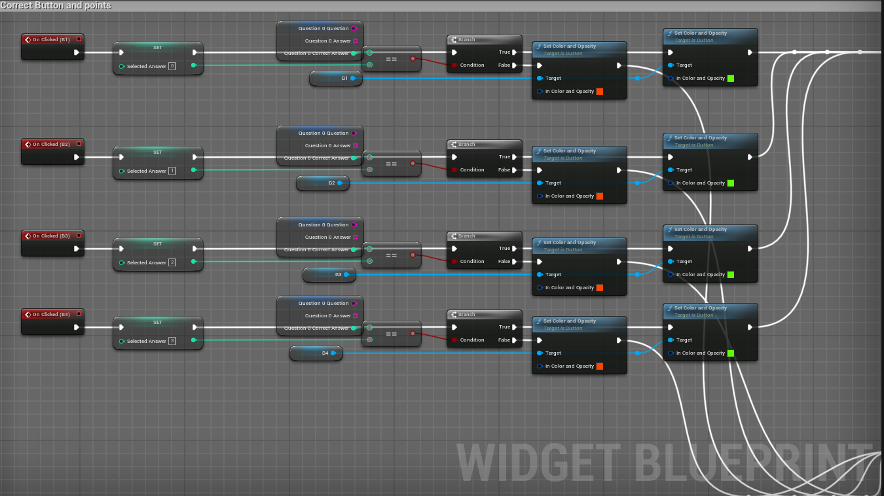

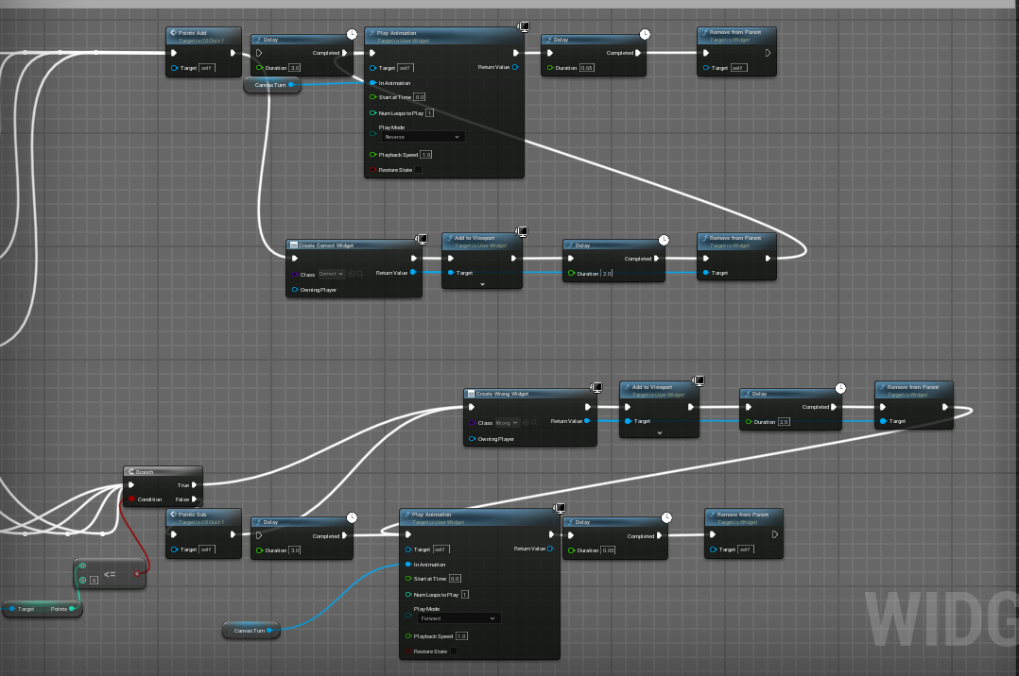

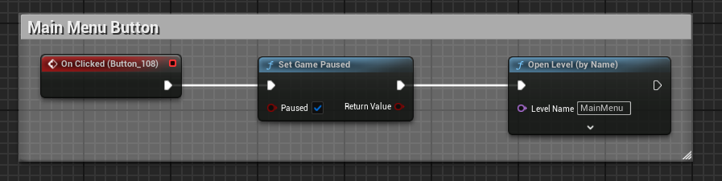

**POO Concepts**

* *Classes:* 
  + UUserWidget: This is the main class defined in the code, representing a user interface widget and inheriting from UWidget and INamedSlotInterface.
  + UWidget: The base class for all widget-type objects in Unreal Engine.
  + INamedSlotInterface: An interface that provides functionality for managing named slots.
* *Inheritance:* 
  + UUserWidget inherits from UWidget and INamedSlotInterface. This means that UUserWidget will inherit the public and protected members and methods of these base classes.
* *Acces specifiers:* 
  + Member data is protected through access specifiers such as private, protected, and public, ensuring that the internal state of the object is shielded from unauthorized direct access. For example, InputComponent is a protected member, meaning it can only be accessed by the class itself and classes that inherit from UUserWidget.
* *Abstraction:* 
  + The code defines interfaces and base classes (for example, INamedSlotInterface and UWidget) that hide complex implementation details from users and other parts of the program. Users can interact with objects through public methods without needing to know the internal implementation.
* *Polymorphism:* 
  + The code includes virtual functions and pure virtual functions (specified through virtual and UFUNCTION()), allowing the class to provide implementations that can be overridden by derived classes. For example, NativeOnFocusReceived is a virtual method that can be overridden to provide specific behavior when a widget receives focus.

**Performance indicators:**

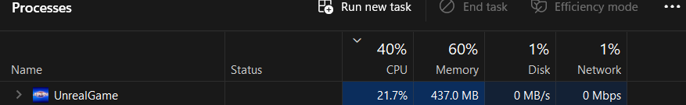

The screenshot provided appears to be a snapshot of the Task Manager on a Windows operating system, displaying the resource consumption of a process named "UnrealGame". Based on the information shown, "UnrealGame" is using a substantial amount of CPU resources, registering at 21.7%. For memory, it is using 437.0 MB, which indicates that while the game may not be very large or complex, it still requires a moderate amount of RAM to function.

Despite the game's apparent simplicity, such a high CPU utilization could indicate that the game is not optimized for performance. High CPU usage can lead to increased power consumption and may affect the performance of other applications running concurrently on the system. Moreover, on systems with less powerful hardware, this level of CPU usage could lead to heat generation, potential throttling, and a generally less responsive system.

Memory usage, on the other hand, doesn't seem excessively high, but it's still significant for a "very simple" game. This could suggest that the game may be keeping a lot of assets in memory or that there are memory management improvements to be made.

No disk or network activity is reported for the game at the moment of the snapshot, which is expected if the game is not in the process of loading new content from the disk or communicating over the network.

In summary, while the game might be simple, the CPU usage indicates that there could be room for optimization. This could include profiling the game to find inefficient code paths, optimizing algorithms, ensuring that graphics rendering is efficient, and looking into potential issues like memory leaks or unnecessary background processes. Reducing the CPU load would not only make the game run smoother on a wider range of hardware but also contribute to the longevity of the hardware by reducing thermal stress.

**Each member's contribution**

* Ilie Ioan-Călin: Home Menu, Design of playing board, Buttons functionality, Debugging.
* Gherghișan Andrei-Vlad: Design of questions, Creating categories and questions, Back to Main Menu from questions button.
* David Florin-Leonard: Timer functionality, Score System, Debugging
* Iurea Andreea-Irina: Credits page, Rules page, Identify bugs.
* Mărunțelu Gabriel-Sebastian: Game soundtrack, Easter Egg Implementation, Identify bugs.

**Conclusions:**

The development of the Jeopardy game focusing on SEO and Digital Marketing using Unreal Engine has been a multifaceted learning experience. It significantly enhanced our technical skills, particularly in game development and the practical application of Object-Oriented Programming principles. Working with advanced tools like Unreal Engine advanced our understanding of complex software development and graphical interface design.

Moreover, integrating SEO and Digital Marketing concepts into the game reinforced our knowledge in these domains, demonstrating the effectiveness of interactive learning tools. This project also honed critical soft skills, including project management, teamwork, and a user-centric design approach. The creative challenge of developing an educational game pushed us to think innovatively and adaptively.

In essence, this project was not only a success in creating an engaging educational tool but also a valuable experience in personal and professional development, preparing us for future challenges in the tech industry.