CO5
ASSESSMENT TOOL 1: Constraint-Based Problem Solving

QUESTION 1
Design an HDFS-based storage solution for a media platform under the constraints that data availability must remain above 99.9%, replication factor cannot exceed 3, and storage growth must stay cost efficient. Justify your design.
Answer
A media platform generates a large volume of data such as videos, images, audio files, thumbnails, user activity logs, and metadata. Since the volume of media data continuously increases, a distributed storage system such as the Hadoop Distributed File System (HDFS) is suitable for providing scalable and fault-tolerant storage.
The proposed HDFS solution is designed around three major constraints: availability must remain above 99.9%, the replication factor cannot exceed three, and storage expansion must be cost efficient.
HDFS Storage Design
The HDFS cluster consists of a highly available NameNode configuration and multiple DataNodes.
The NameNode manages the HDFS namespace and stores metadata about files, directories, permissions, and the locations of data blocks. To improve availability, an Active NameNode and a Standby NameNode can be configured. If the Active NameNode fails, the Standby NameNode can take over.
The DataNodes store the actual media files. Large media files are divided into blocks, and these blocks are distributed across multiple DataNodes.
Replication Strategy
A replication factor of 3 is selected for critical media data because it is the maximum allowed by the given constraint.
Each important HDFS block therefore has up to three copies stored on different DataNodes. If one DataNode fails, another replica can be used to serve the data.
The replicas should also be distributed using rack awareness. This prevents all replicas from being located on the same physical rack. Therefore, even if an entire rack becomes unavailable, another replica can still be accessed.
Maintaining 99.9% Availability
The following techniques are used to maintain high availability:
- HDFS replication factor of three for critical data.
- Rack-aware placement of replicas.
- NameNode High Availability using Active and Standby NameNodes.
- Continuous monitoring of DataNodes.
- Automatic re-replication when a DataNode fails.
- Regular metadata checkpointing.
- Backup and disaster-recovery mechanisms.
If a Data Node fails, HDFS detects the missing replica and automatically creates another replica on a healthy Data Node.
Cost-Efficient Storage Growth
Replication increases storage consumption, so additional measures are required to control costs.
Data compression can be used wherever the media format permits it to reduce storage requirements.
Data lifecycle management can be applied by keeping frequently accessed media on primary storage and moving older or rarely accessed content to lower-cost archival storage.
Temporary data and obsolete files should be removed according to appropriate retention policies.
The cluster can also be expanded incrementally by adding new Data Nodes only when additional storage capacity is required.
For temporary or easily regenerated data, a lower replication level can be considered where the business requirements allow it.
Constraint Satisfaction
Constraint | Design Solution
Availability above 99.9% | HDFS replication, rack awareness and Name Node HA
Replication factor cannot exceed 3 | Replication factor of 3 for critical data
Cost-efficient growth | Compression, archiving and incremental expansion
Data Node failure | Automatic re-replication
Large media files | Distributed HDFS block storage
Justification
HDFS is appropriate because it distributes large files across multiple machines while providing fault tolerance through replication. A replication factor of three provides a good balance between availability and storage overhead. Name Node High Availability prevents a single metadata-server failure from making the entire filesystem unavailable. Compression, archival policies, and incremental cluster expansion further reduce the cost of storage growth.
Conclusion
The proposed HDFS solution satisfies all three constraints. Replication and rack awareness provide high availability, while the replication factor remains within the maximum limit of three. Compression, lifecycle management, and incremental addition of Data Nodes ensure that the media platform can grow without unnecessary storage costs.
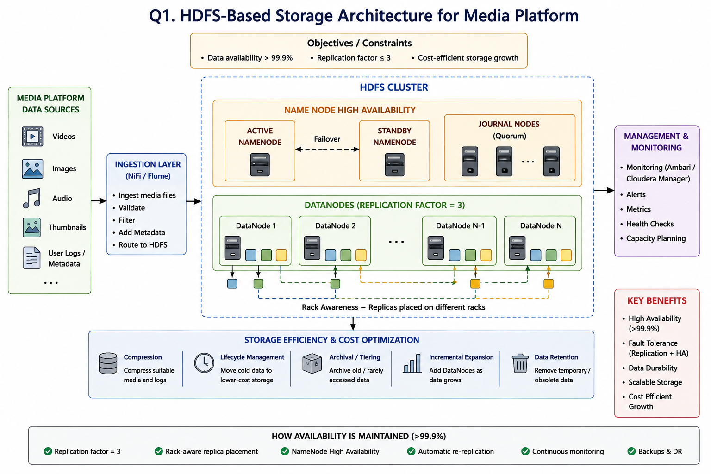

QUESTION 2
A MapReduce workflow must process log data within a 20-minute batch window using limited cluster nodes. Propose a job design under these constraints and explain task distribution.
Answer
Large-scale applications generate millions of log records containing information such as timestamps, IP addresses, URLs, HTTP status codes, response times, and error messages. MapReduce can process these logs in parallel and is suitable for batch processing.
The major constraint is that the complete log-processing job must finish within a 20-minute batch window while using a limited number of cluster nodes.
Proposed MapReduce Job Design
The log files are first stored in HDFS. HDFS divides large files into blocks, which can be processed in parallel by Mapper tasks.
The MapReduce workflow consists of the following stages:
- Input data stored in HDFS.
- Input splitting.
- Mapper processing.
- Combiner processing.
- Shuffle and Sort.
- Reducer processing.
- Final output stored in HDFS.
Mapper Processing
The Mapper reads individual log records and extracts the required fields.
For example, if the objective is to count the number of requests received by each URL, the Mapper generates key-value pairs in the following form:
Key: URL
Value: 1
For multiple requests to the same URL, the Mapper generates multiple records with the same key.
Combiner
A Combiner performs local aggregation before the Mapper output is transferred to the Reducers.
For example, if a Mapper produces several records for the same URL, the Combiner can add these values locally.
This reduces the amount of intermediate data transferred during the shuffle phase and therefore reduces network traffic.
Shuffle and Sort
During the Shuffle and Sort phase, Hadoop groups all values associated with the same key and sends them to the appropriate Reducer.
For example, all records associated with a particular URL are grouped together.
Reducer Processing
The Reducer receives each key along with its list of values and calculates the final result.
For example, if a URL receives values such as 3, 5, and 7 from different Mapper tasks, the Reducer calculates the total as:
3 + 5 + 7 = 15
The final results are stored in HDFS.
Task Distribution
Assume that the cluster has one ResourceManager/Master node and three worker nodes.
The input files are divided into HDFS blocks. Mapper tasks are distributed across the available worker nodes.
Each worker node can execute multiple Mapper tasks depending on its available CPU and memory.
After the Map phase, Reducer tasks are distributed across the available worker nodes. The exact number of Mapper and Reducer tasks should be selected based on the input data size and available cluster resources.
Techniques for Meeting the 20-Minute Requirement
1. Data Locality
Mapper tasks should preferably execute on nodes where the required HDFS blocks are stored. This reduces network communication.
2. Parallel Processing
Multiple Mapper and Reducer tasks should run simultaneously to reduce the total execution time.
3. Combiner
The Combiner reduces intermediate data and decreases network traffic during Shuffle and Sort.
4. Compression
Intermediate Map output can be compressed to reduce network transfer time and storage requirements.
5. Proper Number of Reducers
The number of Reducers should be selected according to available CPU, memory, and network resources. Too few Reducers may increase processing time, while too many can introduce unnecessary task overhead.
6. Filtering Unnecessary Data
Unnecessary log records and fields should be filtered as early as possible to reduce the amount of data processed.
7. Fault Recovery
If a Mapper or Reducer fails, Hadoop can execute the failed task again on another available node.
Constraint Satisfaction
Constraint | Design Solution
20-minute batch window | Parallel processing and optimized MapReduce stages
Limited cluster nodes | Controlled Mapper and Reducer parallelism
Network limitations | Combiner and intermediate compression
Large log files | HDFS input splitting
Processing efficiency | Data locality
Task failures | Automatic task re-execution
Justification
The proposed design minimizes processing time by dividing the logs into independent input splits and processing them in parallel. Data locality minimizes unnecessary network communication, while the Combiner reduces the amount of intermediate data transferred between nodes. Compression further reduces network overhead.
Conclusion
The proposed MapReduce workflow can efficiently process large log datasets within the required 20-minute batch window by using parallel task execution, data locality, Combiners, compression, and appropriate Mapper and Reducer configurations. The design also provides fault recovery without requiring additional dedicated nodes for every task.
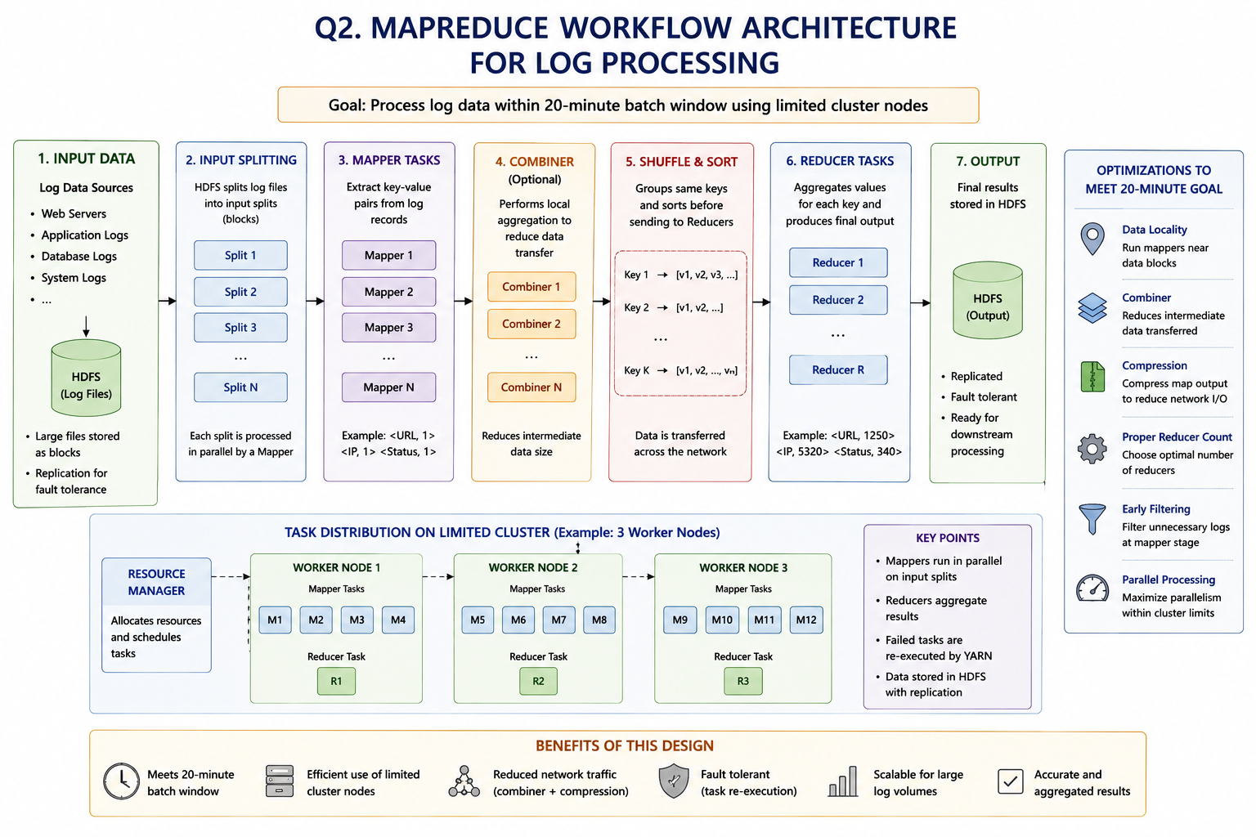

QUESTION 3
A YARN-managed cluster supports ETL, reporting, and machine learning jobs. Design a scheduler policy under the constraints of fairness, priority for ETL, and recovery from node failure.
Answer
YARN is responsible for managing computing resources in a Hadoop cluster. In this scenario, the cluster simultaneously supports ETL, reporting, and machine learning workloads. A suitable scheduling policy must give priority to ETL while ensuring that reporting and machine learning workloads continue to receive sufficient resources.
A queue-based scheduling approach using the Capacity Scheduler is appropriate because it allows resources to be divided among different workload categories while supporting priority and resource sharing.
Proposed Queue Structure
The cluster can be divided into three queues:
Queue | Workload | Priority | Example Minimum Capacity
ETL | Data extraction and transformation | High | 50%
Reporting | Business and analytical reports | Medium | 25%
Machine Learning | Training and model processing | Normal | 25%
These capacity values are example design values and can be adjusted according to actual organizational requirements.
ETL Priority
ETL jobs are given the highest priority because they may prepare and transform data required by reporting and machine learning applications.
When ETL jobs require additional resources, unused resources from other queues can be temporarily allocated to ETL, provided that the minimum resource requirements of other queues are maintained.
Maintaining Fairness
Although ETL has the highest priority, Reporting and Machine Learning jobs should not be completely blocked.
Fairness can be maintained by:
- Providing minimum capacity to each queue.
- Sharing unused cluster resources.
- Preventing starvation of lower-priority workloads.
- Monitoring queue utilization.
- Applying maximum capacity limits when required.
- Using appropriate application priorities.
This ensures that high-priority ETL workloads receive resources without completely preventing other workloads from executing.
Node Failure Recovery
YARN uses the ResourceManager and NodeManagers to monitor and manage cluster resources.
If a worker node fails, the ResourceManager detects that the corresponding NodeManager is no longer available.
The failed node is removed from active resource allocation, and tasks or containers that were running on the failed node can be rescheduled on healthy nodes.
For example, if an ETL container running on one worker fails because the node becomes unavailable, YARN can allocate a new container on another available worker node.
Recovery Process
The recovery process consists of:
- Detecting the failed NodeManager.
- Marking the node as unavailable.
- Identifying containers affected by the failure.
- Rescheduling the failed tasks.
Checkpointing can also be used for long-running machine learning workloads where supported, reducing the amount of computation that needs to be repeated after failure.
Proposed Scheduling Policy
The scheduling policy can be summarized as follows:
- Reserve minimum resources for ETL, Reporting, and Machine Learning.
- Assign the highest priority to ETL.
- Allow unused resources to be temporarily shared.
- Prevent starvation of Reporting and Machine Learning jobs.
- Continuously monitor worker nodes.
- Detect worker-node failures through YARN.
- Reschedule failed containers on healthy nodes.
- Monitor resource usage and adjust queue capacities when necessary.
Constraint Satisfaction
Requirement | Solution
ETL priority | High-priority ETL queue
Fairness | Minimum capacity for all queues
Resource efficiency | Dynamic sharing of unused capacity
Node failure | ResourceManager detects failures
Task recovery | Containers are rescheduled
Justification
The queue-based design ensures that ETL receives higher priority without completely starving Reporting and Machine Learning workloads. Minimum resource allocations maintain fairness, while unused resources can be shared to improve cluster utilization. YARN's monitoring and rescheduling capabilities provide recovery from worker-node failures.
Conclusion
The proposed YARN scheduler provides a balanced solution for ETL, reporting, and machine learning workloads. ETL receives higher priority, while minimum resources are reserved for the other workloads. Node failure recovery through YARN task and container rescheduling ensures that applications can continue operating despite individual worker failures.
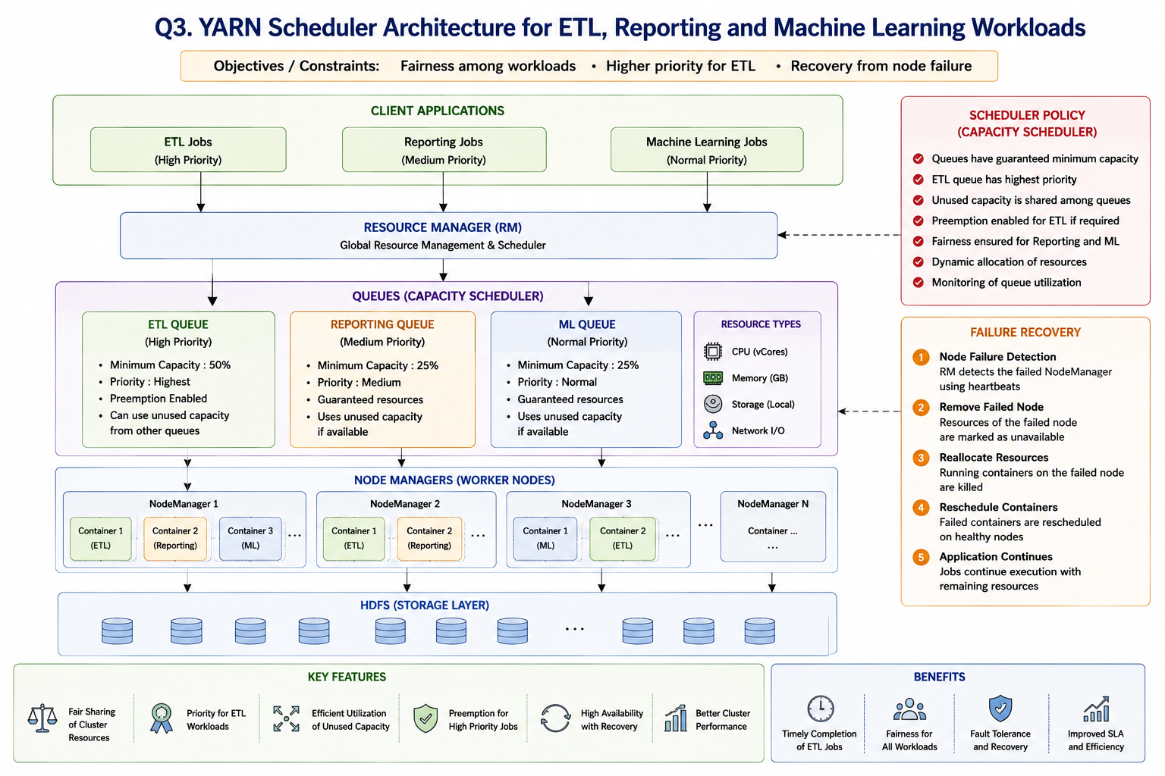

QUESTION 4
An enterprise needs to ingest data from SAN, NAS, and operational databases into a big data platform while maintaining backup reliability and minimal duplication. Propose a constrained architecture and justify each component.
Answer
An enterprise may store information across different systems, including Storage Area Networks (SAN), Network Attached Storage (NAS), and operational databases. A Hadoop-based platform can consolidate this information for large-scale storage and analytics.
The proposed architecture focuses on controlled ingestion, deduplication, reliable backup, and scalable storage.
Data Ingestion Architecture
Apache NiFi can be used as the central data-ingestion and flow-management layer.
Data from SAN, NAS, and operational databases is transferred to NiFi. NiFi validates, transforms, routes, and monitors the incoming data before storing it in HDFS.
SAN Integration
SAN provides block-level enterprise storage. Required data from SAN can be transferred to the Hadoop environment through appropriate storage access and ingestion mechanisms.
Only the required datasets should be transferred instead of repeatedly copying the complete SAN contents. This reduces storage consumption and network traffic.
NAS Integration
NAS provides shared file-based storage. Required files can be collected from NAS through controlled ingestion flows.
Metadata such as the file name, file size, source, timestamp, and checksum can be captured during ingestion.
Operational Database Integration
Operational databases contain structured transactional data.
Instead of performing a complete database extraction every time, incremental data ingestion should be used.
An initial load can transfer the required existing dataset. Subsequent ingestion operations should transfer only new or modified records.
This reduces:
- Network traffic.
- Processing time.
- Storage duplication.
- Database load.
Apache NiFi
Apache NiFi provides an effective ingestion layer because it can perform:
- Data collection.
- Data routing.
- Data transformation.
- Data validation.
- Data filtering.
- Data monitoring.
- Data provenance tracking.
- HDFS integration.
NiFi can also help maintain controlled data flows from multiple enterprise sources.
Deduplication Strategy
Duplicate files and records should be identified before they are stored unnecessarily.
For files, a checksum can be calculated and compared with existing metadata.
For database records, primary keys, source-system identifiers, timestamps, or change-tracking mechanisms can be used.
The basic process is:
- Receive the data.
- Generate or identify a unique identifier.
- Compare it with existing metadata.
- If the data already exists, avoid storing another unnecessary copy.
- If the data is new, store it in HDFS.
HDFS Storage
HDFS can be organized into different logical zones:
Raw Zone: Stores the original ingested data.
Processed Zone: Stores cleaned and transformed data.
Archive Zone: Stores older data that must be retained.
Metadata Zone: Stores information about the source, ingestion time, checksum, version, and processing status.
This organization simplifies data management and processing.
Backup Reliability
Backup reliability can be achieved through multiple mechanisms.
HDFS Replication
HDFS replication protects against individual DataNode failures by maintaining multiple copies of important blocks.
Snapshots
HDFS snapshots can provide point-in-time recovery for supported datasets.
Disaster Recovery
A separate disaster-recovery or backup environment should be maintained to protect against large-scale cluster failures.
Backup Verification
Backups should be periodically tested to ensure that data can actually be restored when required.
Minimizing Data Duplication
Duplication can be minimized using:
- Incremental database ingestion.
- File checksums.
- Unique record identifiers.
- Metadata management.
- Duplicate detection.
- Data retention policies.
- Avoidance of unnecessary full data loads.
Component Justification
Component | Purpose
SAN | Source of enterprise storage data
NAS | Source of shared files
Operational Database | Source of structured transactional data
Apache NiFi | Data ingestion and flow management
Metadata | Tracks source and dataset identity
Deduplication | Prevents unnecessary duplicate storage
HDFS | Distributed and fault-tolerant storage
YARN | Resource management
MapReduce | Large-scale batch processing
Backup/DR | Disaster recovery
Justification
Apache NiFi provides a centralized mechanism for managing data from different sources. Incremental database ingestion minimizes repeated transfers, while checksums and unique identifiers reduce duplicate storage. HDFS provides scalable and fault-tolerant storage, and backup and disaster-recovery mechanisms protect data against failures.
Conclusion
The proposed architecture provides controlled ingestion from SAN, NAS, and operational databases. Apache NiFi manages the data flow, while incremental ingestion and deduplication minimize unnecessary copies. HDFS provides distributed storage and replication, while snapshots and disaster-recovery mechanisms improve backup reliability. The architecture is therefore scalable, reliable, and suitable for an enterprise big data environment.
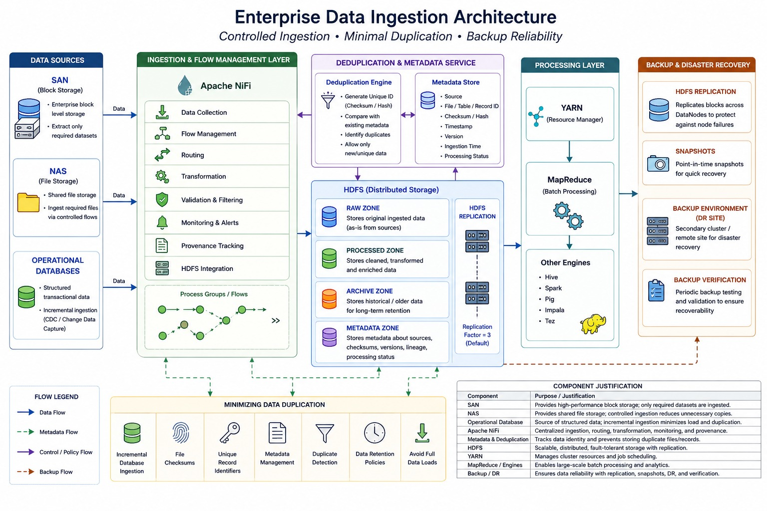

QUESTION 5
Design an end-to-end Hadoop ecosystem solution under the constraints of secure data movement, high availability, and integration with Apache NiFi or ETL pipelines. Explain how your design satisfies all constraints.
Answer
An enterprise Hadoop ecosystem should provide a complete pipeline from data ingestion to storage, processing, resource management, and analytics. The proposed solution integrates Apache NiFi or existing ETL pipelines with HDFS, YARN, and MapReduce.
The architecture is designed to satisfy three major constraints:
- Secure movement of data.
- High availability.
- Integration with Apache NiFi or existing ETL pipelines.
Data Ingestion Layer
Data may originate from:
- Operational databases.
- File systems.
- Enterprise applications.
- APIs.
- IoT and other data-producing systems.
Apache NiFi can be used as the primary ingestion layer.
NiFi receives data from multiple sources and performs validation, transformation, filtering, routing, and metadata management before sending the data to HDFS.
Secure Data Movement
Data must be protected when moving from external sources to the Hadoop ecosystem.
TLS/SSL
TLS/SSL can be used to encrypt supported network communication between data sources, NiFi, and Hadoop services.
Kerberos Authentication
Kerberos can provide strong authentication for users and services operating within the Hadoop environment.
Authorization
Hadoop permissions and appropriate access-control mechanisms should be used to ensure that only authorized users and applications can access particular datasets.
Encryption
Sensitive information should be encrypted during transmission and, where required, while stored.
Therefore, the data movement process follows a secure approach in which the source authenticates with the ingestion layer and data is transferred through protected communication channels.
Apache NiFi Integration
Apache NiFi manages the movement of data from external sources to Hadoop.
A typical processing sequence consists of:
- Receive data.
- Validate the data.
- Filter unnecessary records.
- Transform the data where required.
- Check for duplicates.
- Add metadata.
- Transfer the data to HDFS.
NiFi also provides monitoring and data provenance, allowing administrators to track the movement and origin of data.
Integration with Existing ETL Pipelines
Organizations that already use ETL systems do not necessarily need to replace them.
Existing ETL processes can prepare and transform enterprise data before it is passed to NiFi and subsequently stored in HDFS.
Alternatively, NiFi can perform part of the required ingestion and transformation process before Hadoop processing.
This provides flexibility and allows Hadoop to integrate with existing enterprise data systems.
HDFS High Availability
HDFS provides distributed and fault-tolerant storage.
A highly available HDFS configuration can use an Active NameNode and a Standby NameNode.
The Active NameNode manages the filesystem during normal operation, while the Standby NameNode is available to take over if the Active NameNode fails.
HDFS Replication
Important HDFS blocks are replicated across multiple DataNodes.
If one DataNode fails, another replica remains available. HDFS can also create replacement replicas to restore the required replication level.
This protects the system against individual DataNode failures.
YARN Resource Management
YARN manages CPU, memory, and other cluster resources.
It allocates containers to applications according to available resources and scheduler policies.
YARN can manage different Hadoop workloads, including MapReduce processing and other distributed applications.
MapReduce Processing
Large datasets stored in HDFS can be processed using MapReduce.
The processing stages include:
- Reading input from HDFS.
- Mapper processing.
- Optional Combiner processing.
- Shuffle and Sort.
- Reducer processing.
- Storing the final output in HDFS.
Mapper tasks process different portions of the input in parallel, while Reducers combine and produce the final results.
Failure Recovery
High availability requires recovery mechanisms at multiple levels.
HDFS Failure Recovery
When a DataNode fails, HDFS uses another available replica and can create a replacement replica on a healthy DataNode.
NameNode Failure Recovery
If the Active NameNode becomes unavailable, the Standby NameNode can take over in a properly configured HA environment.
YARN Failure Recovery
If a worker node fails, YARN detects the failure and reschedules affected tasks or containers on healthy nodes when possible.
Monitoring
The Hadoop ecosystem should be continuously monitored for:
- NameNode health.
- DataNode availability.
- HDFS storage utilization.
- YARN resource utilization.
- Application status.
- Failed tasks.
- NiFi data-flow status.
- Network and processing performance.
Monitoring helps administrators identify failures and capacity problems early.
Constraint Satisfaction
Constraint | Proposed Solution
Secure data movement | TLS/SSL and encrypted communication
Authentication | Kerberos
Authorization | Hadoop permissions and access controls
High availability | NameNode HA
Storage fault tolerance | HDFS replication
Processing recovery | YARN task/container rescheduling
Data ingestion | Apache NiFi
Overall Justification
The proposed architecture combines the major Hadoop ecosystem components according to their specific responsibilities. Apache NiFi provides controlled data ingestion and flow management. HDFS provides distributed and fault-tolerant storage. YARN manages cluster resources, while MapReduce performs distributed batch processing.
Security mechanisms such as TLS/SSL, Kerberos, authentication, and authorization protect data and cluster resources. NameNode High Availability, HDFS replication, and YARN recovery mechanisms reduce the impact of system and node failures.
Conclusion
The proposed end-to-end Hadoop ecosystem provides a secure, highly available, and scalable big data processing solution. Apache NiFi or existing ETL pipelines can be integrated for data ingestion, HDFS provides reliable distributed storage, YARN manages resources, and MapReduce performs large-scale processing. Secure communication, authentication, replication, high availability, and failure recovery ensure that all the constraints specified in the problem are satisfied.
