C05 - Assessment Tasks 2
Hadoop Ecosystem – Design Error Analysis and Corrective Actions

Question 1: Uneven Input Splits and Idle Reducers
Problem
A Hadoop MapReduce job repeatedly fails because the input splits are uneven. Some Map tasks receive much more data than others, causing them to take longer to complete. As a result, reducers may remain idle while waiting for intermediate data from the slower Map tasks.
Likely Design Error
The likely design error is poor input data partitioning and an unsuitable split configuration. If input files are highly uneven or the input format does not divide the data effectively, the workload becomes unbalanced. In addition, an inappropriate partitioner can cause some reducers to receive significantly more intermediate data than others.
Analysis
Hadoop achieves parallel processing by dividing input data into splits and assigning them to Map tasks. If one Map task receives a much larger workload, it becomes a straggler. Reducers that depend on its output cannot complete their work efficiently. Data skew in the intermediate key-value pairs can also overload particular reducers while leaving others underutilized.
Corrective Actions
- Configure appropriate HDFS block sizes and input split sizes.
- Use a suitable InputFormat to distribute input records evenly.
- Ensure input files are reasonably balanced in size.
- Use an appropriate Partitioner to distribute intermediate data evenly among reducers.
- Identify and handle data-skewed keys.
- Configure a suitable number of Map and Reduce tasks.
- Use a Combiner when applicable to reduce intermediate data.
- Monitor Map and Reduce task execution to identify stragglers.
Conclusion
The Hadoop job should be redesigned to provide balanced input splits and evenly distributed intermediate data. Proper partitioning and task configuration will improve parallelism and reduce idle reducer time.
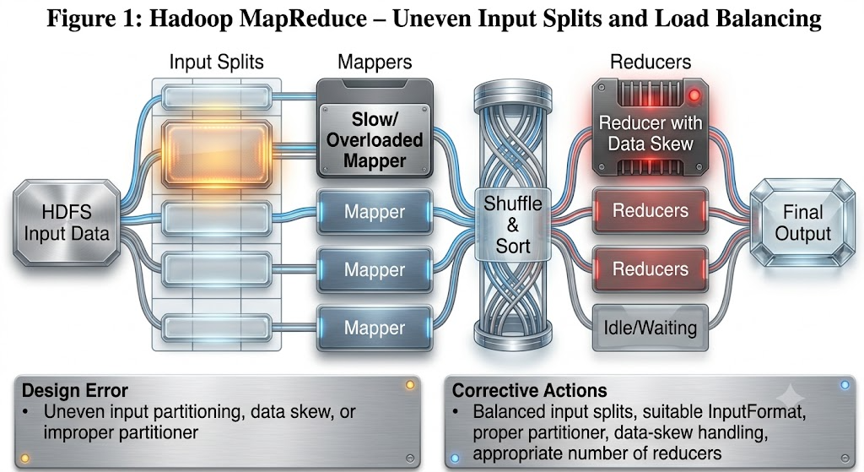

Question 2: HDFS Data Unavailability After a Single Node Failure
Problem
An HDFS deployment frequently experiences data unavailability after a single DataNode fails. HDFS is designed to provide fault tolerance, so the failure of one node should normally not make replicated data unavailable.
Probable Design Error
The most probable design error is an insufficient replication factor. If the replication factor is set to one, a block has only one copy. If the DataNode containing that block fails, the block becomes unavailable.
Another possible design problem is the absence of NameNode High Availability (HA). If the deployment relies on only one NameNode and that NameNode fails, the HDFS namespace can become unavailable.
Analysis
HDFS stores data as blocks and normally maintains multiple replicas of each block on different DataNodes. If only one replica exists, a DataNode failure can make that block inaccessible. Similarly, a single NameNode creates a single point of failure for namespace management.
Corrective Actions
- Set an appropriate HDFS replication factor, commonly 3 for production systems.
- Ensure replicas are stored on different DataNodes.
- Use rack-aware replica placement so replicas are not concentrated in one rack.
- Configure NameNode High Availability with Active and Standby NameNodes.
- Use the required JournalNode/shared-edit mechanism for NameNode HA.
- Monitor under-replicated and missing blocks.
- Regularly check DataNode health.
- Test NameNode and DataNode failure recovery.
Conclusion
The HDFS architecture should use sufficient block replication and NameNode High Availability. This ensures that the failure of a single node does not result in data unavailability.

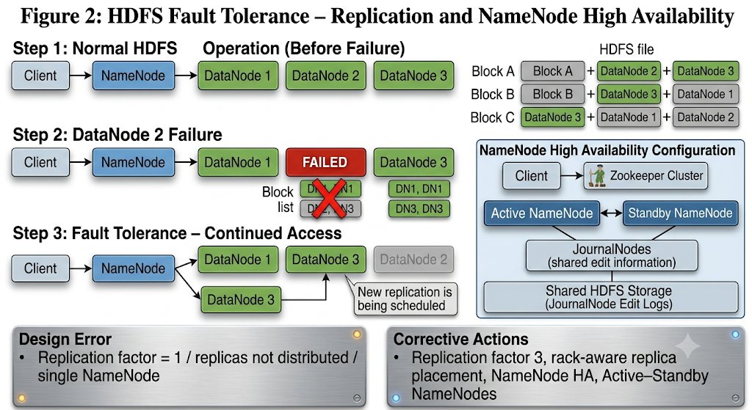

Question 3: Duplicate Records in ETL and Apache NiFi
Problem
An ETL workflow using Apache NiFi creates duplicate records in the analytics data store. The same record may be processed or inserted more than once during normal processing, retries, or failure recovery.
Likely Causes
The major causes may include:
- Repeated FlowFile processing due to processor retries.
- Network or destination failures causing NiFi to resend records.
- Lack of unique identifiers for incoming records.
- Incorrect checkpoint or state management.
- ETL jobs processing the same source data repeatedly.
- The destination database accepting repeated INSERT operations.
- Lack of deduplication before storing records.
- Improper handling of failures and acknowledgements.
Analysis
In a distributed ingestion system, a record can sometimes be processed again when a processor fails or a transaction is retried. If the destination simply inserts every received record without checking whether it already exists, duplicate records are created.
Recommended Fixes
- Assign a unique ID to every incoming record.
- Use NiFi state management to track successfully processed data.
- Use appropriate deduplication mechanisms such as DetectDuplicate where applicable.
- Configure retry and failure relationships correctly.
- Maintain source offsets or checkpoints for incremental ingestion.
- Add unique constraints to important database fields.
- Use UPSERT/MERGE operations instead of blindly inserting records.
- Maintain an ingestion log containing record IDs and processing status.
- Ensure the ETL process can safely retry the same record without creating another copy.
Example
Instead of:
Receive Record → INSERT into Database
use:
Receive Record → Generate/Check Unique ID → Detect Duplicate → Transform → UPSERT → Confirm Success
Conclusion
The ingestion pipeline should be designed with unique identifiers, state tracking, deduplication, and idempotent database operations. These measures prevent repeated processing from creating duplicate records.

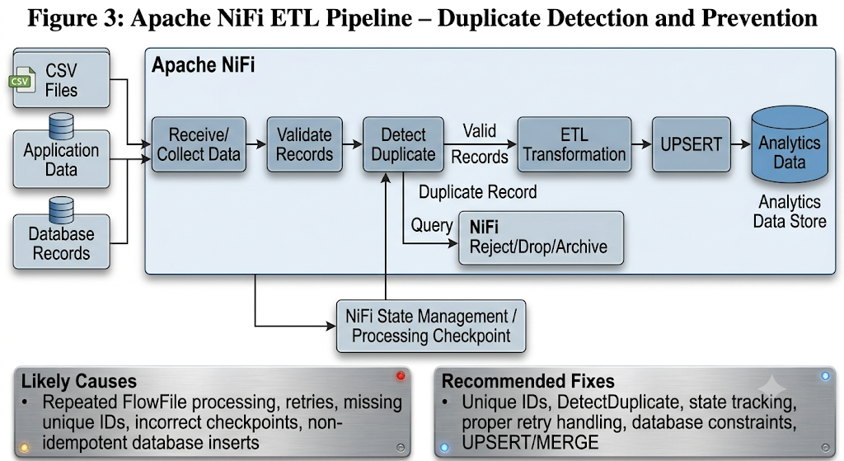

Question 4: YARN Resource Starvation with Multiple Users
Problem
A YARN cluster experiences resource starvation when multiple users submit jobs simultaneously. Some applications consume most of the available CPU and memory, leaving insufficient resources for other applications.
Likely Scheduling Error
The likely design error is poor YARN scheduling and resource allocation. If all applications are submitted to one unrestricted queue, a large job or a group of jobs may consume most of the cluster's available resources.
Analysis
YARN uses the ResourceManager to manage cluster resources and allocates containers to applications. Without appropriate queues, capacities, priorities, and limits, one user or application can dominate CPU and memory resources. This results in long waiting times and resource starvation for other users.
Better Resource Management Approach
A queue-based scheduling approach should be used. The YARN Capacity Scheduler is suitable when organizations need guaranteed resource capacity for different departments or workloads.
For example:
YARN Queue | Allocated Capacity
Production | 50%
Analytics | 30%
Research | 20%
The actual percentages can be adjusted according to organizational requirements.
Corrective Actions
- Configure the YARN Capacity Scheduler or another appropriate scheduler.
- Create separate queues for different users, departments, or workloads.
- Assign appropriate capacity to each queue.
- Set maximum resource limits for queues.
- Configure CPU and memory limits for containers.
- Apply user and group-based access controls.
- Give appropriate priority to critical workloads.
- Monitor ResourceManager and NodeManager resource utilization.
- Prevent individual applications from consuming the entire cluster.
Conclusion
A properly configured YARN scheduler with queues, resource limits, and priorities will provide fair resource sharing. This prevents resource starvation and allows multiple users to run jobs efficiently.

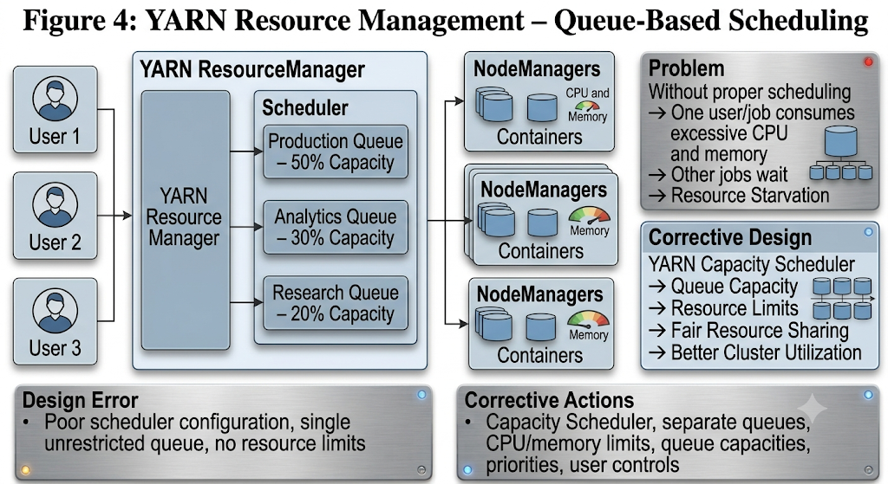

Question 5: Outdated Data After Distributed Storage Recovery
Problem
A backup strategy for distributed storage restores outdated data after a failure. The recovered data does not represent the latest valid state of the system.
Probable Design Flaw
The probable design flaw is an outdated or improperly synchronized backup/replication strategy. The recovery system may be using an old full backup or a replica that was not synchronized with the primary storage before the failure.
Analysis
If backups are performed infrequently, changes made after the most recent backup will not be included in recovery. Similarly, if replication has significant lag, the replica may contain an older version of the data. If the recovery system does not track backup timestamps and versions, it may restore an older copy instead of the latest valid one.
Corrective Actions
- Perform regular full and incremental backups.
- Maintain multiple backup versions.
- Record backup timestamps and version information.
- Monitor replication synchronization and replication lag.
- Use checksums or hashes to verify data integrity.
- Keep independent or off-site backup copies.
- Implement appropriate backup retention policies.
- Ensure the recovery system selects the latest valid backup.
- Test backup restoration regularly.
- Use synchronized replicas and maintain recovery points.
Recommended Backup Structure
Primary Distributed Storage
↓
Synchronized Replica
↓
Incremental Backups
↓
Periodic Full Backups
↓
Off-Site Backup
During recovery, the latest valid full backup should be combined with subsequent incremental backups, when applicable, to restore the most recent consistent state.
Conclusion
The backup architecture should provide frequent backups, synchronized replication, version tracking, integrity verification, and regular recovery testing. This minimizes data loss and prevents outdated information from being restored.

