NAME:K FLORINA
CO4 : ASSESSMENT TOOL 3: Reverse Engineering Task
SET 1 – Big Data Characteristics and Challenges Across Domains
1. Big Data Platform for Website Clicks, Mobile Interactions, and Customer Transactions
Introduction
A large digital platform that collects billions of website clicks, mobile interactions, and customer transactions requires a distributed Big Data architecture. Since the data is generated continuously and contains structured as well as semi-structured information, the platform would typically use distributed storage, stream ingestion, batch processing, and real-time analytics.
Probable Distributed Storage System
A distributed file system such as Hadoop Distributed File System (HDFS) or a cloud-based object store such as Amazon S3, Azure Data Lake Storage, or Google Cloud Storage would probably be used.
The storage layer could be organized into:
- Raw data layer – stores original clickstreams, logs, and events.
- Processed data layer – stores cleaned and transformed data.
- Curated data layer – stores business-ready datasets for analytics.
Data is distributed across multiple nodes to provide scalability and fault tolerance.
Data Ingestion Framework
Tools such as Apache Kafka, Apache Flume, or cloud streaming services could collect website events, mobile events, and transactions.
Kafka is particularly suitable because it:
- Handles very high event volumes.
- Supports distributed message queues.
- Provides fault tolerance.
- Allows multiple consumers to process the same data.
- Supports real-time event processing.
Batch Processing
For large-scale historical analysis, Apache Spark or Hadoop MapReduce would probably be used.
Spark can process:
- Customer behavior
- Transaction histories
- Clickstream statistics
- Business reports
- Historical trends
Spark is preferred because it provides fast distributed processing and supports SQL, machine learning, and streaming.
Structured and Semi-Structured Data
Structured transaction data can be stored in relational databases or data warehouses.
Examples include:
- Customer ID
- Product ID
- Transaction amount
- Purchase date
Semi-structured data such as JSON clickstream events and application logs can be stored in distributed storage systems.
Metadata catalogs and schema-based processing can be used to organize these different data types.
Indexing and Querying
Structured data can be indexed using database indexes and partitioned tables. Semi-structured data can be organized using schemas, partitions, metadata catalogs, and distributed query engines such as Presto/Trino or Spark SQL.
Stream Processing
Real-time analytics could use:
- Apache Spark Structured Streaming
- Apache Flink
- Kafka Streams
These tools can detect events immediately and generate real-time metrics.
Scalability and Partitioning
The platform would use horizontal scaling by adding more nodes rather than depending on one powerful server.
Data can be partitioned according to:
- Date and time
- Customer region
- Customer ID
- Product category
- Event type
Replication is also used to prevent data loss when a node fails.
Dashboards and Business Intelligence
The analytics layer can be connected to BI tools such as Power BI, Tableau, or similar visualization platforms.
The architecture can be represented as:
Web/Mobile/Transaction Sources → Kafka → Distributed Storage → Spark/Flink → Data Warehouse → BI Dashboards
Conclusion
This architecture provides high scalability, fault tolerance, real-time processing, and historical analytics. The major challenges include data volume, processing speed, data quality, security, and maintaining consistent information across distributed systems.
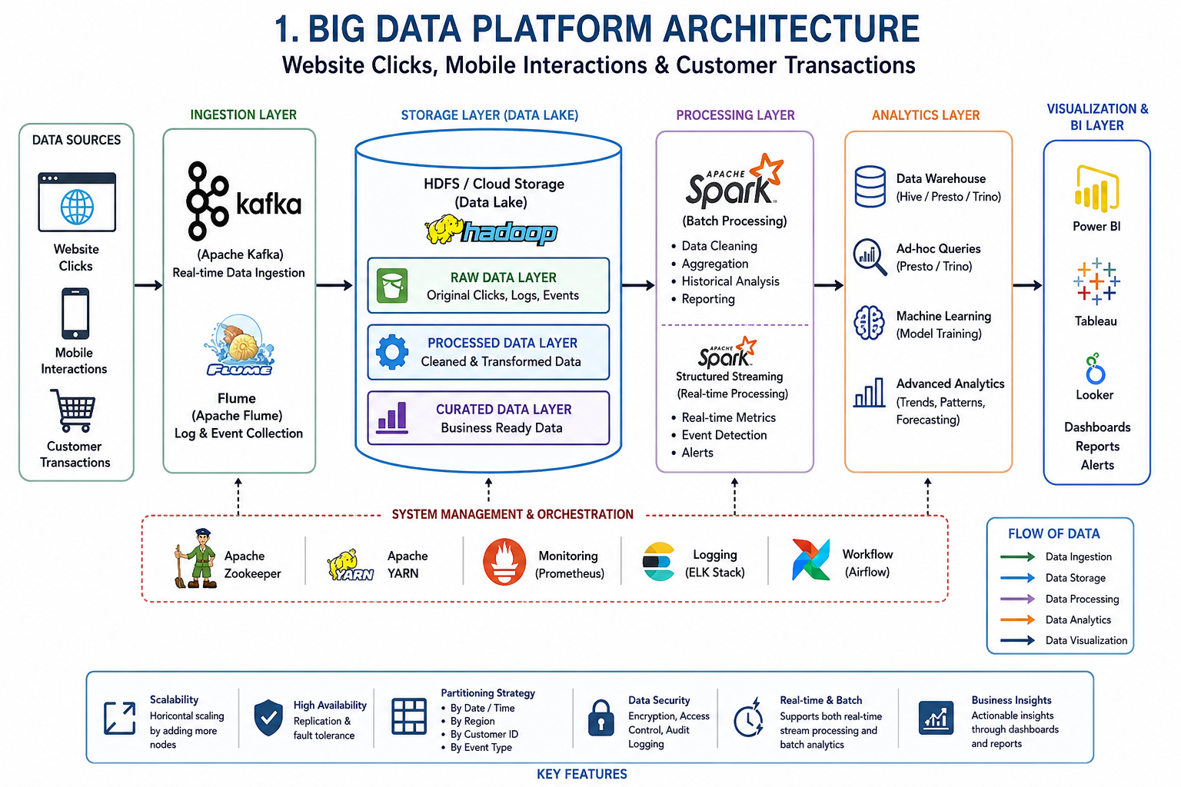

2. E-Commerce Platform for Customer Behavior and Real-Time Personalization
Introduction
An e-commerce platform produces large amounts of clickstream, transaction, customer, and behavioral data. A Big Data architecture can combine these sources to provide personalized recommendations, real-time offers, and business intelligence.
Event Streaming
Customer activities such as:
- Product views
- Cart additions
- Checkout attempts
- Payments
- Searches
can be captured as events using Apache Kafka or similar streaming platforms.
Each event can contain information such as customer ID, product ID, timestamp, location, and event type.
Customer Profiling Database
A distributed NoSQL database such as Apache Cassandra, MongoDB, or a cloud-based key-value database could store customer profiles.
Profiles may contain:
- Purchase history
- Browsing history
- Preferences
- Frequently viewed products
- Location
- Customer segments
Recommendation Workflow
The recommendation pipeline could follow these stages:
User Activity → Event Streaming → Data Processing → Feature Engineering → ML Model → Product Recommendation
Machine learning algorithms can analyze previous behavior and identify products that may be relevant to the customer.
Synchronization of Data
Session information and clickstream events can be collected through Kafka.
Transaction data from the order database can then be integrated with browsing data through Spark or another distributed processing framework.
Unique customer IDs and timestamps help correlate events belonging to the same user or session.
Caching
A high-speed cache such as Redis could store:
- Popular products
- Customer recommendations
- Session information
- Frequently accessed product information
Caching reduces database load and improves response time.
Distributed Query Engines
Tools such as Trino/Presto, Spark SQL, or cloud data warehouse engines can query large datasets without moving all the data into a single server.
Machine Learning Stages
A typical ML pipeline includes:
- Data collection
- Data cleaning
- Feature engineering
- Model training
- Model evaluation
- Recommendation generation
- Real-time model serving
- Continuous model monitoring
Merging Structured and Semi-Structured Data
Structured order data can contain customer IDs, product IDs, quantities, prices, and payment details.
Semi-structured browsing data may contain JSON-based events.
Both can be joined using common identifiers such as Customer ID, Product ID, and Session ID.
Scalability and Fault Tolerance
The system would use:
- Horizontal scaling
- Kafka partitions
- Replication
- Distributed databases
- Load balancing
- Automatic failover
- Multiple processing nodes
If one processing node fails, another node can continue processing replicated data.
KPI Monitoring and Dashboards
Business dashboards can display:
- Conversion rate
- Cart abandonment rate
- Revenue
- Average order value
- Customer retention
- Product popularity
- Recommendation performance
These dashboards can be created using Power BI, Tableau, Grafana, or similar tools.
Conclusion
The architecture enables an e-commerce company to analyze customer behavior and provide personalized experiences in real time. The major challenges are high event volume, low-latency processing, data synchronization, privacy, recommendation accuracy, and fault tolerance.
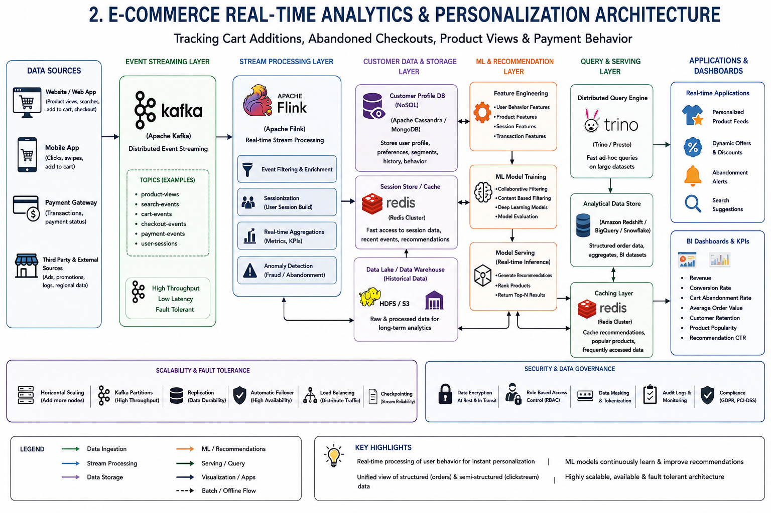

3. Big Data Healthcare System for Patient, Diagnostic, Sensor, and Prescription Data
Introduction
Healthcare generates different types of data, including patient records, medical images, wearable sensor streams, laboratory reports, and prescriptions. A Big Data healthcare system therefore requires a hybrid architecture capable of handling structured, semi-structured, and unstructured information.
Hybrid Database Architecture
A combination of databases would probably be used.
Relational databases can store:
- Patient information
- Prescriptions
- Laboratory results
- Appointments
- Billing information
NoSQL databases can store:
- Sensor readings
- Medical documents
- JSON records
- Large-scale healthcare events
Object storage/data lakes can store large medical images and other unstructured files.
Data Integration
Healthcare organizations can use integration technologies and interoperability standards such as:
- HL7
- FHIR
- DICOM
FHIR can support the exchange of healthcare information, while DICOM is widely used for medical imaging information.
ETL/ELT platforms can extract information from hospitals, laboratories, pharmacies, and insurance systems and transform it into standardized formats.
Streaming Framework
Wearable devices continuously produce:
- Heart rate
- Blood oxygen
- Temperature
- Activity
- Other physiological measurements
These streams can be processed using Kafka, Spark Structured Streaming, or Apache Flink.
Machine Learning
Machine learning can be used for:
- Disease risk prediction
- Patient monitoring
- Readmission prediction
- Medical image analysis
- Patient classification
- Population health analysis
The pipeline can be:
Healthcare Data → Cleaning → Feature Engineering → ML Model → Risk Prediction → Clinical Decision Support
Privacy and Security
Healthcare data is highly sensitive. Security mechanisms may include:
- Encryption at rest
- Encryption during transmission
- Role-Based Access Control (RBAC)
- Multi-factor authentication
- Data masking
- Audit logging
- Access monitoring
- Secure APIs
Only authorized healthcare personnel should access specific categories of patient information.
Compliance
The platform should follow applicable healthcare privacy and data-protection regulations. Data governance policies should define:
- Who can access data
- How long data is retained
- How data is shared
- How access is audited
Clinical Analytics Pipeline
The analytics pipeline can combine historical patient records with real-time sensor information.
For example:
Patient Records + Lab Data + Wearable Data → Data Lake → Spark → ML Models → Risk Score → Clinical Dashboard
Population Health Studies
Distributed processing allows researchers to analyze large numbers of patient records without depending on a single server.
Aggregated datasets can be used to identify:
- Disease trends
- Risk factors
- Treatment outcomes
- Regional health patterns
Conclusion
Big Data enables healthcare organizations to combine different information sources and provide better clinical and population-level insights. However, privacy, security, interoperability, data quality, and regulatory compliance are major challenges.

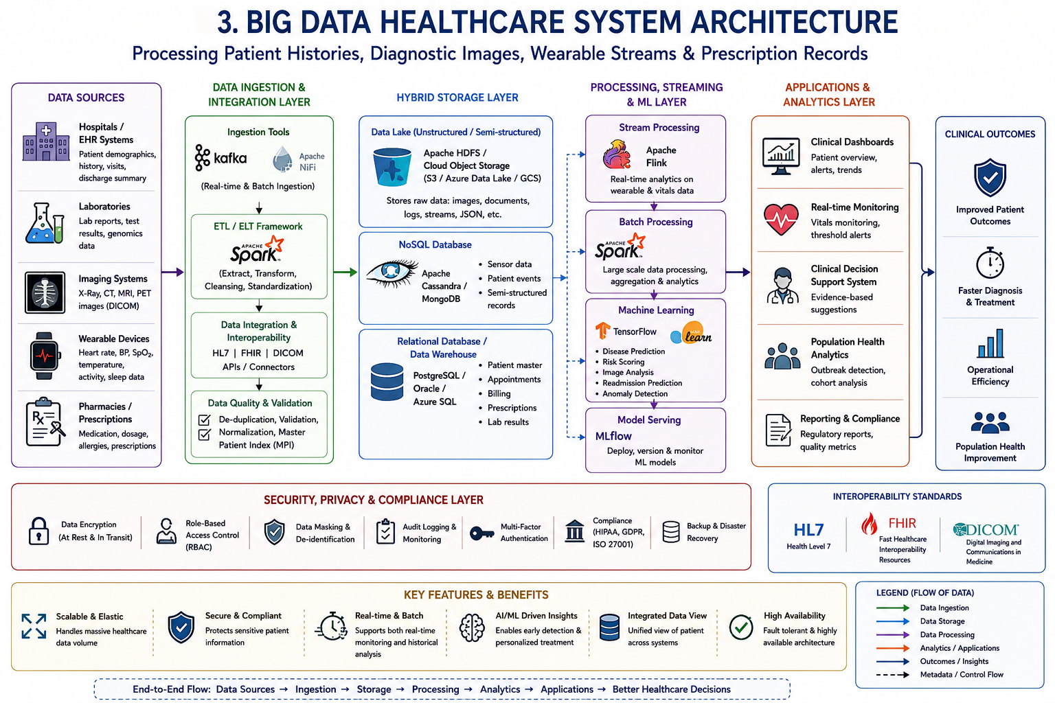

4. Smart City Platform for Traffic, CCTV, Weather, and Public Transport
Introduction
A smart city generates continuous data from traffic sensors, cameras, weather systems, GPS-enabled vehicles, and public transportation. A distributed Big Data architecture is required to process this information in real time and support urban planning.
Edge Computing
Edge devices can process data close to where it is generated.
For example:
- Traffic cameras can perform initial video analysis.
- Road sensors can calculate vehicle counts.
- Transport devices can generate local statistics.
Only important information may be sent to the central platform, reducing network bandwidth and latency.
Distributed Messaging
A messaging platform such as Apache Kafka can collect data from:
- Traffic sensors
- Public transport systems
- Weather stations
- CCTV metadata
Kafka topics can separate different types of city events.
Centralized Storage
A data lake based on HDFS or cloud object storage can store historical information.
Different datasets can be organized by:
- Date
- Location
- Sensor
- Event type
Geospatial Analytics
Location-based processing can identify:
- Traffic congestion
- Accident-prone areas
- Vehicle movement
- Public transport delays
- Road utilization
Geospatial databases such as PostGIS can support location-aware queries.
Time-Series Databases
Traffic and sensor readings are time-dependent. Time-series databases such as InfluxDB or similar systems can store:
Timestamp + Sensor ID + Location + Measurement
This makes historical and real-time sensor analysis efficient.
Streaming Computation
Apache Flink or Spark Structured Streaming can process live sensor events.
For example:
Traffic Sensors → Kafka → Flink → Congestion Detection → Alert System
If traffic density crosses a threshold, the system can generate an immediate alert.
Batch and Real-Time Analytics
Both approaches are required.
Real-time analytics supports:
- Traffic alerts
- Public transport monitoring
- Emergency response
- Congestion prediction
Batch analytics supports:
- Long-term traffic planning
- Road construction decisions
- Transport planning
- Historical trend analysis
Security and Access Control
Security mechanisms may include:
- Authentication
- Role-Based Access Control
- Encryption
- Network segmentation
- API security
Sensitive citizen and infrastructure information should only be accessible to authorized users.
Visualization
Operational dashboards can display:
- Traffic density
- Road conditions
- Bus locations
- Weather conditions
- Congestion alerts
- Sensor status
Tools such as Grafana, Power BI, Tableau, or custom dashboards can provide real-time visualization.
Conclusion
The smart city architecture combines edge computing, streaming, distributed storage, geospatial analytics, and visualization. Its major challenges include massive sensor volumes, network reliability, privacy, cybersecurity, latency, and interoperability between different city systems.
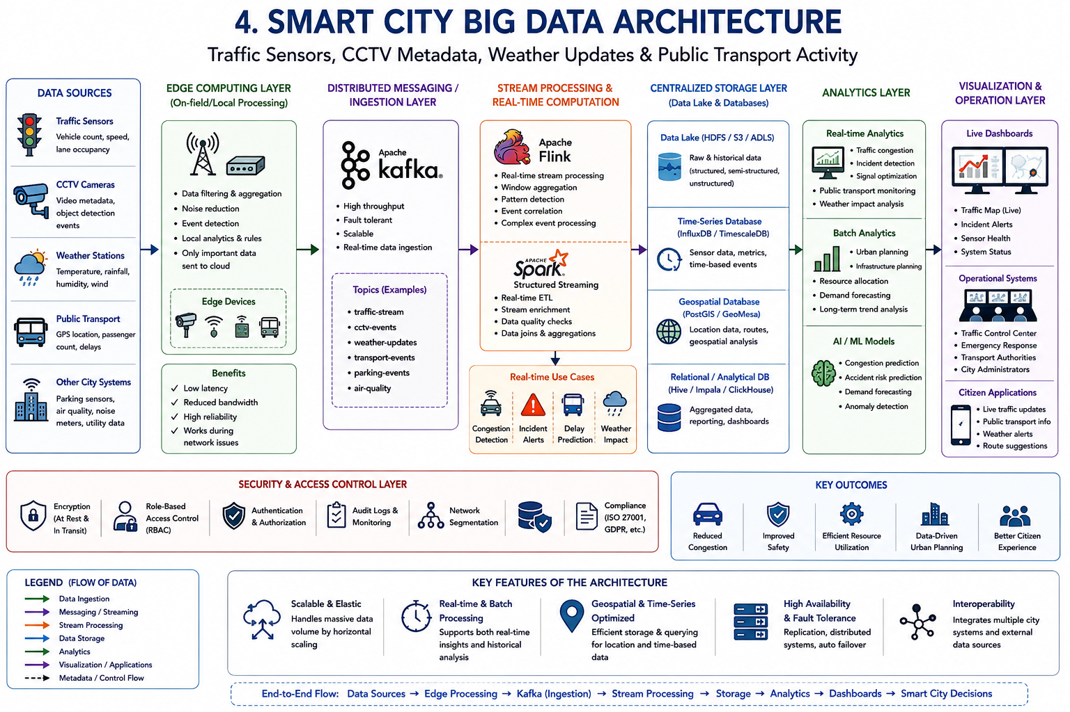
5. Healthcare Analytics System for Patient Records, Wearables, Labs, and Appointments
Introduction
A healthcare analytics system must combine structured patient information with semi-structured wearable data and unstructured medical documents. A hybrid Big Data architecture can support both real-time health monitoring and large-scale predictive analytics.
Hybrid Storage Architecture
A possible architecture includes:
Relational Database
- Patient records
- Appointments
- Laboratory results
- Prescriptions
NoSQL Database
- Wearable readings
- Sensor events
- Semi-structured healthcare information
Data Lake/Object Storage
- Medical documents
- Reports
- Images
- Large unstructured files
This approach allows each type of data to be stored using an appropriate technology.
ETL and Interoperability
ETL pipelines can perform:
Extract → Transform → Validate → Integrate → Store
Healthcare interoperability standards such as HL7 and FHIR can help exchange clinical information between hospitals and clinics.
DICOM can be used when medical imaging information is involved.
Real-Time Monitoring
Wearable devices continuously generate health measurements.
A streaming architecture can be:
Wearable Device → Kafka → Stream Processor → Analytics Engine → Alert/Dashboard
Stream-processing frameworks such as Spark Structured Streaming or Flink can identify abnormal patterns quickly.
Predictive Health Analytics
Machine learning models can analyze historical and current patient information to estimate health risks.
Potential outputs include:
- Risk scores
- Early warning indicators
- Readmission risk
- Disease progression estimates
- Patient monitoring alerts
Distributed Processing
Frameworks such as Apache Spark allow large healthcare datasets to be processed across multiple machines.
This is useful for population-level studies involving:
- Large patient groups
- Long-term medical histories
- Multiple hospitals
- Regional disease trends
Encryption and Data Governance
Because healthcare data is sensitive, the system should implement:
- Encryption at rest
- Encryption in transit
- Role-Based Access Control
- Authentication
- Audit logging
- Data masking
Every important access or modification should be recorded in an audit trail.
Machine Learning for Risk Scoring
The ML workflow can be:
Patient Data → Data Cleaning → Feature Engineering → Model Training → Validation → Risk Prediction → Clinical Support
For example, historical laboratory measurements, appointment patterns, and wearable readings can be combined to calculate a patient's risk score.
The model should support healthcare professionals rather than independently making critical medical decisions.
Treatment Recommendation Support
Analytics can identify patterns in historical data that may help clinicians compare possible treatment approaches. Such systems should be validated carefully and should provide explainable results to healthcare professionals.
Overall Architecture
Patient Records + Wearables + Labs + Appointments
↓
ETL/Streaming + Interoperability Layer
↓
Data Lake + Relational DB + NoSQL DB
↓
Apache Spark / Stream Processing
↓
Machine Learning + Analytics
↓
Risk Scores + Monitoring + Clinical Dashboards
Conclusion
The healthcare Big Data platform combines multiple data sources and processing methods to support real-time monitoring and population-level analytics. The main challenges are privacy, security, interoperability, data quality, scalability, regulatory compliance, and ensuring that machine-learning results are reliable and explainable.
