Project report – week 1

Lilian Mirabel – Florian Chapoullie-Pino – Luc Lacotte – Floris Rimbeau

Summary
Introduction 2
Context 2
Objective 2
Project Overview 3
Introducing Sprints 3
Methodology 3
Work completed 4
Database collection 4
Data generation & import into the database 5
Creation of the API 6
Conclusion 7

Introduction

Context

The project is part of the partnership between Xiatech and the University of La Rochelle. Xiatech provides real-time integration and artificial intelligence solutions for the retail sector, enabling companies to make quick, data-driven decisions.
In this project, we are exploring Agentic AI, an AI capable not only of analysing data, but also of making decisions and acting autonomously.
The use case chosen concerns sales and inventory management: detecting items at risk of shortage, automating supply orders and updating e-commerce platforms in near real time.
The project is based on a comprehensive architecture comprising:
- MongoDB database to centralise data,
- Python backend orchestrating the agent's workflows,
- React frontend to visualise the agent's data and actions.

Objective

The first week of the project was devoted to setting up the technical foundation necessary for developing Agentic AI. The main objectives were:
- Install and configure the essential tools: MongoDB for the database, Python for the backend, as well as the necessary libraries (pandas, pymongo, FastAPI, etc.).

- Design the database schema by defining the main collections (products, sales, stock, purchase_orders) and their relationships, in order to centralise and structure the retail data.

- Generate and import synthetic data to simulate sales, stock and orders, enabling the testing and validation of queries and aggregations in MongoDB.

- Verify data consistency and quality through aggregation queries and simple calculations (total sales per SKU, remaining stock, etc.) to ensure a stable environment for future development.
These objectives laid the foundations for the project and provided a better understanding of it, ensuring that the data and backend infrastructure were ready for the integration of the autonomous agent and frontend in the following weeks.

Project Overview

We are using the Scrum method to carry out this project. We have each divided up the tasks we are carrying out in a sprint. For this project, the duration of the sprint is set at one week.

Introducing Sprints
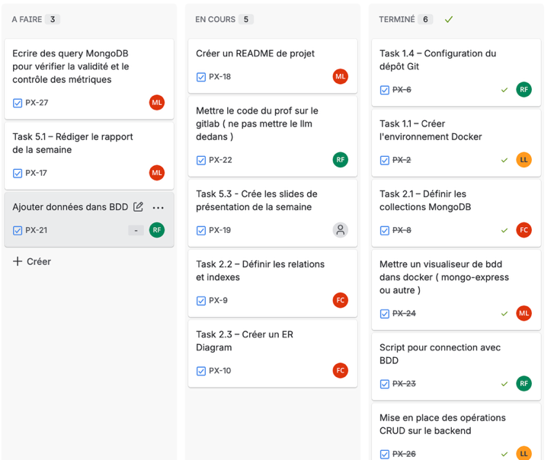
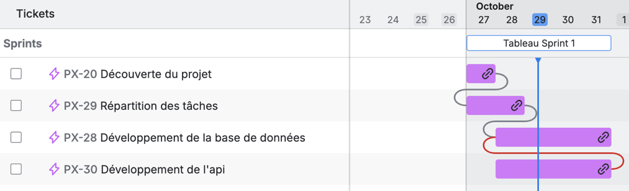

For this first sprint, we assigned tasks by project area. For example, one person is responsible for installing the tools, another for the database and API, another for generating and inserting data, etc.

Methodology

To manage task visualisation and see the work remaining, we used Jira and the tools it offers to better distribute the work and also to better navigate the project.
Technically speaking, in order to avoid confusion but still be able to easily share the work and have a reliable project, we used GitLab, which was provided by the university.
We also each created our own work branch so as not to impact each other's functionality.
This working method allowed us to each work on different things but still be able to easily assemble the work once it was finished.
We also held daily meetings every morning to review the work that had been completed and the work that remained to be done.
This also gave us an opportunity to assist each other if necessary.

Work completed

During this week, work was done to lay the foundations for the project so that concrete results can be achieved next week.
This work consists of several major parts, which are presented below.

The team divided up the tasks as follows:

Luc : API, Docker services architecture

Floris : Database, insertion, start of indexing

Florian : Database collections, debugging help

Lilian : Project management, start of the front

Database collection

To ensure that our collections were relevant to our case, we first analyzed the different needs and drew inspiration from the example provided by Xiatech. As such, we managed to create three simple yet sufficient collections, which are the following:
- products: stores all essential information about each product, such as its SKU, name, category, and price.

- stock_levels: keeps track of the available quantity in stock for every product.

- sales_transactions: records all product sales, including transaction ID, product sold, date, and quantity.
At first, we thought about using JavaScript to create the different collections. However, this idea changed during development. To standardize our technology stack and simplify the integration between FastAPI and the database, we decided to use Beanie, a Python library that provides an Object-Document Model (ODM) for MongoDB.

Data generation & import into the database

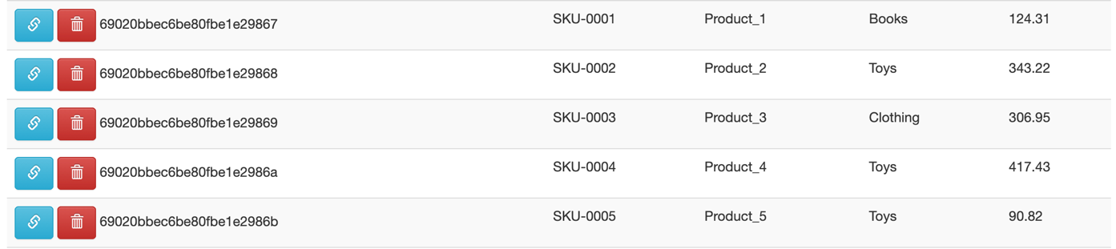
We used the data generation script provided and modified it by creating a function that returns three Pandas dataFrames : one for products, one for inventory, and one for purchases.
Next, we created an insertion script that uses the httpx library because we are using FastAPI with POST requests. This script inserts the data into the database.
We have to run this script manually after creating the container to insert the data.

Creation of the API

To create the API, in addition with FastAPI we chose to use Beanie. Beanie is an ODM (Object Document Mapper) to link the models in the API to a MongoDB database so that the 2 services work well with each other’s. And this library removes boilerplate code so the API development will be faster.
The API was developed following the CRUD architecture where every model has the following routes :
- Get (Unique)
- Get (Collection)
- Post
- Put
- Delete
The API is built with the following architecture :
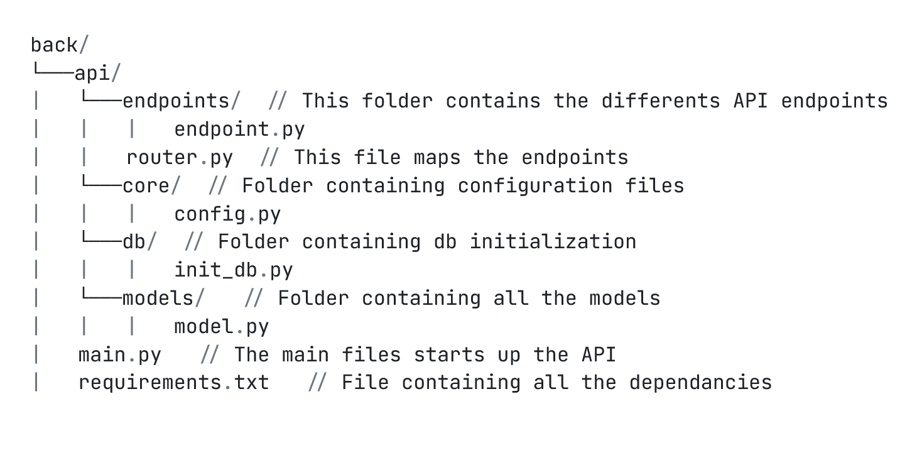
Here is an example of object that beanie will map in the MongoDB database :
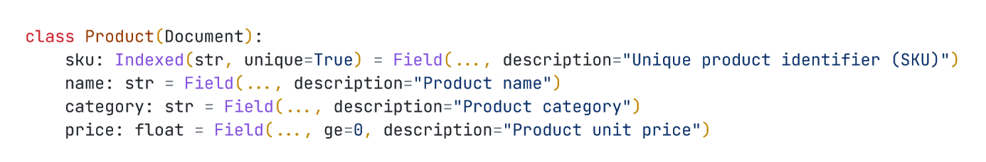

Here is another example of a specific endpoints :
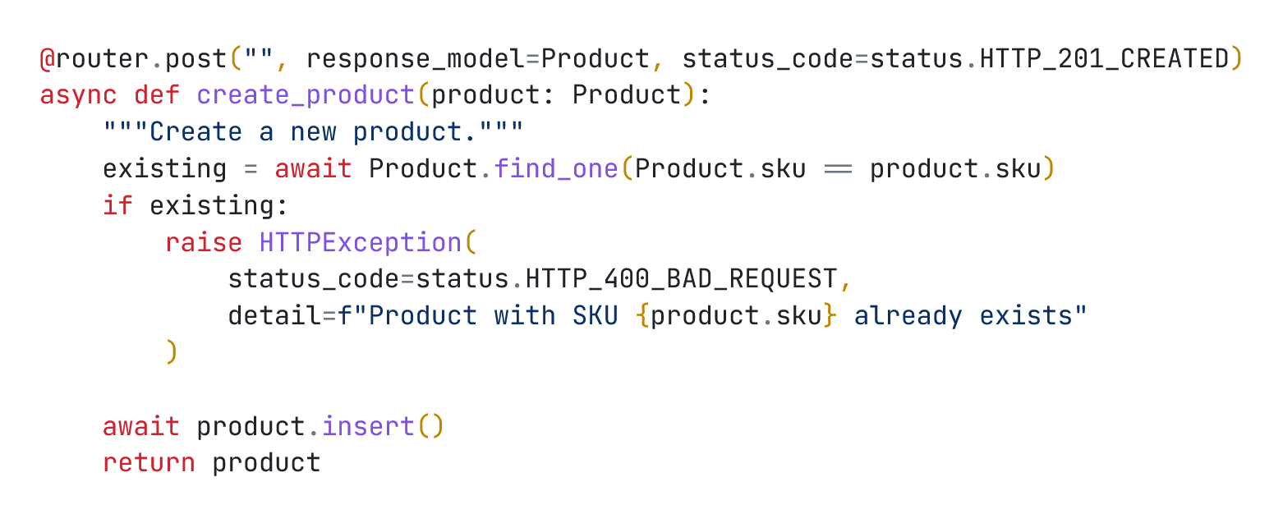
And here is an example of how the data is returned by the API
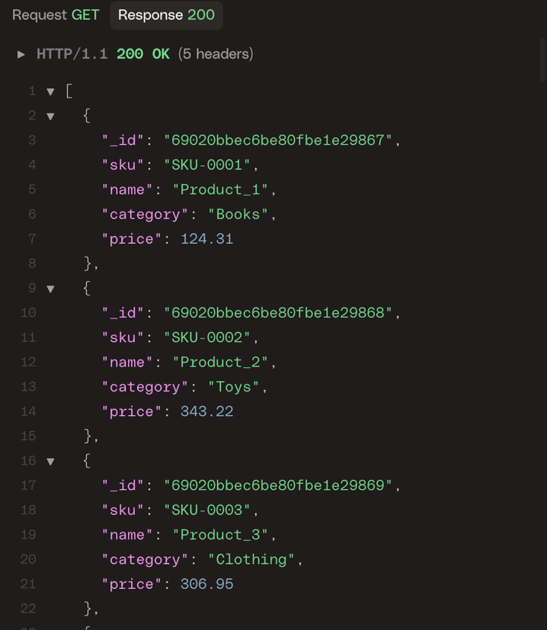

Conclusion

To conclude this first week, we have made good progress and have gained a good understanding of the project.
We find this work very interesting and believe it has real potential for the various companies that could use it.
We are eager to begin the second part of this project in order to produce a more meaningful and visual result.

