Project report – Week 2

Lilian Mirabel – Florian Chapoullie-Pino – Luc Lacotte – Floris Rimbeau

Summary
Introduction 2
Context 2
Objective 2
Project Overview 2
Distributing tasks 3
Story Point Estimation 3
LLM and test script 3
Work completed 4
Setting up the AI model 4
Backend Endpoints 4
MCP Layer 5
Linking the LLM to the MCP server 6
Minimalist Dashboard 7
Conclusion 8

Introduction

Context
We have established a solid technical foundation that enables efficient development in this second sprint. With MongoDB collections structured, CRUD operations implemented via FastAPI, and frontend development already in progress, our next step is to integrate an Agentic AI model into the system through an MCP (Model Control Protocol) server.
This week will therefore focus on developing the remaining backend endpoints and crafting prompts to provide our AI model, Mistral, with the necessary project context so it can accurately determine its actions. In addition, we will connect the backend to the frontend (a React application) to build a dashboard that enables quick visualization of relevant data and allows direct interaction with our model through the user interface.

Objective
The main objective of this sprint is to integrate AI-driven automation into the retail inventory management system. Specifically, the goal is to:
- Enable the AI agent to analyze sales and stock data to identify at-risk SKUs.
- Automatically generate purchase orders through the backend MCP layer.
- Deliver a functional dashboard that provides visibility into stock levels, purchase orders and key performance metrics.

Project Overview
This project is managed using the agile scrum methodology. The project being tracked by Jira, here are the different tickets we made for this sprint, which duration goes from November 3, 2025, to November 7, 2025 :
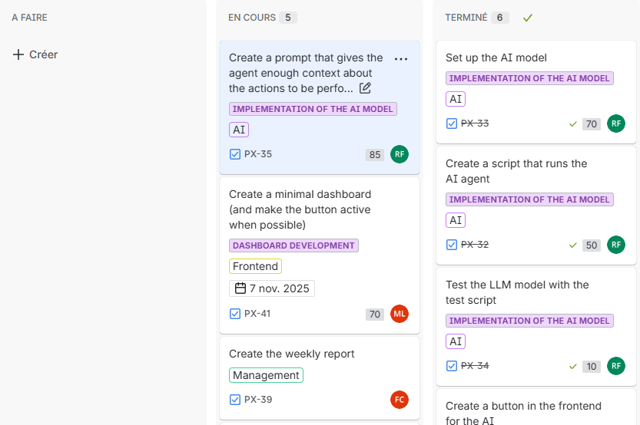

Distributing tasks
One of the challenges of the last sprint concerned the distribution of the different tasks, we got confronted with problem with parallelization, meaning that someone had to wait for the implementation of another person to start its work. To counter this problem, we splitted the tickets properly, and gave each person a series of tasks that follow one another.

Story Point Estimation
Another important improvement we introduced in our agile methodology was the use of story point estimation for each task. This approach provides a clearer visualization of the effort, complexity, and relative importance of the different tasks within the sprint. These estimations enhance our project management by helping us better plan workload distribution. They also serve as a valuable reference when analyzing our burndown chart, allowing us to verify whether our progress has remained consistent throughout the week.
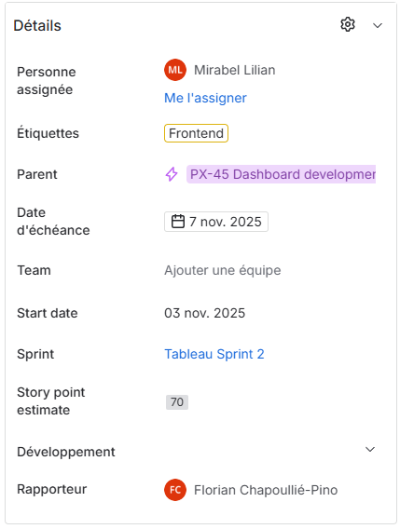
There are several methods for assigning story point estimates, in our case, we decided to use a scale from 0 to 100.

LLM and test script
At the beginning of the project, we were provided with a series of files designed to verify the proper setup and functionality of our technical stack. For this second sprint, the most relevant file was test_llm.py, a Python script used to validate communication with the LLM (Large Language Model). Running this script allowed us to confirm that the model, Mistral, in our case, was correctly installed.
Here is an example of the output returned by the test script, demonstrating that the connection with the model was successfully established and that it could generate coherent text responses:

Work completed
The team divided the tasks as follows:
- Luc: API development
- Floris: AI Agent implementation
- Florian: Project management & front-end development
- Lilian: Front-end development

Setting up the AI model
To install the AI model, we chose to create a new container specifically dedicated to this service.
To do this, we installed Python in the container, followed by the Hugging Face and llama-cpp python libraries.
Hugging Face will allow us to download the Mistral LLM model, and llama-cpp will allow us to run it.
After that, we were able to run the script to test the LLM and move on to developing the MCP server and endpoints in the backend so that we could interact with the MCP server.

Backend Endpoints
In the Backend, we still have the CRUD endpoints, and we added new endpoints to help the agent get more precise information.
The following endpoints are :
- Get the products that will be out of stock in n days
- Get the daily sales of multiple products based on a recent sale
- Get the current stock of multiple products
- Order multiple products

MCP Layer
As we said earlier, we created a new service for the AI agent. This forces us to simulate HTTP calls to a supplier because having the MCP in the same service as our backend could have direct access to the database using the CRUD functions instead of the endpoints.
To create the MCP Layer, we used the “mcp” library
This is an example on how you create to tool usable for a LLM :

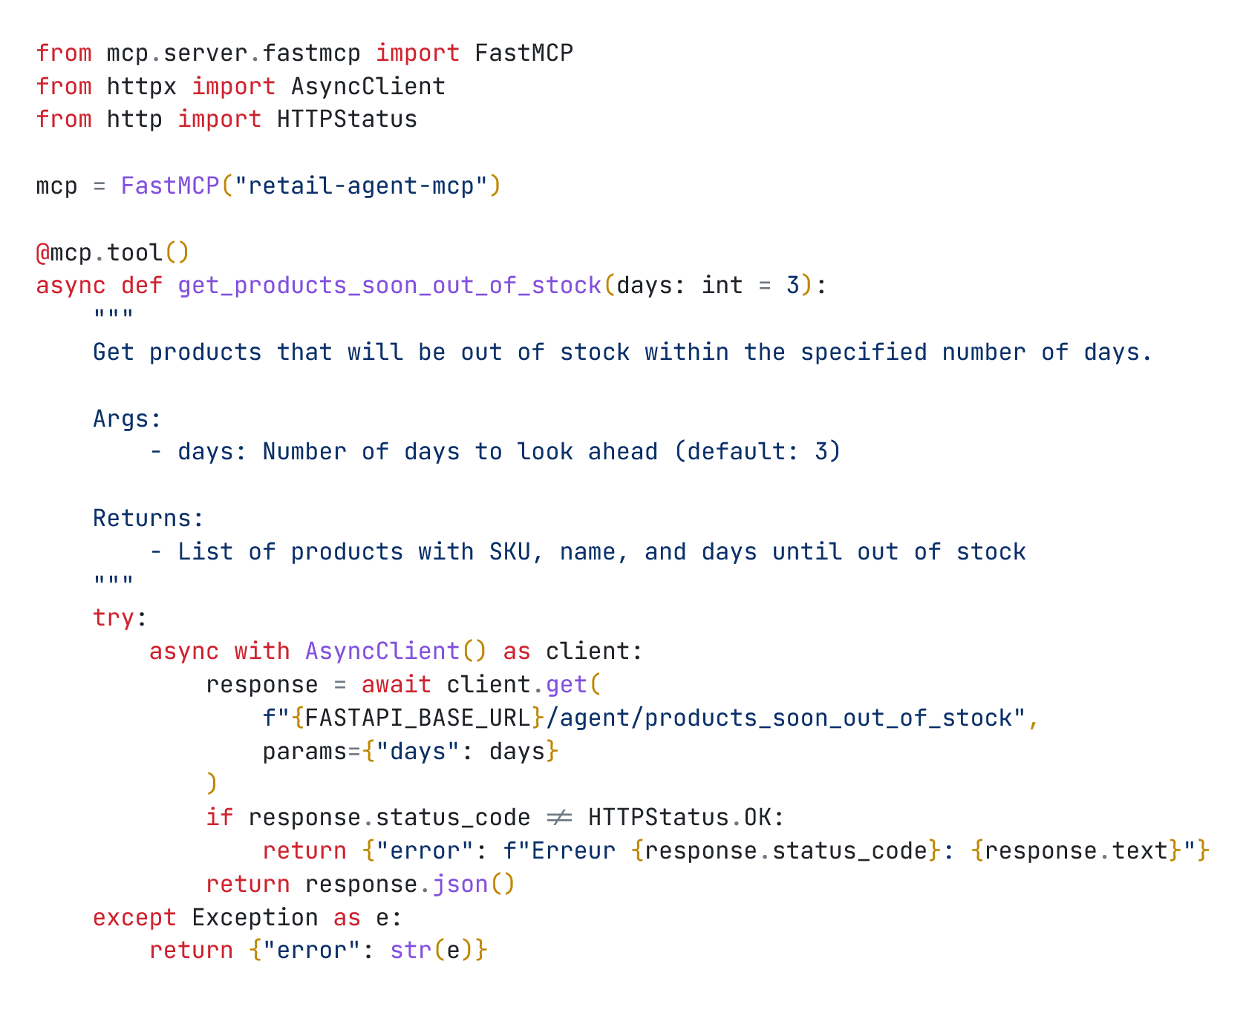
We first import FastMCP from mcp.server.fastmcp and we initialize it by calling its constructor and assigning it to the mcp variable.
Then we can use decorators using the tool function of the FastMCP class to flag the function as a tool that the LLM will be able to use.
Then we can write the logic of our function.
Adding a comment explaining the function will give context for the LLM and the response will be sent to the LLM when both sides will be linked.

Linking the LLM to the MCP server
To link both sides, when starting the services, we first initialize both the MCP server and the LLM so that they are ready to be used.
We first created a script that will retrieve the products that will be out of stock and order a fixed quantity.

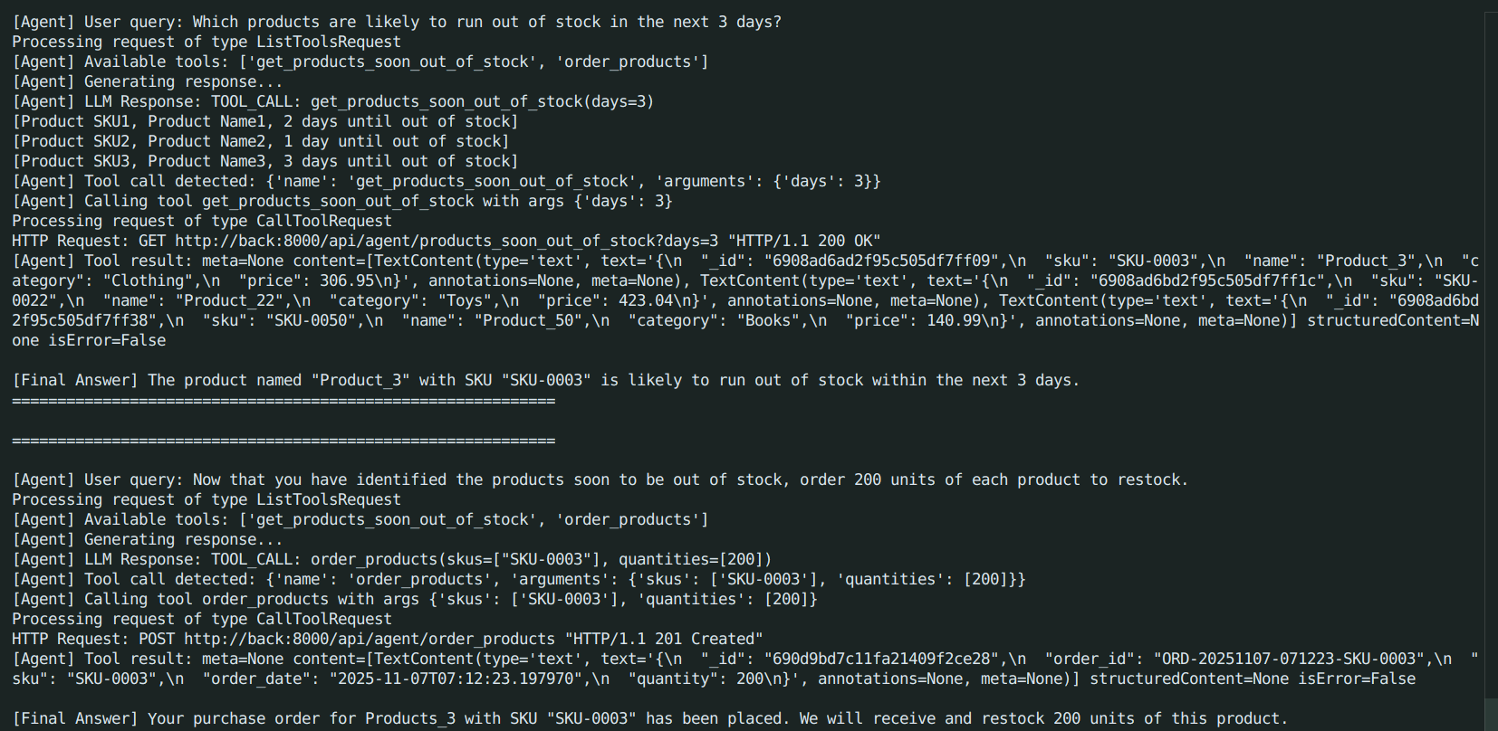
As we can see from the output, the tool gives us 3 products that will soon be out of stock but the answer of the LLM contains a single product. This a problem we could not figure out how to fix it. We will try to figure it out in week 3 maybe by changing the LLM model or by changing the prompt used to achieve the result.
One of the other problems that we have right now is that our agentic AI has a set script and an interaction with a user is currently possible only by changing the prompt directly in the code.

Minimalist Dashboard
For the dashboard, we used TypeScript with the React library.
For the style of this dashboard, we used Tailwindcss and DaisyUI, which greatly facilitates design and allows for beautiful rendering with ease.
To create the graphs, we used the recharts library, which offers a wide range of graphs, which was perfectly suited to our dashboard usage.
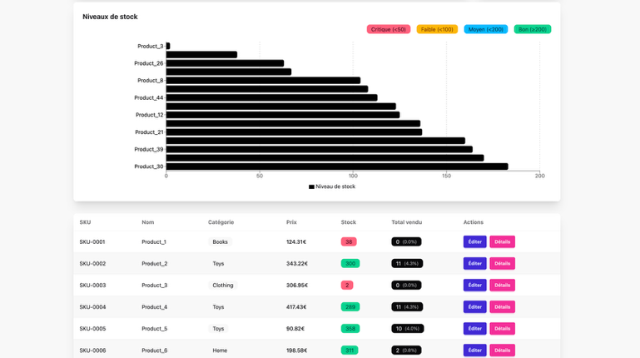
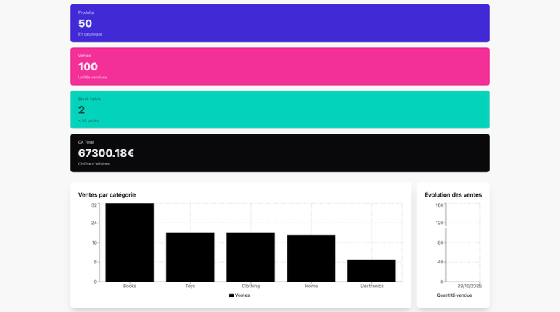
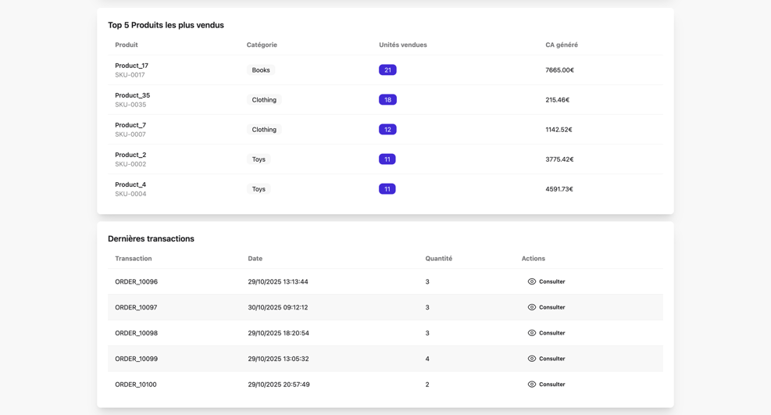

Conclusion
During the second week (Sprint 2), we focused on strengthening the robustness of our stack. We integrated a beginning script for the Agentic AI logic into our service. This integration marked a key step toward achieving a fully automated and data-driven retail inventory management solution and we will be focusing on it in the next sprint. We also develop the dashboard so that it now displays all relevant data by retrieving it using our backend.
This integration marked a key step toward achieving a fully automated and data-driven retail inventory management solution.
Thanks to this sprint, we were able to develop our knowledge in:
- Agent automation and decision-making with Python and open-source LLMs
- Backend integration using FastAPI
- React dashboard development for data visualization and agent interaction
- API orchestration between the agent, MongoDB, and the user interface

