EFZN_RDM

Resources and Materials for the RDM Course sponsored by EFZN

[Logos]

Course Overview

Welcome to "Research Data Management in the Energy Sector"! This course is dedicated to teach all skills necessary to understand the principles and motivation behind Research Data Management (RDM) and enable you to implement RDM in your work and research group.

The course will focus on applicability in the energy sector.

Roadmap

If you complete the course, you will have established a basic Data Management Plan for a project of your choice that you can build upon and adapt. However, if you have time restraints or already a broad understanding of handling research data, you may choose to go for individual learning sections by clicking on them.

[link to learning path map]

What is Research Data Management?

In early 2020, the COVID-19 disease, caused by the coronavirus SARS-CoV2, broke out globally, which led to the closure of many shops and businesses for quarantine reasons. The result, especially in the USA, was a large number of unemployed people who urgently needed money for their next rent payment, food or other expenses. As a consequence, the government decided to set up a relief package for anyone who registers as unemployed - but why didn't the money get to the people? The reason for this was the overload of critical systems on which COBOL is still running. COBOL is a programming language that was developed in the late 1950s to control commercial applications. From today's perspective, the programming language is very outdated and no longer taught in the training of programmers. That is why there was no personnel to take care of the systems when they collapsed. Unfortunately, many applications with the outdated programming language are still running in the business sector.

Source: [Scarytales 26: If it ain't broken... CC 0](https://forschungsdaten-thueringen.de/fdm-scarytales/articles/ueberblick.html)

**Exercise**: Suggest two possible process changes that could have prevented the outcome of the scenario:

There are several solutions possible: Existing systems should be questioned, since requirements can change and established habits can lead to problems from today's perspective. For example, at some point data might no longer be able to be called up or might exist in formats that are increasingly difficult to be processed. A thorough documentation of the programs might also help in some cases to rebuild them in other languages. For timely relief, the administration called out to retired COBOL programmers to work on the issues.

While maybe not as critical for society at large, scientists can face similar problems when trying to access old data or programs that were written for other purposes but are now needed for the current tasks: Data are insufficiently labeled, have been overwritten, commercial computer programs have been discontinued or process details have not been recorded.

**Research Data Management** (RDM) aims to break this dynamic by ensuring a sustainable and coherent strategy for all data types throughout the research process, enabling researchers to store, access and re-use their own work effectively and safely and opening their findings worldwide to improve on cross-disciplinary collaboration, monitoring and replication.

RDM includes all activities associated with

* processing
* storage
* preserving and
* publication

of research data.

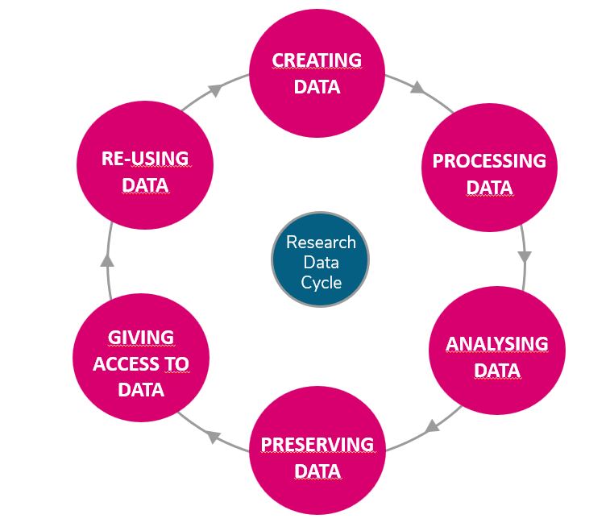

Quelle: <https://ukdataservice.ac.uk/learning-hub/research-data-management/>, recreated by Antje Ahrens. Licensed under CC-BY-4.0