Open Science

**[missing paragraph:** Definition of open Science, relevance for society]

**Research**: Is there an open science or research data policy at your institution? What is its scope? What is regulated and how?

If not: Would you like to have a research data policy? What content should it have?

FAIR Guiding Principles

"As open as possible, as closed as necessary"

This is the main idea behind the FAIR principles. The acronym stands for

* Findable
* Accessible
* Interoperable
* Re-Usable

For the original paper on the FAIR Guiding Principles, see: <https://www.nature.com/articles/sdata201618>

**Exercise**: Look closely at the graph to indentify which measures especially apply to your area of work and data types you are using.

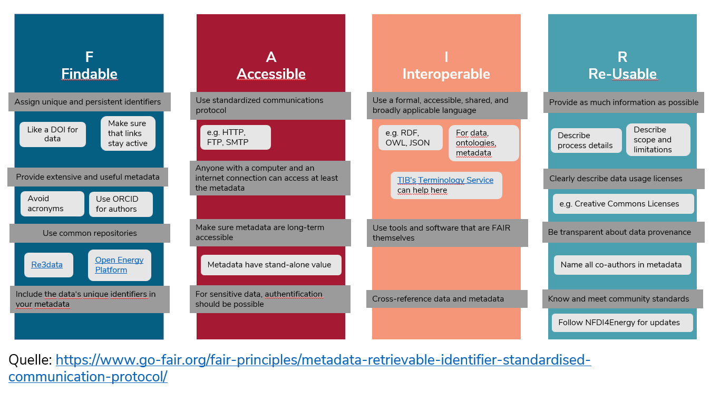

**Quiz**: What can you do to make your data FAIRer?

[[X]] use Creative-Commons or GNU Licenses

[[ ]] keep processing details undisclosed

[[ ]] ensure access security

[[X]] create detailed Metadata

[[X]] ensure long-term accessibility in repositories