Data Management Plan

The Data Management Plan (DMP) contains all information that describes and documents sufficiently the collection, processing, storage, archiving and publication of research data within a research project.

Many public funding organizations require a DMP prior to granting funds for research projects, thus making DMPs an integral part of the scientific process, especially in data-intensive research fields such as the energy sector.

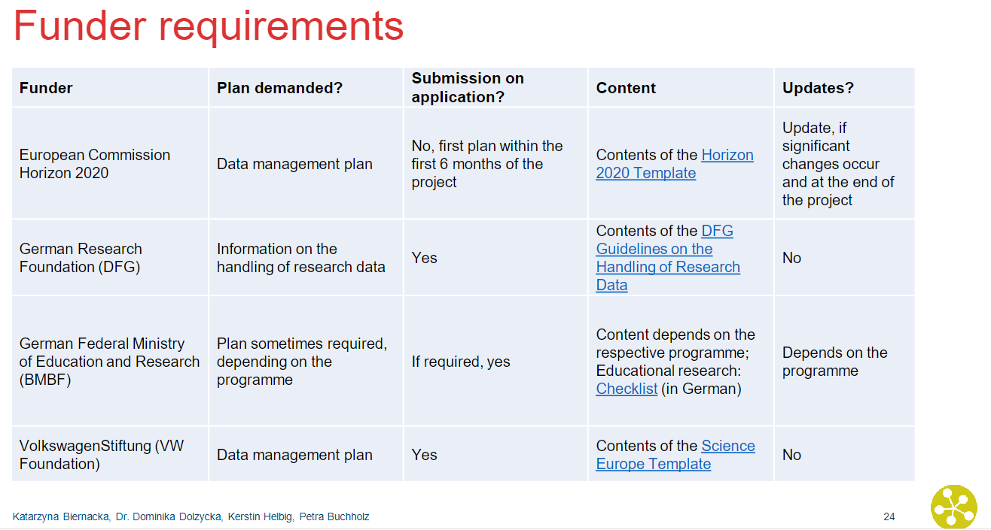

 [update this table and add relevant funders for energy sector]

There are several tools available that can be helpful in the creation of a DMP (see Tricks & Tools for some examples). In our example, we will work with **RDMO**, a tool that can be used collaboratively and exports into different formats.

Start by clicking on the following Link: <https://rdmo.forschungsdaten.info/>

[work with short screencasts/gifs that show the important steps?]

**Exercise**: Choose a questionnaire that you want to follow. Start by filling in your project details.

Congratulations! You have started your first DMP!