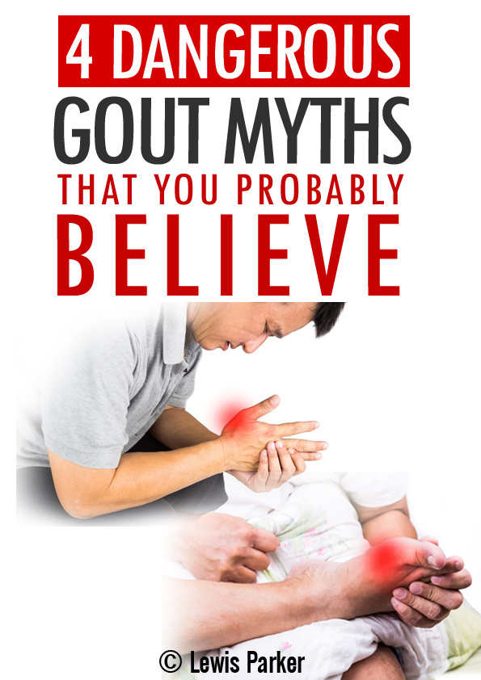

**Have you been Diagnosed with Gout?**

Are you experiencing gout related pains? Do friends and family brew up questionable remedies or tell you to watch certain star patterns to help cure your pain?

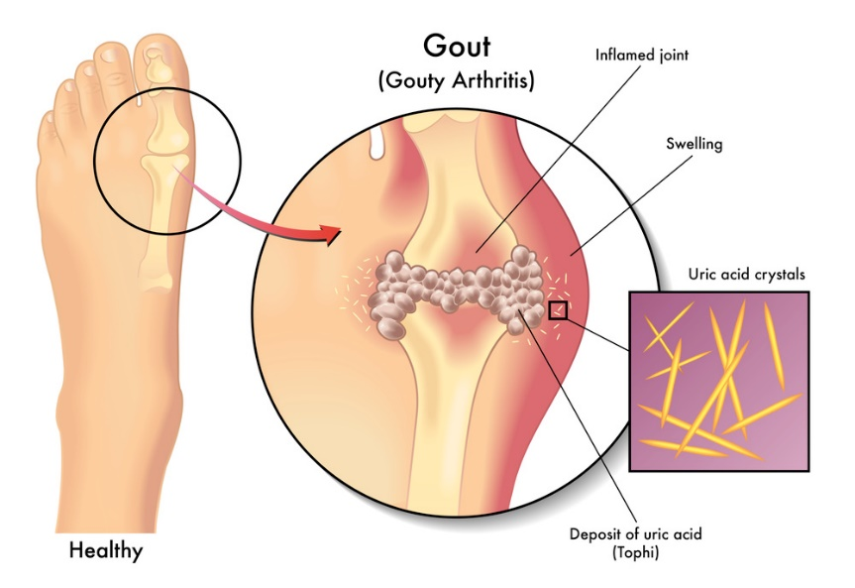

I know the feeling of having an unclear path ahead. My name is Robert Miller, and I used to have gout myself. The lightest pressure from simply putting weight on the front of my big toe would send me into a baby-like crying fit.

It HURT bad.

Friends and family would naturally try and help. They probably suggested many of the same things that you’ve heard yourself.

Well it’s time to finally dispel truth from myth.

Below are four common gout related myths that you need to know about in order to really understand what goes on in your body. Once we begin to understand the inner workings of gout, can we proceed to an actual solution.

**Myth #1: Thinking that Gout is a lifelong illness**

I’m shocked every time I hear a concerned person tell me in an almost accepting voice that they have gout “and that’s just life.”

You know what’s another part of life? Getting rid of gout!

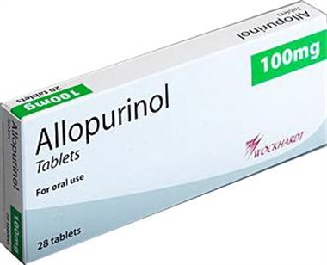

I don’t recommend medications because of their harmful side effects, but any doctor will happily prescribe you meds that whilst they may contain your symptoms, they do NOTHING to actually cure your gout.

“Side effects of allopurinol include: numbness/tingling of arms/legs, easy bleeding/bruising, signs of infection (e.g., fever, persistent sore throat), unusual tiredness, signs of kidney problems (such as change in the amount of urine, painful/bloody urination), yellowing eyes/skin, severe stomach/abdominal pain, persistent nausea/vomiting, dark urine, unusual weight loss, eye pain, vision changes...” - **WebMD**

Of course to treat the underlying issue requires some changes, which we’ll discuss in just a moment. But the fact of the matter remains that gout is perfectly treatable, and yes fully curable.

So don’t let anyone relegate you to a life sentence with gout. You can win this war!

**Myth #2: Believing that Gout is caused by uric acid**

This one is a half-truth.

It’s a partial myth because uric acid is responsible for gout, yes. But it’s NOT true that uric acid in the blood equals gout. This is a key difference that helps us understand what the true cause of the issue is.

Did you know that it is perfectly normal for uric acid to be present in the blood? This is true for both healthy and unhealthy individuals.

It’s when the uric acid levels exceed a certain threshold that they become problematic. The general guideline is 6.5 mg/dl, in case you’d like to ask your doctor to run a test for you.

Scientists estimate that once this threshold is crossed for a sustained period of time, uric acid begins to spill over from the blood into the joint cavities, and begin an unhealthy process of accumulating in crystallized form.

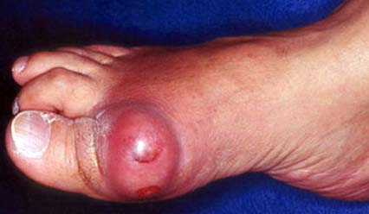

This is as bad as it sounds. The good news is that the build-up takes an extremely long time before it causes painful swelling – we’re talking years.

Interestingly, the time of life when gout affects people depends on gender.

For males, the uric acid buildup process begins to happen after puberty, again assuming elevated uric acid levels are present. Because it takes many years to reach critical levels of buildup in the joints, men deal with gout issues in their late 30s or later.

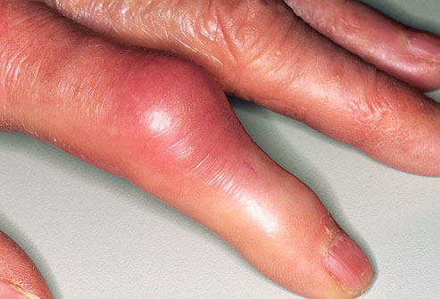On the other hand, the uric acid crystal build up in the joints tends to occur after menopause in women, meaning it takes them much longer to experience gout related symptoms. It’s not uncommon for a woman to be well into her 60s or 70s before dealing with gout symptoms.

It is important to remember that uric acid is a naturally-present waste product in the body, and your body is more than equipped to deal with it. Gout occurs when something in the body disrupts this status-quo, but thankfully this can be restored by providing the right trigger and the right substances.

**Myth #3: Gout only affects the big toe**

From the above we understand now that it takes a long time for gout to occur up in the joints. But not all joints are affected equally.

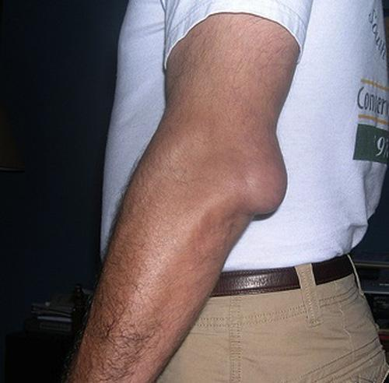

The uric acid crystallization process needs colder temperatures in order to occur. Therefore, it is usually the big toe that is the first to be affected by gout. However, gout can also occur in other joints, particularly those of the fingers and also the elbows.

Gout is considered a type of arthritis. It’s an especially painful type, which can cause swelling and redness around the affected area. However, as we’ve learned from myth one, this is a reversible illness and all it takes is nudging our bodies back to their previous balanced state.

**Myth #4: Thinking that eating vegetables and other high purine foods increases uric acid production, leading to gout.**

As you now know by now, uric acid buildup is responsible for gout-related pains. There is a misunderstood notion that purines found in vegetables and other healthy foods can turn into uric acid and exacerbate the problem.

It is true that purines can turn to uric acid, but studies have shown that the human body generally doesn’t do this with produce-based purines, except in emergency circumstances. It certainly wouldn’t overproduce uric acid leading to gout. In fact, many of these healthy ingredients are exactly what we use to help reverse gout all naturally.

“Limiting purine-rich vegetables intake for lowering plasma urate may be ineffectual, despite current recommendations” – **Journal of Arthritis & Rheumatism**

Going on some weird, restrictive diet is NOT the way to get rid of gout effectively.

**Cure gout all naturally by getting to the foot of the matter**

Now that you understand what gout isn’t, it’s important to know what gout is and how to solve it.

Quite simply, gout is an imbalance ailment. Uric acid is produced from birth, yet normally the body does a good job of getting rid of it as quickly as it is produced. Symptoms occur when an inefficient body over-stores uric acid where it shouldn’t.

Doesn’t it make sense then, that rather than masking the symptoms (as drugs do), you fix what has gone wrong?

After all, we’re not asking your body to do anything magical. We’re simply getting it back to its natural state. Is it really that complicated?

In **The Gout Eraser™**, you’ll learn how Okinawans have been curing gout for centuries, and how to use this knowledge to cure yourself of gout in 7 days or less.

“Besides holding the record for longevity and centenaries of the world, Okinawa is the only place where 80-90 year-olds live like persons 30 years younger. Ancient Chinese legends already called Okinawa ‘the land of the immortals’ ” - **Indian Journal of Community Medicine**

The process is both easy to follow and straightforward – it’s a fool proof way for anyone to get rid of gout rapidly, safely, and permanently.

**Does it Really Work That Fast?**

At this stage, you’re probably thinking that the program sounds powerful – but can it really work that fast?

I don’t blame you for being skeptical. Most people are. But have a look at the experiences of some of the people who tried the program:

Here’s an example from Mary Nolan, from Canberra:

*I got your guide when I was suffering from a 13 day long acute attack that wasn’t getting any better even with high dose Advil and Colcrys. After doing your recommendations, I IMMEDIATELY started feeling better and the pain was completely gone barely 30 hours later. The Gout Eraser is a MUST HAVE for any gout sufferer.*

John Hunter, from Texas, writes:

*Dear Robert, I wanted to send you a quick thank you email as your guide has saved my life. I had been plagued with gout for over 5 years and even though I’m just 41 I was feeling more like a 70 year old with the pain and lack of mobility. I had previously been relying heavily on Catafast to aid with the pain but it had started to cause problems with my stomach. Now I’ve been completely off Catafast and yet all the pain is gone thanks to The Gout Eraser. God bless*

And Karl Johnson, from London:

*Just 3 weeks of following The Gout Eraser and my uric acid levels are down from 9.8mg/dL to 5.9mg/dL – my doctor was astonished when he saw my results and said he never saw such a drop in such a short amount of time, even with medications!!! He said he’ll look you up as I gave him your details (hope that’s ok!)*

These are just a few of the success stories – there are many at The Gout Eraser™ website. [**Click here to check them out**](http://zzzxxxxxzzz.goutcode.hop.clickbank.net)**.**

**How Does The Gout Eraser™ Work So Well?**

Gout can make even basic tasks such as sleeping or wearing a shoe extremely painful. It’s also a condition that the medical profession often doesn’t take seriously – which can be incredibly frustrating for those affected by it.

Robert understands these frustrations, and using ancient Okinawan methods, has designed **The Gout Eraser**™ to provide rapid pain relief without dangerous medicine, expensive treatments or hours of therapy.

The program also doesn’t rely on covering up pain or temporarily reducing it. Instead, it is designed to eliminate gout PERMANENTLY.

Best of all, The Gout Eraser™ system is completely natural, meaning that it is totally free of side effects. In fact, most people who have used The Gout Eraser™ not only experience rapid eradication of their gout, but also report feeling a sense of rejuvenation and wellbeing.

Best thing about it? It is 100% risk-free for you: If it works– great! And if it doesn’t, Robert offers a **full no-questions-asked money-back guarantee**…basically if for any reason (or no reason at all) you are not blown away by the results, you get all your money back – *no questions asked*.

You’ll also get to keep the entire system for free!

You really have nothing to lose, except your gout pain – fast. So what are you waiting for?

Take advantage of this incredible offer right now -100% risk-free.

**[CLICK HERE To Watch the FREE Gout Eraser™ VIDEO](http://xxxxx.gout1.hop.clickbank.net/)**

**[and get started immediately!](http://xxxxx.gout1.hop.clickbank.net/)**

[](http://xxxxx.gout1.hop.clickbank.net/)

Scientific References:

* Bendjilali, N et al., 2014, ‘Who Are the Okinawans? Ancestry, Genome Diversity, and Implications for the Genetic Study of Human Longevity From a Geographically Isolated Population’, *Journals of Gerontology Series A: Biological Sciences and Medical Sciences,* Volume 69 Issue 12
* Jeyaruban, A et al., 2016, ‘Prevalence of comorbidities and management of gout in a tropical city in Australia’, *Rheumatology International,* Volume 36 Issue 12
* Choi, HK et al., 2005, ‘Intake of Purine-Rich Foods, Protein, and Dairy Products and Relationship to Serum Levels of Uric Acid: The Third National Health and Nutrition Examination Survey’, *Arthritis & Rheumatism*, Vol 52 Issue 1
* Mishra, BN. 2009, ‘Secret of Eternal Youth; Teaching from the Centenarian Hot Spots (“Blue Zones”)’, *Indian Journal of Community Medicine*, Volume 34 Issue 4
* Saseen, WL., 2016, ‘Gouty Arthritis: A Review of Acute Management and Prevention’, *Pharmacotherapy,* Volume 36 Issue 8