Proposal to FFplus Project Call-2 – Type-2: Innovation Studies for the Development of Generative AI Models

Part B
Call Information:
Identifier: FFplus_Call-2-Type-2
Call title: Second call for innovation studies for the development of generative AI models
Project full name: Fortissimo Plus
Acronym: FFplus
EuroHPC Project 101163317
Deadline: February 25th, 2026, at 17:00 Brussels local time
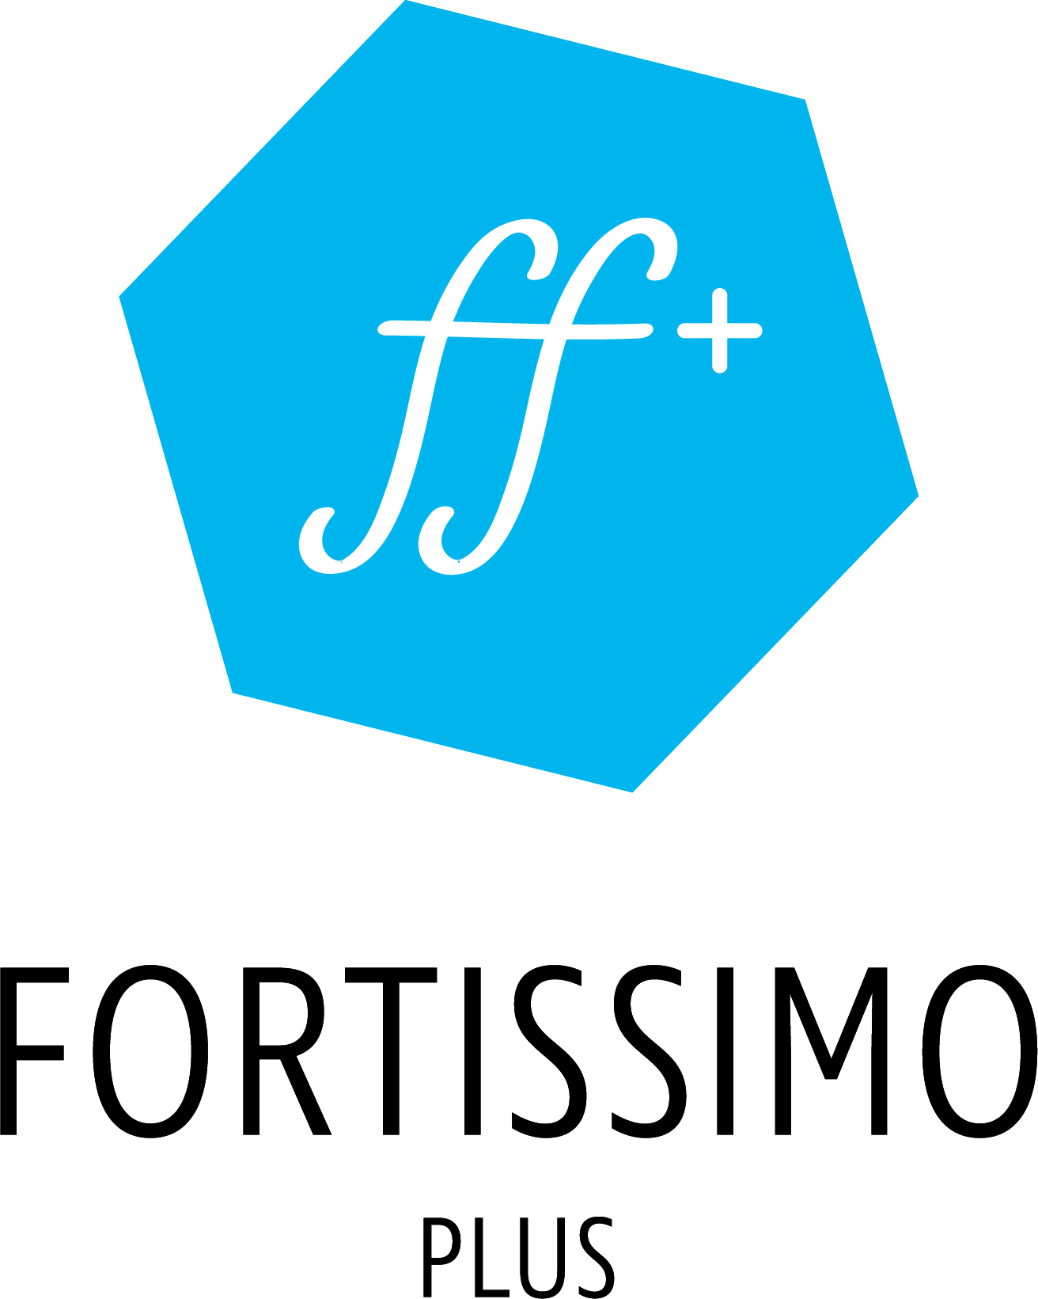

  - CosTERRA — Cognitive System for Technical Engineering, Research & Architectural Documentation

Name of the coordinating person: Evgeniy Areshkin, ALD Engineering & Construction LLC
E-mail: evgeniy@ald.ua

This cover page may not be extended with any additional text/information.
This cover page will be ignored when the page count of the proposal is checked.

Summary
CosTERRA (Cognitive System for Technical Engineering, Research & Architectural documentation) is a 10-month innovation study to develop a domain-specific generative AI model for the automated generation of construction cost estimation documents compliant with Ukrainian building standards (DBN, DSTU). The main participant, ALD Engineering & Construction LLC, is a Ukrainian SME (219 employees) operating a proprietary ERP system and SaaS platform that processes thousands of cost estimation documents annually. Over six years of operations, ALD has accumulated a unique structured dataset encompassing bills of quantities, material specifications, regional pricing histories, supplier databases, and standardized project templates — a corpus that no publicly available large language model has been trained on. General-purpose LLMs cannot reliably generate cost estimation documents because they lack knowledge of Ukrainian construction norms, cannot produce internally consistent numerical calculations, and fail to integrate real-time structured database inputs. CosTERRA addresses this gap by fine-tuning an open-source multilingual foundation model (7–13B parameters) on ALD's proprietary instruction–output pairs using EuroHPC pre-exascale GPU infrastructure, augmented with a custom structured-data encoder to condition text generation on ERP database inputs (current prices, material codes, regulatory coefficients). The supporting participant, Zaporizhzhia National University's Laboratory of Parallel and Distributed Computing, contributes HPC optimization expertise, distributed training pipeline engineering, and rigorous model evaluation. Expected outcomes include a validated generative model achieving ≥85% document-level compliance with construction standards, a 70–80% reduction in document creation time, and a clear integration pathway into ALD's commercial SaaS platform. The study encompasses the full ML lifecycle — data preparation, model development, and evaluation — and will apply for EuroHPC AI Factories access for 8,000 GPU-node-hours of training on A100/H100-class accelerators. Neither ALD nor ZNU is an FFplus beneficiary, and neither participates in FFplus Type-1 business experiments. Ukraine has been associated with the Digital Europe Programme since September 2022, confirming full eligibility [1].

Industrial relevance, potential impact and exploitation plans
ALD Engineering & Construction LLC is a Ukrainian SME with 219 employees, established as a limited liability company and fully qualifying under the European Commission's SME definition (<250 employees, independent enterprise). ALD's core business comprises construction engineering, cost estimation, and procurement management across the Ukrainian construction market. The company operates a proprietary Enterprise Resource Planning (ERP) system that serves as the backbone for processing construction project documentation, procurement workflows, and cost estimation across hundreds of active projects.
ALD has developed and commercialises a Software-as-a-Service (SaaS) platform offering construction documentation services to external clients, generating recurring subscription revenue. The platform currently handles thousands of cost estimation documents per year, and ALD's software engineering division (18 developers) maintains and evolves both the ERP backend and the SaaS frontend. This existing digital infrastructure provides the ideal substrate for integrating a generative AI model into production workflows.
- Regarding HPC awareness, ALD's current computational needs are met through cloud-based infrastructure sufficient for ERP operations but entirely inadequate for training multi-billion-parameter generative models. ALD recognises that large-scale model training constitutes a fundamentally different computational paradigm requiring distributed GPU clusters, high-bandwidth interconnects, and optimised training pipelines — capabilities available through EuroHPC pre-exascale systems. The partnership with ZNU's Laboratory of Parallel and Distributed Computing specifically addresses this capability gap, bringing expertise in parallel computation, distributed systems, and GPU-accelerated workloads [2].
- Construction cost estimation in Ukraine requires generating detailed technical documents that strictly comply with national building standards — DBN (State Building Norms) and DSTU (State Standards of Ukraine). These documents include bills of quantities (BOQs) with material specifications and unit pricing, cost estimate summaries, resource statements breaking down labour, materials, and equipment, and technical specifications referencing current norms and regulatory coefficients.
- The document generation process is currently manual, labour-intensive, and error-prone. A single comprehensive cost estimation package for a mid-size construction project requires 3–7 working days of effort by a qualified cost engineer who must simultaneously: (a) consult current regional material prices across multiple suppliers, (b) apply the correct building standard references from a corpus of hundreds of active DBN/DSTU documents, (c) calculate quantities, apply pricing coefficients and overhead rates, and ensure internal numerical consistency, and (d) format the output according to strict documentation standards.
ALD processes approximately 2,500 such documents annually. At an average of 4 person-days per document, this represents over 10,000 person-days of specialist effort per year — a bottleneck that limits scaling. Human error rates in manual cost estimation are estimated at 5–12% per document [3], where errors in standard references, pricing coefficients, or quantity calculations can invalidate entire estimates, causing project delays, contractual disputes, and financial losses.

Description of the work plan, technological/algorithmic approach and software development strategy
The CosTERRA innovation study defines five measurable objectives mapped to the ML lifecycle:
- O1 — Data Preparation. Extract, transform, and validate ALD's proprietary procurement data into a high-quality training corpus of ≥50,000 instruction–output pairs, achieving ≥95% data quality score (completeness, consistency, correctness).
- O2 — Model Architecture Design. Design and implement a transformer-based generative architecture with a structured-data encoder capable of conditioning document generation on ERP database inputs (prices, material codes, regulatory coefficients).
- O3 — Model Training. Conduct full-parameter fine-tuning of a 7–13B parameter multilingual foundation model on EuroHPC pre-exascale infrastructure, completing ≥3 full training runs with systematic hyperparameter optimisation.
- O4 — Evaluation and Benchmarking. Evaluate the trained model against defined baselines achieving: (a) ≥85% document-level compliance with DBN/DSTU standards; (b) ≥90% numerical consistency in calculations; (c) ≥0.75 ROUGE-L score against reference documents; (d) ≥80% expert acceptance rate in blind evaluation.
- O5 — Reporting and Impact Assessment. Deliver a pre-final results and potential impact report by Month 7, and a comprehensive final report documenting the model, training methodology, evaluation results, and business impact projections.
The primary training dataset is ALD's proprietary procurement database, accumulated over six years of production use in the company's ERP system. The dataset is immediately available and under ALD's full ownership and control.
- Dataset composition:
- ~12,000 completed cost estimation documents with associated metadata
~180,000 line items with material specifications, quantities, unit prices, and supplier references
CosTERRA — Cognitive System for Technical Engineering, Research & Architectural Documentation
Participant short name | ALD | ZNU
Role | SME (Main Participant) | HPC Expert (Supporting)
CosTERRA develops a domain-specific generative AI model (7–13B parameters) for automated generation of construction cost estimation documents compliant with Ukrainian building standards (DBN, DSTU). The model is fine-tuned on ALD’s proprietary dataset of ≥50,000 instruction–output pairs using EuroHPC pre-exascale GPU infrastructure, with a custom structured-data encoder for real-time ERP database integration.

Task 1: Data Engineering
Duration: M1–M3
Participants: ALD: 6 PM, ZNU: 1 PM
Deliverable: D1.1: Validated training corpus (M3)
Technical description:
Extract structured data from ALD ERP (PostgreSQL); transform into instruction–output pairs; augment with standards references; validate quality (automated + expert review); establish data versioning with DVC.
Computational Resources: ALD development servers; 100 GPU-hours for data quality profiling

Task 2: Architecture Design & Baselines
Duration: M2–M4
Participants: ZNU: 3 PM, ALD: 2 PM
Deliverable: D2.1: Model architecture specification (M3); D2.2: Baseline evaluation report (M4)
Technical description:
Design structured-data encoder; implement integration with transformer base model; benchmark 4 baseline systems on held-out test set; select optimal base model; implement distributed training pipeline (FSDP).
Computational Resources: 500 GPU-node-hours for baseline experiments

Task 3: Model Training & Optimisation
Duration: M4–M8
Participants: ZNU: 4 PM, ALD: 3 PM
Deliverable: D3.1: Trained CosTERRA model (M8)
Technical description:
Full-parameter fine-tuning on EuroHPC; 3+ training runs with hyperparameter search (learning rate, batch size, sequence length); mixed-precision training; checkpoint management; convergence monitoring via MLflow.
Computational Resources: 6,400 GPU-node-hours (main training)

Task 4: Evaluation & Benchmarking
Duration: M7–M9
Participants: ALD: 4 PM, ZNU: 2 PM
Deliverable: D4.1: Month 7 pre-final report (M7); D4.2: Final evaluation report (M9)
Technical description:
Evaluate against all metrics (compliance, numerical consistency, ROUGE-L, BERTScore, expert acceptance); ablation studies; comparison against baselines; error analysis and failure mode documentation.
Computational Resources: 800 GPU-node-hours for evaluation

Task 5: Integration Design & Reporting
Duration: M8–M10
Participants: ALD: 5 PM, ZNU: 1 PM
Deliverable: D5.1: Integration architecture (M9); D5.2: Final report (M10); D5.3: Success story (M10)
Technical description:
Design API interface for ERP integration (architecture only, no deployment); document model card; prepare final report with business impact analysis; contribute to FFplus success story.
Computational Resources: 200 GPU-node-hours for demonstration

Total required GPU-node-hours: 8,000 on A100/H100-class GPU nodes (8 GPUs per node, equivalent to 64,000 GPU-hours).
EuroHPC access plan: The consortium will apply for EuroHPC AI Factories access. Target systems: LUMI (CSC, Finland), MareNostrum 5 (BSC, Spain), or Leonardo (CINECA, Italy). Application will be submitted with HPC National Competence Centre assistance.
Software: PyTorch ≥2.2, HuggingFace Transformers, DeepSpeed/FSDP, MLflow, CUDA ≥12.0. Storage: ~10 TB for training data, model checkpoints, and experiment logs.

Outputs:
• Validated training corpus of ≥50,000 instruction–output pairs for construction cost estimation
• CosTERRA generative model: fine-tuned 7–13B parameter transformer with structured-data encoder
• Comprehensive evaluation report with metric scores against 4 baselines
• Model card and integration architecture specification
• Open-source evaluation benchmark for construction document generation
• Data management plan and trustworthy AI assessment
Impact:
• Validated technical feasibility for AI-powered cost estimation (de-risks €1.5M+ annual savings)
• Production-ready model architecture for integration into ALD’s SaaS platform
• Competitive advantage in Ukrainian construction technology market
• Foundation for regional market expansion (Kazakhstan, Georgia, Moldova)
• Demonstrated EuroHPC utilisation pathway for SME generative AI development

Participants and effort
Participant | ALD | ZNU |  |  |  | TOTAL
Effort (PM) | 20 | 11 |  |  |  | 31
~45,000 BOQ entries with standard references (DBN/DSTU codes)
Regional pricing data covering 18 Ukrainian oblasts over 6 years (~2.1M price records)
~800 project templates covering residential, commercial, infrastructure, and industrial construction

Quality of the consortium as a whole and of the individual proposers
Organisational capability. ALD is a Ukrainian SME (LLC, 219 employees) with over six years of operations in construction engineering, cost estimation, and procurement management. The company operates a proprietary ERP system and a commercial SaaS platform for construction documentation services, demonstrating proven capability in enterprise software development, large-scale data management, and SaaS product delivery. ALD's software engineering division comprises 18 developers experienced in full-stack development, database engineering (PostgreSQL), API design, and cloud infrastructure management. The company processes approximately 2,500 cost estimation documents annually through its ERP system, maintaining a production database of over 2.1 million price records, 12,000 completed documents, and 180,000 structured line items.
ALD's qualifications directly address the call's requirements for generative AI, software development, project management, and data processing: (a) Generative AI: ALD's development team has implemented ML-based data analytics within the ERP system (automated anomaly detection in pricing, predictive material demand forecasting) and has conducted preliminary experiments with LLM-based document generation (GPT-4 API integration for draft descriptions, LoRA fine-tuning tests on Llama-3); (b) Software development: professional SaaS platform development with CI/CD pipelines, automated testing, and production deployment experience; (c) Project management: PRINCE2-aligned project management for construction projects with typical budgets of €1–10M, including milestone tracking, risk management, and stakeholder reporting; (d) Data processing: management of multi-terabyte production databases with data quality assurance, ETL pipelines, and analytics dashboards.
Key staff assigned to CosTERRA:
Oleksandr Danilov, CEO & Project Coordinator (4 PM). 15 years in construction engineering and procurement management. Responsible for overall project coordination, business impact assessment, and exploitation strategy. Oversees ALD's SaaS business.
Dmytro Kovalenko, Lead Software Engineer (8 PM). 10 years in enterprise software development. Leads the ERP development team. Responsible for data extraction pipeline, structured-data encoder implementation, and integration architecture design. Experience with PyTorch, PostgreSQL, and cloud-native architectures.
Iryna Marchenko, Senior Data Engineer (5 PM). 7 years in data engineering and analytics. Responsible for data preparation pipeline, quality validation, and dataset versioning. Expert in SQL, Python, ETL processes.

Justification of costs and resources
CosTERRA requires 8,000 GPU-node-hours on A100/H100-class GPU nodes (8 GPUs per node, equivalent to 64,000 GPU-hours). This demand arises from: (a) full-parameter fine-tuning of a 7–13B parameter model requiring substantial memory and compute (estimated 1,800 GPU-node-hours per full training run × 3 runs = 5,400 hours); (b) hyperparameter search across 6 configurations (600 hours); (c) baseline experiments and ablation studies (500 hours); (d) evaluation runs and demonstration (500 hours); (e) contingency for failed runs and debugging (1,000 hours). This significantly exceeds EuroHPC AI Factories playground access allocations (typically <1,000 hours for exploratory work), confirming the innovation study classification.
- The consortium will apply for EuroHPC AI Factories access as the primary HPC resource channel. Candidate systems include LUMI (CSC, Finland), Leonardo (CINECA, Italy), and MareNostrum 5 (BSC, Spain), all offering AMD MI250X or NVIDIA A100/H100 GPU partitions with high-bandwidth interconnects suitable for distributed LLM training. Application will be submitted with assistance from relevant HPC National Competence Centres. Should EuroHPC access not be secured in time for Month 4 (training start), the consortium has identified commercial fallback options (Lambda Cloud, CoreWeave) budgeted under Other Direct Costs, though EuroHPC remains the strongly preferred and expected pathway, as access for AI development is a stated EuroHPC priority.
- Software requirements: PyTorch ≥2.2, HuggingFace Transformers, DeepSpeed, MLflow, CUDA ≥12.0 — all standard on EuroHPC systems. No proprietary software licences required for HPC training.
ALD Engineering & Construction LLC (Main Participant):
*Personnel (€160,000):* 20 person-months across 4 staff members — project coordinator (4 PM), lead software engineer (8 PM), senior data engineer (5 PM), senior cost engineer (3 PM). Rates reflect Ukrainian market levels (avg. €8,000/PM), appropriate for qualified engineering and domain specialist roles.
*Other Direct Costs (€25,000):* Travel for consortium coordination meetings and FFplus events (€5,000 — 3 trips); specialised dataset acquisition for construction standards reference corpus (€5,000); cloud computing for development/staging environments and data preparation (€10,000); ERP data extraction infrastructure costs (€5,000).
*Total ALD: €185,000*
ZNU — Laboratory of Parallel and Distributed Computing (Supporting Participant):
*Personnel (€66,000):* 11 person-months across 3 researchers — laboratory head (5 PM), senior researcher (4 PM), researcher (2 PM). Rates reflect Ukrainian academic sector (avg. €6,000/PM).
*Other Direct Costs (€19,000):* Travel for consortium meetings and EuroHPC system onboarding (€4,000 — 3 trips); HPC compute contingency for commercial cloud resources if needed for time-critical training phases (€15,000 — at actual cost, not commercial rates, used only if EuroHPC access timing requires supplementation).
*Total ZNU: €85,000*

References
[1] European Commission, 'Solidarity with Ukraine: Digital Europe Programme now open to Ukraine for access to calls for funding,' Digital Strategy, September 2022. https://digital-strategy.ec.europa.eu/en/news/solidarity-ukraine-digital-europe-programme-open-ukraine-access-calls-funding
[2] D. B. Kirk and W. H. Wen-mei, 'Programming Massively Parallel Processors: A Hands-on Approach,' 4th ed., Morgan Kaufmann, 2022.
[3] P. E. D. Love, D. J. Edwards, and Z. Irani, 'A rework reduction model for construction projects,' IEEE Transactions on Engineering Management, vol. 51, no. 4, pp. 426–440, 2004.
[4] A. Imani, L. Du, and H. Shrivastava, 'MathPrompter: Mathematical reasoning using large language models,' in Proc. ACL Industry Track, 2023, pp. 37–42.
[5] E. J. Hu et al., 'LoRA: Low-Rank Adaptation of Large Language Models,' in Proc. ICLR, 2022.
[6] T. Dettmers, A. Pagnoni, A. Holtzman, and L. Zettlemoyer, 'QLoRA: Efficient finetuning of quantized language models,' in Proc. NeurIPS, 2023.
[7] World Bank, 'Ukraine Rapid Damage and Needs Assessment,' Washington, DC, 2023.
[8] W. Yin, M. Guo, and S. Li, 'Structuring language model outputs with structured inputs: A survey,' arXiv preprint arXiv:2312.09854, 2023.
[9] Y. Zhao et al., 'PyTorch FSDP: Experiences on scaling fully sharded data parallel,' in Proc. VLDB Endowment, vol. 16, no. 12, 2023.
[10] T. Zhang, V. Kishore, F. Wu, K. Q. Weinberger, and Y. Artzi, 'BERTScore: Evaluating text generation with BERT,' in Proc. ICLR, 2020.
[11] Databricks, 'MLflow: A platform for the machine learning lifecycle,' 2024. https://mlflow.org
[12] European Commission, 'Ethics guidelines for trustworthy AI,' High-Level Expert Group on Artificial Intelligence, 2019.
[13] M. Mitchell et al., 'Model cards for model reporting,' in Proc. FAT*, 2019, pp. 220–229.
[14] H. Touvron et al., 'Llama 2: Open foundation and fine-tuned chat models,' arXiv preprint arXiv:2307.09288, 2023.
[15] A. Q. Jiang et al., 'Mistral 7B,' arXiv preprint arXiv:2310.06825, 2023.
[16] S. Rajbhandari, J. Rasley, O. Ruwase, and Y. He, 'ZeRO: Memory optimizations toward training trillion parameter models,' in Proc. SC, 2020.

A main participant is an SME or a Start-up and supporting participants are organisations assisting the main participant
https://ec.europa.eu/newsroom/dae/document.cfm?doc_id=60419
Examples of roles: SME, application expert, HPC expert
https://www.eurohpc-ju.europa.eu/ai-factories/ai-factories-access-modes_en

