**MVP - SPEC DOCUMENT**

# Overview

1. Modules in the MVP

* Forms in each module.
* Details of Interaction Recording Form & Fields included.

1. Task Management

* Overview of Task Management
* Task Execution and Workflow Navigation

1. Workflow System

* Workflow Page & Task Actions
* Workflow Panel & Fields
* Understanding Task Actions: **RFI, Reassign, and Return step**
* Detailed Workflow Layout
* Workflow Steps Overview

# Modules in the MVP

1. INTERACTION RECORDING FORM
2. CONTRACTOR REGISTRATION
3. MODIFICATION REQUEST
4. RESALE NOC
5. NEW SALE

# INTERACTION RECORDING FORM

The process is initiated when a customer, primarily via email / call, communicates their intent to modify a unit. at this point, an interaction sheet is completed by the project management office staff to document the relevant details and track the request.

This is a simple form that will record the nature of Interaction with Internal / External customer. customers will be defined as internal and external customers.

**Field Specifications (Internal Submission Form)**

* **Date**: Default value will be set to the current date.
* **Customer Type**: Selection between **Internal** and **External**.
* **If Internal**:
  + Options:
    - **Other Departments**
    - **Staff**
    - **Service Provider**
* **If External**:
  + Categories:
    - **Third-Party Contractor**
    - **Owner**
    - **Tenant**
* **Project Name:** Text field to enter the project’s name.
* **Unit Number:** Dropdown selection from the provided list of units.
* **Email**: Text field for entering the customer’s email address.
* **Contact Number:** Number field for entering a valid phone number.
* **Type of Interaction**:
  + Options include:
    - **Walk-in**
    - **Site Visit**
    - **Telecom – Inbound**
    - **Telecom – Outbound**
    - **Email**
    - **Notice of Violation (NOV)**
    - **Referred by Other Department**
* **Reason for Interaction**:
  + Select from the following: **[In the Fully Functional we need to have feature to add more options here without major code modifications]**
    - **Application for Modification**
    - **Completion Form for Refund**
    - **Resale NOC**
    - **Request for Inspection**
    - **Enquiry for Modification**
    - **Enquiry for Renewal**
    - **Tenant Move-In**
    - **General Enquiry**
* **Follow-up Required**:
  + Options: **Yes / No**
* **Follow-up Date**:
  + Date picker field to select the follow-up date (if applicable).
* **Remarks**:
  + Text field to enter any additional notes or comments.
* **FORM SUBMISSION**

**NOTE**:

If a customer reaches out with a "Reason for Interaction" that isn't listed in our current options, we need a way to capture it so it’s available for future interactions. This may be something unexpected, but recording these new reasons will help us identify and include additional "Reasons for Interaction" as we build a more complete model.

**Form Submission Logic**

* Upon clicking the **Submit** button:
  + If the selected **Reason for Interaction** is **"Application for Modification"**, an **automated email** will be sent to the customer.
  + The email will contain a **form URL**, prompting the customer to complete and submit the form.

**NOTE**:

*All the interactions which do not proceed, should be logged in the database to enable report generation.*

**Customer Form (External Submission Form)**

The external submission form, sent via the provided URL, will collect the following information from the customer:

* **Property Type**: Radio button selection: **Villa / Apartment**
* **Owner Name**: Text field for the property owner’s name.
* **Contact Number(s)**: Allows multiple numbers with a **country code field**.
* **Email Address**: Email address will be auto picked from Internal Submission
* **Contractor Representative Name**: Text field to input the name.
* **Name of Contracting Company**: Dropdown list of **listed contractors** to select from.

If a **listed contractor** is selected:

* + - * **Upload option** only for the **Contract Agreement**.
    - If **Other** is selected (for unlisted contractors):
      * Text field to enter the unlisted contractor's **name, contact, email, and company name**.
      * **File upload option** to attach required contractor documents. Each File upload must be labelled
      * **Mandatory Documents for Unlisted Contractors**:
        + Contract Agreement
        + Detailed Scope of Work
        + Contractor Trade License
        + Emirates ID of Employees
        + Third-Party Liability Insurance Certificate
        + Current & Proposed Layout Drawing (if applicable)

**NOTE**:

**A message to be displayed here as mentioned below**

*"Any external contractor not registered with the management will be charged AED 525/- for approval."*

* **The “Other” Field will disappear if the customer select a listed contractor in the previous step.**
* **Duration**:
  + **Start** (Date & Time Picker) / **End** (Date & Time Picker)
  + **Maximum allowed duration**: 30 days.
    - If the selected date range exceeds 30 days, the submission should not be accepted.
* **Work Type**:
  + Dropdown lists for **Internal Work** and **External Work**.
  + (Options for each will be provided separately.)
* **FORM SUBMISSION - TRIGGERS A WORKFLOW**

**Automatic Trigger Mechanism:**

* + The **workflow process is initiated automatically** when the **(External Submission Form)** data is **written to the database**. This event triggers the predefined series of workflow steps.

When the **workflow is triggered**, the designated **Project Management user** receives a **task assignment**. This task will appear under the **user's task menu** as a notification, ensuring that the user is aware of their responsibility.

**TASK NAGEMENT**

The **Task Management Module** provides users with an organized view of their assigned tasks. Each task is associated with a unique ID and key attributes, such as **task name, subject, department, type, template, due date, age, and status**. This module ensures seamless workflow management by enabling users to track task progress and respond to due items efficiently.

**Example Task List Overview**

(Refer to the attached screenshot for details)

**Task Execution and Workflow Navigation:**

The **Project Management user** initiates action on an assigned task by **clicking on the task** within the task menu. Upon selecting the task, the system will **automatically navigate the user to the corresponding workflow page**, where further actions can be performed as part of the workflow process.

**WORKFLOW SYSTEM**

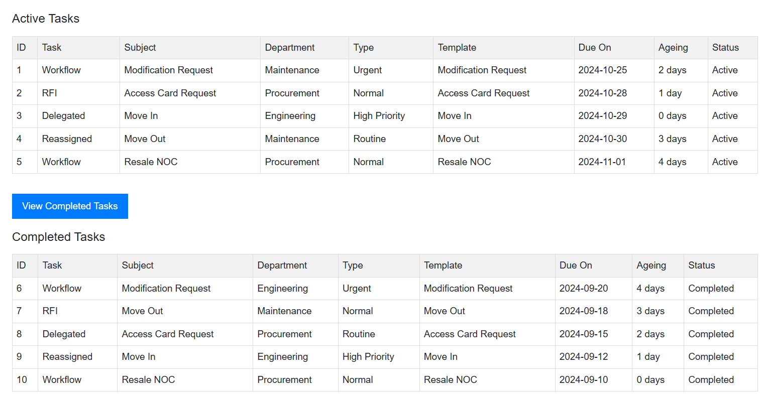

**WORKFLOW PAGE AND TASK ACTIONS**

Upon clicking the assigned task, the user is **redirected to the workflow page**, where the necessary actions can be performed. The layout of the workflow page is provided below as a reference. While the overall structure will remain similar, the specific **fields** required for our workflow will be outlined on the following page.

**Example Workflow Overview**

(Refer to the attached screenshot for details)

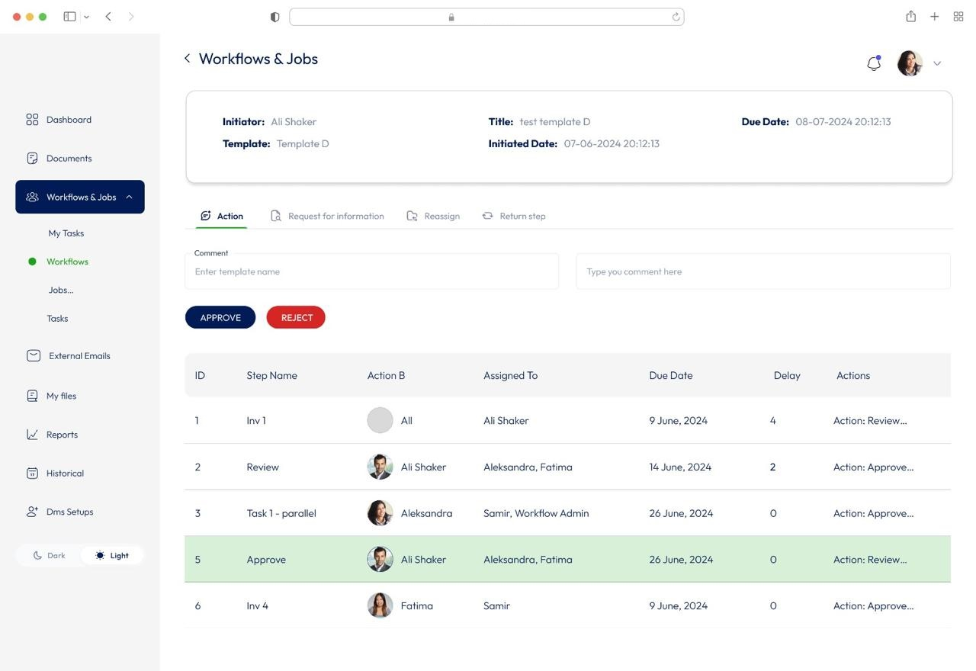

**WORKFLOW PANEL & FIELDS:**

The **Workflow Page** will be structured into three distinct panels before proceeding to the workflow steps, each serving a specific purpose:

1. **Information Panel**: (Note: The name "Information Panel" will not be displayed on the interface):
   * This panel displays all the information collected during the **workflow initiation**.
   * The fields include:
     + Initiator Name
     + ID
     + Department
     + Type
     + Template
     + Subject
     + Started On
     + Progress
     + Process Owner
2. **Content Panel**: (Note: The name "Content Panel" will not be displayed on the interface):
   * This panel contains data gathered throughout the various **workflow steps**.
   * The fields include:
     + Invoice Date
     + Invoice Number
     + Invoice Document
     + Amount
     + Vendor Name
     + Paid By
     + Item Name
3. **Action Panel** (Note: The name "Action Panel" will not be displayed on the interface):
   * This panel provides step-specific details and the **action** required from the user at the current **queue**.
   * **Visibility**:
     + The Action Panel is only visible to the user assigned to the current step.
     + Once the task progresses to the next step, the panel will disappear from the current user’s view and become visible to the user responsible for the next step.
   * **Actions** (Execution happens based on template setup):
     + **RFI (Request for Information)** – *Refer next page for further details.*
     + **Reassign** – *Refer next page for further details.*
     + **Return Step** – *Refer next page for further details.*
   * **Step Details**:
     + **Step Name**: (e.g., *Review Scope*) – Indicates the current workflow step.
     + **Step Description**: (e.g., *Upload Invoice for the current job.*) – Describes the task to be performed.
     + **Upload Button**: For attaching necessary files.
     + **Comment Field**: For adding relevant notes or remarks.
     + **Due Date**: Automatically populated based on workflow configuration.
   * **Control Buttons**:
     + **Submit Button** – To finalize and submit the task.
     + **Clear Button** – To reset the inputs.

**Task Actions: RFI, Reassign, and Return Step**

**RFI (Request for Information)**

* An **RFI** can be assigned to **any user** in the Active Directory, including users who are **not part of the original workflow**.
* While the RFI is in progress, the **approval queue remains with the original user** assigned to the workflow step. The RFI-assigned user can only **add comments and attachments**, which will be reflected within the workflow step for the queued user to review.
* The user receiving the RFI will get a **task notification**, informing them that they have been assigned an RFI by another user and need to provide additional information in the form of **comments or attachments**.

**Reassign**

* A task can be **reassigned** to any user within the Active Directory.
* When **User-A** reassigns the task to **User-B**, **User-A** is **removed from the current step** in the workflow, and **User-B** is added to the step with full action permissions.
* Although **User-A** will retain **view-only access** to the workflow, they will no longer have permission to take action, as **User-B** assumes responsibility for the step.

**Return Step**

* The **Return Step** action moves the process **back to the previous step** in the workflow.
* If **User-B** performs a "Return Step" from their queue, the task will revert to **User-A**.
* Once **User-A** completes the required action and approves the step, **User-B** will automatically be added back into the workflow to continue the process from where it left off.

**DETAILED WORKFLOW PAGE LAYOUT**

**INFORMATION PANEL**

In this panel all the information populated is the data collected at the time of workflow initiation.

***[ Initiator Name, ID, Department, Type, Template, Subject, Started on, Progress, Process Owner]***

**CONTENT PANEL**

In this panel all data illustrated will be collected from the various workflow steps.

***[ Invoice date, Invoice Number, Invoice Document, Amount, Vendor Name, Paid by, Item name ]***

**ACTION PANEL**

**RFI, REASSIGN, RETURN STEP - (these are Clickable Tabs, if there is any need for RFI/Reassign/Return STEP)**

**STEP NAME : Review Scope ( on the basis of step requirement )**

**STEP DESCRIPTION: Ex: Upload Invoice for the current job.**

**Upload Button. Comment _________ Due date (Auto Picked)**

**SUBMIT BUTTON CLEAR BUTTON**

**ACTION PANEL ( The Name “ Action Panel” is wont be displayed, but panel tells you the Step details and the Action that you are meant to take in the current Que )**

***NOTE: Action Panel is only visible to the person who is in the current Que. Once the current Que moves to the next step, it will be disappeared from the previous persons workflow View and Visible to the user in the next step***

**In this panel all the execution happens on the basis of template setup**

**RFI, REASSIGN, RETURN STEP - (these are Clickable Tabs, if there is a need for RFI/Reassign/Return STEP)**

**STEP NAME : Review Scope ( on the basis of step requirement )**

**STEP DESCRIPTION: Ex: Upload Invoice for the current job.**

**Upload Button. Comment _________ Due date (Auto Picked)  
SUBMIT BUTTON CLEAR BUTTON**

**WORKFLOW STEPS**

|  |  |  |  |  |  |  |  |  |
| --- | --- | --- | --- | --- | --- | --- | --- | --- |
| **STEP** | **STEP NAME** | **TYPE** | **ASSIGNED TO** | **RECEIVED** | **DUE ON** | **ACTION/RFI/ REASSIGN/**  **RETURNSTEP** | **EXECUTED ON** | **COMMENTS** |
| 1 | REVIEW SCOPE AND SITE REQUIREMENTS | ALL / ANY | ALI | 03-OCT-2024,  14:24 HRS | 05-OCT-2024,  14:23 HRS | COMPLETED | 06-OCT-2024 | TEXT + DOWNLOAD ICON (IF ANY ATTACHMENT) |
| 2 | REVIEW SCOPE | **ANY** | **SUHAIL**  ANEES | 02-OCT-2024,  14:24 HRS  -- | 07-OCT-2024,  14:23 HRS  -- | COMPLETED  -- | 08-OCT-2024  --- | TEXT + DOWNLOAD ICON (IF ANY ATTACHMENT)  -- |
| 3 | REVIEW SCOPE | **ALL** | **BEJOY**  **DINIL** | 01-OCT-2024,  14:24 HRS  01-OCT-2024,  14:24 HRS | 05-OCT-2024,  14:23 HRS  05-OCT-2024,  14:23 HRS | COMPLETED  COMPLETED | 06-OCT-2024  06-OCT-2024 | “DONE WITH CHANGES”  “CONDITIONALLY APPROVED, REFER ATTACHMENT” (ICON) |
| 4 | ISSUE INVOICE | ALL / ANY | RIYAS | 10-OCT-2024,  14:24 HRS | 17-OCT-2024,  14:23 HRS |  |  |  |
| 5 | CONFIRM PAYMENT | ALL / ANY | ESHAN / ALI | 11-OCT-2024,  14:24 HRS | 22-OCT-2024,  14:23 HRS |  |  |  |
|  |  |  |  |  |  |  |  |  |
|  |  |  |  |  |  |  |  |  |

**MODIFICATION WORKFLOW STEPS OVERVIEW**

**Step 1: Review Scope and Site Requirements**

* **Step Name**: Review Scope and Site Requirements
* **Workflow Type**: **Any (The task can be completed by either of the assigned users)**
* **Assigned Users**:
  + **User 1**: bejoy.george@email.com
  + **User 2**: jinu.joy@email.com
* **Action**: An input field will be provided for adding comments.

**Work Category Selection**:  
Requests submitted via the “Modification Request” form will be classified as:

* + **Minor Works**
  + **Major Works**
* **Minor Works Sub-Categories**:
  + **Minor Work (Without Charges)**
  + **Minor Work (With Charges)**
* A **radio button** will be used to select the appropriate work category.
* **Action Required**:
  + **Minor Work (Without Charges)**:
    - A **Work Permit (PDF)** will be generated and sent to the provided email address.
    - An email notification with the permit will be sent to the customer, completing the workflow.
  + **Major Work** or **Minor Work (With Charges)**:
    - The workflow will proceed to **Step 2**.

**Step 2: Review Scope**

* **Step Name**: Review Scope
* **Event**: This step is initiated if the selected category is **Major Work** or **Minor Work (With Charges)**.
* **Assigned User**:
  + abubaker.yafai@email.com
* **Action**: An input field will be provided for adding comments.
* **Event**: If **Major Work (With Charges)** is selected, the workflow will move to **Step 3**.

**Step 3: Review Scope**

* **Step Name**: Review Scope
* **Assigned User**:
  + suhail.abdullah@email.com
* **Action**: An input field will be provided for adding comments.

**Step 4: Review Scope and Fees Calculation**

* **Step Name**: Review Scope
* **Assigned User**:
  + dilin.varkey@email.com
* **Action**: An input field will be provided for adding comments.
* **Fees Section**:
  + **Modification Fee (AED)**: [Field to input amount]
  + **Unlisted Contractor Fee (AED)**: [Field to input amount]
  + **Built-up Extension Fee (AED)**: [Field to input amount]
  + **Total (AED)**: [Auto-calculated total based on inputs]
* **Communication with Customer**:
  + A **notification** will be sent to the customer, informing them that the request has been approved and is pending **payment of the specified amount**.

**Step 5: Upload the Invoice**

* **Step Name**: Upload the Invoice
* **Assigned User**: Cashier
* **Action**: An **upload button** will be provided for attaching the invoice once the customer pays the amount mentioned in the previous step.
* **Payment Details**:
  + **Name of the Person Making Payment**: [Text Field]
  + **Email Address**: [Text Field]
  + **Contact Number**: [Text Field]
  + **Comment**: [Text Box]

**Step 6: Confirm Payment Received**

* **Step Name**: Confirm Payment Received
* **Workflow Type**: **Any (The task can be completed by either of the assigned users)**
* **Assigned Users**:
  + **User 1**: bejoy.george@email.com
  + **User 2**: jinu.joy@email.com
* **Action**:
  + A **file uploader button** will be provided for attaching the invoice.
* **Work Permit Generation**:
  + At this step, a **PDF Work Permit** will be automatically generated and made available for **download**.
* **END OF WORKFLOW**

# CONTRACTOR REGISTRATIOn

* Contractor will reach out to the Management Office (Manually)
* PM Office will send a URL to the contractor email with a registration form

URL WILL HAVE DETAILS SUCH AS

Contractor Company

Contractor Name

Email

Contacts

Upload Documents

1. Contractor Trade License
2. Emirates ID of Employees
3. Third Party Liability Insurance Certificate
4. Vehicle Registration

NOTE: Instructing the contractor to visit the cashier with a unique reference number (generated with each form submission) for payment processing.

SUBMIT BUTTON

THIS ACTION TRIGGERS A WORKFLOW. IT IS NOT CAPTURED HERE.

THE WORKFLOW STEPS WILL BE AS FOLLOWS

STEP 1: REVIEW DOCS – ANY – Bejoy / Jinu –

STEP 2: APPROVE – MOVES TO THE NEXT STEP (ALL) – SUHAIL / ABUBACKER (AUTOMATIC NOTIFICATION TO VISIT CASHIER AT SO AND SO LOCATION TO MAKE PAYMENT)

STEP 3- CASHIER – UPLOAD INVOICE

STEP 4 – FILE CLOSURE - – ANY – Bejoy / Jinu

WORKFLOW END

The final step of this workflow will involve the cashier confirming whether the payment has been received.

At the end of the workflow, the contractor name / Company name will be added automatically to the contractors DB and will be listed in the Modification Request Form – Under Contractor list dropdown list.

# resale noc

* The Customer Relation Department - Clicks on a "Resale NOC" Button

This form will include the relevant information about the customer and property, such as:

* Master Community
* Project Name
* Sub-Project Name
* Unit Number
* Customer Name
* Contact Number

**SUBMIT BUTTON** - > Raise a Workflow Task for the Assigned User in PM

* **Automatic Task Assignment:** A task will automatically be assigned to a property management representative, who will coordinate the inspection of the property.
* **Property Inspection:** An inspector will visit the specified property to conduct the necessary checks with options to upload images related to the inspection. And Approval will be (YES/NO) by ANY (**Bejoy / Jinu**)

YES AND NO WILL SEPARATE TYPE OF CUSTOM NOTIFICATION BASED ON THE COMMENTS MENTIONED HERE.

* **Notification to Customer Representative**: Based on the above selection of (YES/NO) with Comments

**Note:** If the request is REJECTED, , a comment section must be included in the response

End of Workflow

# new sale

* Sales Ops - Clicks on a "New Sale" Button (Fields will be: - Date, Unit Number, Customer Name, Contact Number, Email, Name of Initiator (Drop down list of users) & Reservation Form (RF) Attached (PDF / IMAGE FORMAT)
* A URL / FORM is populated in the PM User Page
* The URL/ Form will have all details mentioned above and the Reservation Form & The details of the RF to be picked up into this Form using OCR.
* When the URL is picked up at the PM User side, the workflow is raised and assigned to the users’ who are included in the workflow
* End of this workflow will create a **"NEW SALE EXECUTION"** pdf and an automatic email is sent to a specific email (and CC to the Security) to release the Access Card.

**End of Workflow**