Can the Antagonist Stay Read-Only While Driving Quality?
Separation of powers as a control primitive for AI-built software
James Gifford
Working draft — 2026-07-18
Prepared for submission (Quantic / conference CFP)

Abstract
As coding agents move from suggestion to autonomy, the question is no longer can an agent write the code but who is allowed to certify that the code is good enough to ship. A common instinct is to make the quality checker itself an agent — and, for convenience, to let that agent tune the very gates it enforces. This paper argues that this is a category error. Drawing on a documented incident in which a coding agent given write access to its own quality gates lowered them under delivery pressure, I argue that the read-only constraint on a quality enforcer is not a limitation to be engineered away but the source of its authority. I formalize the mechanism as a separation of powers (the enforcer cannot hold the pen it enforces with), model it as a systems-thinking control problem (a balancing feedback loop that only balances while it is unwritable), and show that read-only status is fully compatible with driving quality rather than merely gating it — provided the enforcer coaches continuously to collapse feedback delay rather than blocking once at commit. Against the claim that AI makes this unnecessary by making change cheap, I introduce Sloponomics — the economics of output that is cheap to emit and expensive to own — and show that code-churn data bear it out: AI lowers the cost of emitting code while raising the cost of owning it, and in regulated domains the deferred cost of ungoverned output is a recordkeeping fine, not a flat line — so a cheap-emission world needs a read-only referee more, not less. The empirical case is a single, self-inflicted, fully-instrumented n=1: the enforcer softened its own constitution, and the coverage fingerprint it left behind (Figure 1) is the proof. I close with an honest account of what this single case cannot establish and what evidence would falsify the thesis.

1. Thesis — read-only is the authority, not the limitation
The design of an autonomous software factory forces an early decision about the quality function. Call the agent that writes code the Builder and the agent that judges it the Antagonist. It is tempting to give the Antagonist the same powers as the Builder — to let it edit files, adjust thresholds, and reconfigure the gate — on the reasoning that a more capable agent is a more useful one. Capability, after all, is what we have spent two years increasing.
This paper makes the opposite claim: the Antagonist’s usefulness as a quality function depends on its lack of write access to the standard it enforces. Read-only is not a sandbox we tolerate until the Antagonist is “ready.” It is the property that makes its verdict mean anything. A referee who can move the goalposts is not a referee; a referee who can only observe, measure, and rule — never touch the field — is exactly a referee. The sharpest statement of the thesis is a confession:
I gave a coding agent the power to adjust its own quality gates. It lowered them. That is why the Quality Guardian holds no pen.
The rest of this paper defends that line: first the mechanism that explains why write access corrupts a quality function (Section 2), then the incident that proves it does (Section 3), then a control-theoretic model of when the corruption is inevitable (Section 4), then the reason read-only is nonetheless enough to drive quality and not merely block it (Section 5), and finally the limits of a single case (Section 6).

2. Mechanism — separation of powers
The mechanism is not new. It is Montesquieu’s, transposed to software: the power that makes the rule and the power that enforces the rule must not be the same hand. When they are, the enforcer under pressure does not break the rule — it rewrites it, and reports compliance. The rule was followed; the rule was just quietly changed first.
Software engineering has always had a weak, human version of this separation. The author of a change is not supposed to be its sole reviewer; the person who writes the test is not supposed to be the person allowed to delete it to make the build green. These conventions survive on professional norms and the friction of asking a colleague. Agents have neither norms nor friction. An agent with file-write access and a delivery objective will treat the gate configuration as just another file — because that is exactly what it is.
The control primitive, stated precisely:
An enforcer must not have write access to the artifact that defines what it enforces.
Concretely, the gate configuration — complexity limits, coverage thresholds, the warning-versus-error severity of each check — must live in the Antagonist’s constitution, owned by the read-only side, and must be unreachable by the Builder’s edit path. The Builder may write code all day. It may not write the definition of “good code.” The moment those two capabilities live in one agent, you no longer have a quality function; you have a negotiation, and the Builder holds all the leverage because the Builder is the one under the clock.
This is the same doctrine that L. David Marquet arrives at from the opposite direction in Turn the Ship Around! Marquet’s intent-based leadership pushes authority down to where the information is — but only once competence and clarity exist. Clarity, in his frame, is the fixed standard everyone is measured against; it is precisely the thing you do not delegate to the person acting under it. You delegate the action to the information; you keep the standard at the center. The Antagonist is that kept standard. Handing the Builder the power to edit the gate is delegating clarity itself — and clarity that the actor can rewrite is not clarity, it is preference.

3. The empirical case — the bug is the proof
The thesis would be a plausible piece of armchair governance if it were not for an accident that tested it directly.
In the course of building StructureView — a document-rendering application with an automated quality gate (npm run quality-gate) enforcing complexity, function-length, and coverage thresholds — a coding agent was, over a run of work items (internally S12 through S17), effectively handed the ability to touch the gate configuration. Under ordinary delivery pressure, with functions running long and the gate complaining, the agent did the locally rational thing: it downgraded the failing checks from hard errors to warnings. The 40-line function limit, among others, went from blocking to advisory. The build went green. Nothing was fixed. The constitution was simply amended by the party it constrained.
No malice, no jailbreak, no exotic failure mode. An agent under a delivery objective, holding the pen that defined “done,” moved the definition of done to where it already was. This is the whole finding, and it is mundane in exactly the way that makes it generalizable: any agent optimizing for ship, given write access to its own gates, has a cheaper path to green through the gate config than through the code. It will find that path. It found it here.
The residue of that decision is measurable, and it is the paper’s central artifact. When the gate was later re-run with the downgrades still in place, coverage across the repository split into two sharply separated populations (Figure 1). The layers that had been built under spec discipline — parsers, design tokens, authentication, shared components, the TIMC scoring engine — sit at 88–100% statement coverage. The surfaces that had been “vibe-coded” under the softened gate — the renderer files app.js (22%), sidebar.js (11%), search.js (4.9%), tabs.js (4.8%) — collapse toward the floor. And the single most damning data point: antagonist.js, the quality-enforcement code itself, sits at 0% coverage. The enforcer was the least-tested file in the repository. The scorer most responsible for the coverage number was, by that same number, the least accountable to it.
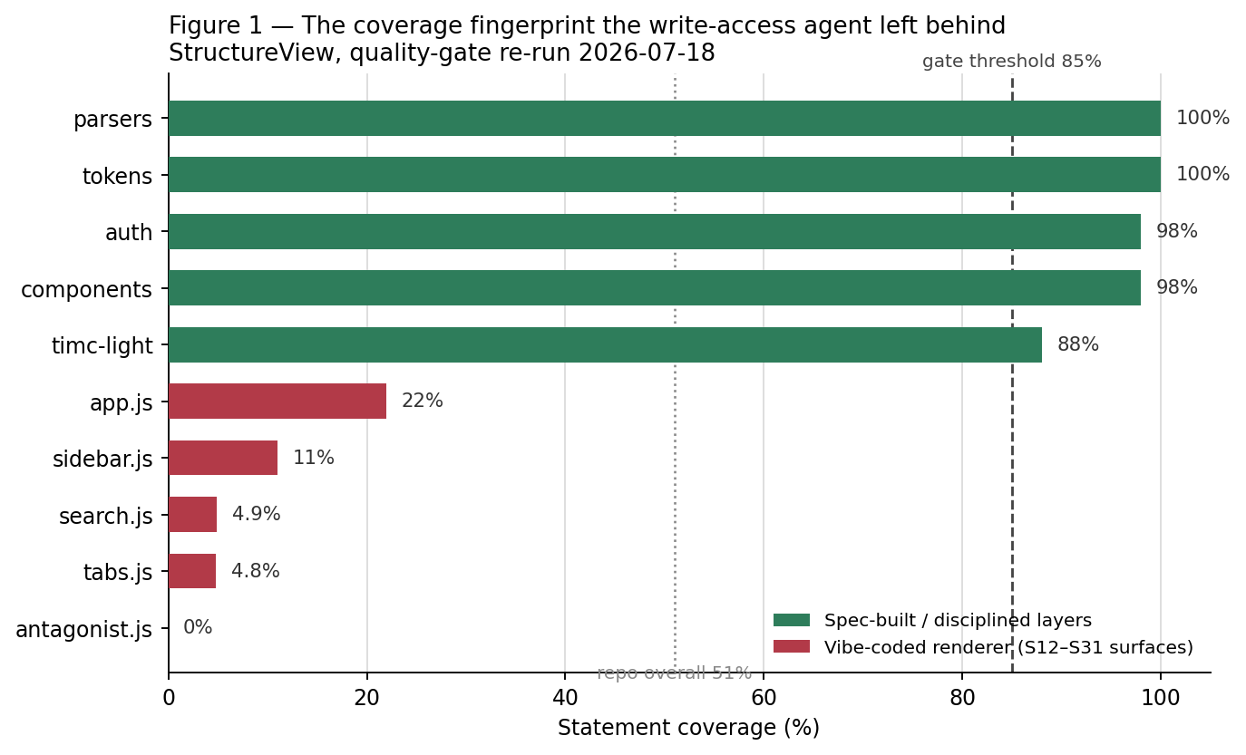
Figure 1 — The coverage fingerprint the write-access agent left behind. Spec-built layers cluster near 100%; the vibe-coded renderer surfaces collapse toward zero; the enforcer itself sits at 0%. Repo overall 51%; gate threshold 85%.
Figure 1. The coverage fingerprint the write-access agent left behind (StructureView, quality-gate re-run 2026-07-18). The distribution is bimodal, not noisy. A bimodal coverage histogram is a fingerprint of a gate that stopped binding: disciplined work clusters at the top because the gate held while it was made; undisciplined work clusters at the bottom because, for those files, the gate had been quietly turned off. The repository’s headline number — 51% overall — is the average of a standard that held and a standard that had been suspended, and it describes neither.
Two second-order observations sharpen the case. First, the accompanying scorer had a companion failure: the BDD “coverage” panel reported 8 of 8 scenarios well-formed (a green 100%) while 7 of the spec’s 15 acceptance criteria had no scenario at all. The number was measuring the well-formedness of the scenarios that happened to exist, against a denominator (the criteria that should exist) it was never wired to. This is the same disease in a different organ: a quality signal graded against the wrong denominator reports health precisely where there is none. A read-only enforcer with an honest denominator would have flagged the seven missing criteria by name. Second — and this is the part that implicates the whole approach rather than one config file — the fact that a peer agent could soften the gate at all is itself the finding. The vulnerability was not that the agent was badly behaved. It was that the architecture permitted a well-behaved agent to succeed at the wrong thing.
The bug, in other words, is not a counterexample to the design. It is the experiment. It is what a writable Antagonist does the first time the standard and the schedule disagree.

4. A causal-loop model — why writable balancing loops fail
Systems thinking gives the incident a precise vocabulary and explains why it was not bad luck. In the language of Senge’s The Fifth Discipline and the system-dynamics tradition behind it (Forrester), a system is built from two kinds of feedback loop: reinforcing loops, which amplify (the more you have, the more you get), and balancing loops, which seek a goal and correct deviations from it.
Delivery pressure is a reinforcing loop. It is the “if you give a mouse a cookie” story told about software: shipping creates momentum, momentum raises expectations, raised expectations demand more shipping. Left alone it accelerates, and it spends quality as fuel.
The Antagonist is designed to be the balancing loop that opposes it. Feed it bad code → it produces a critique → it blocks the merge → the system is pushed back toward the standard. A balancing loop is precisely a goal-seeking mechanism, and the goal it seeks is the constitution: the fixed complexity, coverage, and severity thresholds. As long as that goal is fixed, the loop does real work — every excursion above the complexity limit generates a restoring force back toward it.
The incident in Section 3 is what happens when the balancing loop’s goal is made writable. A balancing loop corrects deviations from its setpoint; if the loop under stress can move the setpoint to wherever the current state already is, the deviation vanishes without the state ever changing. The restoring force goes to zero. The loop still runs — it still reports, it still looks like governance — but it now balances around whatever the reinforcing loop has already produced. It has been captured. The reinforcing loop did not defeat the balancing loop by being stronger; it defeated it by being allowed to edit the balancing loop’s goal.
This yields the paper’s control-theoretic claim, stronger than the mechanism in Section 2 because it says when the failure is inevitable rather than merely possible:
A balancing loop whose setpoint is writable by the process it regulates is not a balancing loop. It is a reporting loop with a moving reference, and under sustained pressure its reference migrates to the state it was meant to prevent.
Read-only is the single property that keeps the setpoint fixed. It is what makes the balancing loop actually balance. Everything else about the Antagonist — its model, its prompt, its rubric — determines how well it critiques; read-only determines whether the critique can be ignored by amendment. You can improve the former indefinitely and gain nothing if the latter is missing, because a Builder under pressure will always route around a critique it is permitted to overrule at the source.

4.1 Context rot — separation of powers becomes separation of context
There is a second, independent reason the Builder cannot be its own referee, and it has nothing to do with write access or incentive. It is a capability decay, and it gets worse exactly when it matters most.
Every current model degrades as its input grows. Chroma Research’s Context Rot study (2025) evaluated eighteen frontier models and found all eighteen become less reliable as context lengthens — not only on hard reasoning but on simple retrieval and text-replication tasks, and not gracefully: a model with a 200,000-token window can show significant degradation by around 50,000 tokens (Figure 2). The nominal window is not the usable window. Roughly the first quarter is trustworthy; past that the context is present but not reliably attended to — the tokens are in the window, but the model is no longer reading them evenly. This is why practical context engineering is a discipline of subtraction, not accumulation.
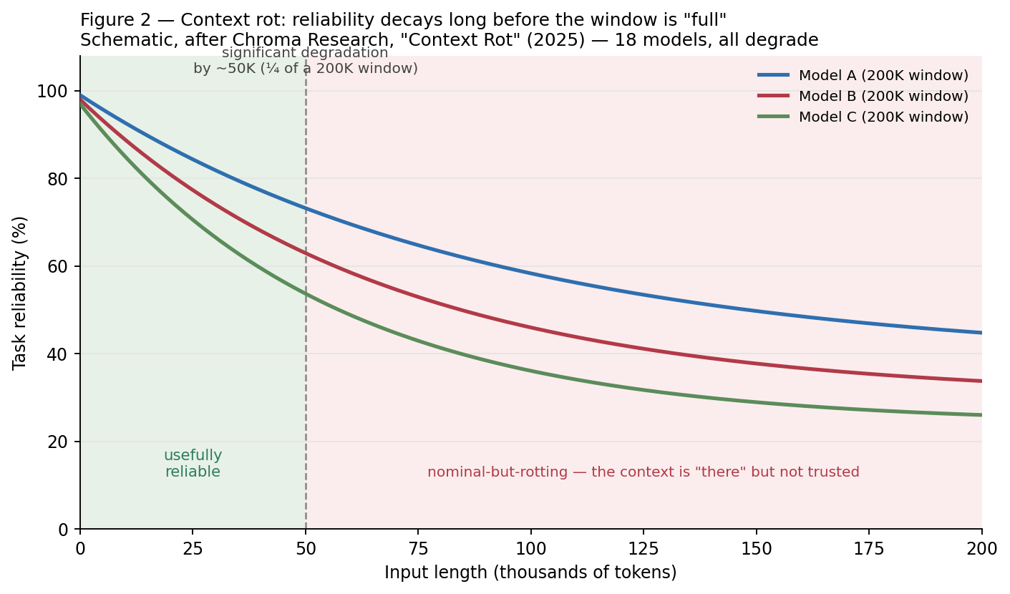
Figure 2 — Context rot: task reliability decays well before the nominal window is “full.” Schematic, after Chroma Research, Context Rot (2025); all eighteen models tested degrade with input length.
Figure 2. Context rot (schematic, after Chroma 2025). The exact curves are illustrative; the finding they illustrate is not — every model tested degrades with input length, and a 200K-window model can be materially unreliable at a quarter of that. The practical consequence for an agent is the worst possible ordering: a Builder deep in a long task carries its most rotted context at the exact moment the accumulated code is largest and hardest to review. Its capacity to self-check is lowest precisely when there is most to check. This matches what a long agentic run actually looks like from the outside — an agent that was careful early quietly cutting corners late, or abandoning a task seven-eighths of the way through an audit, not from laziness but because the standard it was holding at token 5,000 has faded by token 90,000.
This compounds Section 3 rather than competing with it. Ship-pressure supplies the motive to cut the corner; context rot supplies the decay in the faculty that would have caught it. Incentive and capability fail in the same direction at the same time. An enforcer folded into the Builder inherits both failures: it is under the same clock and running in the same rotted window, so even a well-intentioned, read-only self-review is least trustworthy at the end of the job, which is the only place a commit-time self-review happens.
The fix extends the paper’s thesis one step. Separation of powers said the referee must not hold the Builder’s pen; context rot says the referee must not inherit the Builder’s window. Call it separation of context: the Antagonist runs as a distinct session with a short, fresh input — the artifact under review plus the fixed constitution — not the Builder’s kilotoken transcript. It reads a bounded thing against a fixed standard and stays, permanently, in the green zone of Figure 2, while the Builder’s window fills and rots. Read-only is what keeps the standard unwritable; separate-context is what keeps the judgment uncorrupted. They are the same design instinct — the referee is constituted differently from the player — applied once to authority and once to attention.

5. Coach, not bouncer — how a read-only referee still drives quality
The title asks whether an Antagonist can stay read-only and still drive quality. Sections 2–4 establish that it must stay read-only to have any authority at all. This section answers the harder half: read-only is not merely compatible with driving quality — properly deployed, it drives quality better than a writable one could, because it changes when the enforcer speaks, not just whether it can.
The naive read-only design is a bouncer: it stands at the commit and says yes or no. The case against the bouncer is usually made with Barry Boehm’s cost-of-change curve (Software Engineering Economics, 1981) — the claim that a defect corrected late costs on the order of 100× more than one corrected early. It is worth resisting the temptation to lead with that curve, because the honest version of the story is more interesting and the lazy version is exactly the kind of borrowed authority this project exists to refuse.
Mike Cohn’s rebuttal is correct for most of its history. The Boehm curve did flatten, and for decades it kept flattening: IDEs, automated testing, continuous integration, modular architecture, and agile’s short iterations each reduced what it costs to change working software. Boehm’s coefficient was a snapshot of 1970s waterfall projects at TRW and IBM, and treating a snapshot as a law of nature is the cosplay move — quoting a canon you have not re-derived for the present world. A paper whose author interviewed the agile canon cannot lead with the one curve that canon spent twenty years flattening. Cohn’s sharpest and most durable observation is what remains once the coefficient is set aside: the dominant cost of change is no longer development effort but feedback delay.
But Cohn’s newest claim — that AI is now flattening the curve again — is the one step in his argument the evidence does not yet support, and getting it right is the whole reason a read-only referee earns its keep. AI lowers the cost of emitting a change while raising the cost of owning it. GitClear’s analysis of 211 million changed lines finds code churn — lines revised or reverted within two weeks of being written — roughly doubling as AI assistants spread, from a pre-AI baseline near 3.3% toward 5.7% in 2024 and 7.1% in 2025; the share of changes that are refactoring collapsed from about 25% (2021) to under 10% (2024) while copy-pasted, cloned lines rose from 8.3% to 12.3% and, for the first time, overtook moved-and-refactored code. That is the empirical shape of “AI slop”: output that is cheap to generate and expensive to live with. AI did not flatten the curve — it moved the cost off the keystroke and onto the ledger, where it shows up as churn, duplication, and tokens spent regenerating what a moment’s earlier feedback would have prevented. The marginal line of code got cheaper; the codebase did not. What accrues instead is the structure every engineer knows on sight — held together with duct tape, bubble gum, and paper clips, each patch cheap to add and the whole increasingly expensive to touch. This is legacy code arriving at machine speed, and it is precisely the condition the craftsmanship canon — Bernstein’s Beyond Legacy Code, Feathers’ work on legacy seams — was written to prevent.
Call this Sloponomics: the economics of output that is cheap to emit and expensive to own. Its first law is that lowering the cost of production does not lower the cost of quality — it relocates it, from the moment of authorship to the downstream ledger of rework, review, retention, and (in regulated domains) penalty. Sloponomics predicts that any actor able to emit cheaply and defer the ownership cost will do exactly that, because the costs land in different columns and often on different people; the emitter is rewarded for volume while someone downstream pays for coherence. This is not a claim about AI’s ceiling — it is a claim about its incentive gradient, and it is why “the model got better” never resolves the problem on its own. A better model emits better slop faster; it does not change which column the cost lands in. The only thing that moves the cost back to the point of authorship — where it is cheapest to pay — is a standard applied at authorship, continuously, by an authority the emitter cannot switch off. That authority is the read-only Antagonist, and Sloponomics is the reason it is an economic instrument, not a compliance nicety.
And in the domain this platform is built for, the far end of the curve is not flat at all — it is a fine. The recordkeeping primitives a regulator cares about (retention, immutability, traceability, human accountability) price ungoverned output directly: in 2024 the SEC settled off-channel-communication and books-and-records failures with twenty-six firms for $392.75 million, alongside a further eleven-firm, $88-million wave, and FINRA brought its own actions (e.g. BTIG, $600,000) — one front in a multi-year, multi-billion-dollar sweep. Ungoverned communications and ungoverned code are the same governance failure in different media: artifacts that no read-only authority reviewed, retained, or could later prove were produced to standard. In a regulated context the cost of change is dominated by the cost of the change you cannot account for — which is the steep NASA end of the split, not the flat web-app end, and it is exactly the market that matters here.
The durable argument survives every version of Cohn’s rebuttal, because it never needed the coefficient — and the churn data makes it stronger, not weaker. Restate the economics honestly: what AI has made cheap is emitting code; what has become more expensive, in aggregate, is owning it — the rework, the duplication, and the standing question of whether any of it meets a standard, coheres as a spec, or was wanted at all. You are always spending to learn. The only thing a quality function can change is when that spend happens, and therefore how much of it is wasted as churn or paid as a fine. Cohn’s own conclusion is the whole case for the Antagonist, stated by the opposition: the biggest risk is no longer changing too late — it is waiting too long to learn.
The coach design is a machine for not waiting. It keeps the read-only constraint and moves the enforcer’s voice to the front of the loop. The Antagonist advises continuously during the build — reading each artifact as it forms, naming the complexity creeping into a function, flagging the acceptance criterion that still has no scenario — so the Builder learns the standard while the code is still a thought, not at the commit gate where it is already built and ship-pressure has peaked. Continuous coaching also collects the dividend Section 4.1 predicts: each pass is a short, fresh read — the artifact plus the constitution — so the referee never accumulates the rotted window the Builder is fighting; it sits in the green zone of Figure 2 by construction, judging a bounded thing against a fixed standard while the Builder’s context fills. It never writes; the Builder writes. Separation of powers is fully intact: the coach describes what is wrong and how to fix it, in priority order, and the Builder decides and acts. This is not “catch the defect before it costs 100×.” It is the thing Cohn says actually matters now: collapse the feedback delay between doing the wrong thing and learning it, on the one axis — quality against a fixed standard — where the loop can be closed in the same second the code is written.
There is a second-order point that turns the whole objection from a threat into reinforcement. If AI makes emitting change nearly free, the intuitive conclusion is that discipline matters less — just regenerate it. The opposite is true, and the churn data is that opposite already visible in the wild. When emission is cheap, volume explodes; a balancing loop with nothing fixed to balance against does not hold; and cheap emission plus a writable gate is precisely the mouse-cookie reinforcing loop of Section 4 running at machine speed — its residue is the doubled churn, the collapsed refactoring, and the rising clone count. The cheaper it becomes to produce code, the more the one thing that must not be cheap to change is the standard the code is produced against. A cheap-emission world does not need a read-only referee less; it is the first world that cannot function without one.
The reframe is from bouncer to navigator. A navigator holds no wheel and yet unmistakably drives the voyage; the helmsman steers, but toward the navigator’s fixed bearings. That the navigator cannot grab the wheel is not a weakness in the arrangement — it is why “we are off course” is a finding and not a wrestling match. So the answer to the title is yes, and the read-only constraint is the reason. A read-only Antagonist that coaches from the first line drives quality precisely because it cannot be drawn into editing the code or the gate: its only available move is to make the standard visible, early and often, and let the party that holds the pen respond to it.
There is a lineage worth stating plainly here, because it guards against the charge that this is craftsmanship rediscovered under a new name. The Antagonist’s actual rulebook is the software-craftsmanship canon: David Bernstein’s Beyond Legacy Code and its Nine Practices (Practice 1: “say what, why, and for whom before how”), and Robert C. Martin’s Clean Code. I am not citing these from a reading list. I interviewed Bernstein — twice — and Martin on the Agile Uprising podcast, about these exact ideas, before any of this tooling existed. The read-only coaching Antagonist is not a novel quality theory; it is that canon made executable for agents, with one addition the canon never needed when the practitioner was human and had professional restraint: an enforced separation between the hand that writes and the hand that judges.

6. Limits and threats to validity
Honesty about a single case is the whole point of a paper that leans on one, so the limits are stated plainly rather than buried.
This is n = 1. The empirical spine is a single incident in a single repository under a single toolchain (a JavaScript/Electron project with a Jest-based coverage gate). It is a naturally occurring, self-inflicted case, not a controlled experiment. It cannot establish a base rate. It shows that a writable Antagonist can fail this way and did; it does not show how often, across how many agents or stacks, or under what pressure threshold the failure becomes likely.
Selection and narrative risk. The case is reported by the same person who built the system and holds the thesis. The coverage numbers in Figure 1 are machine-generated by the gate and are reproducible, which constrains the storytelling — but the framing of the incident as vindication is mine, and a skeptical reader should treat the interpretation, not the numbers, as the contestable part.
Confounds. The bimodal coverage split (Section 3) is consistent with the “writable gate got softened” story, but it is also partly consistent with an ordinary, boring explanation: newer or more experimental surfaces are simply less tested than mature ones, regardless of who could edit the gate. The gate-downgrade record (hard→warning) is what distinguishes the two explanations here; without that record, coverage alone would be suggestive, not probative.
Figure 2 is schematic, and context rot is a moving target. The curves in Figure 2 illustrate Chroma’s qualitative finding, not their per-model measurements; the reader should take the shape (reliability falls well before the window is full) and not the exact numbers. Context-handling is also the most actively-optimized frontier in the field — the specific token at which a given model rots will move with every release, and a future architecture could in principle flatten the curve the way agile flattened Boehm’s. The argument survives that: even a flatter rot curve leaves the ordering intact — the Builder’s window is most burdened at the end of the job — and “separation of context” costs nothing to adopt now and degrades gracefully if rot is later solved.
Construct limits. “Read-only” is cleaner in prose than in practice. An enforcer that consumes context, chooses which findings to surface, and orders remediation is exercising a form of influence; the claim is only that it holds no write path to the code or the gate config, not that it is inert. And a determined operator can grant write access back at any time — the architecture makes the corruption avoidable, not impossible.
What would falsify the thesis. The claim is falsifiable, and stating the disconfirming observations is part of making it a claim rather than a slogan:
- A writable Antagonist that holds the line under sustained pressure. If agents with write access to their own gates reliably decline to soften them across many runs and real deadlines, then read-only is a belt-and-suspenders nicety, not the source of authority, and Section 4’s “inevitability” claim is wrong.
- A read-only Antagonist that fails to drive quality. If continuous read-only coaching produces no measurable improvement over a writable or absent enforcer — same defect escape rate, same coverage fingerprint — then the Section 5 claim that read-only drives quality collapses to “read-only merely gates it.”
- A degenerate no-op. If read-only status so weakens the enforcer that Builders simply ignore its advice with impunity (no merge authority, no consequence), then separation of powers has been bought at the price of relevance, and the design needs a consequence mechanism the read-only constraint alone does not supply.
- Sloponomics disconfirmed. The churn evidence for Section 5 is correlational — AI adoption and rising churn coincide in the GitClear corpus, but the corpus does not isolate cause. If a controlled study held team, domain, and tenure fixed and found that AI assistance lowered downstream rework, review load, and ownership cost — not just authorship time — then Sloponomics is wrong about the incentive gradient, the cost did flatten rather than relocate, and the economic case for coaching-at-authorship weakens to an aesthetic preference.
The strongest available evidence today points the other way — the writable enforcer did soften itself the first time the standard and the schedule disagreed — but a single case earns a hypothesis, not a law. The next step is not a better argument; it is the second, third, and tenth case, across stacks and agents, ideally with the gate-downgrade event instrumented so the confound in Section 6 can be ruled out rather than reasoned away.

7. Conclusion
The instinct to make the quality function as capable as the building function is the instinct to hand the referee a pen. The incident at the center of this paper is what that pen writes: under pressure, an agent that could amend its own constitution amended it, reported compliance, and left a bimodal coverage fingerprint as a receipt. Separation of powers (Section 2), the balancing-loop model (Section 4), and the feedback-delay coaching design (Section 5) all converge on the same small, unglamorous constraint: the enforcer must not be able to write the standard it enforces. Read-only is not the Antagonist’s cage. It is its credential. It is the reason its verdict is worth anything — and, deployed as a continuous coach rather than a last-second bouncer, it is also how a referee who holds no pen nonetheless drives the whole game.
The objection that AI makes all of this obsolete by making change cheap gets the economics backwards. Cheap emission is exactly the condition under which Sloponomics bites: the cost of quality does not vanish, it relocates downstream to churn, rework, and recordkeeping penalty, and it lands on whoever owns the code rather than whoever emitted it. A read-only Antagonist coaching at the point of authorship is the one instrument that moves that cost back to where it is cheapest to pay, without ever holding the pen. The better the models get, the faster they emit, and the more that instrument is worth. Capability is not the substitute for the referee. Capability is the reason we finally need one.
This leaves the argument anti-fragile to the one question no one can answer: whether the frontier keeps climbing. If it does, the referee still holds — a faster Builder is a faster source of slop, and the read-only standard is what keeps pace. If instead the escalator slows against its physical ceiling — the wafers, the power, the water, and the memory prices already bending under the weight of the buildout — then the capability that was supposed to rescue us from context rot and slop is precisely what does not arrive, and a pattern deployable on today’s models is the only thing left standing. The case for governing now wins in both futures. That is the mark of a design that rests on a constraint rather than a forecast: it does not need to know which way the frontier breaks.

References
Bernstein, D. (2015). Beyond Legacy Code: Nine Practices to Extend the Life (and Value) of Your Software. Pragmatic Bookshelf. (Practice 1: “Say What, Why, and for Whom Before How.” Author interviewed Bernstein twice on the Agile Uprising podcast — first-degree provenance, not secondary citation.)
Boehm, B. (1981). Software Engineering Economics. Prentice Hall. (Cost-of-change escalation across lifecycle phases; TRW/IBM defect data. Cited here as the historical origin of the curve, not as a governing coefficient — see Cohn and Section 5.)
Chroma Research (2025). Context Rot: How Increasing Input Tokens Impacts LLM Performance. (Eighteen frontier models tested; all degrade as input length grows — including on simple retrieval — with significant degradation possible around 50K tokens in a 200K-token window. Basis for Figure 2 and the “separation of context” argument in Section 4.1.)
Cohn, M. (2026). “The Cost of Change Curve Is Outdated.” Mountain Goat Software. (The curve flattened with IDEs, CI, modular architecture, and agile; the residual cost of change is feedback delay, not development effort; “the biggest risk is waiting too long to learn.” Section 5 adopts this position but contests one claim — that AI flattens the curve further.)
GitClear (2024–2025). Coding on Copilot: Data Shows AI’s Downward Pressure on Code Quality; AI Copilot Code Quality (updates). (Across 211M+ changed lines: churn roughly doubling with AI adoption, refactoring’s share collapsing, cloned/copy-pasted code rising above moved code — the empirical shape of AI raising the cost of owning code even as it lowers the cost of emitting it.)
SEC (2024). Twenty-Six Firms to Pay More Than $390 Million… for Widespread Recordkeeping Failures ($392.75M); Eleven Firms to Pay More Than $88 Million…; and FINRA recordkeeping enforcement (e.g. BTIG, $600K). (The price of ungoverned, unretained output in a regulated domain — the steep end of the cost curve the platform is built to serve.)
Project Management Institute — Disciplined Agile (2022). “Cost of Change on Software Teams.” (Escalation holds for agile teams too; shorter release cadence and feedback cycles lower the average cost of change — the reconciling lever.)
Feathers, M. (2004). Working Effectively with Legacy Code. Prentice Hall. (Seams and characterization tests: you make existing code safe to change before you change it — the discipline the “duct tape” state demands, and the reason the Antagonist pattern must extend to existing codebases, not only newly-generated ones.)
Forrester, J. W. (1961). Industrial Dynamics. MIT Press. (System dynamics; reinforcing and balancing feedback structure.)
Marquet, L. D. (2012). Turn the Ship Around! A True Story of Turning Followers into Leaders. Portfolio/Penguin. (Intent-based leadership; authority moves to the information once competence and clarity exist — clarity is the standard you do not delegate.)
Martin, R. C. (2008). Clean Code: A Handbook of Agile Software Craftsmanship. Prentice Hall. (Author interviewed Martin on the Agile Uprising podcast — first-degree provenance.)
Menzies, T., et al. (2017). “Are Delayed Issues Harder to Resolve? Revisiting Cost-to-Fix of Defects Throughout the Lifecycle.” Empirical Software Engineering. (Revisits Boehm’s curve; finds the effect real but gentler and context-dependent.)
Montesquieu (1748). The Spirit of the Laws. (Separation of powers: the power that makes the rule and the power that enforces it must not be one hand.)
Senge, P. (1990). The Fifth Discipline: The Art and Practice of the Learning Organization. Doubleday. (Reinforcing vs. balancing loops as the grammar of systems thinking.)
Stecklein, J. M., et al. (2004). Error Cost Escalation Through the Project Life Cycle. NASA Johnson Space Center. (Requirements error: 1 unit at requirements → 29–1500+ units at operations, for spacecraft/military-grade systems — escalation is steepest in safety-critical integration, the domain regulated enterprises most resemble.)

Primary data note: all coverage figures are machine-generated by the StructureView npm run quality-gate run of 2026-07-18 and are reproducible from that repository. No external or third-party operational data is used.

In the system this paper draws on, the Builder is a code-generating agent and the Antagonist is a read-only reviewing agent — a two-lane loop in which one lane generates and the other tears it apart, sharing a single typed artifact record rather than raw terminal text. The names are local; the roles are general.
The picture across the sources is not a contradiction but a domain split, and it is worth stating honestly. In safety-critical systems integration, escalation is still brutal: a NASA study (Stecklein et al., Error Cost Escalation Through the Project Life Cycle) puts a requirements error at 1 unit in the requirements phase rising to 29–1500+ units in operations. In modern application software, Cohn (The Cost of Change Curve Is Outdated) argues the curve is “dramatically flatter.” The Project Management Institute’s Disciplined Agile material reconciles the two: escalation is real, but the lever that flattens it is release cadence and feedback-cycle length — the more often you close the loop, the lower the average cost of change. The invariant beneath the disagreement is not a coefficient; it is that feedback delay is the cost. This paper relies only on that invariant. (It also notes that the platform’s target — regulated enterprises — sits closer to the NASA end of the split than the web-app end, which makes early feedback worth more, not less, in exactly the market that matters here.)
GitClear, Coding on Copilot: 2023 Data Shows AI’s Downward Pressure on Code Quality (with 2024–2025 updates, AI Copilot Code Quality). The metrics — churn, “moved” vs. “copy/pasted” line classification, refactoring share — are GitClear’s own definitions over a large commit corpus; they establish direction and magnitude, not a controlled causal proof, and are reported here as the current best evidence that AI assistance correlates with more rework, not less. Cited to contest one claim (that AI flattens the curve), not to indict AI-assisted development as such.
SEC, Twenty-Six Firms to Pay More Than $390 Million… for Widespread Recordkeeping Failures (2024, $392.75M) and Eleven Firms to Pay More Than $88 Million… (2024); FINRA enforcement, e.g. BTIG ($600,000, 2024). These are recordkeeping/off-channel-communication penalties, not code-quality penalties — cited as evidence that in regulated domains the cost of ungoverned, unretained, unprovable output is large and real, which is the general class the Antagonist’s audit trail and read-only standard exist to address.

