# CS 255 System Design Document

Damean Murphy-Short

February 20, 2024

## UML Diagrams

### UML Use Case Diagram

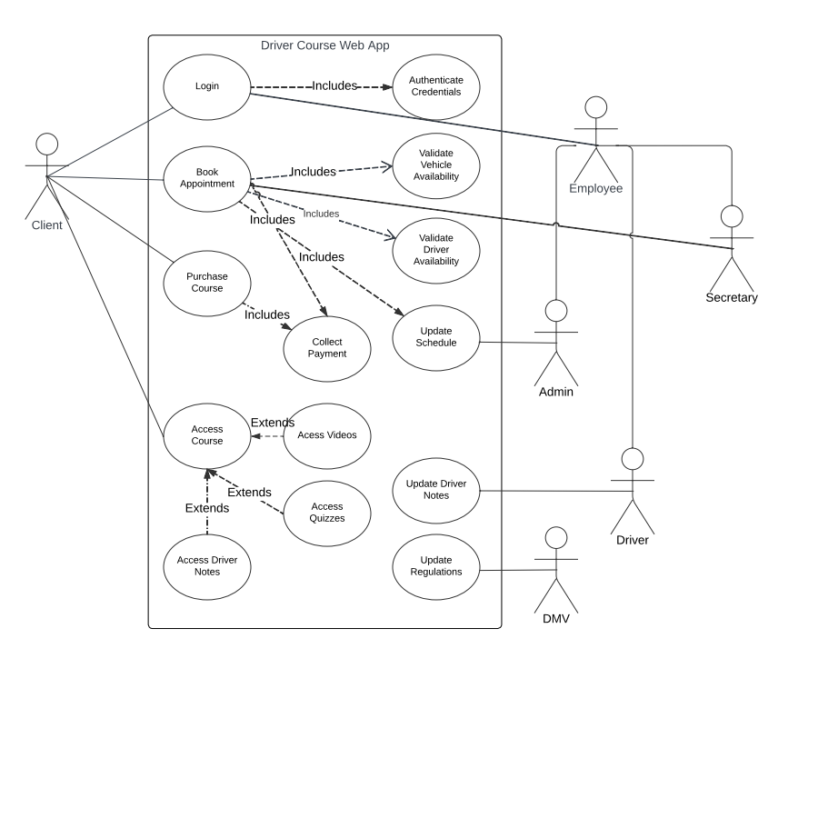

### UML Activity Diagrams

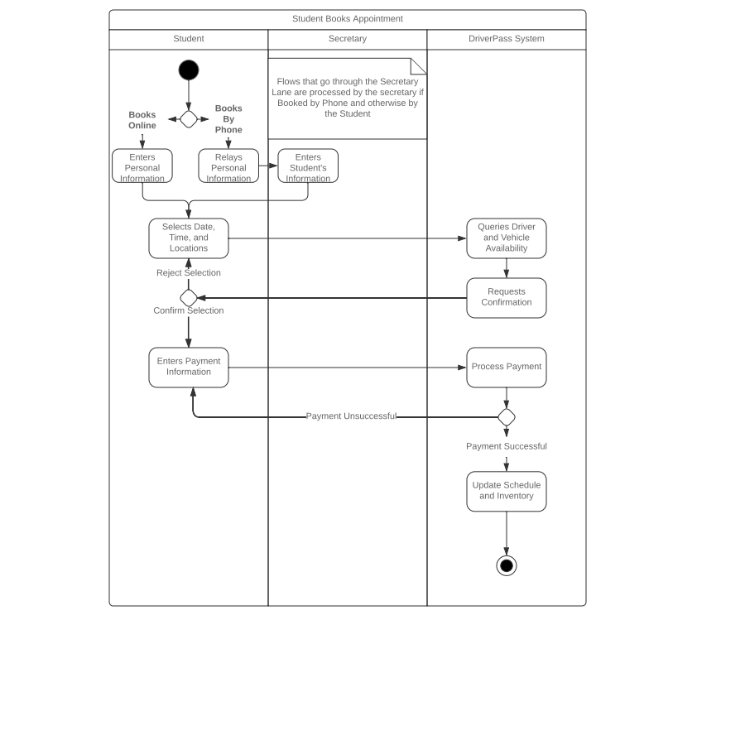

### UML Sequence Diagram

**Use Case: A Student Books an Appointment By Phone**

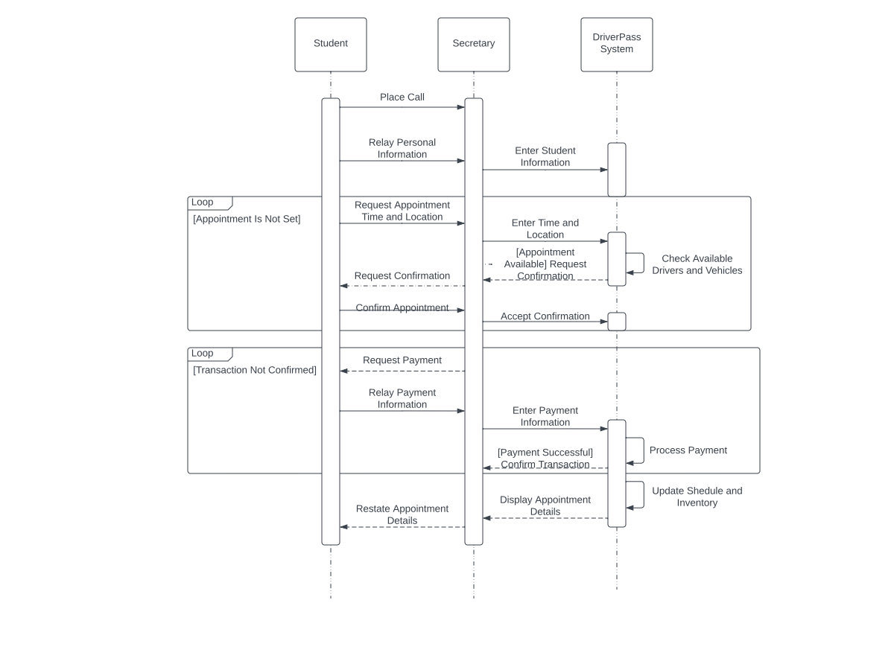

### UML Class Diagram

**DriverPass Class Representation**

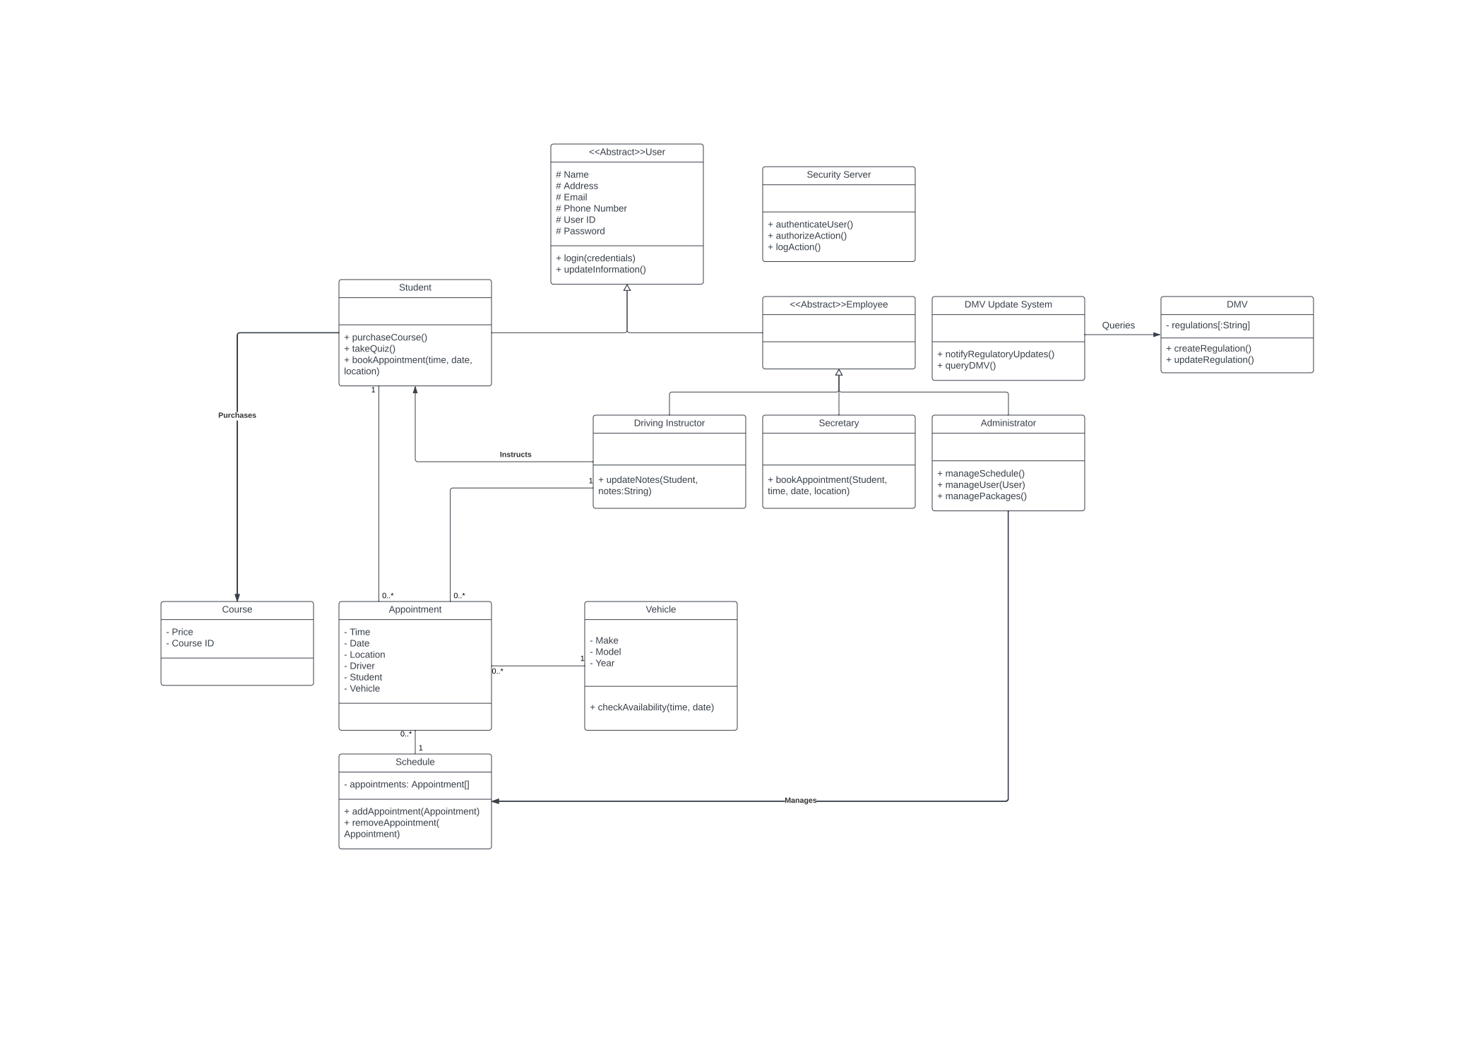

## Close-Up View of Right Side of Class Diagram (Employees, Security, and DMV))

## Close-Up View of Left Side of Class Diagram (Student and Appointment System)

## 

## Technical Requirements

Based on the needs of DriverPass, the system described above will adhere to various technical requirements.

**Hardware and Infrastructure:**

The system shall be located off-site and hosted by a cloud-provider as part of an infrastructure as a service(IaaS) solution. The client will not be burdened with the maintenance of physical servers and will be able to focus more greatly on other aspects of their operations. This also allows for scalability with the cloud provider if the hardware needs of DriverPass are ever to grow. Some machines capable of accessing a web browser will be required on site for the company’s employees, like the secretaries and the administrator.

**Software and Tools:**

The DriverPass system should be accessible and manageable through a web interface in a browser. This allows for the most portable solution that accomodates all of DriverPass’s clients and provides an easy way to distribute the needed software to all employees. A web server shall run the website that is both client-facing and the backend that is managed by the employees. There shall also be database software tracking scheduling and inventory. These databases shall be made available through the web client so that no technical knowledge is required by employees to make adjustments as necessary.

**Availability, Maintenance, and Performance:**

As a cloud-provided solution, barring major outages by the cloud host, uptime should be rather consistent. Only scheduled maintenance should interrupt service, and this may take place outside of DriverPass operating hours to minimize impact on business. Maintenance should be manageable through a web interface provided by the cloud host, as this will ensure that changes can be made remotely by DriverPass IT.

Performance should scale to the amount of traffic generated by DriverPass to their website. Webpages should be responsive to users, loading in under a second given an average internet connection speed in the United States. The system should also provide for security measures like password authentication of users logging in, accounting of all user actions, and authorization of certain user groups like employees to access privileged resources. Since payments are being handled by a third-party, DriverPass should ensure that no payment information is stored by the system or passed to the third party without an encrypted connection.