GLH Feedback
Adam Porter

Contents
Purpose of Data Collection 2
Design of Form 2
Target Audience and Size of Sample 2
Process of Distribution 2
Evidence of Data Collection 2
Summary of Data Collected 2

Purpose of Data Collection
The data for this collection was for feedback from users on the website, concentrating mainly on ease of use, navigation, design and content. To understand how users are using the system, what the problems are with the current implementation and the information this information could be used to improve the system in the future.

Method of Data Collection
The data for this collection was done using an online questionnaire using google forms. This questionnaire used a combination of multiple-choice, scale-questions and short-answer questions to collect quantitative and qualitative data. The data collection was completed by sending the google forms link out to users and receiving the results over the space of one week.

Design of Form
The questionnaire for data collection used both quantitative and qualitative questions to retrieve data from the user, divided into sections concerning ease of use, visual design and overall experience.
Quantitative Questions: Rating scale questions to find user experience regarding the ease of use of the navigation and visual design of the system.
Qualitative Questions: Open questions were used to find detail on the users’ problems and solutions.

Target Audience and Size of Sample
The target audience for this collection of data was general users who have used the website. There were 12 replies for the form over the course of 1 week, which is a small sample size but enough to find any relevant trends from users.

Process of Distribution
The questionnaire was delivered via a link directly to the user, the user was told to fill in the questionnaire when they were finished using the system.
The form was sent out multiple times to potential users to achieve a reasonable number of answers. A weakness of this delivery process is that the users may belong to a certain user group, not representing all the data.

Evidence of Data Collection

Account types used:
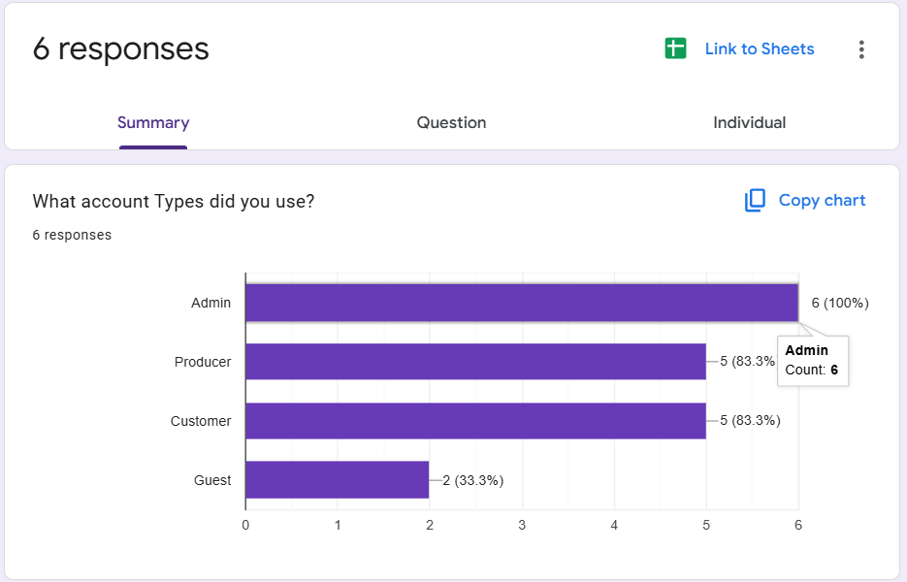

Navigation:
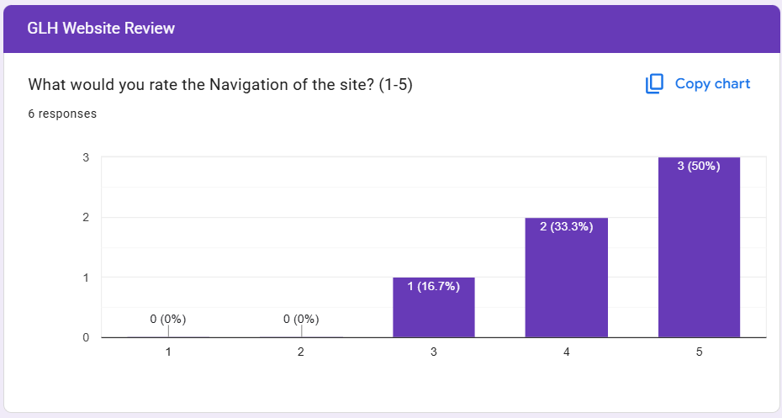
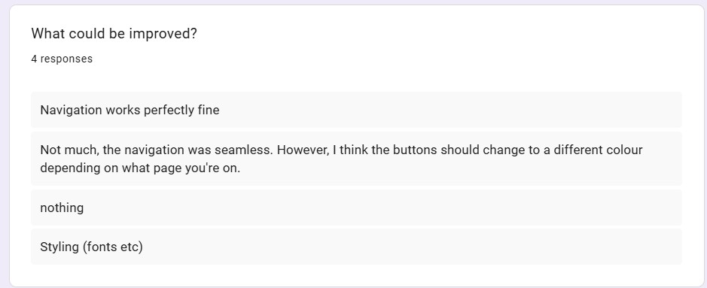

Layout:

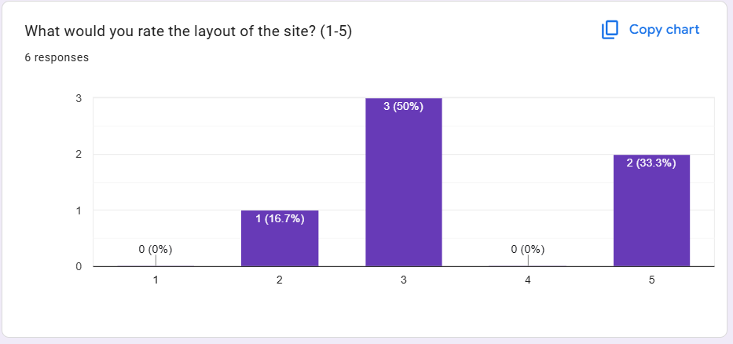
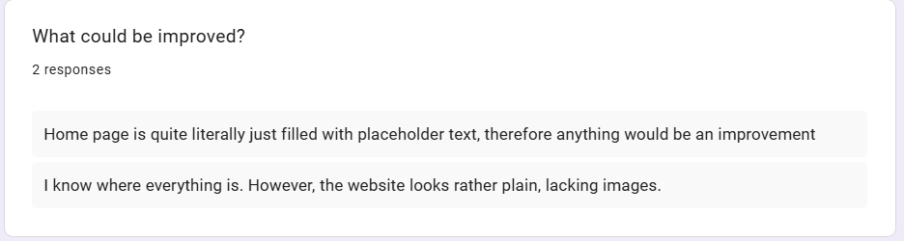

Colour Scheme:

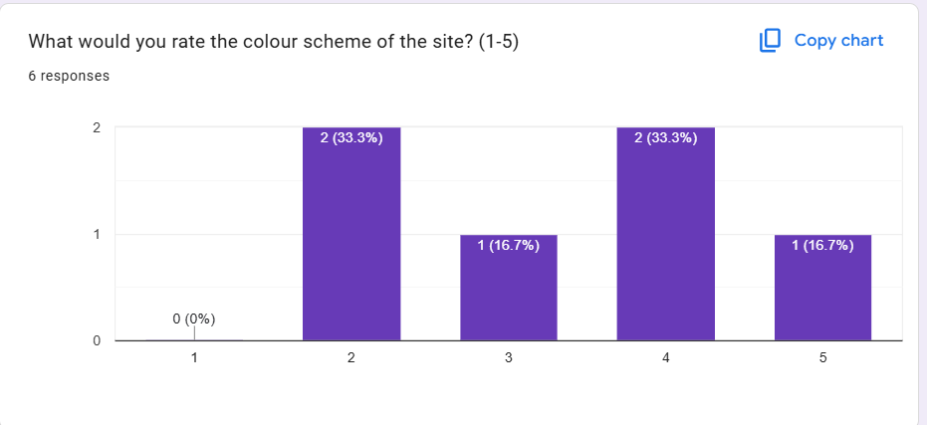
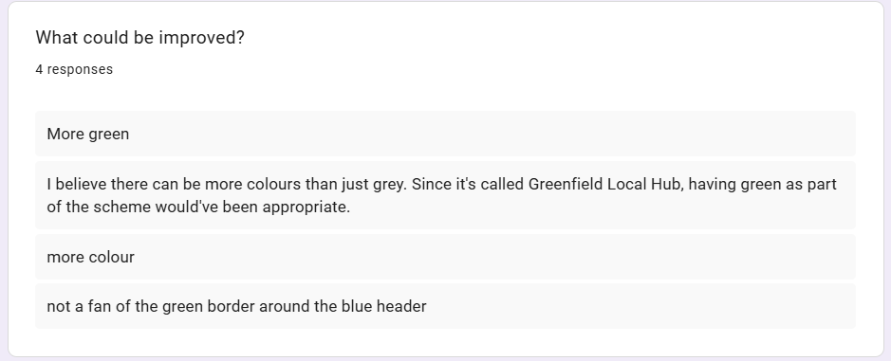

Create account:

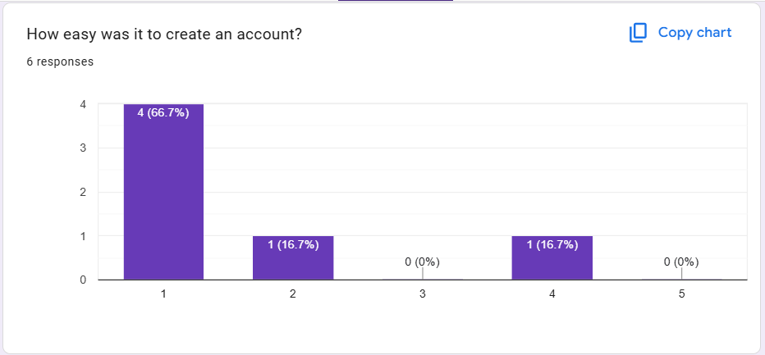
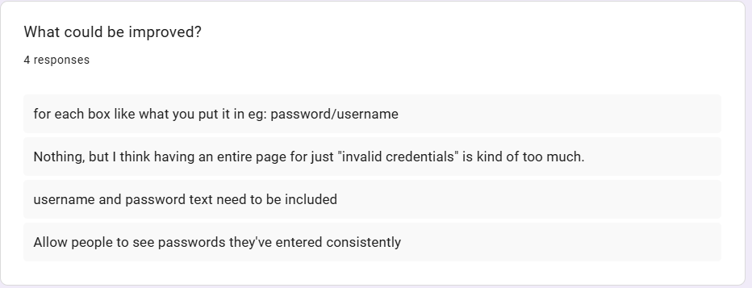

Sign in:

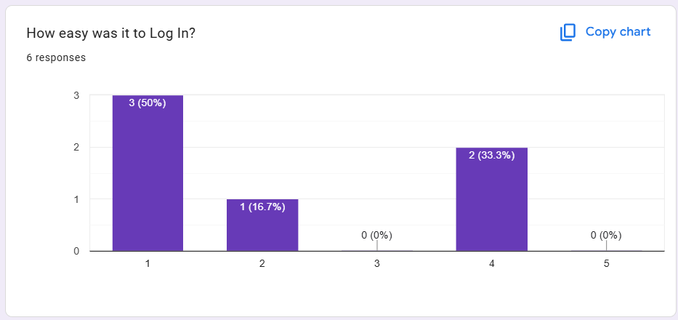
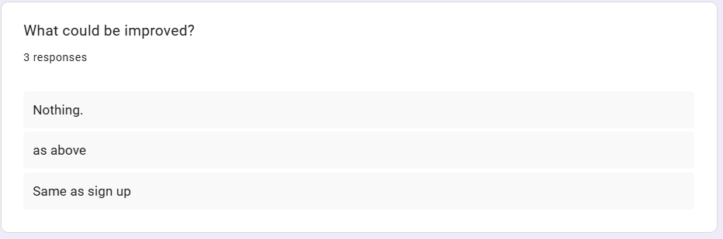

Create product:

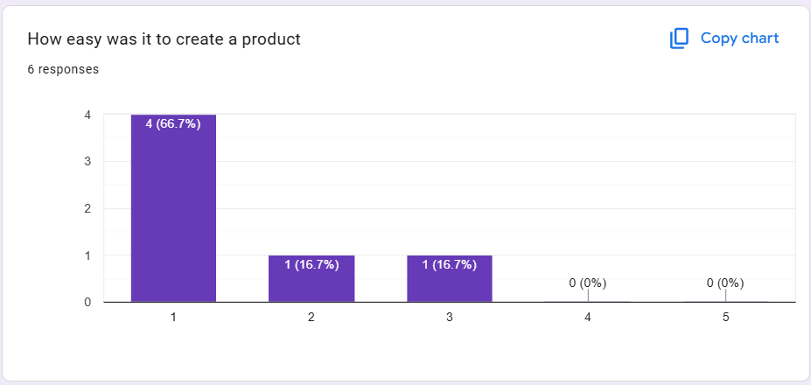
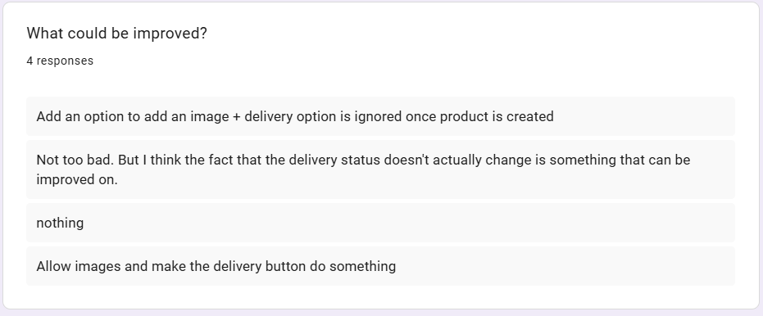

Edit Product:

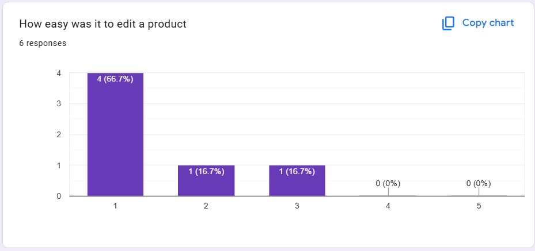
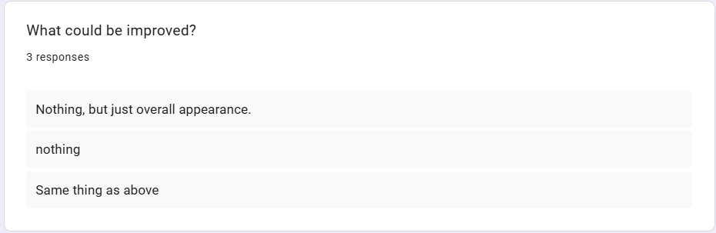

Overall:

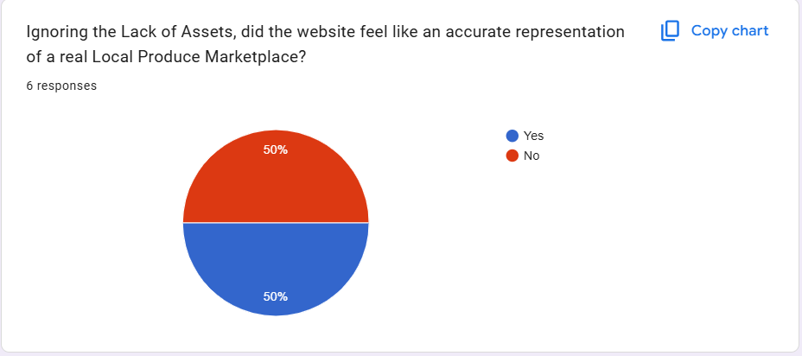

Summary of Data Collected
The data from this collection is summarized below:
50% of the users stated the website was client fit. The fact that 50% believe there is still a way to go to fully meet expectations.
Navigation was perceived to be easy to use by all (100%) users, so we are performing well in terms of the website navigation.
It is evident that many users asked for clearer username and password fields.

