**AC-10 — AI and Music Processing**

**Project Plan**

CS 4850 - Section 03 – Fall 2024

Sep 1, 2024

|  |  |
| --- | --- |
| Joseph Zboinski | Michael Egwuatu |
| Selam Kelil (Team Leader) | Trey Wilson |

**Team Members:**

|  |  |  |
| --- | --- | --- |
| Name | Role | Cell Phone / Alt Email |
| Joseph Zboinski | Developer | 919.912.6612  [mjzboinski@hotmail.com](mailto:mjzboinski@hotmail.com) |
| Michael Egwuatu | Project Manager | 678.956.3992  [mikegwuatu@gmail.com](mailto:mikegwuatu@gmail.com) |
| Selam Kelil (Team Lead) | Documentation | 404.551.6625  [selamkelil@gmail.com](mailto:selamkelil@gmail.com) |
| Trey Wilson | Developer | 478.508.8746  [tjwilson003@gmail.com](mailto:tjwilson003@gmail.com) |
| Arthur Choi | Project Owner/Advisor | [achoi13@kennesaw.edu](mailto:achoi13@kennesaw.edu) |

## 1.0 Project Overview / Abstract (Research)

This project explores the application of machine learning techniques to music classification and generation, with a focus on simulating human-like learning in music composition. Current methods have achieved success by relying on audio wave features such as Mel-Frequency Cepstral Coefficients (MFCC) for music analysis, but this research seeks to advance the field by utilizing MIDI data for model training. By leveraging MIDI, which captures the symbolic representation of music notes and timing, the project aims to enable the model to learn from musical patterns in a manner akin to human cognition. This approach emphasizes intuitive and anthropic learning processes, aiming to mimic the way a composer creates music through a learned vocabulary of musical themes and patterns. Expected outcomes involve a web-based demonstration and tutorial showcasing AI's capability to compose and recognize music, contributing to advancements in AI-driven music generation.

## 2.0 Project website

The current URL for our project website is ac-10-research.github.io though the html, CSS, and JavaScript files are not yet implemented for it.

## Deliverables - Specific to Your Project

1. Project Plan & Software Requirements Specification (SRS)
2. Software Design Document (SDD)
3. MIDI Testbed for Model Training
4. Model Prototype
5. Model Test Data
6. Final Report Package
   1. Final Report
   2. Jupyter Notebook Tutorial on Model Implementation
   3. C-Day Poster
   4. Model-Generated Music (C-Day presentation)
   5. Source Code
   6. Project Website
   7. Project GitHub

## Milestone Events

Project Plan & SRS Approval - By 9/1/24

Software Design Document Submission - By 9/1/24

Prototype Presentation - By 10/14/24

Prototype Testing & Reiteration - By 11/11/24

Final Report Draft & Submission - By 11/18/24

## Meeting Schedule

Regular meetings, between the entire team and the project owner, will be conducted on Mondays from 12:30 – 1:00 pm on Teams with additional team meetings scheduled as needed. An ongoing stream of communication will also be kept open on Discord.

## Project Schedule and Task Planning

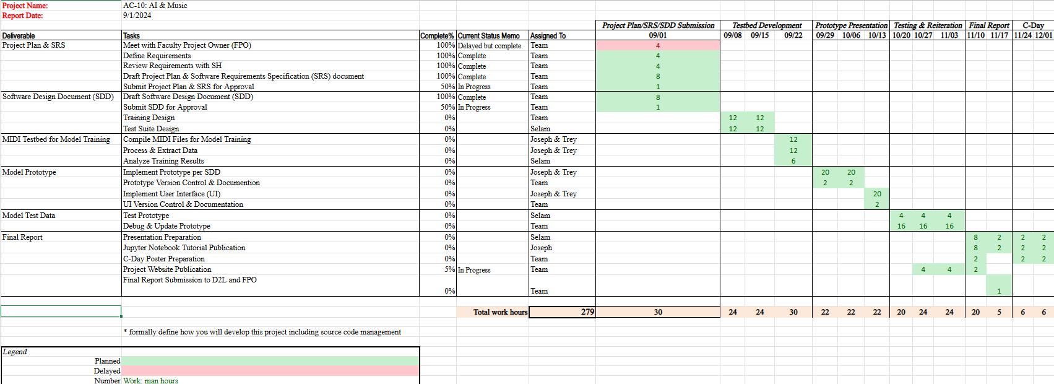

## Risk Assessment

Given the educational nature of this project, the fair use doctrine provides protection from Intellectual Property (IP) risks. Any future enterprise applications derived from this research will need to exercise caution in their training testbed and model implementation to avoid IP infringement.

## Version Control Plan

GitHub will be used to provide version control for this project. The following link will direct you to our organizational account and repositories: [AC-10-Research (github.com).](https://github.com/AC-10-Research)