Da Nang Trip Guide
2026-08-14 – 2026-08-18 · 4 nights · Singapore (SIN) → Da Nang

Companion to the Excel booking-strategy workbook. Each place has description, photo, official link, and Google Maps pin.

🗺️ Regional Overview Map
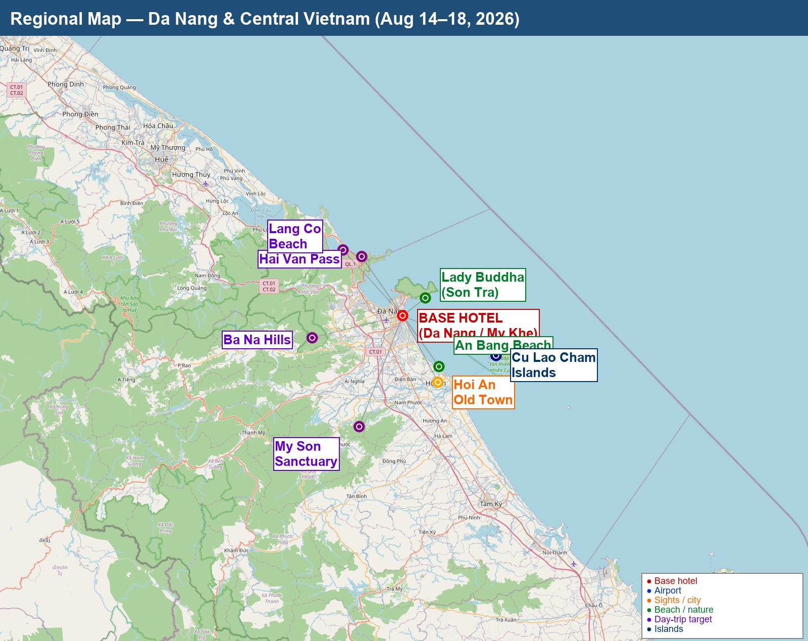
Regional map — base hotel + day-trip targets · OpenStreetMap data

🏯 Iconic Sights

Dragon Bridge (Cầu Rồng)
A 666-metre, six-lane bridge across the Han River shaped as a dragon. Every Fri/Sat/Sun at 21:00 it breathes fire and water for ~15 min. Best from east-side deck.
• Wikipedia
• Vietnam Tourism
Map: Google Maps

Ba Na Hills & Golden Bridge
Mountain resort accessed via 5,801m cable car (Guinness record). Golden Bridge held aloft by giant stone hands, French Village, Linh Ung Pagoda, Alpine Coaster. Klook group day tour bundles transport+cable car+lunch ~1.2M VND.
• Sun World Ba Na Hills (official)
• Klook Ba Na Hills tours
Map: Google Maps

All photos from Wikimedia Commons under permissive licences (CC-BY-SA / public domain). Map data © OpenStreetMap contributors. Verify all prices and operating hours 2 weeks before travel.

