Manila Trip Guide
2026-05-28 – 2026-06-01 · 4 nights · Domestic / Provincial Philippines → Manila

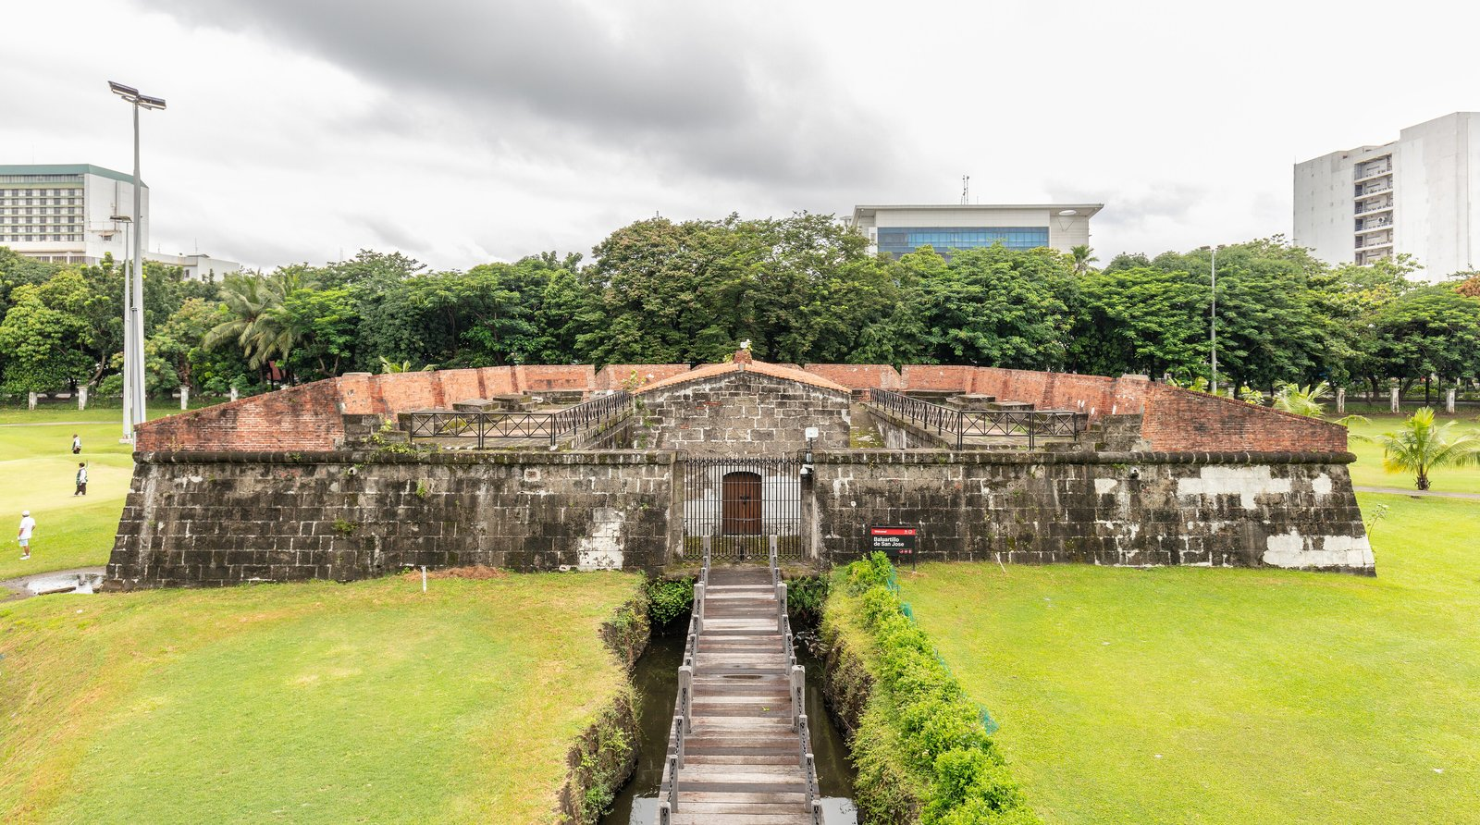
Intramuros (Walled City) — Manila
Companion to the Excel booking-strategy workbook. Each place has description, photo, official link, and Google Maps pin.

🗺️ Regional Overview Map
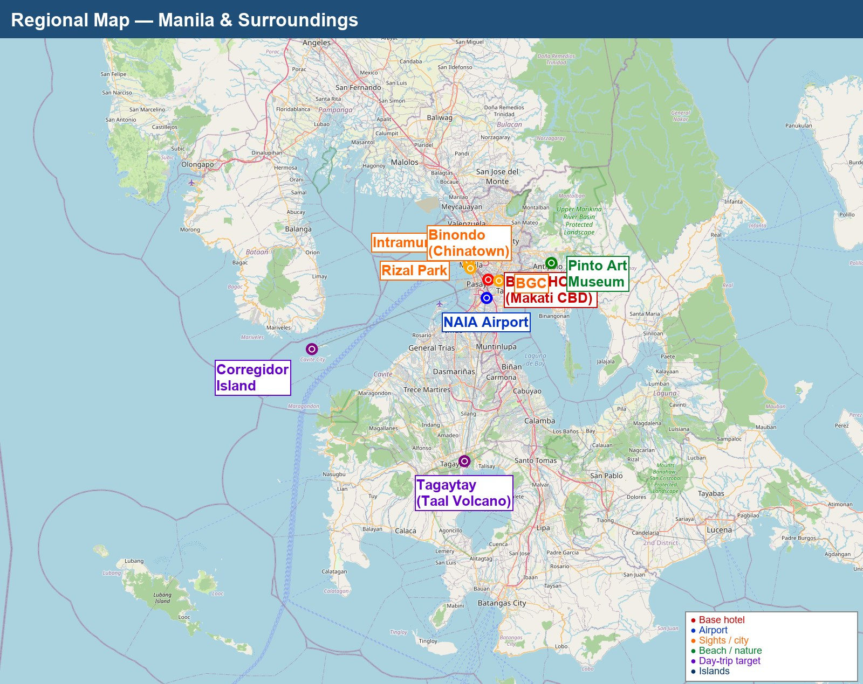
Regional map — base hotel + day-trip targets · OpenStreetMap data

🗺️ City Close-up
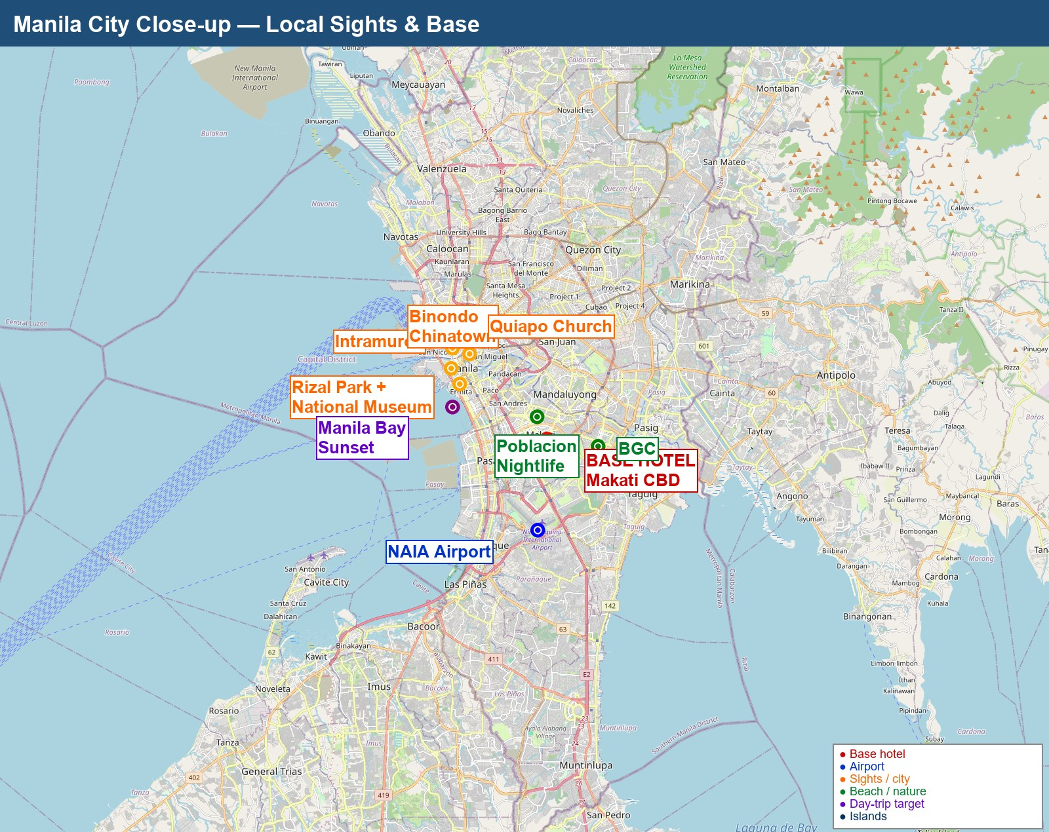
Manila city close-up — local sights

🏯 Iconic Sights

Intramuros (Walled City)
Manila
16th-century Spanish walled city — the historic core of colonial Manila. Contains Fort Santiago (Rizal's last prison), San Agustin Church (1607, UNESCO, oldest stone church in PH), Manila Cathedral, Casa Manila, Bahay Tsinoy. Best explored on foot or by bamboo bike (Bambike eco-tours ₱1,200). Allocate half a day minimum.
• Wikipedia
• Intramuros Administration (official)
• Bambike Ecotours
Map: Google Maps

Rizal Park (Luneta)
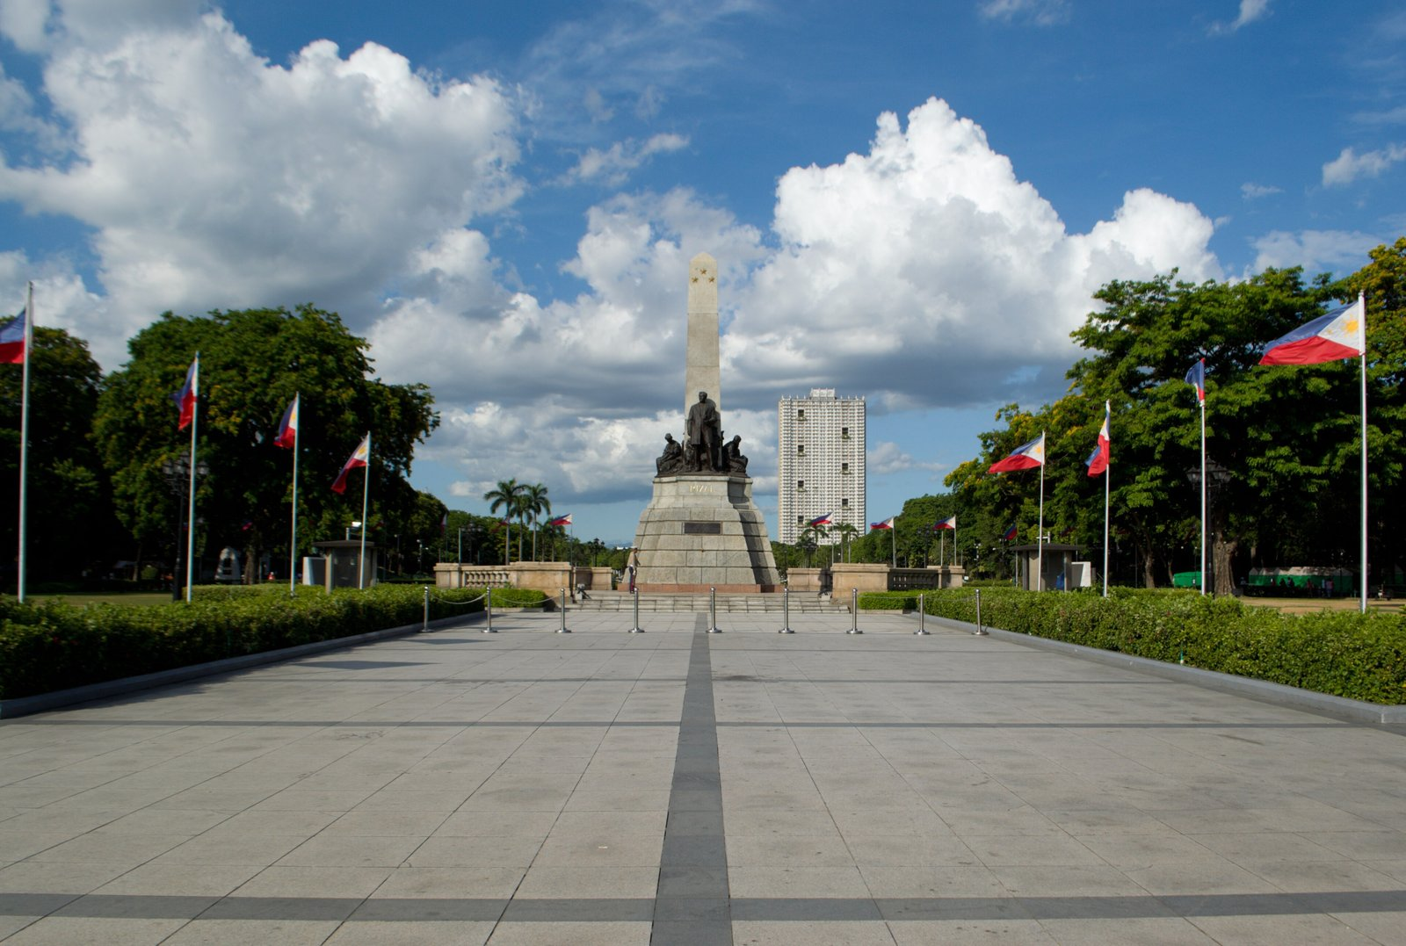
Ermita, Manila
Largest urban park in PH and site of national hero José Rizal's execution (1896). Houses Rizal Monument (24/7 honor guard), Chinese & Japanese gardens, National Museum complex nearby. Free entry. Best at sunrise or late afternoon to avoid heat.
• Wikipedia
Map: Google Maps

National Museum Complex

Padre Burgos Ave, Ermita
Three free museums — Fine Arts (Spoliarium by Luna), Anthropology, Natural History (Lolong the croc). FREE admission since 2016. AC, 3-4 hr comfortable visit. Closed Mondays.
• Wikipedia
• Official site
Map: Google Maps

Binondo (Chinatown)
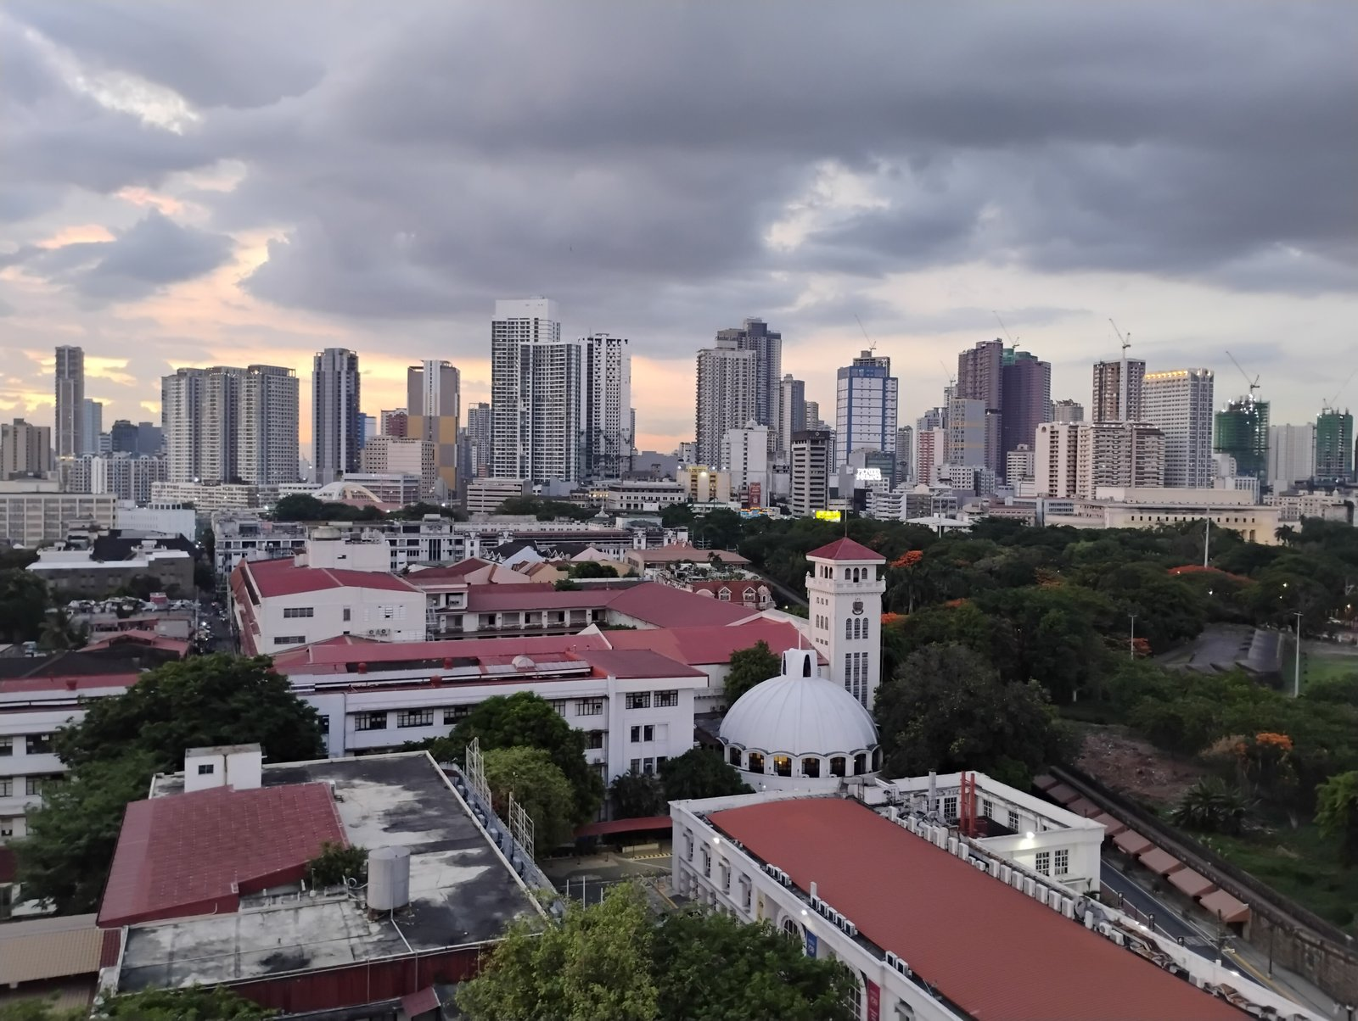
Manila
World's oldest Chinatown (established 1594). Food crawl heaven — Eng Bee Tin (hopia), Wai Ying (dimsum), Sincerity Cafe (kiampong + fried chicken), Lord Stow's (egg tart), Polland (pork siopao). Old Manila Walks 'Big Binondo Food Wok' tour ₱1,500.
• Wikipedia
• Old Manila Walks
Map: Google Maps

Quiapo Church (Minor Basilica of the Black Nazarene)
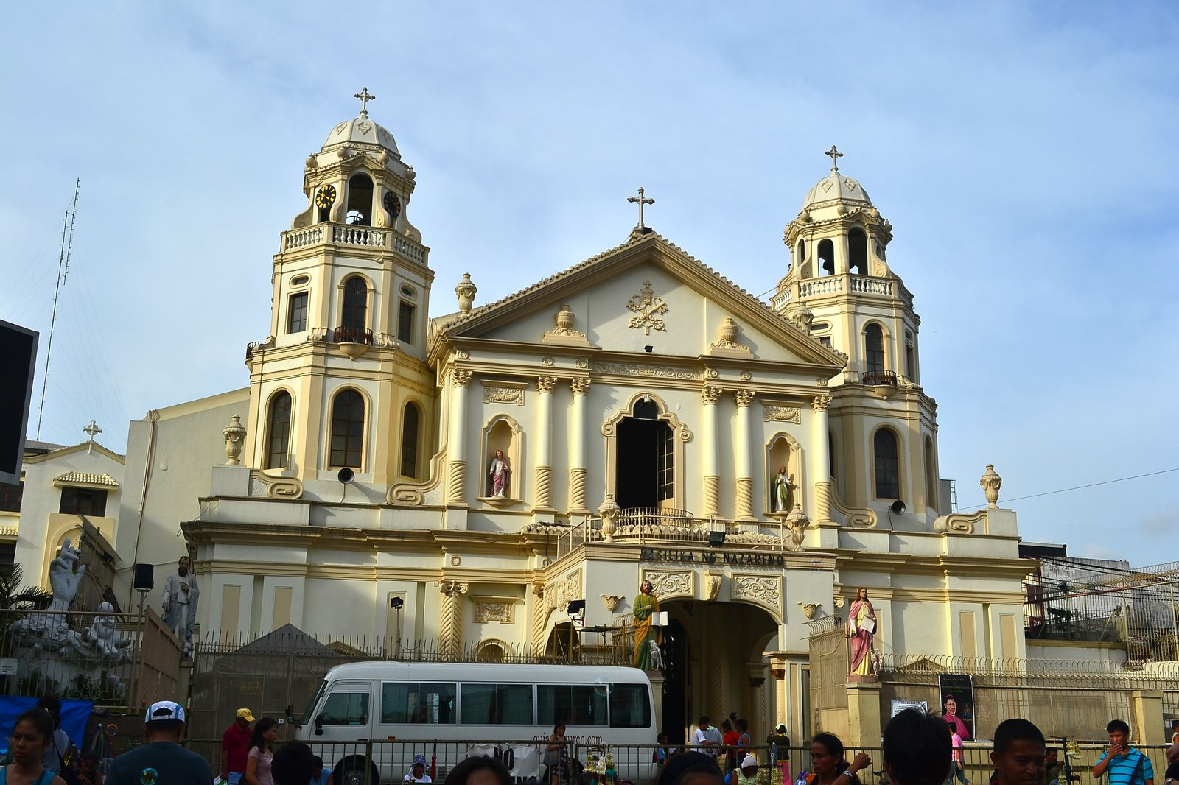
Quiapo, Manila
Home of the Black Nazarene — focal point of one of the largest Catholic devotions in Asia (Traslación every Jan 9). Surrounding Quiapo: Hidalgo St photography row, Raon St electronics, Villalobos herb stalls. Watch pickpockets in crowded plaza.
• Wikipedia
Map: Google Maps

Manila Cathedral
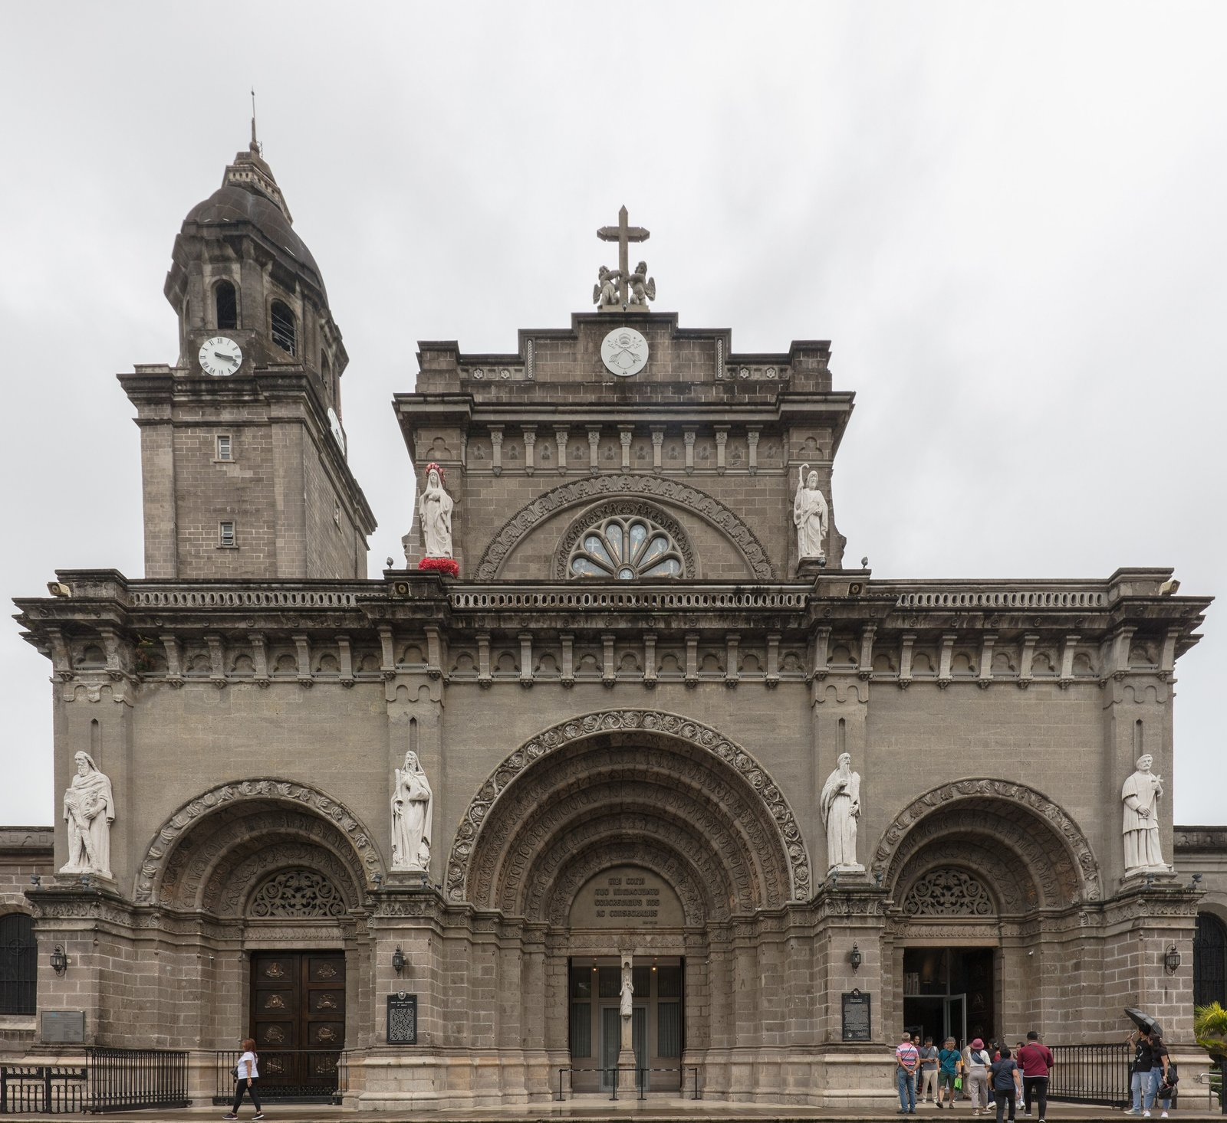
Intramuros
Minor Basilica and seat of the Archbishop of Manila. Current (8th) structure consecrated 1958 after WWII destruction. Free entry outside Mass times. Stained glass, papal organ. Pair with San Agustin walk.
• Wikipedia
Map: Google Maps

San Agustin Church
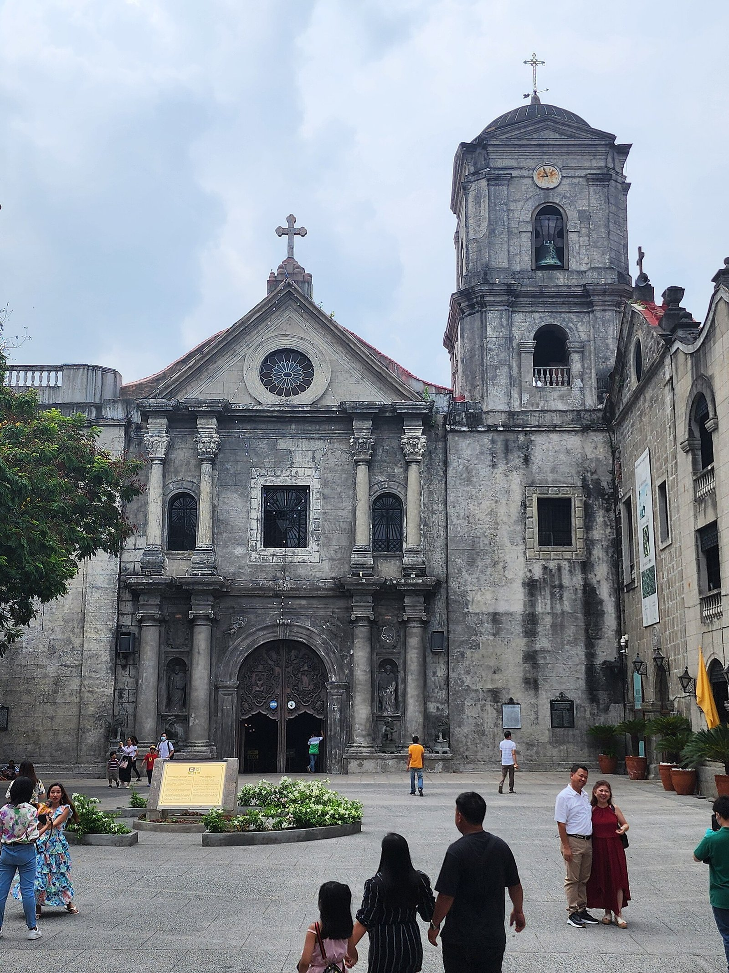
Intramuros
Oldest stone church in the Philippines (1607). UNESCO World Heritage. Survived 7 earthquakes + WWII bombing of Intramuros. Adjacent museum has religious art and relics. Entry ₱200.
• Wikipedia
Map: Google Maps

Ayala Museum
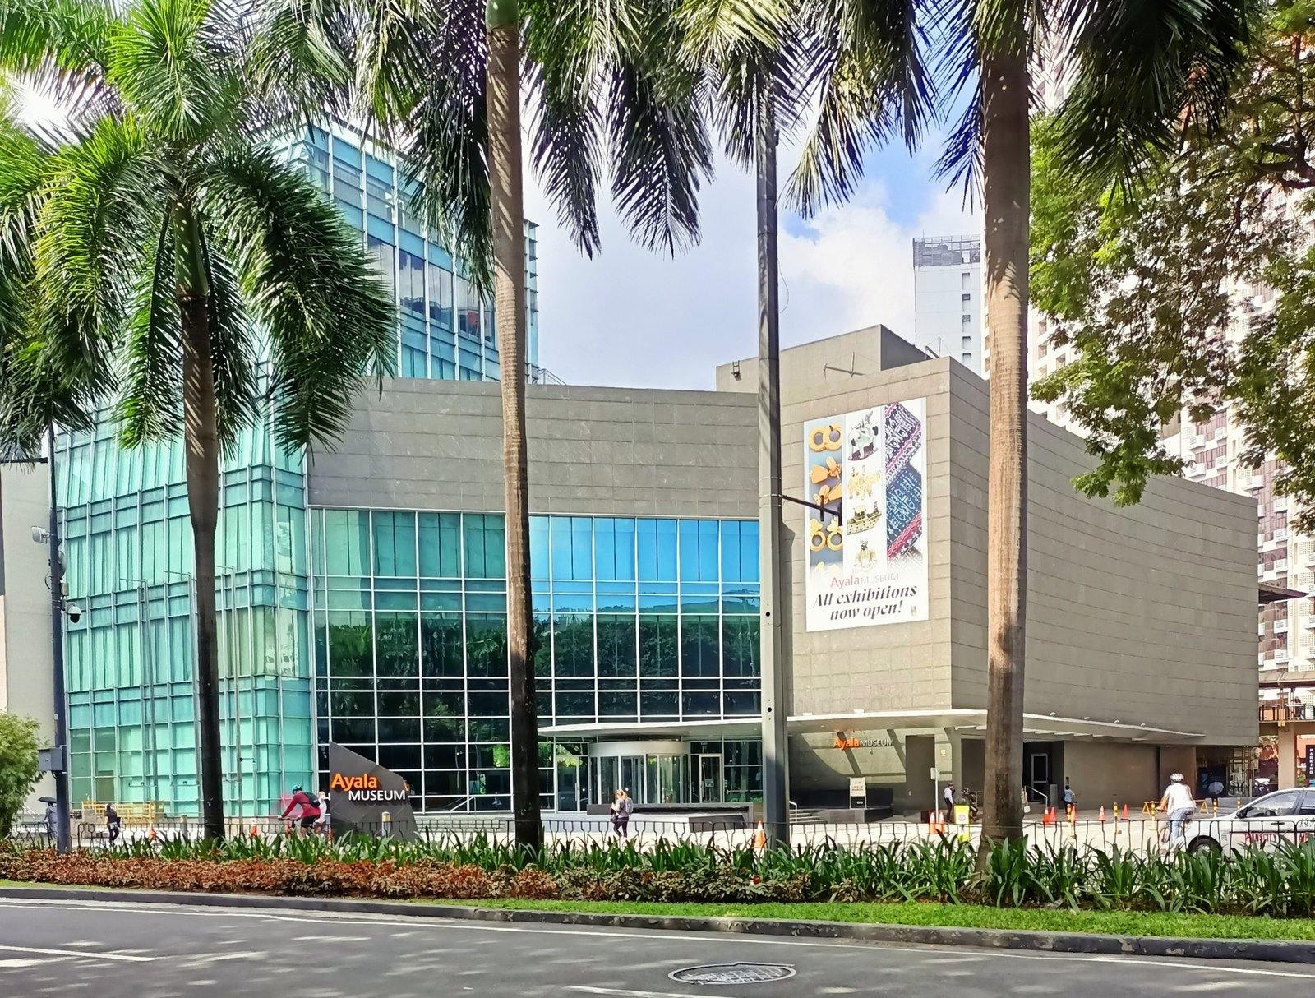
Makati
Reopened 2022 with stunning Gold of Ancestors gallery (precolonial gold artifacts, world-class), Diorama Experience (60+ scenes of PH history), and rotating contemporary exhibits. Entry ₱650. Allocate 2-3 hours.
• Wikipedia
• Official site
Map: Google Maps

Bonifacio Global City (BGC)
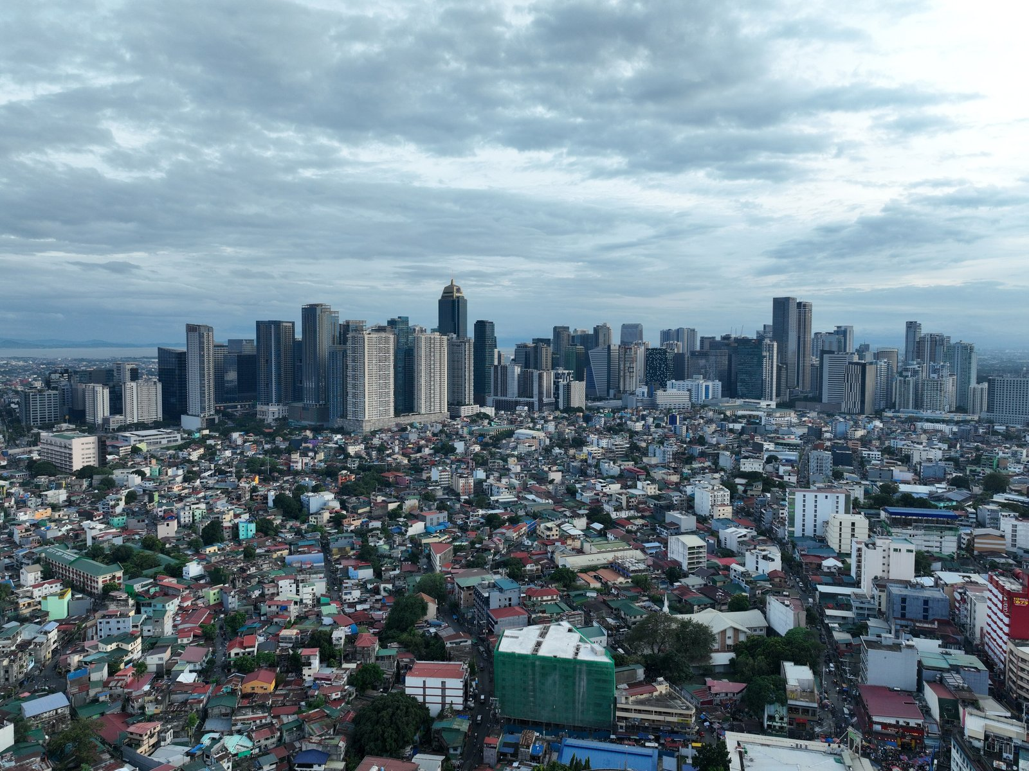
Taguig
Modern CBD with Bonifacio High Street (pedestrian zone), Mind Museum, The Alley at Karrivin Plaza (art galleries), and the BGC street-art trail. Best for upscale shopping + dining. Walkable.
• Wikipedia
Map: Google Maps

Manila Baywalk + Sunset
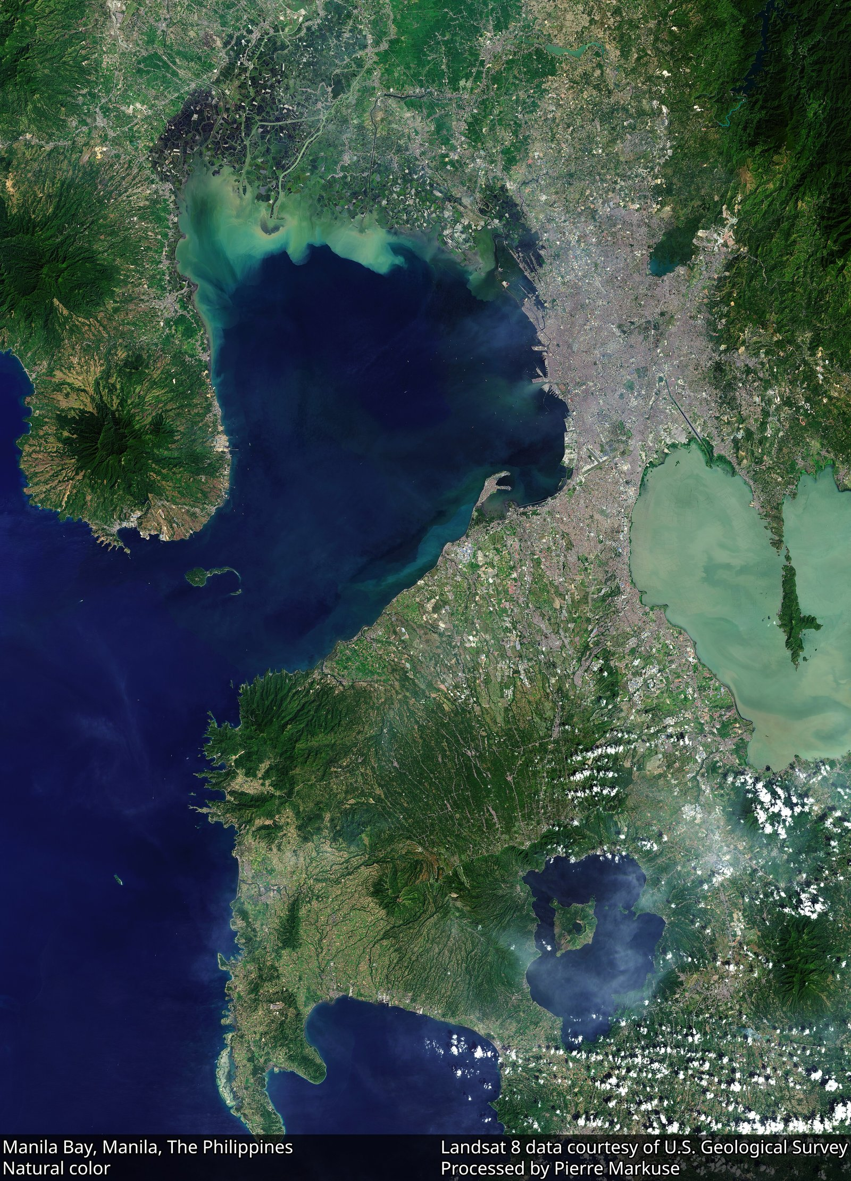
Roxas Blvd, Ermita
Famous Manila Bay sunset stretch along Roxas Blvd. Free. Best 17:30-18:30. Newly rehabilitated 'White Beach' near US Embassy. Skip if tide low (smell). Pair with dinner at CCP/Aristocrat.
• Wikipedia
Map: Google Maps

Tagaytay (Taal Volcano view)
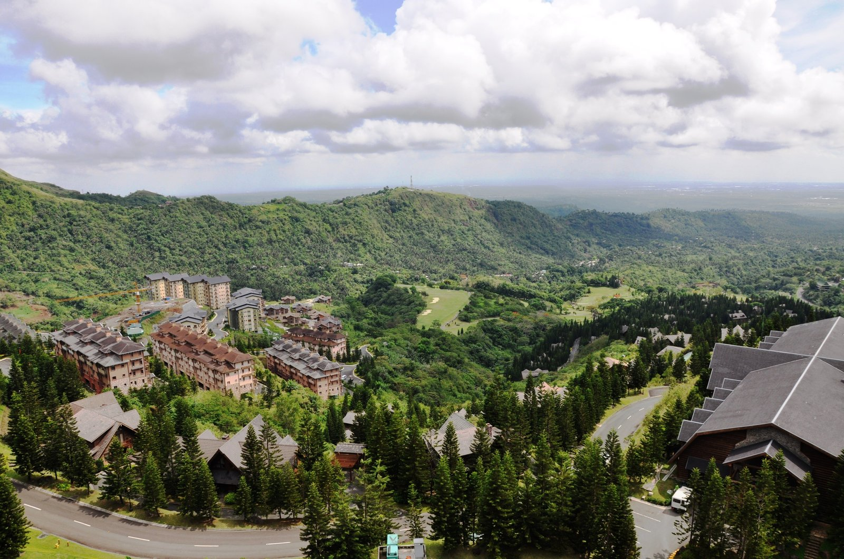
Cavite (60km S of Manila)
Cool-climate ridge city overlooking Taal Volcano. 1.5-2hr drive from Makati. Bulalo (bone-marrow beef stew) at Leslie's or Diner's. Sky Ranch amusement park. People's Park in the Sky for volcano panorama. Sonya's Garden for organic lunch. Easy day trip.
• Wikipedia
Map: Google Maps

Corregidor Island
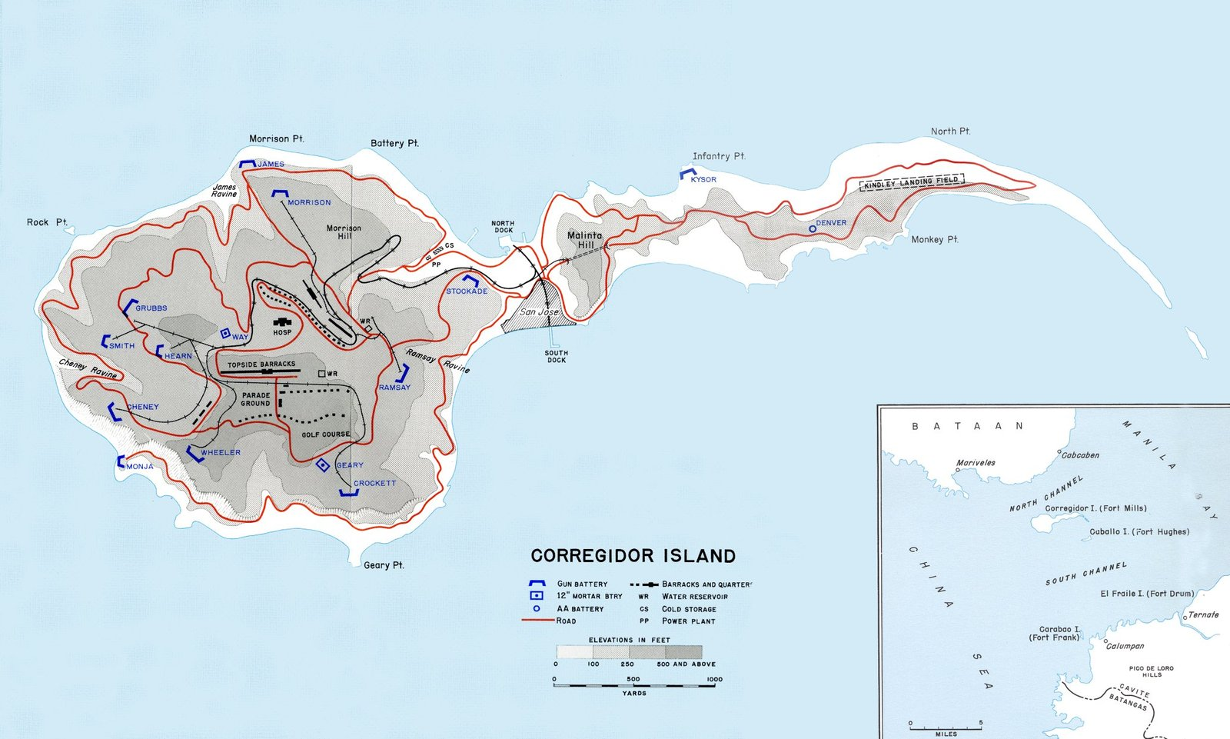
Manila Bay entrance
WWII tadpole-shaped island fortress at Manila Bay entrance. Sun Cruises ferry from ESPLANADE Seaside Terminal (CCP). Malinta Tunnel, Pacific War Memorial, Mile-Long Barracks, Battery Way. Full-day tour 06:30-15:30. ~₱2,999/pax incl ferry+lunch+tram.
• Wikipedia
• Sun Cruises (official ferry)
Map: Google Maps

💎 Hidden Gems & Less-Touristy Alternatives

Escolta Street
Once Manila's Wall Street — now a heritage art district. First Saturday Block Party (Saturdays of the month). Calvo Building, Regina Building, Capitol Theatre ruins. HUB:Make Lab for indie design. Often missed by tourists.
• Wikipedia

Poblacion (Makati nightlife district)
Gritty-cool district reinvented as Manila's premier bar/food crawl zone. Rooftop bars (Z Hostel), speakeasies (Run Rabbit Run), Korean BBQ row, late-night taco stands. Walkable from Makati CBD hotels.
• Wikipedia

Pinto Art Museum (Antipolo)
Whitewashed Mediterranean-style contemporary art compound on a hill in Antipolo. Multiple galleries + gardens + cafe. Phenomenal Instagram spot but actually substantive curation. ₱250. Worth the Grab ride.
• Wikipedia

Manila Chinese Cemetery
Surreal 'mini-city' cemetery where mausoleums have AC, mailboxes, two-storey houses. Built when Chinese were denied burial in Catholic cemeteries during Spanish era. Free, hire pedicab guide (~₱500) at gate.
• Wikipedia

🍜 Food — Where to Eat

Wai Ying Fastfood — Binondo
Cheap, fast Cantonese dimsum + hakaw + soy chicken. Cult favorite. Two branches (Benavidez + Salazar). Cash only.

Manam Comfort Filipino — Greenbelt 2, Makati
Modern Filipino tapas — sinigang sa watermelon, crispy pata, kare-kare. Order classics + twist sides. Walk-ins okay weekday lunch.

Toyo Eatery — Karrivin Plaza, Makati
Asia's 50 Best — pinakbet bukid, Filipino tasting menu. Splurge dinner.
• Official site

Aristocrat Restaurant (Roxas Blvd) — Malate
Manila institution since 1936. Famous chicken BBQ + java rice + atchara. Heritage feel, often packed Sundays after Mass.

Romulo Café — QC original / Makati branch
Heritage Filipino — Tito Greg's adobo flakes, chicken relleno, dinuguan empanadas. Named after Carlos P. Romulo. Good for groups.

Sentro 1771 — Greenbelt 3 / Capitol Commons
Modern Filipino — corned-beef sinigang (iconic), bagnet, ensaladang mangga. Solid sit-down option.

Leslie's Restaurant Tagaytay — Aguinaldo Hwy, Tagaytay
Classic bulalo (beef bone-marrow stew) with Taal Lake panorama. Tourist mainstay but worth it for the view + the broth.

Wildflour Café + Bakery — Salcedo / BGC / Podium
Upscale all-day café — eggs benedict, salted caramel ensaymada, fresh pastries. Reliable any day.

💆 Spas

The Spa (Fort Bonifacio) — BGC
Reliable mid-range chain — Swedish, hilot, hot stone. Couples rooms. Book ahead Sat/Sun.

Nuat Thai — Multiple branches (Makati/BGC/QC)
Cheap reliable Thai massage chain. Walk-in possible. Foot reflex highly recommended after Intramuros walking day.

Devarana Spa (Dusit Thani) — Makati (Ayala Center)
Luxury hotel spa, Thai-inspired rituals, signature Devarana 150min package. Best splurge.

Mandala Spa (Antipolo) — Antipolo (~28km E)
Hidden hillside spa retreat. Pair with Pinto Art Museum for half-day off-radar wellness combo.

🍻 Nightlife

Z Hostel Rooftop Bar — Poblacion, Makati
Open-air rooftop bar — sunset cocktails, Manila skyline view. Crowd builds 21:00 onward.

The Curator — Legaspi Village, Makati
Speakeasy behind coffee shop. World's 50 Best Bars alum. Craft cocktails. Reservation recommended Fri/Sat.

Run Rabbit Run — Poblacion, Makati
Speakeasy behind grocery façade. Cocktails + small plates. Hidden door experience.

The Bank Bar — RCBC Plaza, Makati
Concealed inside RCBC Plaza — enter via Ze Royal Filipino-Cuban restaurant. Classic cocktail focus.

Sky Deck Bayleaf — Intramuros (Bayleaf Hotel)
Rooftop bar atop Bayleaf — Intramuros + Manila Bay views. Less crowded than Poblacion.

🏨 Accommodation Picks

Red Planet Makati (Mabini) — Budget · S$35–55/night
Walking distance Poblacion + Greenbelt. Clean, no-frills. Best budget pick.
• Booking.com

Citadines Salcedo Makati — Mid · S$90–140/night
Aparthotel with kitchen, gym, pool. Salcedo Village near Saturday market. Mid-range sweet spot.
• Citadines official

Dusit Thani Manila — Luxury · S$200–320/night
Across Ayala MRT, walking to Greenbelt/Ayala Museum. Devarana Spa onsite. Reliable luxury.
• Dusit official

Shangri-La The Fort (BGC) — Luxury · S$280–450/night
If staying BGC instead of Makati. Tallest hotel in PH. Samba rooftop bar, CHI Spa.
• Shangri-La official

🔗 Practical Links & Resources

Booking & Transport
• Grab PH
• Klook Manila activities
• Sun Cruises (Corregidor)
• Agoda Manila hotels

Government & Safety
• Bureau of Immigration PH
• PAGASA weather (typhoon track)
• PHIVOLCS (Taal alerts)
• Emergency: 911 (national)

Tourism & Reference
• Tourism Promotions Board PH
• Intramuros Administration
• Old Manila Walks (tours)

Apps to install
• Grab (rides + food)
• GCash (payments)
• Foodpanda (delivery)
• Waze (traffic)

All photos from Wikimedia Commons under permissive licences (CC-BY-SA / public domain). Map data © OpenStreetMap contributors. Verify all prices and operating hours 2 weeks before travel.

