To start this project, I needed to first get an API key to link to a JSON, I chose to use marvel superheroes to do mine, I realised quickly my work will be structured but I also wanted it to be unorganised too. Some work by Benjamin Fox shows how you can have unorganised mess with your work, with the way he uses the lines around the inner squiggles to show how it was following a pattern then he let it go free for a little bit and it made a small section of chaos, I feel this relates to my work being listed and organised and then on the home page when you scroll down there is a mess of images going around the screen , this reflects the chaos in the charm in my work and in Benjamin Fox work.

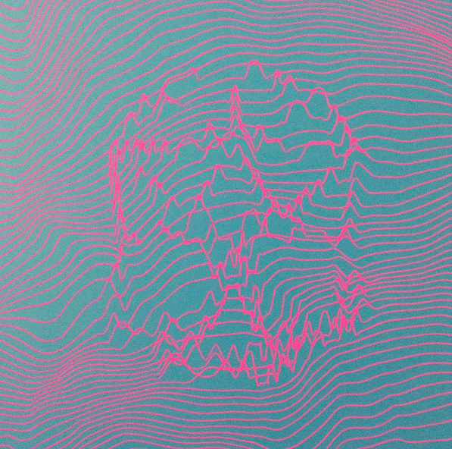

The next piece of work I found inspiriting was some work by David Knape the use of symmetry within the work and the structure and organisation you can see within it reflects my work mine organised with lists and straight lines, this also includes straight lines and it’s in such an organised way it makes a pattern by hitting repeated points and letting the line draw. The use of basic colours is different to mine as this has blue, black and white, while mine has bright colours and the page reflects the colour the JSON has given me for that individual superhero.

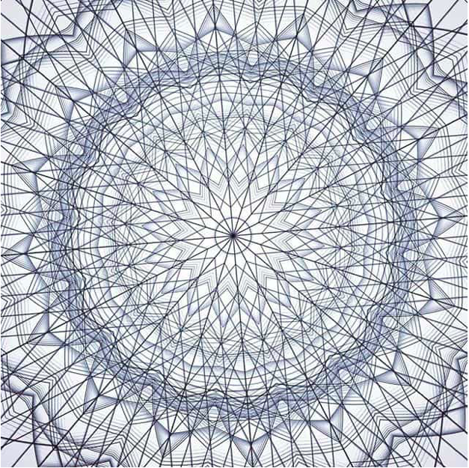

The last piece of work I found was called Metasquema by Hélio Oiticia the off centre squares shows how you can have a perfectly organised mess the way the squares overlap and on further looking they aren’t all squares you have some longer rectangles which makes this piece more interesting, this represents my images at the bottom because they overlap and they are not all perfect and how they bounce off each other which if you look close enough it looks like this piece is sort of reflecting or they could be bouncing off each other.

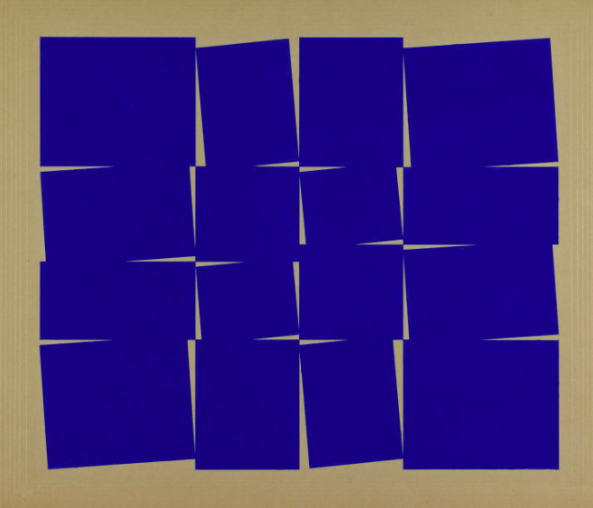

With my JSON I did a simple log on one of the characters to discover its potential then I started with deciding what I would do, I choose to style my work on top trumps so you have links for the different superheroes and then it relays the information of the name, how many comics they have and a short description on them, I made a link from the HTML main page which went to the link for the different superheroes, after I achieved this I then realised the front page was not interesting so I added the pictures on the bottom, I then made them move and fly around the page it sort of gives them a fighting effect which I thought worked well with the superheroes theme.

Calling on the picture from the JSON was the biggest issue with this work, it wasn’t as easy as doing the text and you had to have a lot of knowledge and a lot of patience to achieve getting it to appear, and then getting it to move was worse but with a lot of research and patience it was achievable, in future I think I will want to explore the JSON more to see what more I can do then just the simple looking stuff.

Reference

Benjamin fox (BF)

‘8 WORKS OF GENERATIVE ART BY THE CREATIVE CODING COMMUNITY’

*K Blog*

<https://blog.kadenze.com/arts-culture/generative-art-creative-coding-community/>

January 2018

David Knape (DK)

‘8 WORKS OF GENERATIVE ART BY THE CREATIVE CODING COMMUNITY’

*K Blog*

<https://blog.kadenze.com/arts-culture/generative-art-creative-coding-community/>

January 2018

Hélio Oiticia (HO)

‘Metasquem’

*TATE*

<http://www.tate.org.uk/art/artworks/oiticica-metaesquema-t12419>

January 2018

GIT=

<https://github.com/FluffyBunny123/KyraBoyle-DAT405>

<https://fluffybunny123.github.io/index.html>