**Date of Post 16/07/2025 (Nachmittags)**

🧪 **Surfactant Flooding: Salinity Matters**  
Same surfactant, different salinities — striking contrast in performance.

🔹 **Lower Salinity (Top):**  
Strong emulsification → effective oil displacement  
🔹 **Higher Salinity (Bottom):**  
Weak emulsification → poor recovery

💡 Even in a simple micromodel, the effect is clearly visible.  
**Emulsification plays a central role in oil mobilization.**

With **InspIOR**, we screen salinity and surfactant efficiency under controlled flow conditions — **using live fluids if required**.

#EOR #SurfactantFlooding #OilRecovery #Microfluidics #fluidXlab #InspIOR

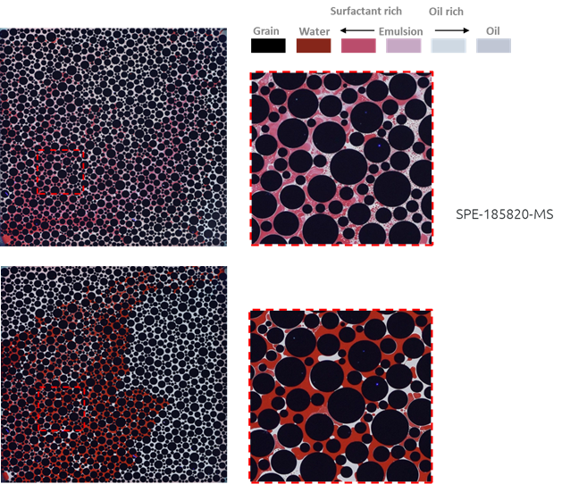

**InspIOR Post 23/07/2025 (Nachmittags)**

**Please reuse this one. Please mention somewhere “operates up to 20.000 psi and 250 °C”:**

**Date of Post 28/07/2025 (Vormittags)**

***Arbeitgeber der Zukunft Post den Du vorbereitet hast!***

**Date of Post 04/08/2025 (Nachmittags)**

**@ Angi: Please add the full details about the presentation e.g. date, time, etc. Talk to Nils to get good visual. If nothing else is available use image of Nils.**

**🧪 Underground Hydrogen Storage at the SCA Conference 🧪**

**We’re proud to share that our Senior Lab Expert Nils Langanke will present at this year’s SCA Conference 2025 in Hannover, hosted by the Society of Core Analysts.**

**Our joint paper,  
“Geochemical reactions in reservoir rock and capillary sealing capacity of caprock during hydrogen admixing in the underground gas storage complex Rehden”,  
was developed together with partners from #SEFEEnergy, #CoreImagingConsultants (Texas), and #ClausthalUniversityofTechnology.**

**As Europe advances its hydrogen storage strategies, our study provides vital insight into geochemical stability and sealing performance under hydrogen exposure — based on in-depth lab testing at one of the continent’s largest storage sites: Rehden UGS.**

**Looking forward to sharing results and connecting with the subsurface community in Hannover!**

**#SCA2025 #SocietyOfCoreAnalysts #HydrogenStorage #UGS #EnergyTransition #SubsurfaceScience #fluidXlab**