An accelerometer-derived ballistocardiogram method for detecting heartrates in free-ranging marine mammals

Max F. Czapanskiy1,✉, Paul J. Ponganis2, James A. Fahlbusch1, and Jeremy A. Goldbogen1

24 October, 2021

Physio-logging methods, which use animal-borne devices to record physiological variables, are entering a new era driven by advances in sensor development. However, existing datasets collected with traditional bio-loggers, such as accelerometers, still contain untapped eco-physiological information. Here we present a computational method for extracting heartrate from high-resolution accelerometer data using a ballistocardiogram. We validated our method with simultaneous accelerometer-electrocardiogram tag deployments in a controlled setting on a killer whale (*Orcinus orca*) and demonstrate the method recovers previously observed cardiovascular patterns in a blue whale (*Balaenoptera musculus*), including the magnitude of apneic bradycardia and progressive relaxation of bradycardia during dives. Our ballistocardiogram method may be applied to mine heart rates from previously collected accelerometery and expand our understanding of comparative cardiovascular physiology.

1 Hopkins Marine Station, Department of Biology, Stanford University, USA  
2 Scripps Institution of Oceanography, University of California San Diego, USA

✉ Correspondence: [Max F. Czapanskiy <[maxczap@stanford.edu](mailto:maxczap@stanford.edu)>](mailto:maxczap@stanford.edu)

Keywords: ballistocardiogram; diving physiology; cardiovascular physiology; accelerometer; bio-logging; marine mammal

# 1 Introduction

Recent advances in physio-logging (recording physiological variables using animal-borne devices) have largely been driven by new developments in sensor technology (Hawkes et al., 2021). For example, new physio-logging tags can detect regional changes in blood flow by incorporating functional near-infrared spectroscopy sensors (McKnight et al., 2021). However, legacy tags with inertial measurement unit (IMU) sensors - accelerometers, magnetometers, and gyroscopes - can also measure important physiological variables under certain conditions. In one case, accelerometers revealed the elevated respiratory rate of an emperor penguin (*Aptenodytes forsteri*) following a 27.6 minute dive, the longest recorded for this species (Sato et al., 2011). While physio-logging tags with cutting-edge biomedical technologies push the boundaries of physiological field research, simpler IMU tags have fewer logistical constraints and provide access to more species and larger sample sizes. This is particularly important for species that cannot be restrained or studied in captivity. For example, of the sixteen species of baleen whales (Mysticeti), heart rate has only been recorded with an electrocardiogram tag on one blue whale (*Balaenoptera musculus*) individual (Goldbogen et al., 2019a). Conversely, IMU tags have been deployed on hundreds of individuals of nearly every species in the clade for the last twenty years (Nowacek et al., 2001) . These existing datasets (and future IMU tag deployments) could hold valuable physiological information, but we lack proper computational methods for mining them.

The ballistocardiogram (BCG) has potential applications to using accelerometers as heartrate monitors. Ballistocardiography is a noninvasive method for measuring cardiac function based on the ballistic forces involved in the heart ejecting blood into the major vessels. The BCG originated as a clinical tool in the first half of the 20th century (Starr et al., 1939), but was largely superseded by electro- and phonocardiography. However the medical community has recently returned to ballistocardiography as a potential means of passive monitoring of heart function in at-risk populations (Giovangrandi et al., 2011), which has led to substantial progress in signal processing methodology for generating interpretable BCGs (Sadek et al., 2019). While the BCG is a three-dimensional phenomenon, it is strongest in the longitudinal (anterior-posterior) axis (Inan et al., 2015). Along this axis, the waveform is composed of multiple peaks and valleys; most prominent of these are the IJK complex, which occurs during systole (Pinheiro et al., 2010). The BCG J wave is analagous to the ECG R wave in that it is the most robust feature in the waveform and typically used for detecting heart beats.

Here we present a method for generating a BCG from bio-logger accelerometry. We validated our method with a simultaneously recorded electrocardiogram (ECG) on a captive killer whale (*Orcinus orca*) and applied it to detect heartrate in a blue whale. The relative orientation of the tag on the body is uncertain in cetacean bio-logging (Johnson and Tyack, 2003), so in addition to a one-dimensional BCG based solely on longitudinal acceleration, we also generated a three-dimensional BCG, which we expected would be more robust in a field setting. Specifically, we tested three hypotheses to validate our method. First, a one-dimensional BCG would, in a controlled setting, produce statistically equivalent instantaneous heartrates as an ECG. Second, a three-dimensional BCG would, in a field setting, produce a more robust signal than a one-dimensional BCG. Third, BCG-derived heartrates would increase from the start to end of dives, consistent with the marine mammal cardiophysiological dive response of progressive bradycardia relaxation (Goldbogen et al., 2019a; McDonald and Ponganis, 2014).

# 2 Materials and methods

## 2.1 Animal tagging

* A captive killer whale was double-tagged with a CATS unit and ECG recorder.
* The CATS unit was placed behind the left pectoral flipper and the ECG recorder on the ventral center line.
* Trainers instructed the whale to hold a submerged position.
* A blue whale was tagged with a CATS unit (originally published in (Goldbogen et al., 2019b)).
* The tag slid behind the right pectoral flipper, where it remained overnight.
* While tagged, the blue whale engaged in apparent resting behavior. We manually labeled motionless periods. Specifically, we looked for regions with low amplitude y-axis gyroscope signal, since fluke-strokes are readily apparent in this signal (Gough et al., 2019)
* CATS tags programmed to collect 400 Hz accelerometer, 50 Hz magnetometer, 50 Hz gyroscope, and 10 Hz pressure. Data processed using CATS Toolbox (Cade et al., 2021).
* Relevant permits (IACUC, NMFS, ???)

## 2.2 Signal processing

The BCG waveform is three dimensional, but strongest in the longitudinal axis (Inan et al., 2015). We tested 1d and 3d metrics for identifying heartbeats in acceleration data based on the methods of (Lee et al., 2016).

For windowed operations, we used 0.5 s for killer whale data and 2.0 s for blue whale data.

**Procedure**

1. Remove noise and de-trend the acceleration signal with a 5th order Butterworth band-pass filter (killer whale: [1-25Hz], blue whale: [1-10Hz]) using package signal (Ligges et al., 2021).
2. Enhance the IJK complex by differentiating acceleration using a 4th order Savitzky-Golay filter using package signal. Differentiation exaggerates impulses like the J wave.
3. Further enhance the peaks by calculating the Shannon entropy (, where is the acceleration axis). Additionally, the Shannon entropy is strictly positive, which facilitates peak detection. In the 1d case, is surge only.
4. Remove noise by applying a triangular moving average smoother.
5. Extract peaks and heuristically remove noisy peaks (see supplemental).

This procedure can be applied to either 1d (i.e., surge-only) or 3d acceleration. In the case of 3d acceleration, the band-pass and Savitzky-Golay filters were applied to each axis independently.

## 2.3 ECG validation on killer whale

We fit ordinary least squares regression to BCG-derived instantaneous heart rates with respect to ECG-derived and tested 1) if the intercept was significantly different than 0 and 2) if the slope was significantly different than 1. We calculated the mean and standard deviation of absolute error as an equivalence measure (1d BCG only).

## 2.4 BCG application to blue whale

We tested whether the 3d BCG was more robust than 1d BCG in field data by comparing the signal-to-noise ratios. For both BCGs, we calculated the power spectral density using package psd (Barbour and Parker, 2014). Previously recorded blue whale apneic heart rate was 4-8 bpm (Goldbogen et al., 2019a), so we quantified *signal* as the integration of the power spectral density curve from 4-8 bpm and *noise* as the integrated remainder, up to 60 bpm.

We also tested whether BCG-derived instantaneous heart rates exhibited bradycardia relaxation over the course of dives, consistent with diving physiology patterns in marine mammals (Goldbogen et al., 2019a; McDonald and Ponganis, 2014). We assigned dive start and end times when the whale swam deeper than 2 m, retaining dives that exceeded 10 m depth and 5 minutes duration. Dive times were normalized from 0 (start of dive) to 1 (end of dive). We regressed instantaneous heart rate against normalized dive time using robust Theil-Sen regression (to account for heteroscedascity) with package RobustLinearReg (Hurtado, 2020; Sen, 1968; Theil, 1992) and tested whether the slope was greater than 0.

## 2.5 Reproducibility

The data and code used in this analysis were packaged as a research compendium using package rrtools (Marwick, 2019; Marwick et al., 2018). The research compendium was written as an R package so other researchers can read, run, and modify the methods described here.

# 3 Results and discussion

## 3.1 ECG validation on killer whale

The ECG and BCG yielded nearly identical heart rate estimations (Fig. 5.1). We collected 14 s of simultaneous ECG and BCG data during a motionless, submerged breath hold. BCG-derived instantaneous heart rates were within 0.8% ± 0.5% of the ECG-derived rates (mean ± standard deviation). The ordinary least squares regression of BCG heartrates on ECG heartrates yielded a slope of 1.02 ± 0.04 and intercept of -1.62 ± 2.71 (mean ± standard error), which were not significantly different from the hypothesized 1 and 0, respectively.

## 3.2 BCG application to blue whale

We generated 1d and 3d BCGs for 2 hours of data, including 10 rest dives and 51 motionless periods totaling 76.9 minutes (Fig. 5.2).

The 3d BCG (Fig. 5.3) produced a more robust signal than the surge-only 1d BCG. The signal-to-noise ratio was 2.00 for the triaxial BCG, compared to 0.17 for the surge-only BCG (Fig. 5.4).

3d BCG-derived heart rates exhibited a relaxation of bradycardia over the course of dives. Average heart rate increased from 4.1 bpm at the start of dives to 8.3 bpm at the end of dives (Theil-Sen regression, ) (Fig 5.5).

## 3.3 Reproducibility

The research compendium containing data, code, and an executable version of this manuscript was archived on Zenodo (TODO). We developed the research compendium as an R package to facilitate investigation and adoption by other researchers. Publishing data and code in standardized formats (such as an R package) is a critical step towards transparency and computational reproducibility (Alston and Rick, 2021; Powers and Hampton, 2019; Stodden et al., 2018).

## 3.4 Conclusions

Here we presented a ballistocardiogram method for detecting resting apneic heartrate in cetaceans using accelerometers. We validated the method in a controlled setting with simultaneous ECG and in a field setting by confirming expected physiological patterns. As accelerometer tags have been deployed on many cetacean species for multiple decades, this method may be applied to mine existing datasets and better understand how heartrate scales with body size and other biological factors. Even as the field of physio-logging progresses with new hardware innovations, this method demonstrates that computational advances can still derive new insights from traditional sensors.

# 4 Acknowledgements

* Everyone who helped collect and process the blue whale data.
* The Sea World trainers.
* Anna Krystalli, Ben Marwick, Karthik Ram, Nicholas Tierney, and other members of the open science R community for developing tools and educational resources that facilitate open science practices.

# 5 Figures

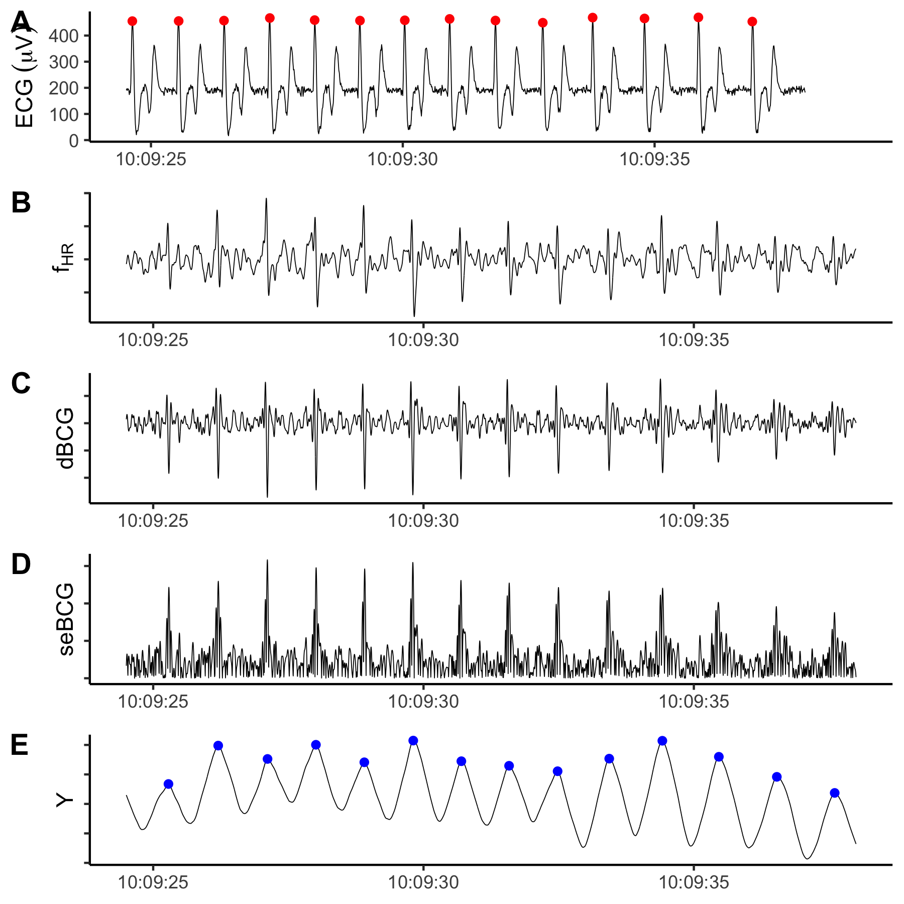

Figure 5.1: The ECG (A) and BCG (E) produced nearly identical heart beat predictions (red and blue points, respectively). B-D display the intermediate steps in the BCG signal processing procedure. B: surge after filtering, C: after differencing, D: Shannon entropy. Y-axis labeling follows Lee et al. (2016 Sensors) and y-axis values were excluded because the filtering process introduces magnitude distortion; only the relative shape of the signal is relevant to the analysis.

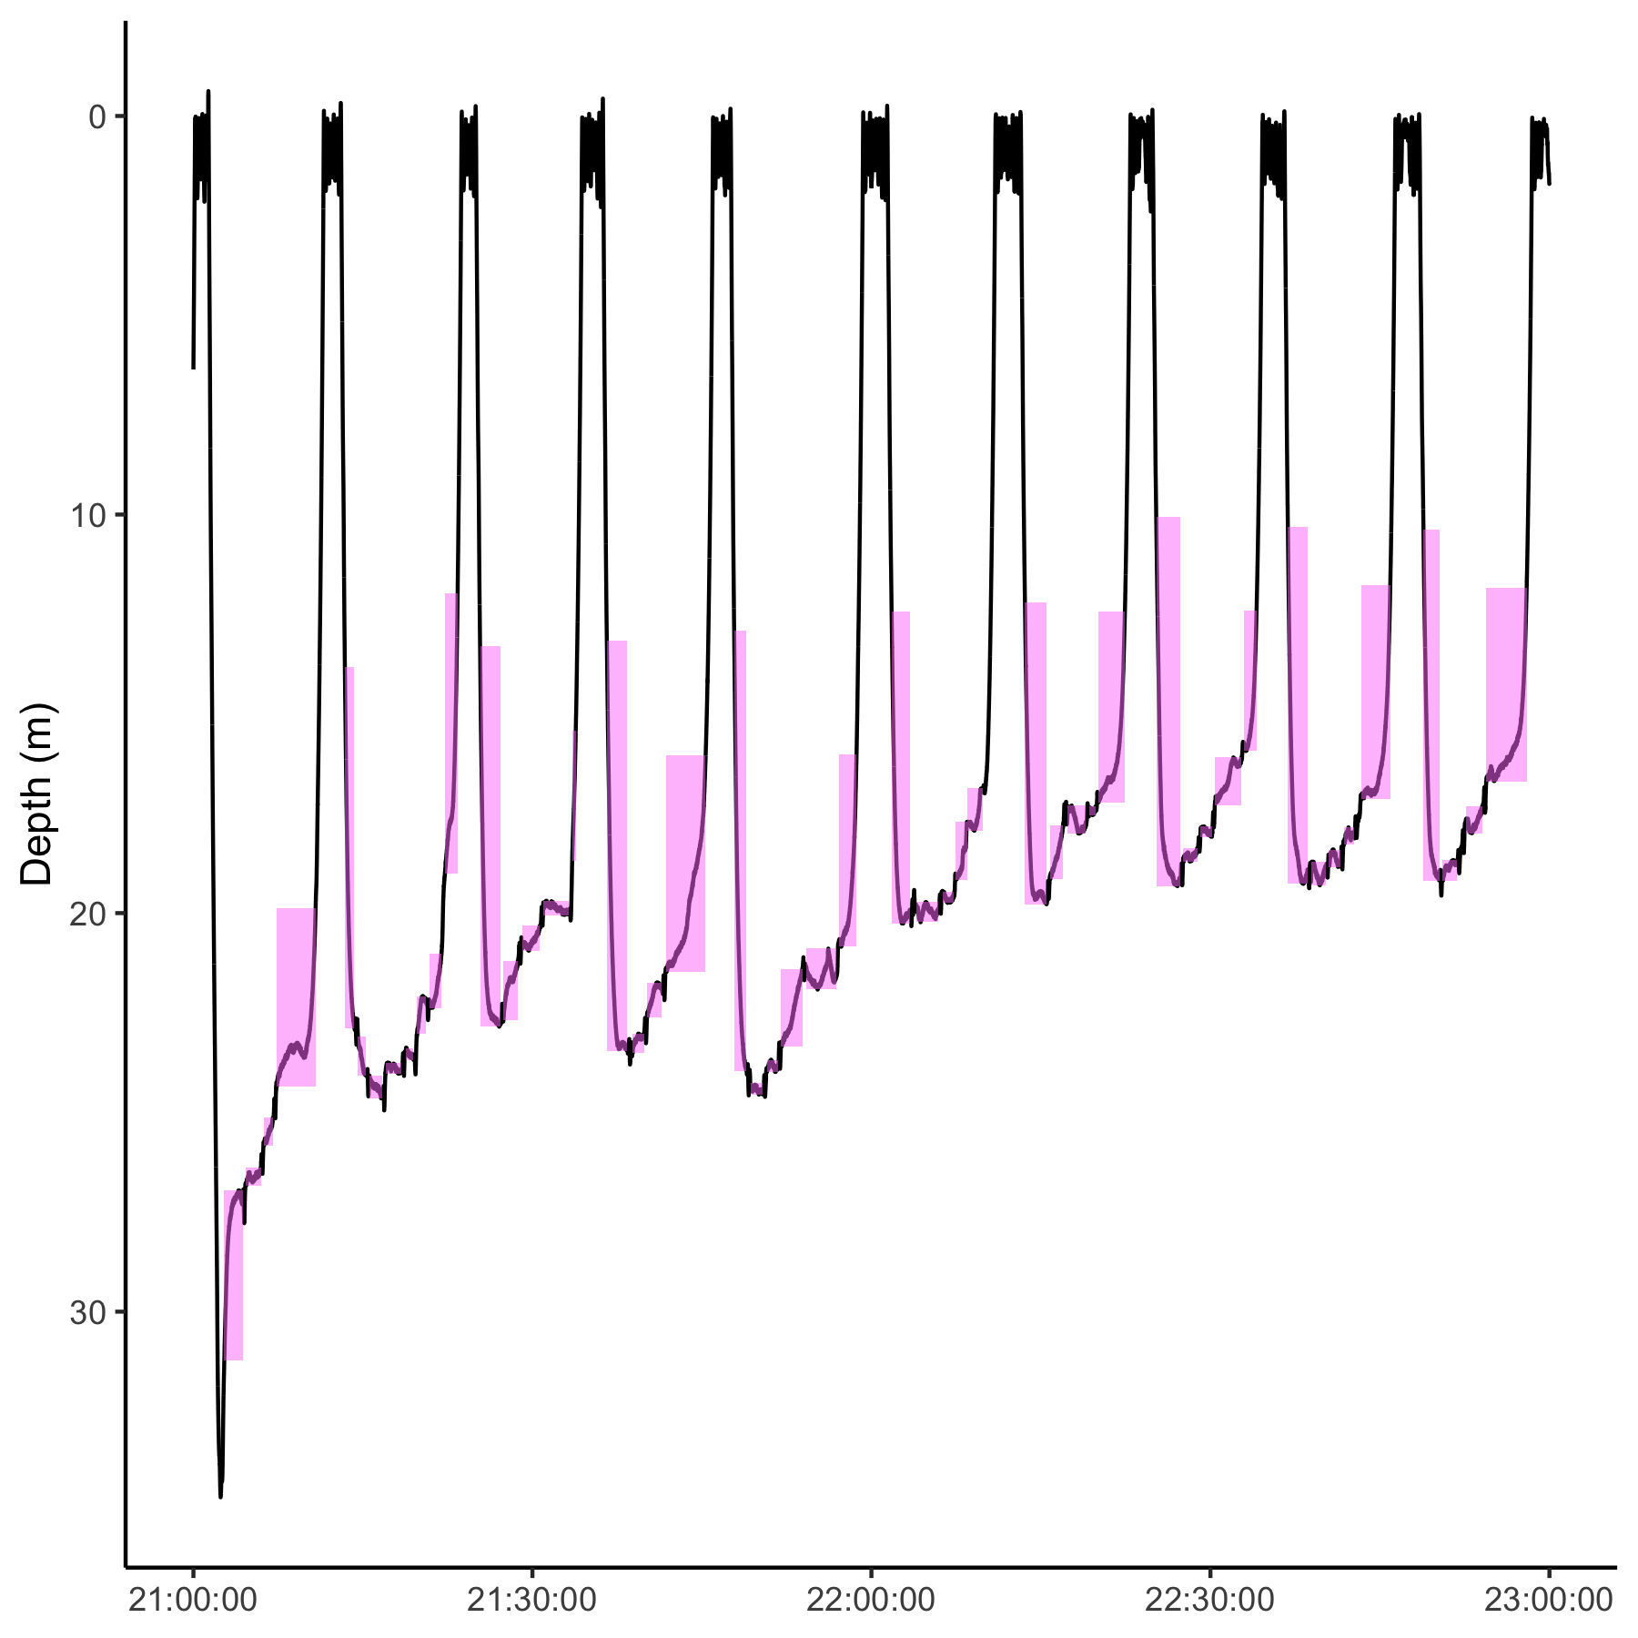

Figure 5.2: Blue whale dive profile. Motionless periods indicated by pink boxes.

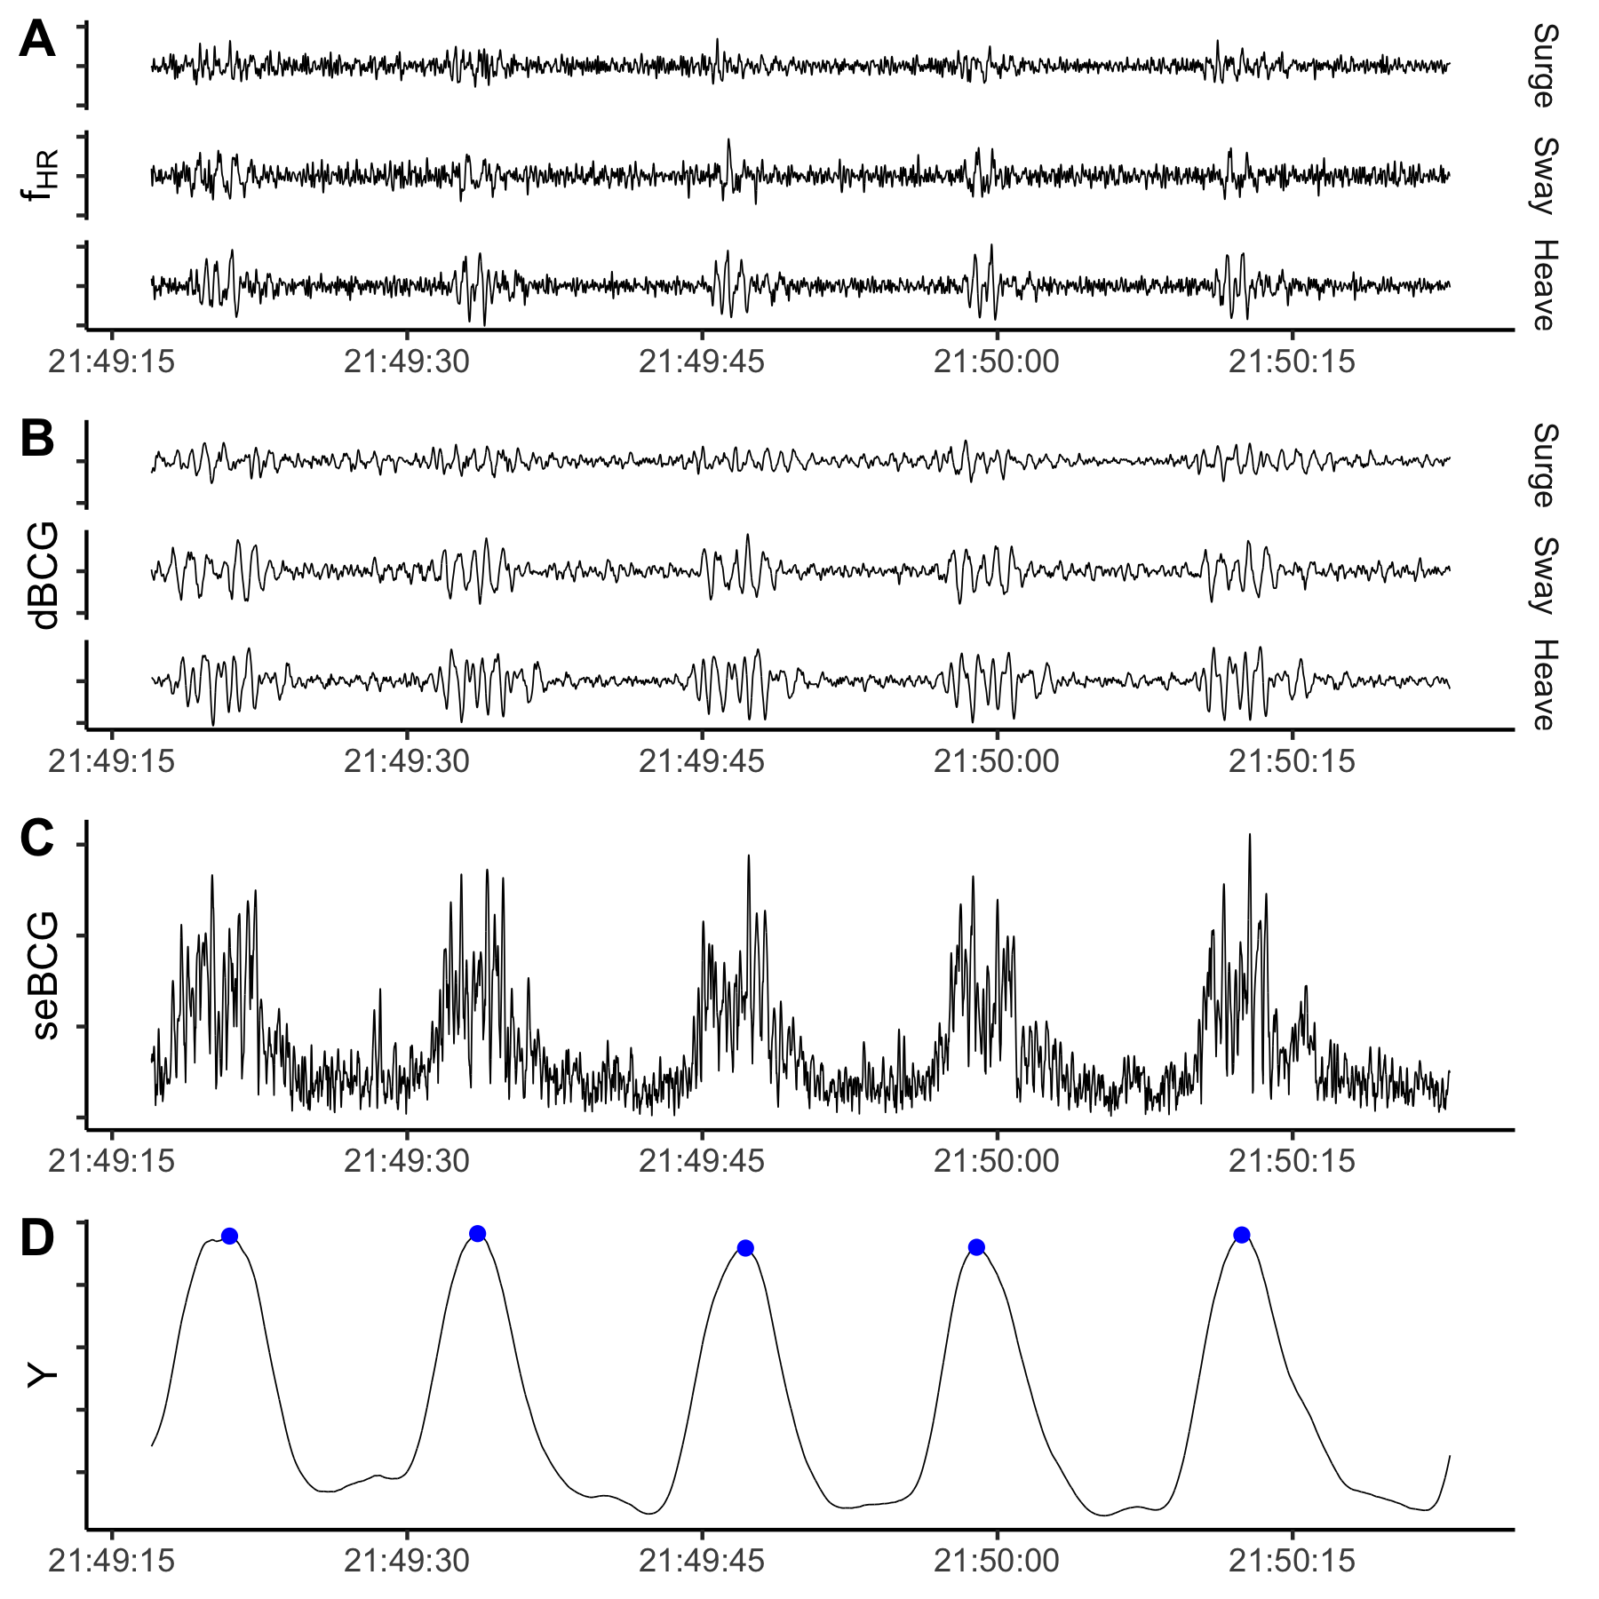

Figure 5.3: Example of signal processing for 3d BCG. A: filtered triaxial acceleration, B: after differencing, C: Shannon entropy, D: after smoothing. Identified heart beats in blue. Y-axis labeling follows Lee et al. (2016 Sensors) and y-axis values were excluded because the filtering process introduces magnitude distortion; only the relative shape of the signal is relevant to the analysis.

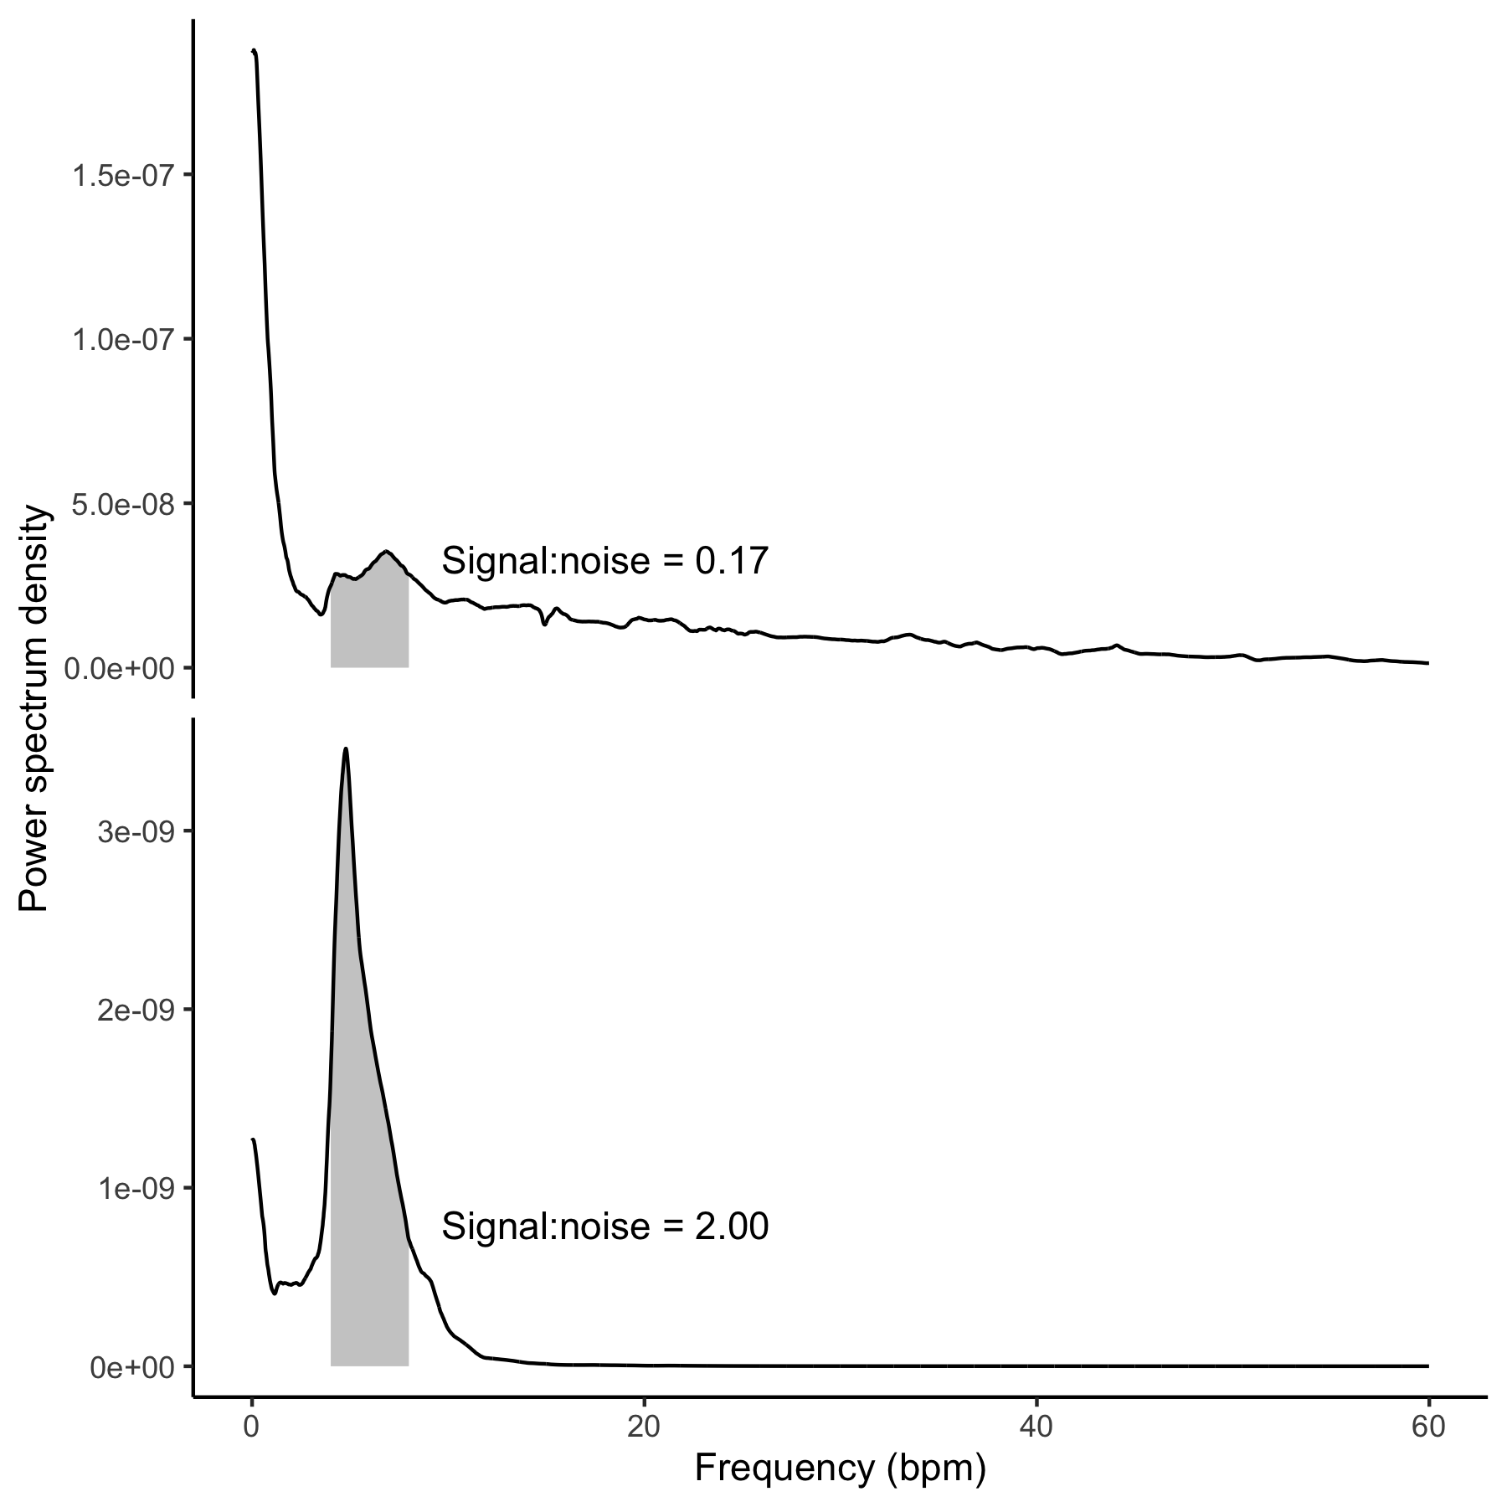

Figure 5.4: Signal-to-noise ratio was higher for the triaxial BCG (lower panel, 2.00) than the surge-only BCG (upper panel, 0.17). Each panel shows the power spectral density for the BCG. Based on previously observed blue whale heart rates, 4-8 bpm was considered signal (gray shading). The signal-to-noise ratio was calculated as the ratio of the area under the curve in the signal band to the area under the rest of the curve, up to 60 bpm.

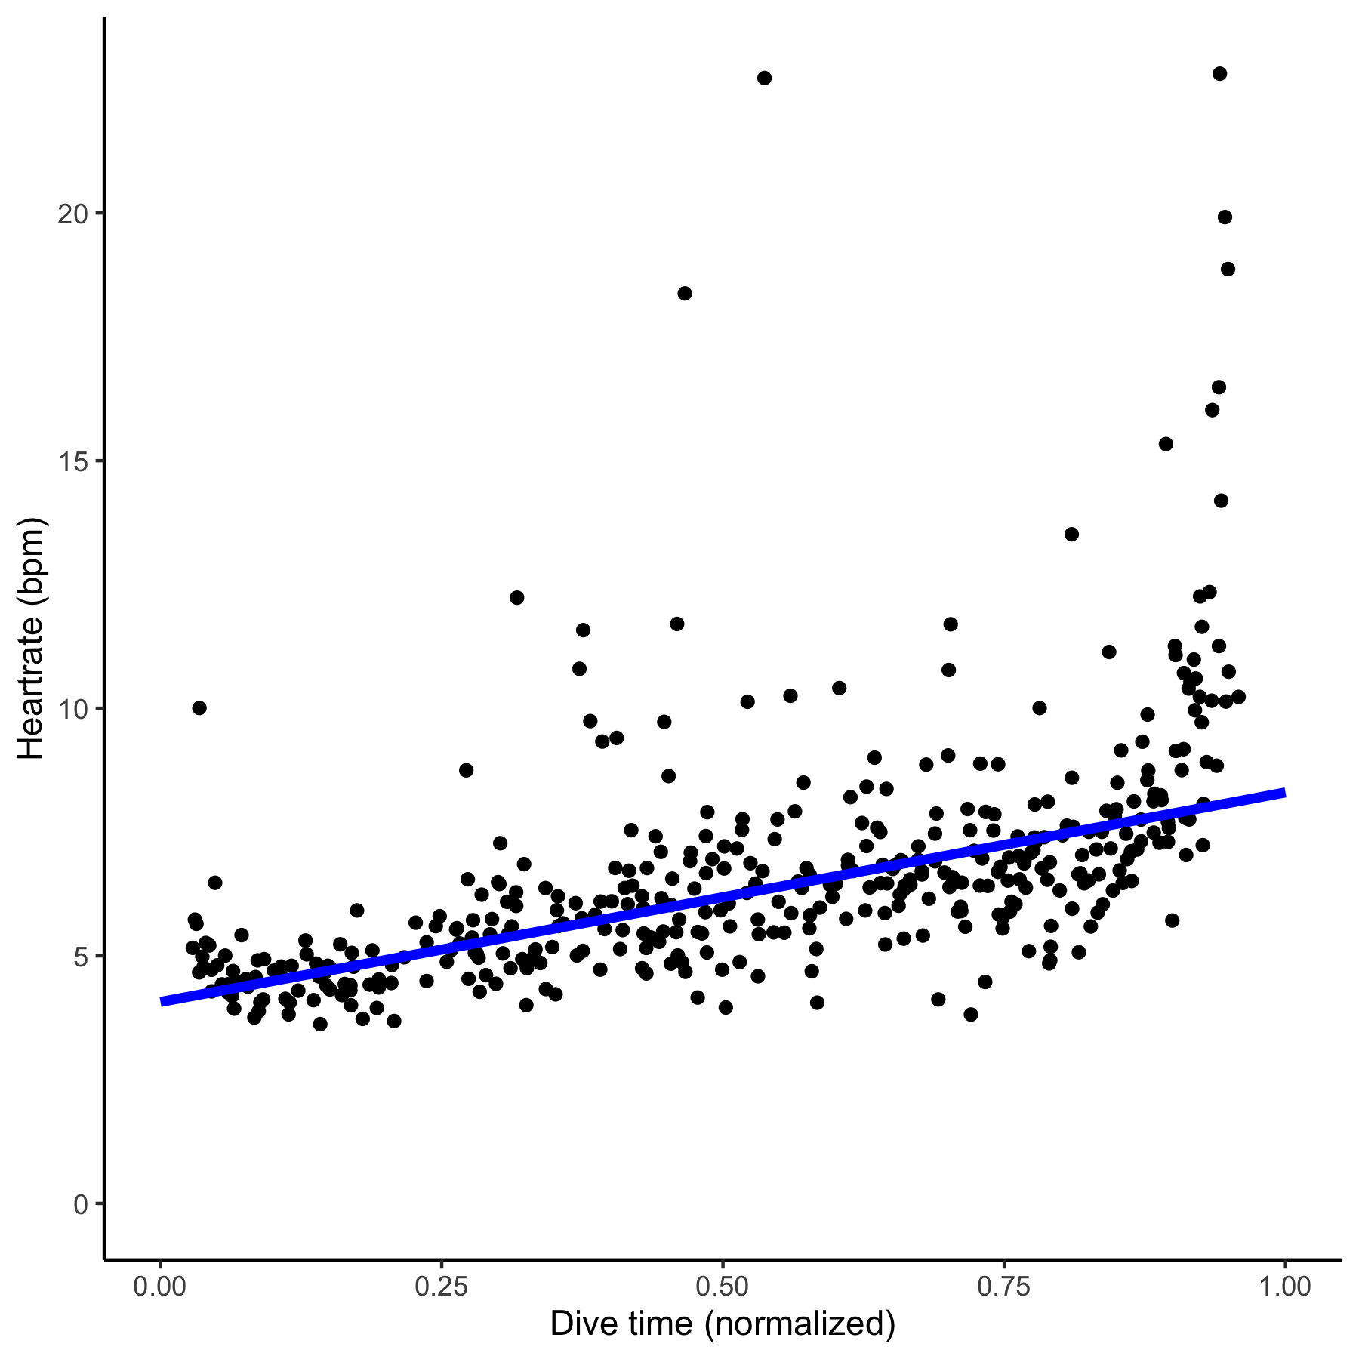

Figure 5.5: Heart rates observed in the 3d BCG followed characteristic diving physiology patterns. Bradycardia is greatest at the start of the dive (~4-5 bpm), relaxing towards the end (~8-9 bpm). Points indicate instantaneous heart rates and the line is a Theil-Sen regression.

# 6 References

**Alston, J. M. and Rick, J. A.** (2021). A Beginner’s Guide to Conducting Reproducible Research. *Bulletin of the Ecological Society of America* **102**, 1–14.

**Barbour, A. J. and Parker, R. L.** (2014). psd: Adaptive, sine multitaper power spectral density estimation for R. *Computers & Geosciences* **63**, 1–8.

**Cade, D. E., Gough, W. T., Czapanskiy, M. F., Fahlbusch, J. A., Kahane-Rapport, S. R., Linsky, J. M. J., Nichols, R. C., Oestreich, W. K., Wisniewska, D. M., Friedlaender, A. S., et al.** (2021). Tools for integrating inertial sensor data with video bio-loggers, including estimation of animal orientation, motion, and position. *Animal Biotelemetry* **9**, 34.

**Giovangrandi, L., Inan, O. T., Wiard, R. M., Etemadi, M. and Kovacs, G. T.** (2011). Ballistocardiography—a method worth revisiting. In *2011 Annual International Conference of the IEEE Engineering in Medicine and biology society*, pp. 4279–4282.

**Goldbogen, J. A., Cade, D. E., Calambokidis, J., Czapanskiy, M. F., Fahlbusch, J., Friedlaender, A. S., Gough, W. T., Kahane-Rapport, S. R., Savoca, M. S., Ponganis, K. V., et al.** (2019a). Extreme bradycardia and tachycardia in the world’s largest animal. *Proceedings of the National Academy of Sciences* **116**, 25329–25332.

**Goldbogen, J. A., Cade, D. E., Wisniewska, D. M., Potvin, J., Segre, P. S., Savoca, M. S., Hazen, E. L., Czapanskiy, M. F., Kahane-Rapport, S. R., DeRuiter, S. L., et al.** (2019b). Why whales are big but not bigger: Physiological drivers and ecological limits in the age of ocean giants. *Science* **366**, 1367–1372.

**Gough, W. T., Segre, P. S., Bierlich, K. C., Cade, D. E., Potvin, J., Fish, F. E., Dale, J., Clemente, J. di, Friedlaender, A. S., Johnston, D. W., et al.** (2019). Scaling of swimming performance in baleen whales. *Journal of Experimental Biology* **222**,.

**Hawkes, L. A., Fahlman, A. and Sato, K.** (2021). Introduction to the theme issue: Measuring physiology in free-living animals. *Philosophical Transactions of the Royal Society B: Biological Sciences* **376**, 20200210.

**Hurtado, S. I.** (2020). *RobustLinearReg: Robust linear regressions. R package version 1.2.0.*

**Inan, O. T., Migeotte, P.-F., Park, K.-S., Etemadi, M., Tavakolian, K., Casanella, R., Zanetti, J., Tank, J., Funtova, I., Prisk, G. K., et al.** (2015). Ballistocardiography and Seismocardiography: A Review of Recent Advances. *IEEE Journal of Biomedical and Health Informatics* **19**, 1414–1427.

**Johnson, M. P. and Tyack, P. L.** (2003). A digital acoustic recording tag for measuring the response of wild marine mammals to sound. *IEEE Journal of Oceanic Engineering* **28**, 3–12.

**Lee, W. K., Yoon, H., Han, C., Joo, K. M. and Park, K. S.** (2016). Physiological Signal Monitoring Bed for Infants Based on Load-Cell Sensors. *Sensors* **16**, 409.

**Ligges, U., Short, T. and Kienzle, P.** (2021). *Signal: Signal processing. R package version 0.7-7*.

**Marwick, B.** (2019). *Rrtools: Creates a reproducible research compendium*.

**Marwick, B., Boettiger, C. and Mullen, L.** (2018). Packaging Data Analytical Work Reproducibly Using R (and Friends). *The American Statistician* **72**, 80–88.

**McDonald, B. I. and Ponganis, P. J.** (2014). Deep-diving sea lions exhibit extreme bradycardia in long-duration dives. *Journal of Experimental Biology* **217**, 1525–1534.

**McKnight, J. C., Ruesch, A., Bennett, K., Bronkhorst, M., Balfour, S., Moss, S. E. W., Milne, R., Tyack, P. L., Kainerstorfer, J. M. and Hastie, G. D.** (2021). Shining new light on sensory brain activation and physiological measurement in seals using wearable optical technology. *Philosophical Transactions of the Royal Society B: Biological Sciences* **376**, 20200224.

**Nowacek, D. P., Johnson, M. P., Tyack, P. L., Shorter, K. A., McLellan, W. A. and D., A. P.** (2001). Buoyant balaenids: The ups and downs of buoyancy in right whales. *Proceedings of the Royal Society of London. Series B: Biological Sciences* **268**, 1811–1816.

**Pinheiro, E., Postolache, O. and Girão, P.** (2010). Theory and Developments in an Unobtrusive Cardiovascular System Representation: Ballistocardiography. *The Open Biomedical Engineering Journal* **4**, 201–216.

**Powers, S. M. and Hampton, S. E.** (2019). Open science, reproducibility, and transparency in ecology. *Ecological Applications* **29**, e01822.

**Sadek, I., Biswas, J. and Abdulrazak, B.** (2019). Ballistocardiogram signal processing: A review. *Health Information Science and Systems* **7**, 10.

**Sato, K., Shiomi, K., Marshall, G., Kooyman, G. L. and Ponganis, P. J.** (2011). Stroke rates and diving air volumes of emperor penguins: Implications for dive performance. *Journal of Experimental Biology* **214**, 2854–2863.

**Sen, P. K.** (1968). Estimates of the Regression Coefficient Based on Kendall’s Tau. *Journal of the American Statistical Association* **63**, 1379–1389.

**Starr, I., Rawson, A. J., Schroeder, H. A. and Joseph, N. R.** (1939). Studies on the estimation of cardiac ouptut in man, and of abnormalities in cardiac function, from the heart’s recoil and the blood’s impacts; the ballistocardiogram. *American Journal of Physiology* **127**, 1–28.

**Stodden, V., Seiler, J. and Ma, Z.** (2018). An empirical analysis of journal policy effectiveness for computational reproducibility. *Proceedings of the National Academy of Sciences* **115**, 2584–2589.

**Theil, H.** (1992). A Rank-Invariant Method of Linear and Polynomial Regression Analysis. In *Henri Theil’s Contributions to Economics and Econometrics: Econometric Theory and Methodology* (ed. Raj, B.) and Koerts, J.), pp. 345–381. Dordrecht: Springer Netherlands.

### 6.0.1 Colophon

This report was generated on 2021-10-24 12:45:59 using the following computational environment and dependencies:

#> ─ Session info ───────────────────────────────────────────────────────────────  
#> setting value   
#> version R version 4.0.4 (2021-02-15)  
#> os macOS Big Sur 10.16   
#> system x86_64, darwin17.0   
#> ui X11   
#> language (EN)   
#> collate en_US.UTF-8   
#> ctype en_US.UTF-8   
#> tz America/Los_Angeles   
#> date 2021-10-24   
#>   
#> ─ Packages ───────────────────────────────────────────────────────────────────  
#> package * version date lib source   
#> assertthat 0.2.1 2019-03-21 [2] CRAN (R 4.0.2)  
#> backports 1.2.1 2020-12-09 [2] CRAN (R 4.0.2)  
#> bookdown 0.22 2021-04-22 [2] CRAN (R 4.0.2)  
#> broom 0.7.6 2021-04-05 [2] CRAN (R 4.0.2)  
#> cachem 1.0.6 2021-08-19 [1] CRAN (R 4.0.4)  
#> callr 3.7.0 2021-04-20 [2] CRAN (R 4.0.2)  
#> cellranger 1.1.0 2016-07-27 [2] CRAN (R 4.0.2)  
#> cetaceanbcg * 0.0.0.9000 2021-10-22 [1] local   
#> cli 3.0.1 2021-07-17 [1] CRAN (R 4.0.2)  
#> colorspace 2.0-2 2021-06-24 [1] CRAN (R 4.0.2)  
#> crayon 1.4.1 2021-02-08 [2] CRAN (R 4.0.2)  
#> DBI 1.1.1 2021-01-15 [2] CRAN (R 4.0.2)  
#> dbplyr 2.1.1 2021-04-06 [2] CRAN (R 4.0.2)  
#> desc 1.4.0 2021-09-28 [1] CRAN (R 4.0.4)  
#> devtools 2.4.1 2021-05-05 [2] CRAN (R 4.0.2)  
#> digest 0.6.28 2021-09-23 [1] CRAN (R 4.0.2)  
#> dplyr * 1.0.7 2021-06-18 [1] CRAN (R 4.0.2)  
#> ellipsis 0.3.2 2021-04-29 [2] CRAN (R 4.0.2)  
#> evaluate 0.14 2019-05-28 [2] CRAN (R 4.0.1)  
#> fansi 0.5.0 2021-05-25 [2] CRAN (R 4.0.4)  
#> fastmap 1.1.0 2021-01-25 [2] CRAN (R 4.0.2)  
#> forcats * 0.5.1 2021-01-27 [2] CRAN (R 4.0.2)  
#> fs 1.5.0 2020-07-31 [2] CRAN (R 4.0.2)  
#> generics 0.1.0 2020-10-31 [2] CRAN (R 4.0.2)  
#> ggplot2 * 3.3.5 2021-06-25 [1] CRAN (R 4.0.2)  
#> glue 1.4.2 2020-08-27 [2] CRAN (R 4.0.2)  
#> gtable 0.3.0 2019-03-25 [2] CRAN (R 4.0.2)  
#> haven 2.4.1 2021-04-23 [2] CRAN (R 4.0.2)  
#> hms 1.1.0 2021-05-17 [2] CRAN (R 4.0.4)  
#> htmltools 0.5.2 2021-08-25 [1] CRAN (R 4.0.4)  
#> httr 1.4.2 2020-07-20 [2] CRAN (R 4.0.2)  
#> jsonlite 1.7.2 2020-12-09 [2] CRAN (R 4.0.2)  
#> knitr 1.36 2021-09-29 [1] CRAN (R 4.0.4)  
#> lifecycle 1.0.1 2021-09-24 [1] CRAN (R 4.0.2)  
#> lubridate 1.7.10 2021-02-26 [1] CRAN (R 4.0.2)  
#> magrittr 2.0.1 2020-11-17 [2] CRAN (R 4.0.2)  
#> memoise 2.0.0 2021-01-26 [2] CRAN (R 4.0.2)  
#> modelr 0.1.8 2020-05-19 [2] CRAN (R 4.0.2)  
#> munsell 0.5.0 2018-06-12 [2] CRAN (R 4.0.2)  
#> pillar 1.6.4 2021-10-18 [1] CRAN (R 4.0.2)  
#> pkgbuild 1.2.0 2020-12-15 [2] CRAN (R 4.0.2)  
#> pkgconfig 2.0.3 2019-09-22 [2] CRAN (R 4.0.2)  
#> pkgload 1.2.3 2021-10-13 [1] CRAN (R 4.0.4)  
#> prettyunits 1.1.1 2020-01-24 [2] CRAN (R 4.0.2)  
#> processx 3.5.2 2021-04-30 [2] CRAN (R 4.0.2)  
#> ps 1.6.0 2021-02-28 [2] CRAN (R 4.0.2)  
#> purrr * 0.3.4 2020-04-17 [2] CRAN (R 4.0.2)  
#> R6 2.5.1 2021-08-19 [1] CRAN (R 4.0.2)  
#> Rcpp 1.0.7 2021-07-07 [2] CRAN (R 4.0.2)  
#> readr * 1.4.0 2020-10-05 [2] CRAN (R 4.0.2)  
#> readxl 1.3.1 2019-03-13 [2] CRAN (R 4.0.2)  
#> remotes 2.3.0 2021-04-01 [2] CRAN (R 4.0.2)  
#> reprex 2.0.0 2021-04-02 [2] CRAN (R 4.0.2)  
#> rlang 0.4.12 2021-10-18 [1] CRAN (R 4.0.2)  
#> rmarkdown 2.8 2021-05-07 [2] CRAN (R 4.0.2)  
#> rprojroot 2.0.2 2020-11-15 [2] CRAN (R 4.0.2)  
#> rstudioapi 0.13 2020-11-12 [2] CRAN (R 4.0.2)  
#> rvest 1.0.0 2021-03-09 [2] CRAN (R 4.0.2)  
#> scales 1.1.1 2020-05-11 [2] CRAN (R 4.0.2)  
#> sessioninfo 1.1.1 2018-11-05 [2] CRAN (R 4.0.2)  
#> stringi 1.7.5 2021-10-04 [1] CRAN (R 4.0.4)  
#> stringr * 1.4.0 2019-02-10 [2] CRAN (R 4.0.2)  
#> testthat 3.1.0 2021-10-04 [1] CRAN (R 4.0.4)  
#> tibble * 3.1.5 2021-09-30 [1] CRAN (R 4.0.2)  
#> tidyr * 1.1.3 2021-03-03 [2] CRAN (R 4.0.2)  
#> tidyselect 1.1.1 2021-04-30 [2] CRAN (R 4.0.2)  
#> tidyverse * 1.3.1 2021-04-15 [2] CRAN (R 4.0.2)  
#> usethis 2.0.1 2021-02-10 [2] CRAN (R 4.0.2)  
#> utf8 1.2.2 2021-07-24 [1] CRAN (R 4.0.2)  
#> vctrs 0.3.8 2021-04-29 [2] CRAN (R 4.0.2)  
#> withr 2.4.2 2021-04-18 [2] CRAN (R 4.0.4)  
#> xfun 0.27 2021-10-18 [1] CRAN (R 4.0.4)  
#> xml2 1.3.2 2020-04-23 [2] CRAN (R 4.0.2)  
#> yaml 2.2.1 2020-02-01 [2] CRAN (R 4.0.2)  
#>   
#> [1] /Users/frank/Library/R/4.0/library  
#> [2] /Library/Frameworks/R.framework/Versions/4.0/Resources/library

The current Git commit details are:

#> Local: main /Users/frank/Documents/GitHub/development/cetaceanbcg  
#> Remote: main @ origin (https://github.com/FlukeAndFeather/cetaceanbcg.git)  
#> Head: [ba640e1] 2021-10-22: Rearrange manuscript and include PSD