Something about cetacean heart rates and ballistocardiograms

Max Czapanskiy1,✉, and More Authors2

03 September, 2021

Text of abstract

1 Stanford University  
2 University of Another Place

✉ Correspondence: [Max Czapanskiy <[maxczap@stanford.edu](mailto:maxczap@stanford.edu)>](mailto:maxczap@stanford.edu)

Keywords: keyword 1; keyword 2; keyword 3

Highlights: These are the highlights.

# 1 Introduction

Here is a citation (Marwick, 2017)

# 2 Background

# 3 Methods

# 4 Results

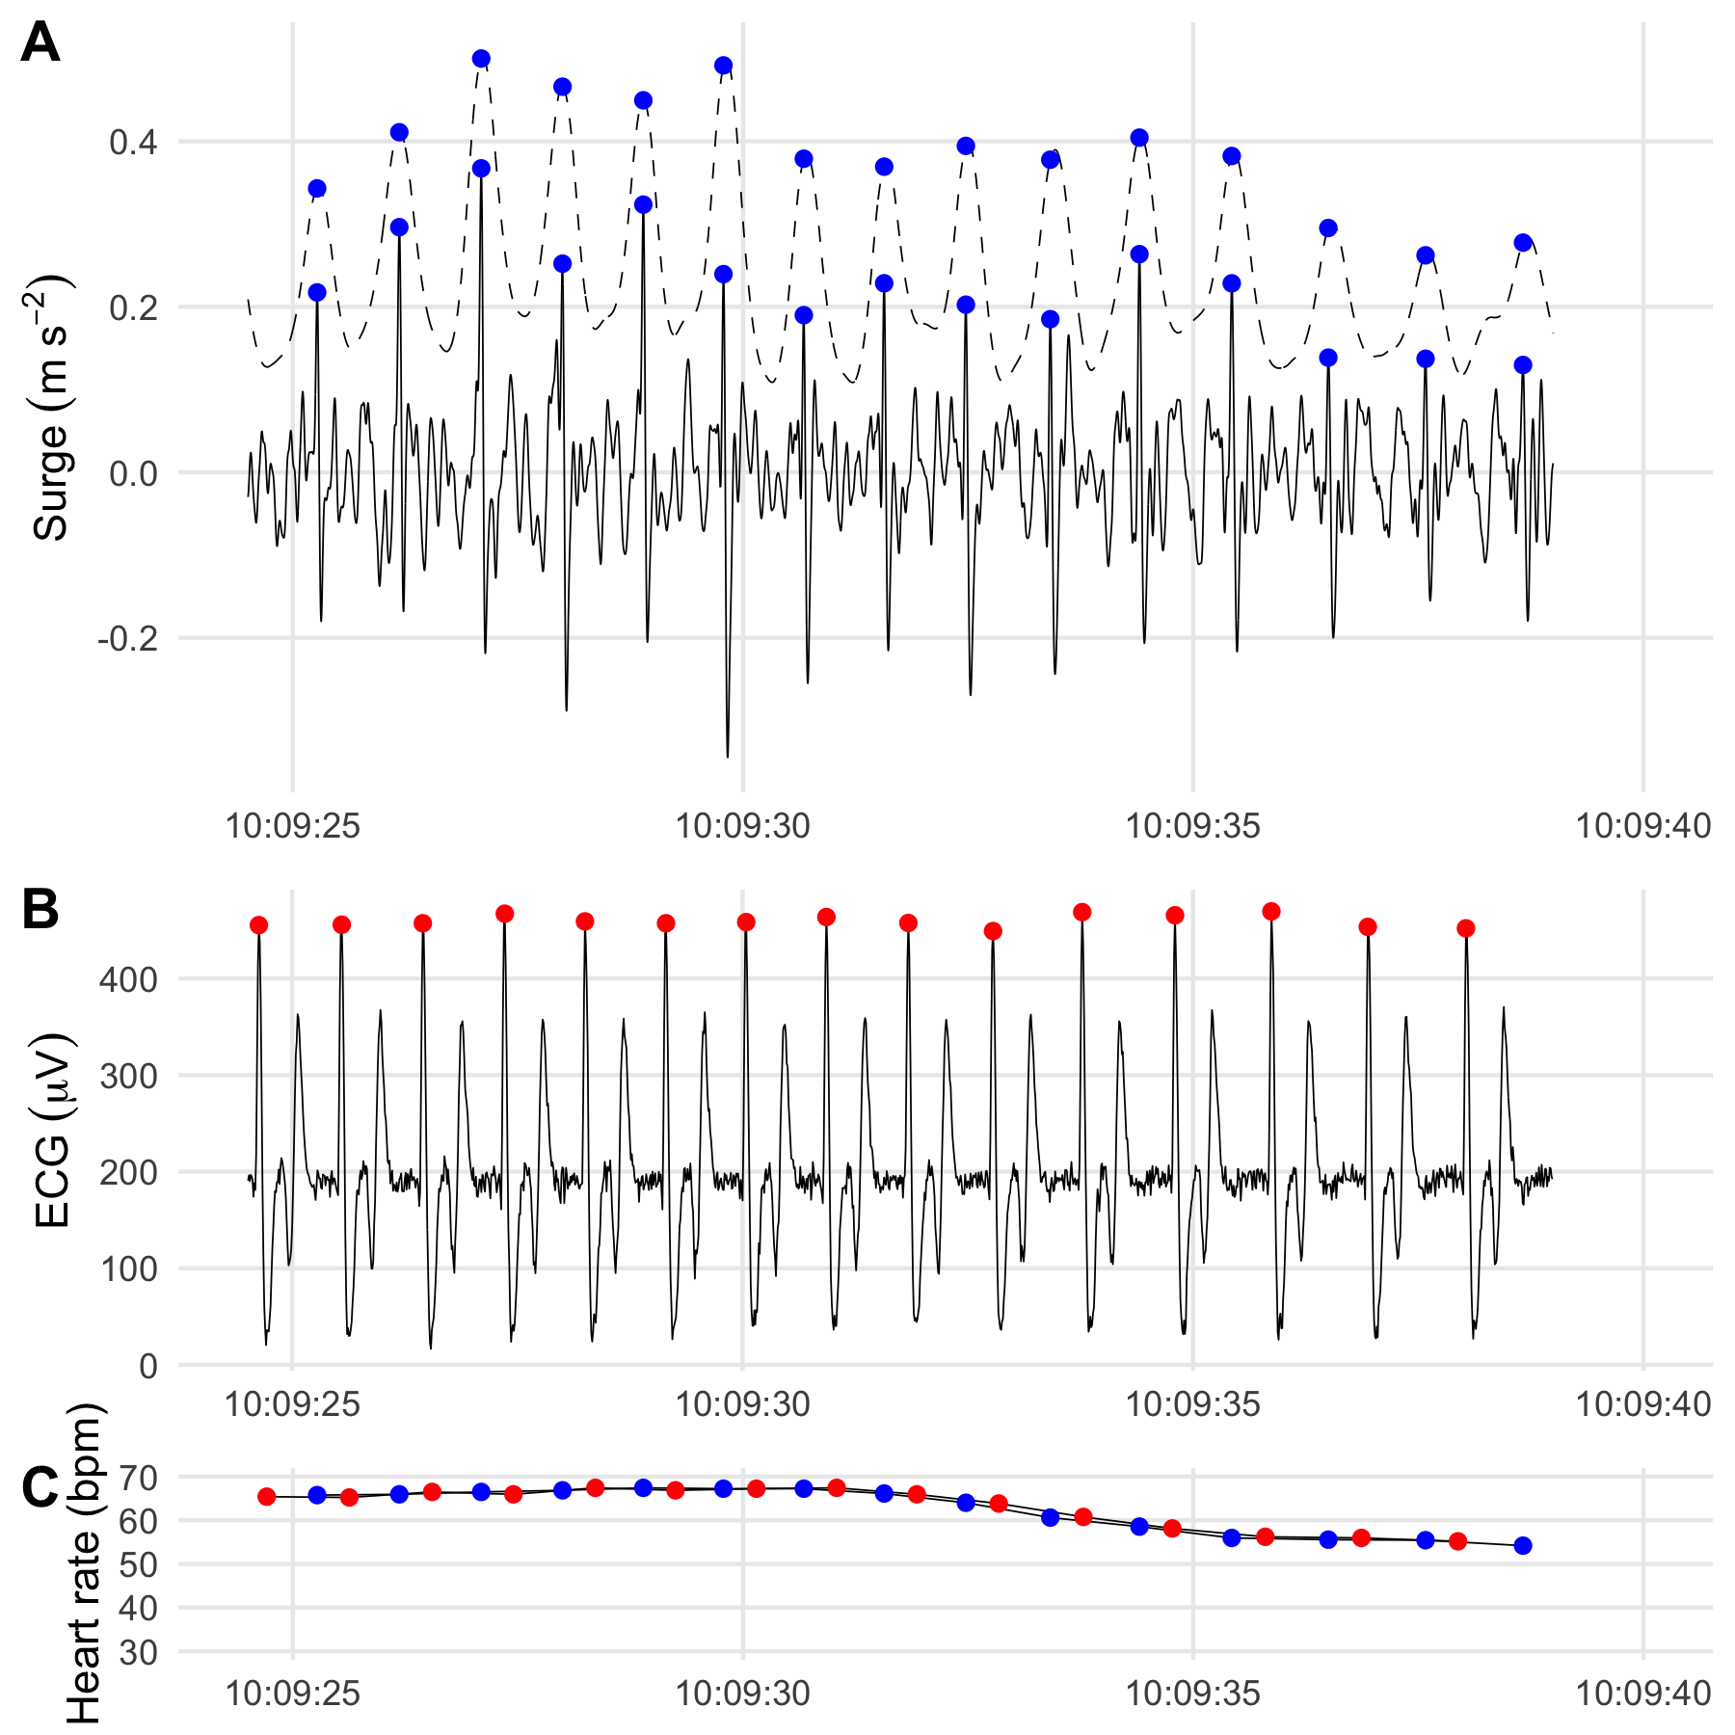

Figure 4.1: A: BCG, B: ECG, C: BPM comparison

#> [1] "0.5% ± 0.3% (mean ± sd))"

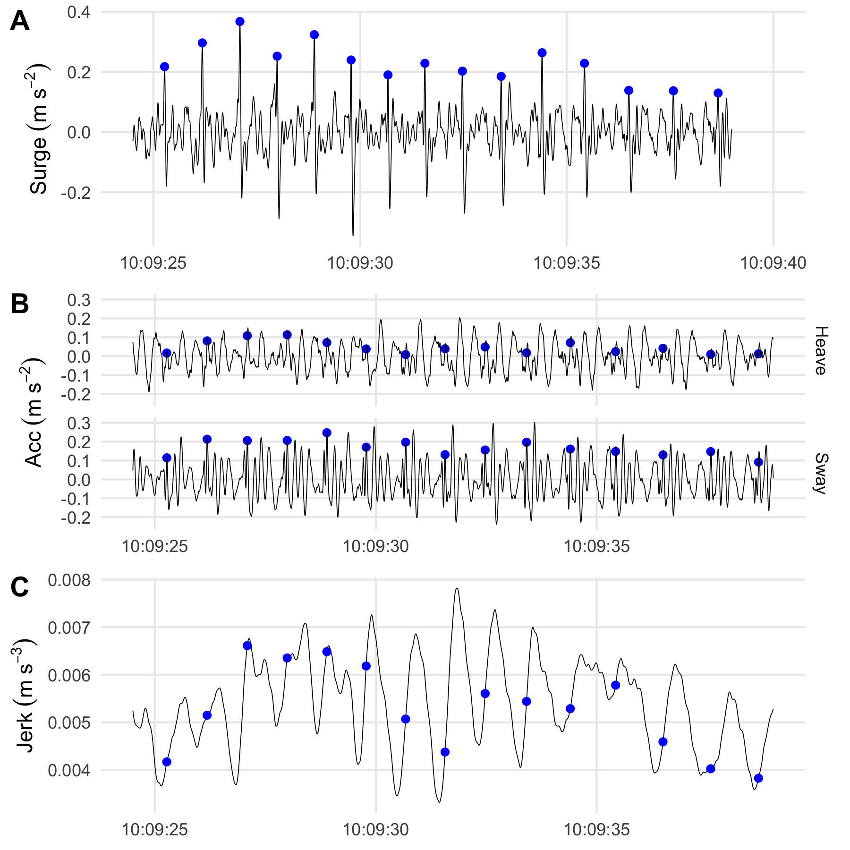

Figure 4.2: A: The BCG signal is clearest in surge (longitudinal axis acceleration). Solid line: surge bandpass filtered to [1.0 25.0] Hz. Dashed line: local range of surge in 0.25 s sliding window (smoothed). Blue dots indicate peak of the BCG I-wave. B: BCG signal is not as strong in heave (dorso-ventral axis) or sway (lateral axis) as in surge. The sway signal is likely due to movement of the chest cavity (see video S1). C: Some, but not all, heart beats are visible as peaks in the norm of the jerk vector.

Figure 4.1 shows how we can have a caption and cross-reference for a plot.

# 5 Discussion

# 6 Conclusion

# 7 Acknowledgements

# 8 References

Marwick, B., 2017. Computational reproducibility in archaeological research: Basic principles and a case study of their implementation. Journal of Archaeological Method and Theory 24, 424–450. <https://doi.org/10.1007/s10816-015-9272-9>

### 8.0.1 Colophon

This report was generated on 2021-09-03 15:35:30 using the following computational environment and dependencies:

#> ─ Session info ───────────────────────────────────────────────────────────────  
#> setting value   
#> version R version 4.0.4 (2021-02-15)  
#> os macOS Big Sur 10.16   
#> system x86_64, darwin17.0   
#> ui X11   
#> language (EN)   
#> collate en_US.UTF-8   
#> ctype en_US.UTF-8   
#> tz America/Los_Angeles   
#> date 2021-09-03   
#>   
#> ─ Packages ───────────────────────────────────────────────────────────────────  
#> package * version date lib source   
#> assertthat 0.2.1 2019-03-21 [2] CRAN (R 4.0.2)  
#> backports 1.2.1 2020-12-09 [2] CRAN (R 4.0.2)  
#> bookdown 0.22 2021-04-22 [2] CRAN (R 4.0.2)  
#> broom 0.7.6 2021-04-05 [2] CRAN (R 4.0.2)  
#> cachem 1.0.5 2021-05-15 [2] CRAN (R 4.0.2)  
#> callr 3.7.0 2021-04-20 [2] CRAN (R 4.0.2)  
#> cellranger 1.1.0 2016-07-27 [2] CRAN (R 4.0.2)  
#> cetaceanbcg * 0.0.0.9000 2021-09-03 [1] local   
#> cli 2.5.0 2021-04-26 [2] CRAN (R 4.0.2)  
#> colorspace 2.0-1 2021-05-04 [2] CRAN (R 4.0.2)  
#> cowplot 1.1.1 2020-12-30 [2] CRAN (R 4.0.2)  
#> crayon 1.4.1 2021-02-08 [2] CRAN (R 4.0.2)  
#> DBI 1.1.1 2021-01-15 [2] CRAN (R 4.0.2)  
#> dbplyr 2.1.1 2021-04-06 [2] CRAN (R 4.0.2)  
#> desc 1.3.0 2021-03-05 [2] CRAN (R 4.0.2)  
#> devtools 2.4.1 2021-05-05 [2] CRAN (R 4.0.2)  
#> digest 0.6.27 2020-10-24 [2] CRAN (R 4.0.2)  
#> dplyr * 1.0.6 2021-05-05 [2] CRAN (R 4.0.2)  
#> ellipsis 0.3.2 2021-04-29 [2] CRAN (R 4.0.2)  
#> evaluate 0.14 2019-05-28 [2] CRAN (R 4.0.1)  
#> fansi 0.5.0 2021-05-25 [2] CRAN (R 4.0.4)  
#> farver 2.1.0 2021-02-28 [2] CRAN (R 4.0.2)  
#> fastmap 1.1.0 2021-01-25 [2] CRAN (R 4.0.2)  
#> forcats * 0.5.1 2021-01-27 [2] CRAN (R 4.0.2)  
#> fs 1.5.0 2020-07-31 [2] CRAN (R 4.0.2)  
#> generics 0.1.0 2020-10-31 [2] CRAN (R 4.0.2)  
#> ggplot2 * 3.3.3 2020-12-30 [2] CRAN (R 4.0.2)  
#> glue 1.4.2 2020-08-27 [2] CRAN (R 4.0.2)  
#> gtable 0.3.0 2019-03-25 [2] CRAN (R 4.0.2)  
#> haven 2.4.1 2021-04-23 [2] CRAN (R 4.0.2)  
#> highr 0.9 2021-04-16 [2] CRAN (R 4.0.2)  
#> hms 1.1.0 2021-05-17 [2] CRAN (R 4.0.4)  
#> htmltools 0.5.1.1 2021-01-22 [2] CRAN (R 4.0.2)  
#> httr 1.4.2 2020-07-20 [2] CRAN (R 4.0.2)  
#> jsonlite 1.7.2 2020-12-09 [2] CRAN (R 4.0.2)  
#> knitr 1.33 2021-04-24 [2] CRAN (R 4.0.2)  
#> labeling 0.4.2 2020-10-20 [2] CRAN (R 4.0.2)  
#> lifecycle 1.0.0 2021-02-15 [2] CRAN (R 4.0.2)  
#> lubridate 1.7.10 2021-02-26 [2] CRAN (R 4.0.2)  
#> magrittr 2.0.1 2020-11-17 [2] CRAN (R 4.0.2)  
#> MASS 7.3-54 2021-05-03 [2] CRAN (R 4.0.4)  
#> memoise 2.0.0 2021-01-26 [2] CRAN (R 4.0.2)  
#> modelr 0.1.8 2020-05-19 [2] CRAN (R 4.0.2)  
#> munsell 0.5.0 2018-06-12 [2] CRAN (R 4.0.2)  
#> pillar 1.6.1 2021-05-16 [2] CRAN (R 4.0.4)  
#> pkgbuild 1.2.0 2020-12-15 [2] CRAN (R 4.0.2)  
#> pkgconfig 2.0.3 2019-09-22 [2] CRAN (R 4.0.2)  
#> pkgload 1.2.1 2021-04-06 [2] CRAN (R 4.0.2)  
#> pracma 2.3.3 2021-01-23 [2] CRAN (R 4.0.2)  
#> prettyunits 1.1.1 2020-01-24 [2] CRAN (R 4.0.2)  
#> processx 3.5.2 2021-04-30 [2] CRAN (R 4.0.2)  
#> ps 1.6.0 2021-02-28 [2] CRAN (R 4.0.2)  
#> purrr * 0.3.4 2020-04-17 [2] CRAN (R 4.0.2)  
#> R6 2.5.0 2020-10-28 [2] CRAN (R 4.0.2)  
#> Rcpp 1.0.7 2021-07-07 [2] CRAN (R 4.0.2)  
#> RcppRoll 0.3.0 2018-06-05 [2] CRAN (R 4.0.2)  
#> readr * 1.4.0 2020-10-05 [2] CRAN (R 4.0.2)  
#> readxl 1.3.1 2019-03-13 [2] CRAN (R 4.0.2)  
#> remotes 2.3.0 2021-04-01 [2] CRAN (R 4.0.2)  
#> reprex 2.0.0 2021-04-02 [2] CRAN (R 4.0.2)  
#> rlang 0.4.11 2021-04-30 [2] CRAN (R 4.0.2)  
#> rmarkdown 2.8 2021-05-07 [2] CRAN (R 4.0.2)  
#> rprojroot 2.0.2 2020-11-15 [2] CRAN (R 4.0.2)  
#> rstudioapi 0.13 2020-11-12 [2] CRAN (R 4.0.2)  
#> rvest 1.0.0 2021-03-09 [2] CRAN (R 4.0.2)  
#> scales 1.1.1 2020-05-11 [2] CRAN (R 4.0.2)  
#> sessioninfo 1.1.1 2018-11-05 [2] CRAN (R 4.0.2)  
#> signal 0.7-7 2021-05-25 [2] CRAN (R 4.0.2)  
#> stringi 1.6.2 2021-05-17 [2] CRAN (R 4.0.4)  
#> stringr * 1.4.0 2019-02-10 [2] CRAN (R 4.0.2)  
#> testthat 3.0.2 2021-02-14 [2] CRAN (R 4.0.2)  
#> tibble * 3.1.2 2021-05-16 [2] CRAN (R 4.0.4)  
#> tidyr * 1.1.3 2021-03-03 [2] CRAN (R 4.0.2)  
#> tidyselect 1.1.1 2021-04-30 [2] CRAN (R 4.0.2)  
#> tidyverse * 1.3.1 2021-04-15 [2] CRAN (R 4.0.2)  
#> usethis 2.0.1 2021-02-10 [2] CRAN (R 4.0.2)  
#> utf8 1.2.1 2021-03-12 [2] CRAN (R 4.0.2)  
#> vctrs 0.3.8 2021-04-29 [2] CRAN (R 4.0.2)  
#> withr 2.4.2 2021-04-18 [2] CRAN (R 4.0.4)  
#> xfun 0.23 2021-05-15 [2] CRAN (R 4.0.2)  
#> xml2 1.3.2 2020-04-23 [2] CRAN (R 4.0.2)  
#> yaml 2.2.1 2020-02-01 [2] CRAN (R 4.0.2)  
#>   
#> [1] /Users/frank/Library/R/4.0/library  
#> [2] /Library/Frameworks/R.framework/Versions/4.0/Resources/library

The current Git commit details are:

#> Local: main /Users/frank/Documents/GitHub/development/cetaceanbcg  
#> Remote: main @ origin (https://github.com/FlukeAndFeather/cetaceanbcg.git)  
#> Head: [5f4e08d] 2021-08-31: Split Corky BCG figure into two