Introduction to random walks

Randomwalk Enthusiast1,✉

28 November, 2021

Random walks - aren’t they great? Useful for everything from modeling animal movement behavior to predicting stock markets. Well, at least for providing a null model.

1 University of Random Walks

✉ Correspondence: [Randomwalk Enthusiast <[random@walk.edu](mailto:random@walk.edu)>](mailto:random@walk.edu)

Keywords: random; walks

# 1 Introduction

The random walk is a useful statistical tool. Here we show how to simulate, plot, and fit random walks.

# 2 Methods

## 2.1 Simulation

We simulate a Gaussian random walk by taking the cumulative sum of random normal numbers.

## 2.2 Visualization

Random walks are best visualized as a line plot.

## 2.3 Fitting

Given a sequence of positions, the step lengths of the sequence is the difference between positions. The parameters of the Gaussian random walk ( $μ$ and $σ$) are the mean and standard deviation of the step lengths, respectively.

# 3 Results

Figure 3.1 shows a simulated random walk with $μ$ = 0.1 and $σ$ = 2 over 100 time steps.

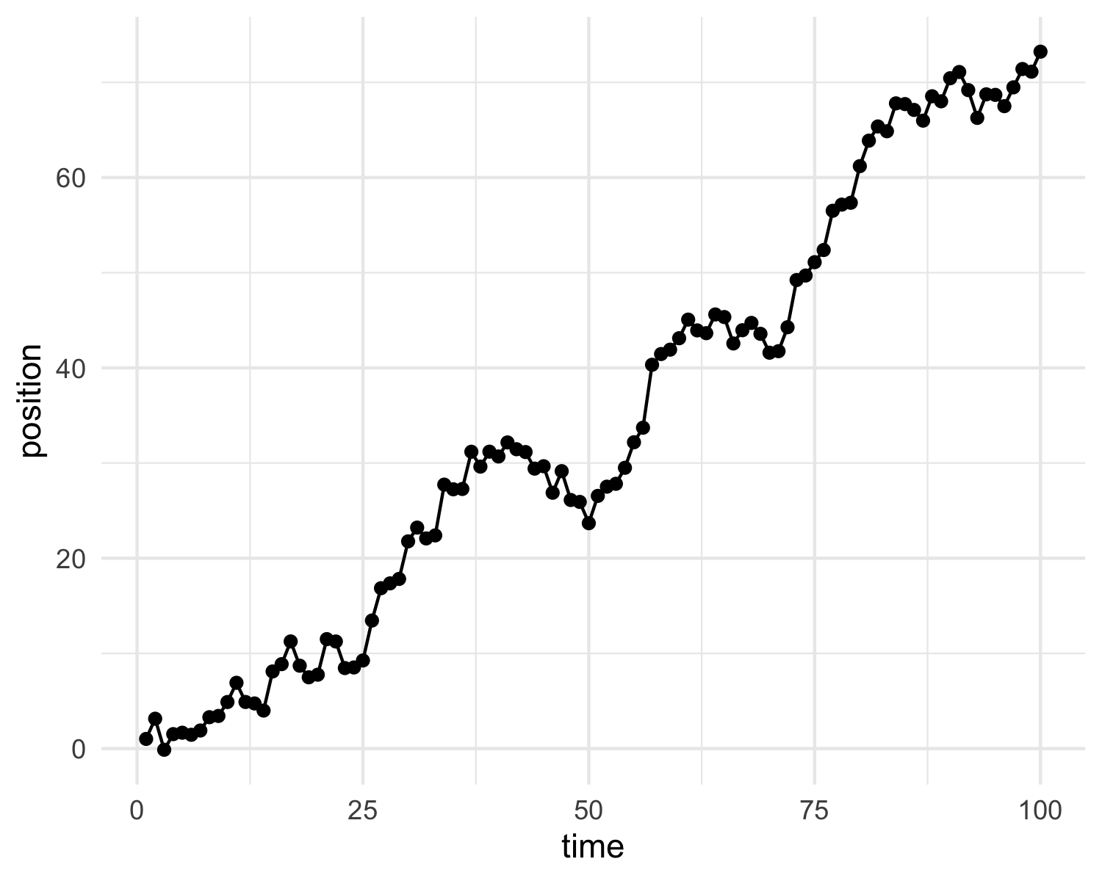

Figure 3.1: A random walk

The fitted walk estimated parameters of $μ$ = 0.7294085 and $σ$ = 1.9882632.

# 4 Conclusion

Gee aren’t random walks swell.

### 4.0.1 Colophon

This report was generated on 2021-11-28 10:53:58 using the following computational environment and dependencies:

#> ─ Session info ───────────────────────────────────────────────────────────────  
#> setting value   
#> version R version 4.0.4 (2021-02-15)  
#> os macOS Big Sur 10.16   
#> system x86_64, darwin17.0   
#> ui X11   
#> language (EN)   
#> collate en_US.UTF-8   
#> ctype en_US.UTF-8   
#> tz America/Los_Angeles   
#> date 2021-11-28   
#>   
#> ─ Packages ───────────────────────────────────────────────────────────────────  
#> package * version date lib source   
#> assertthat 0.2.1 2019-03-21 [2] CRAN (R 4.0.2)  
#> bookdown 0.22 2021-04-22 [2] CRAN (R 4.0.2)  
#> cachem 1.0.6 2021-08-19 [1] CRAN (R 4.0.4)  
#> callr 3.7.0 2021-04-20 [2] CRAN (R 4.0.2)  
#> cli 3.0.1 2021-07-17 [1] CRAN (R 4.0.2)  
#> colorspace 2.0-2 2021-06-24 [1] CRAN (R 4.0.2)  
#> crayon 1.4.1 2021-02-08 [2] CRAN (R 4.0.2)  
#> DBI 1.1.1 2021-01-15 [2] CRAN (R 4.0.2)  
#> desc 1.4.0 2021-09-28 [1] CRAN (R 4.0.4)  
#> devtools 2.4.1 2021-05-05 [2] CRAN (R 4.0.2)  
#> digest 0.6.28 2021-09-23 [1] CRAN (R 4.0.2)  
#> dplyr 1.0.7 2021-06-18 [1] CRAN (R 4.0.2)  
#> ellipsis 0.3.2 2021-04-29 [2] CRAN (R 4.0.2)  
#> evaluate 0.14 2019-05-28 [2] CRAN (R 4.0.1)  
#> fansi 0.5.0 2021-05-25 [2] CRAN (R 4.0.4)  
#> farver 2.1.0 2021-02-28 [2] CRAN (R 4.0.2)  
#> fastmap 1.1.0 2021-01-25 [2] CRAN (R 4.0.2)  
#> fs 1.5.0 2020-07-31 [2] CRAN (R 4.0.2)  
#> generics 0.1.0 2020-10-31 [2] CRAN (R 4.0.2)  
#> ggplot2 3.3.5 2021-06-25 [1] CRAN (R 4.0.2)  
#> glue 1.4.2 2020-08-27 [2] CRAN (R 4.0.2)  
#> gtable 0.3.0 2019-03-25 [2] CRAN (R 4.0.2)  
#> highr 0.9 2021-04-16 [2] CRAN (R 4.0.2)  
#> htmltools 0.5.2 2021-08-25 [1] CRAN (R 4.0.4)  
#> knitr 1.36 2021-09-29 [1] CRAN (R 4.0.4)  
#> labeling 0.4.2 2020-10-20 [2] CRAN (R 4.0.2)  
#> lifecycle 1.0.1 2021-09-24 [1] CRAN (R 4.0.2)  
#> magrittr 2.0.1 2020-11-17 [2] CRAN (R 4.0.2)  
#> memoise 2.0.0 2021-01-26 [2] CRAN (R 4.0.2)  
#> munsell 0.5.0 2018-06-12 [2] CRAN (R 4.0.2)  
#> pillar 1.6.4 2021-10-18 [1] CRAN (R 4.0.2)  
#> pkgbuild 1.2.0 2020-12-15 [2] CRAN (R 4.0.2)  
#> pkgconfig 2.0.3 2019-09-22 [2] CRAN (R 4.0.2)  
#> pkgload 1.2.3 2021-10-13 [1] CRAN (R 4.0.4)  
#> prettyunits 1.1.1 2020-01-24 [2] CRAN (R 4.0.2)  
#> processx 3.5.2 2021-04-30 [2] CRAN (R 4.0.2)  
#> ps 1.6.0 2021-02-28 [2] CRAN (R 4.0.2)  
#> purrr 0.3.4 2020-04-17 [2] CRAN (R 4.0.2)  
#> R6 2.5.1 2021-08-19 [1] CRAN (R 4.0.2)  
#> remotes 2.3.0 2021-04-01 [2] CRAN (R 4.0.2)  
#> rlang 0.4.12 2021-10-18 [1] CRAN (R 4.0.2)  
#> rmarkdown 2.8 2021-05-07 [2] CRAN (R 4.0.2)  
#> rprojroot 2.0.2 2020-11-15 [2] CRAN (R 4.0.2)  
#> rstudioapi 0.13 2020-11-12 [2] CRAN (R 4.0.2)  
#> scales 1.1.1 2020-05-11 [2] CRAN (R 4.0.2)  
#> sessioninfo 1.1.1 2018-11-05 [2] CRAN (R 4.0.2)  
#> simplerc * 0.0.0.9000 2021-11-28 [1] local   
#> stringi 1.7.5 2021-10-04 [1] CRAN (R 4.0.4)  
#> stringr 1.4.0 2019-02-10 [2] CRAN (R 4.0.2)  
#> testthat 3.1.0 2021-10-04 [1] CRAN (R 4.0.4)  
#> tibble 3.1.5 2021-09-30 [1] CRAN (R 4.0.2)  
#> tidyselect 1.1.1 2021-04-30 [2] CRAN (R 4.0.2)  
#> usethis 2.0.1 2021-02-10 [2] CRAN (R 4.0.2)  
#> utf8 1.2.2 2021-07-24 [1] CRAN (R 4.0.2)  
#> vctrs 0.3.8 2021-04-29 [2] CRAN (R 4.0.2)  
#> withr 2.4.2 2021-04-18 [2] CRAN (R 4.0.4)  
#> xfun 0.27 2021-10-18 [1] CRAN (R 4.0.4)  
#> yaml 2.2.1 2020-02-01 [2] CRAN (R 4.0.2)  
#>   
#> [1] /Users/frank/Library/R/4.0/library  
#> [2] /Library/Frameworks/R.framework/Versions/4.0/Resources/library

The current Git commit details are: