Supplemental information for: Evidence of a map sense: elephant seals account for time and space during long-distance migrations

Roxanne S. Beltran1,✉, Alexander L. Yuen1, Richard Condit1, Patrick W. Robinson1, Max F. Czapanskiy2, Daniel E. Crocker3, and Daniel P. Costa1

1 University of California Santa Cruz, Department of Ecology and Evolutionary Biology, 1156 High Street, Santa Cruz, CA 95064, USA  
2 Stanford University, Hopkins Marine Station, 120 Ocean View Blvd, Pacific Grove, CA 93950, USA  
3 Sonoma State University, Department of Biology, 1801 East Cotati Ave, Rohnert Park, CA 94928, USA

✉ Lead contact: [Roxanne S. Beltran <[roxanne@ucsc.edu](mailto:roxanne@ucsc.edu)>](mailto:roxanne@ucsc.edu)

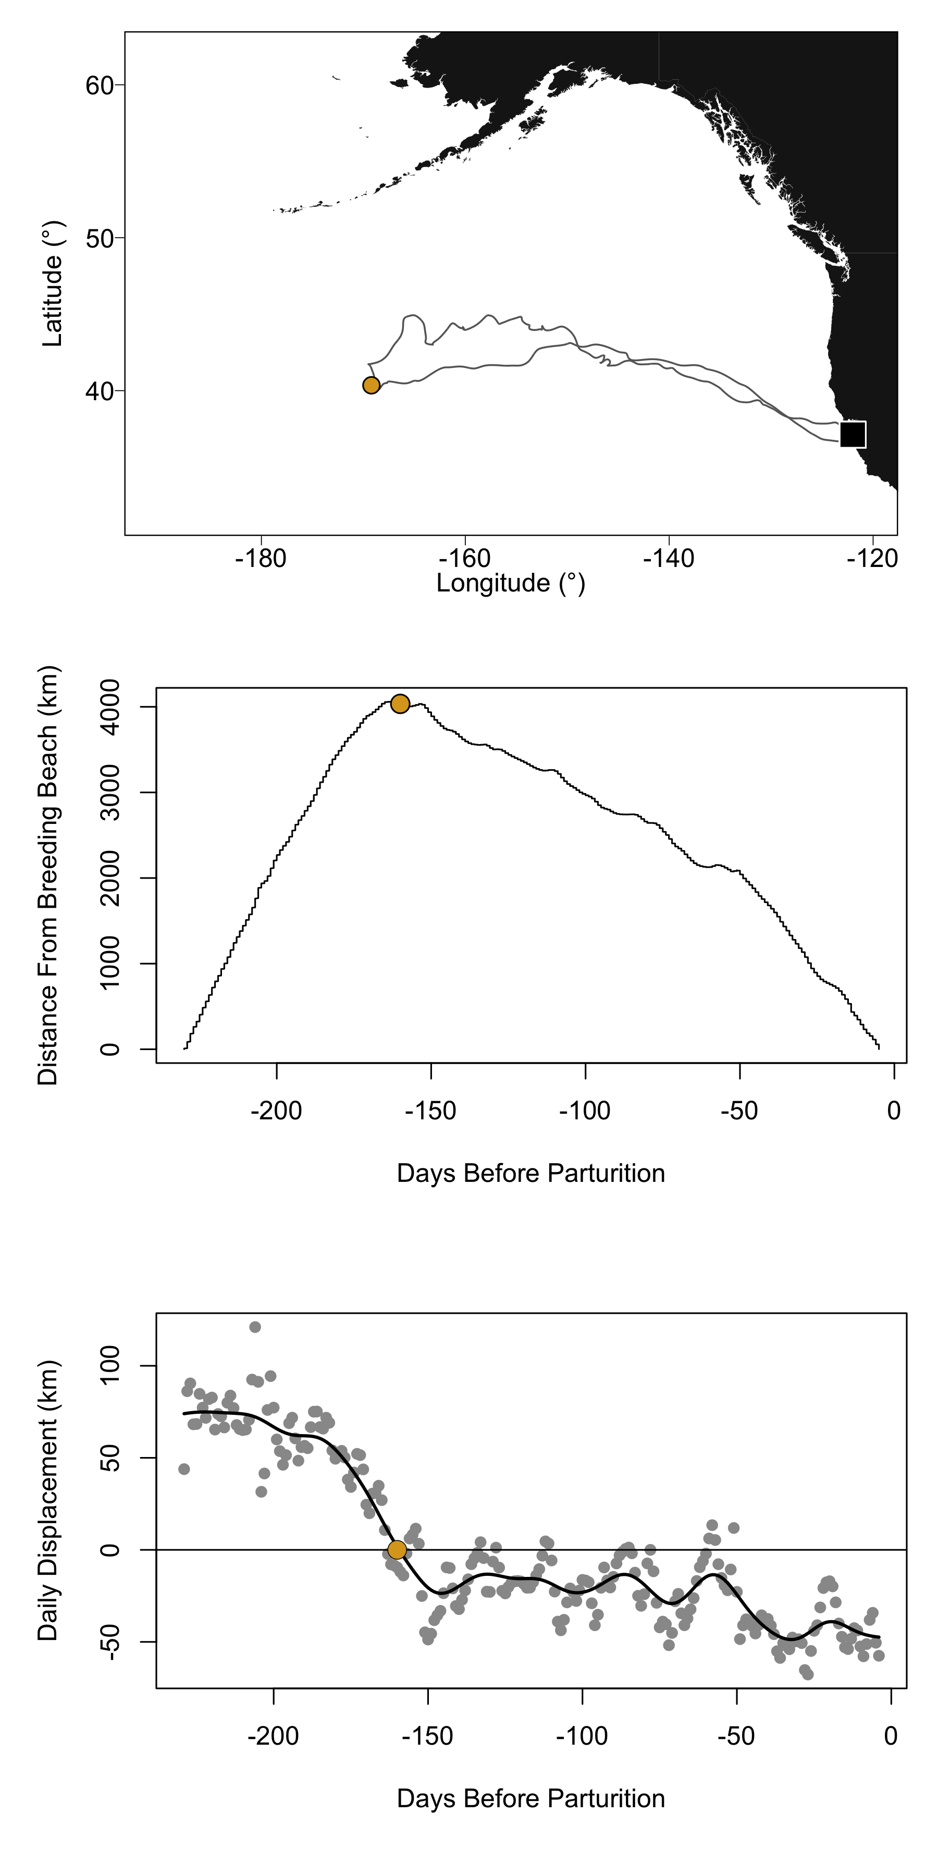

**Figure S1:** Tracking data (top), distance traveled from the breeding beach (middle), and daily displacement from the breeding beach (bottom) for a representative seal (#2007048). Gold points indicate turnaround locations in all panels.

## ─ Session info ───────────────────────────────────────────────────────────────  
## setting value   
## version R version 4.0.4 (2021-02-15)  
## os macOS Big Sur 10.16   
## system x86_64, darwin17.0   
## ui X11   
## language (EN)   
## collate en_US.UTF-8   
## ctype en_US.UTF-8   
## tz America/Los_Angeles   
## date 2022-01-03   
##   
## ─ Packages ───────────────────────────────────────────────────────────────────  
## package * version date lib source   
## bookdown 0.22 2021-04-22 [2] CRAN (R 4.0.2)  
## cachem 1.0.6 2021-08-19 [1] CRAN (R 4.0.4)  
## callr 3.7.0 2021-04-20 [2] CRAN (R 4.0.2)  
## cli 3.0.1 2021-07-17 [1] CRAN (R 4.0.2)  
## crayon 1.4.1 2021-02-08 [2] CRAN (R 4.0.2)  
## desc 1.4.0 2021-09-28 [1] CRAN (R 4.0.4)  
## devtools 2.4.1 2021-05-05 [2] CRAN (R 4.0.2)  
## digest 0.6.28 2021-09-23 [1] CRAN (R 4.0.2)  
## ellipsis 0.3.2 2021-04-29 [2] CRAN (R 4.0.2)  
## evaluate 0.14 2019-05-28 [2] CRAN (R 4.0.1)  
## fastmap 1.1.0 2021-01-25 [2] CRAN (R 4.0.2)  
## fs 1.5.0 2020-07-31 [2] CRAN (R 4.0.2)  
## glue 1.4.2 2020-08-27 [2] CRAN (R 4.0.2)  
## htmltools 0.5.2 2021-08-25 [1] CRAN (R 4.0.4)  
## knitr 1.36 2021-09-29 [1] CRAN (R 4.0.4)  
## lifecycle 1.0.1 2021-09-24 [1] CRAN (R 4.0.2)  
## magrittr 2.0.1 2020-11-17 [2] CRAN (R 4.0.2)  
## memoise 2.0.0 2021-01-26 [2] CRAN (R 4.0.2)  
## pkgbuild 1.2.0 2020-12-15 [2] CRAN (R 4.0.2)  
## pkgload 1.2.3 2021-10-13 [1] CRAN (R 4.0.4)  
## prettyunits 1.1.1 2020-01-24 [2] CRAN (R 4.0.2)  
## processx 3.5.2 2021-04-30 [2] CRAN (R 4.0.2)  
## ps 1.6.0 2021-02-28 [2] CRAN (R 4.0.2)  
## purrr 0.3.4 2020-04-17 [2] CRAN (R 4.0.2)  
## R6 2.5.1 2021-08-19 [1] CRAN (R 4.0.2)  
## remotes 2.3.0 2021-04-01 [2] CRAN (R 4.0.2)  
## rlang 0.4.12 2021-10-18 [1] CRAN (R 4.0.2)  
## rmarkdown 2.8 2021-05-07 [2] CRAN (R 4.0.2)  
## rprojroot 2.0.2 2020-11-15 [2] CRAN (R 4.0.2)  
## rstudioapi 0.13 2020-11-12 [2] CRAN (R 4.0.2)  
## sessioninfo 1.1.1 2018-11-05 [2] CRAN (R 4.0.2)  
## stringi 1.7.5 2021-10-04 [1] CRAN (R 4.0.4)  
## stringr 1.4.0 2019-02-10 [2] CRAN (R 4.0.2)  
## testthat 3.1.0 2021-10-04 [1] CRAN (R 4.0.4)  
## usethis 2.0.1 2021-02-10 [2] CRAN (R 4.0.2)  
## withr 2.4.2 2021-04-18 [2] CRAN (R 4.0.4)  
## xfun 0.27 2021-10-18 [1] CRAN (R 4.0.4)  
## yaml 2.2.1 2020-02-01 [2] CRAN (R 4.0.2)  
##   
## [1] /Users/frank/Library/R/4.0/library  
## [2] /Library/Frameworks/R.framework/Versions/4.0/Resources/library

**Table S1: Computational environment.** This analysis was generated on 2022-01-03 16:29:56 using the above computational environment and dependencies.

**Supplemental experimental procedures**

Animal handling methods, biologger specifications, and calculation of arrival and departure dates are described in Robinson, et al..1 Satellite tracking data were filtered and processed using the R package crawl2,3 to eliminate inaccurate location points and interpolate between locations. The resulting latitude and longitude estimates were used to calculate great circle distance (in kilometers) from the Año Nuevo breeding beach (37.1083°N, 122.3366°W) for each time-latitude-longitude point in the MATLAB function distance(). Across all seals, foraging trip timing (mean ± SD day-of-year) was as follows: departure 157 ± 9, turnaround 287 ± 40, and arrival 15 ± 8 (Figure 1C). Therefore, outbound trip durations were 130 ± 41 days, and inbound trip durations were 93 ± 41 days. Turnaround dates were calculated using Gaussian kernels with standard deviation 6 hours using custom functions in R. Code and data for a subset of animals are available on Zenodo4 (<https://doi.org/10.5281/zenodo.5777504>). Drift rate dates were calculated using a custom MATLAB code based on kernel density estimation of fine-scale changes in depth over time (drift rate, measured in meters/sec).5 Dates are presented as day-of-year relative to parturition date, with negative numbers indicating dates before pupping. All analyses were carried out in R v4.0.2. A linear mixed-effects model of turnaround date (relative to pupping date) as a function of turnaround distance and buoyancy change date was run in the package lme46 after scaling and centering the continuous variables and including individual as a random effect.

**Supplemental references**

1. Robinson, P.W., Costa, D.P., Crocker, D.E., Gallo-Reynoso, J.P., Champagne, C.D., Fowler, M.A., Goetsch, C., Goetz, K.T., Hassrick, J.L., Hückstädt, L.A., et al. (2012). Foraging Behavior and Success of a Mesopelagic Predator in the Northeast Pacific Ocean: Insights from a Data-Rich Species, the Northern Elephant Seal. PLoS ONE *7*, e36728.

2. Johnson, D.S., London, J.M., Lea, M.-A., and Durban, J.W. (2008). Continuous-time correlated random walk model for animal telemetry data. Ecology *89*, 1208–1215.

3. Johnson, D., Josh M. London (NOAA), and Kenady (2016). Crawl: V2.0.

4. Beltran, R.S., Yuen, A.L., Condit, R., Robinson, P.W., Czapanskiy, M.F., Crocker, D.E., and Costa, D.P. (2021). FlukeAndFeather/turnaround: Initial release (Zenodo).

5. Robinson, P.W., Simmons, S.E., Crocker, D.E., and Costa, D.P. (2010). Measurements of foraging success in a highly pelagic marine predator, the northern elephant seal. Journal of Animal Ecology *79*, 1146–1156.

6. Bates, D., Mächler, M., Bolker, B., and Walker, S. (2015). Fitting Linear Mixed-Effects Models Usinglme4. Journal of Statistical Software *67*.